

EquipCaD User Manual

(Version 3.7.6)

Table of Contents

Preface 5
1. Signing up at equip.me 6
1.1. Dealer sign-up 6
1.2. Production technologist sign-up 6
2. Installing EquipCaD 10
2.1. Installing the application 10
2.2. Getting an API key on the portal 11
2.3. Setting up the application 12
2.4. Updating the application 15
3. Installing the Assembly Plan Template 17
4. Application structure 21
4.1. EquipCaD sections 21
4.2. EquipCaD tabs 28
4.3. Utility programs 34
4.4. Service 34
4.5. Write to the developer 35
4.6. Interface language change button 36
5. Layers 38
5.1. 3D view 38
5.2. Plan 38
5.3. Glass 39
5.4. “Water”, “Gas”, “Electricity”, “Freon supply points – 10 degrees”, “Freon supply points – 35 degrees”, “Ventilation supply points”, “Equipment indexing” 40
5.5. Doors 40
5.6. Extraction hoods/Chambers 41
5.7. Objects grouping 42
5.8. Projection 43
5.9. Symbols 44
6. Selecting equipment 46
6.1. Before you start 46
6.2. Selecting equipment in the Structure section 46
6.3. Searching for equipment 47
6.4. Selecting equipment by characteristics 49
6.5. Selecting by available stocks 50
6.6. Brand Access Request 51
6.7. Placing equipment in a project 51
6.8. Placing additional pieces of equipment 53
6.9. Searching for equipment added to a project 55
6.10. Choosing additional equipment and accessories 57
6.11. Favorites 59
6.12. Groups 60
7. Equipment Configurator 67
7.1. Creating a custom block 67
7.2. Editing custom block attributes 70
8. Workshops 72
8.1. Creating and deleting workshop names in the program settings 72
8.2. Creating and deleting workshops in the program menu 74
8.3. Creating workshops in a project 76
8.4. Deleting workshops in a project 79
8.5. Selecting a workshop in a project 80
8.6. Selecting equipment without a group 82
8.7. Adding equipment to a workshop 83
8.8. Deleting equipment from a workshop 85
9. Equipment indexing and callout coordinates 88
9.1. Equipment indexing 88
9.2. Indexing settings 90
9.3. Editing indexing 105
9.4. Saving and deleting callout coordinates 108
10. Creating a specification 110
10.1. Specification in the program 110
10.2. Excluding equipment from the specification 116
10.3. Sorting workshops in the specification 118
10.4. Specification on the portal 120
10.5. Specification on the drawing 128
11. Equipment connection points; callout templates and utilities tables 133
11.1. General explanations for designations 133
11.2. Putting connection points 135
11.3. Callout templates 137
11.4. Editing connection diagram names 141
11.5. Editing connection points in the drawing 144
11.6. Editing connection points in the specification 150
11.7. Utility programs 155
11.8. Utilities tables 168
11.9. Connection points in the specification 169
12. Important operational aspects 171
12.1. Copying projects 171
12.2. Removing workshops in a project 171
12.3. Cancel command execution 172

Preface
EquipCaD is a suite of software tools and services specifically designed for professional designers. EquipCaD uses solely AutoCAD software, allows for automating many operations involved in design, and is capable of generating specifications and quotations. EquipCaD updates the equipment database automatically as 3D model updates become available and shows current prices and available stocks of equipment in real time. This allows you to combine engineering design and pricing to instantly obtain the final result. EquipCaD is a multilingual application.

- Signing up at equip.me
  - Dealer sign-up
  - Production technologist sign-up

To get access to EquipCaD, you need to sign up on the dealer portal at https://equip.me. To work in the application, the user will also need to have the Supervisor status on the portal. Dealers and designing engineers sign up separately. If you need two profiles, you will have to create two different accounts using different email addresses.
With a dealer account, you can use EquipCaD for design purposes and transact on the dealer portal. A designing engineer account allows you to design in EquipCaD, make your own portfolio in the designer’s area, and get access to available orders.
  - Dealer sign-up
To obtain the Supervisor status at equip.me, a dealer should ask their Dealership Manager to make the necessary change. Once you have the desired status, you can generate an API key and run the program.
  - Production technologist sign-up
A production technologist is assigned the Supervisor status automatically after the verification and authentication at equip.me.
    - To sign up as a designing engineer at equip.me, go to My Profile on the portal at https://equip.me/;

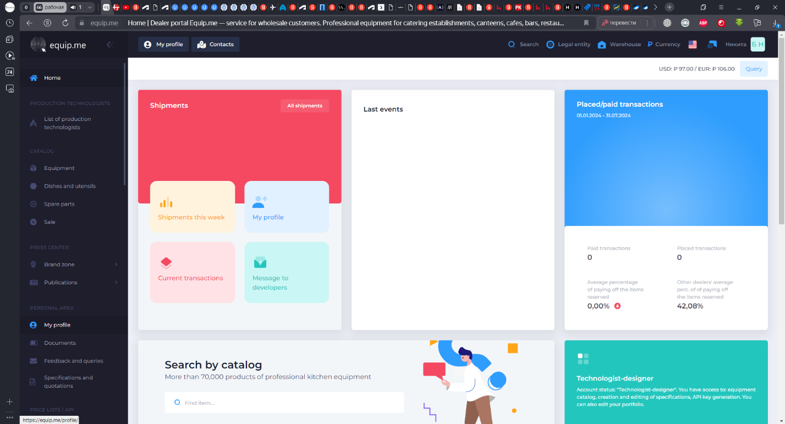
1.2.1
    - Click the Sign-Up button in My Profile;
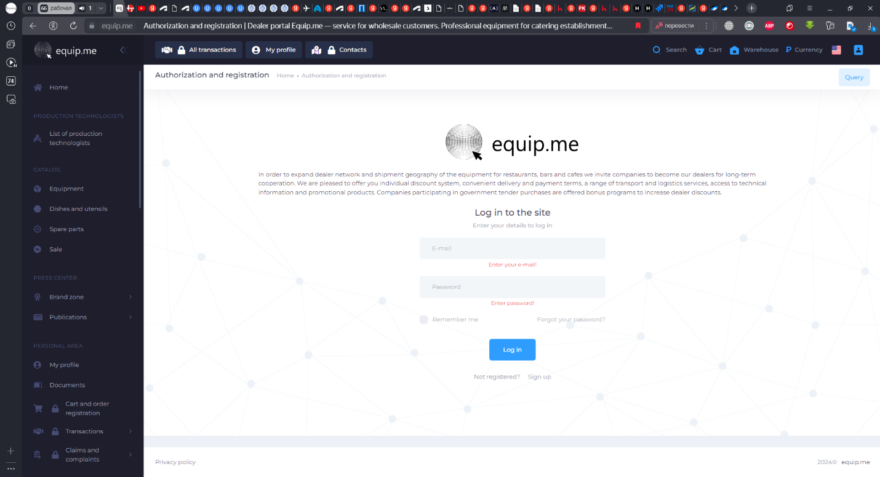
1.2.2
To sign up as a production technologist, you must create a new account. It is not possible to obtain this status for a previously signed up account.
    - In the form that opens, select “Production technologist” under the Profile Type heading, enter your full name, business email address, a password, confirm the password, and enter the details of the company you represent. Then you need to accept our Privacy Policy and confirm reCAPTCHA;
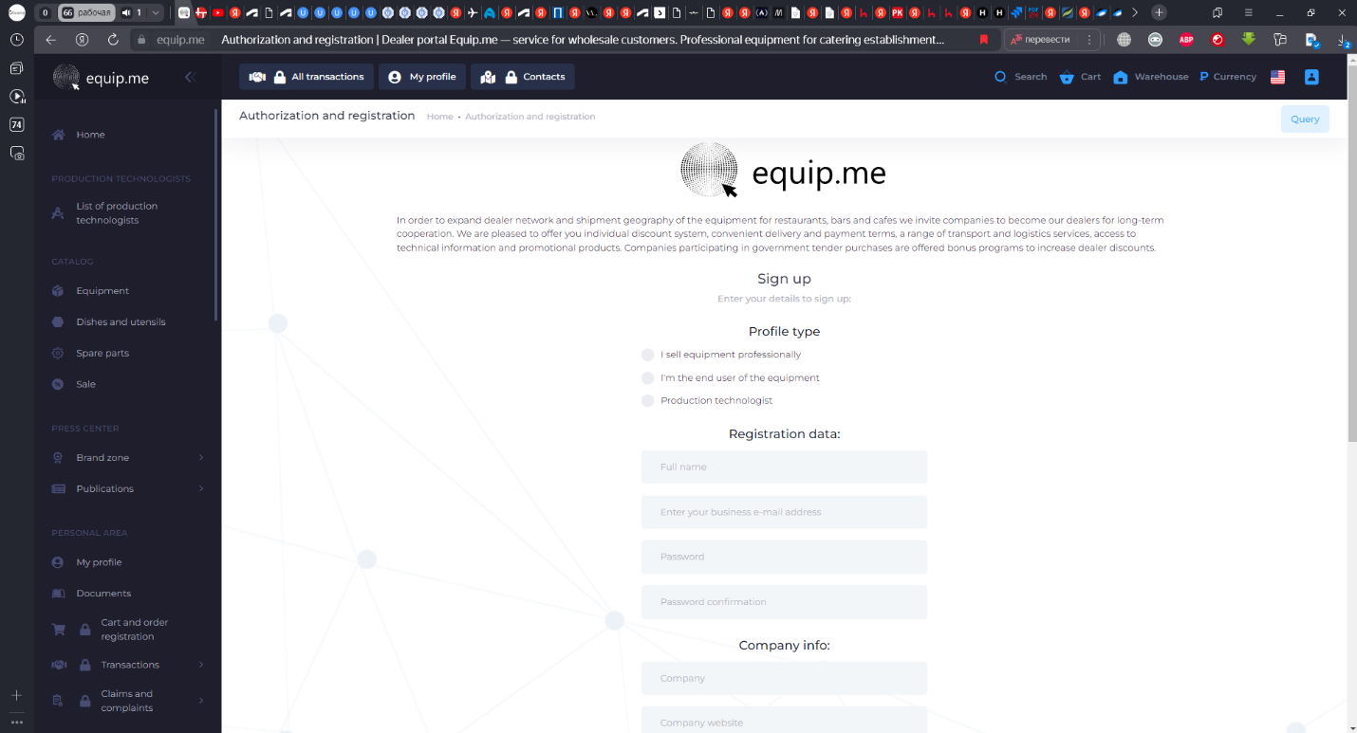
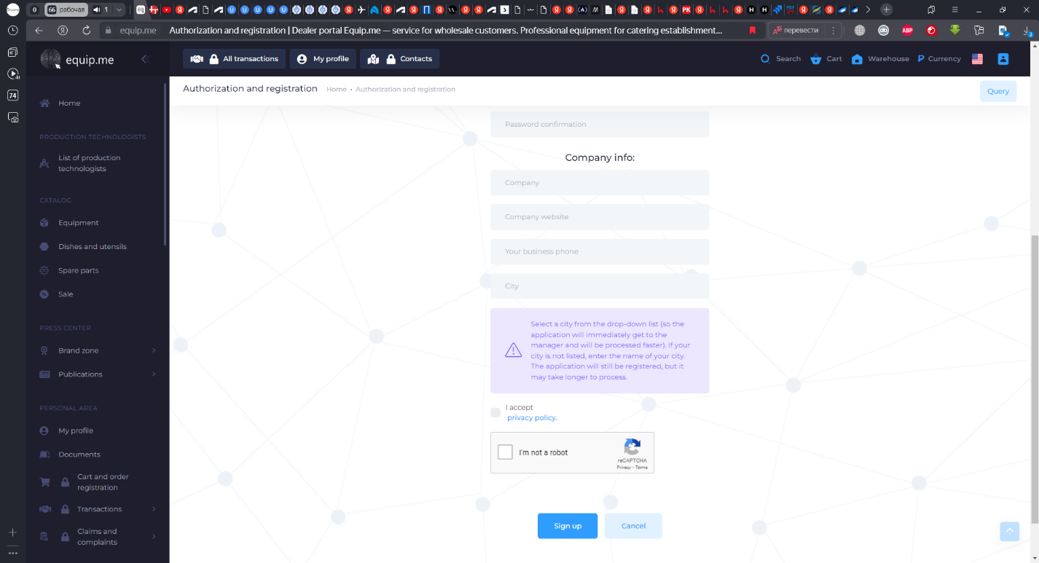

    - A few minutes after the sign-up, you will receive an e-mail asking to confirm your e-mail address;
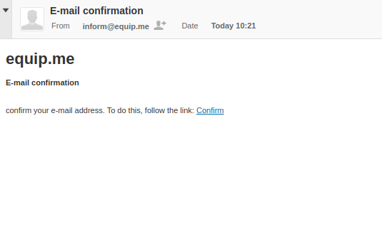
    - Once your email address is confirmed, your profile will be confirmed by the Manager and you will be informed accordingly by email;
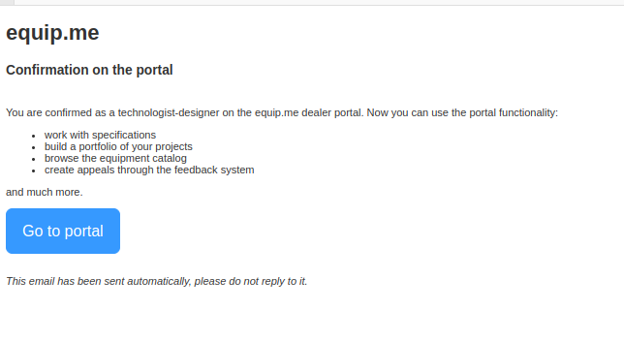

- Installing EquipCaD
2.1 Installing the application
2.2 Getting an API key on the portal
2.3 Setting up the application
2.4 Updating the application

EquipCaD has the following minimum installation requirements:
PC
- Intel Core i5 processor;
- 8 GB of RAM;
- 100 GB of free disk space
Operating system
- Windows 10 (64 bit) and higher.
EquipCaD is only compatible with AutoCAD® (any version from 2018 to 2024) and AutoCAD Architecture.
  - Installing the application
Those users who have previously worked in EquipCaD (versions below 3.3.50) should follow steps 2.1.1 to 2.1.5. New users of the application should complete steps 2.1.2 to 2.1.5.
    - Remove the old version of EquipCaD using the Add or remove Programs;
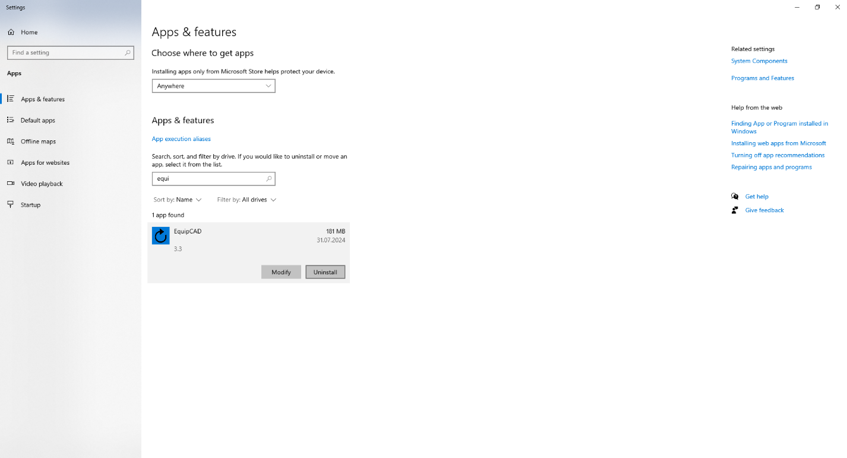
2.1.1

    - Install the application by downloading it at http://77.223.104.140/GetUpdate?downloadType=WebFullFile

Note: You are strongly encouraged to deploy the application to the root folder on your primary drive — by default it is the Local Drive (C:). it is also advisable to add the folder with EquipCaD as an exception in your antivirus program.

    - Start EquipCaD

  - Getting an API key on the portal
If you are not signed up on the dealer portal, please go to Section 1.
    - To generate an API key, go to My Profile on the portal at https://equip.me/;
    - Then choose “For Developers”;
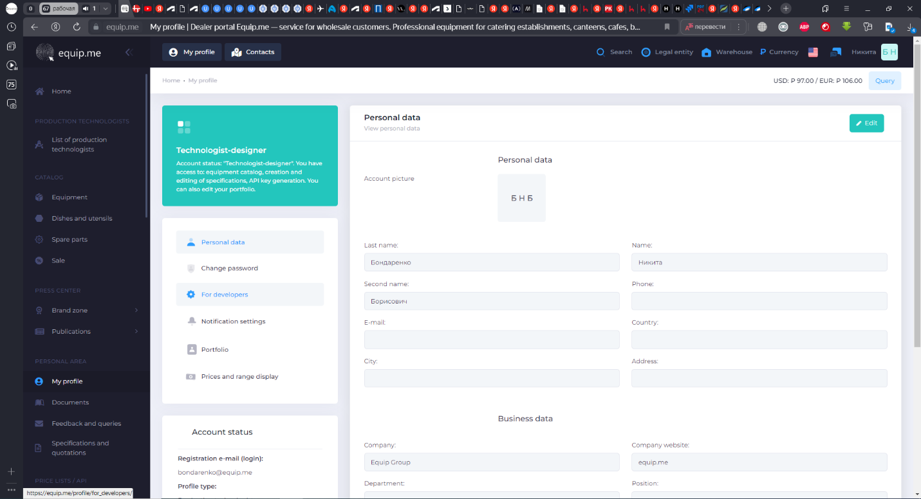
2.2.2
2.2.1

    - Generate an API key (this is done automatically when you click the Regenerate button);
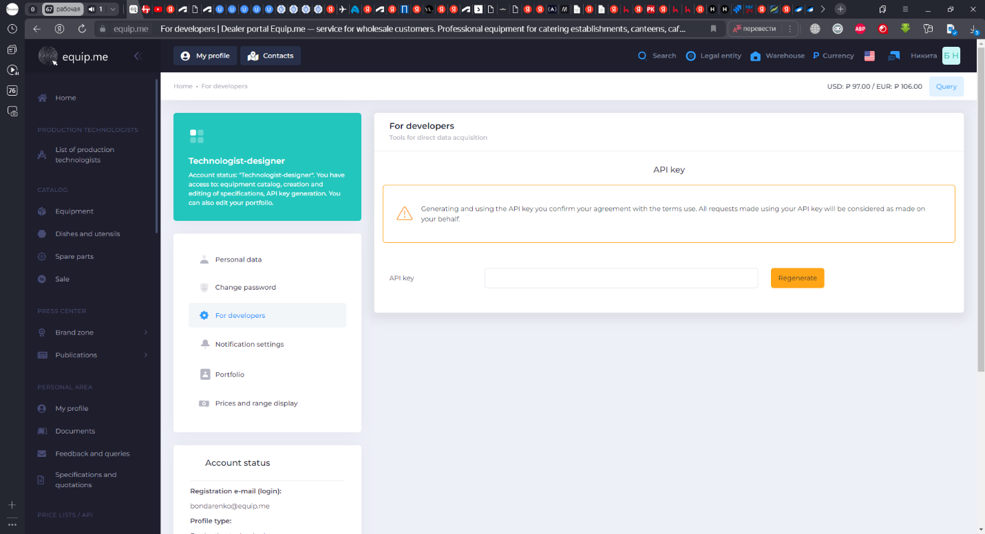
2.2.3

  - Setting up the application

    - When you run the application for the first time, a Registration Form appears;
    - Copy the key from the “Your Key” field;
    - Send the key to ecad@equip.me indicating your last name, company/self-employed status, and the name of the device with the installed application;
    - You will receive a response with a code. Enter it in the Response Key field;
    - Click the Register button;
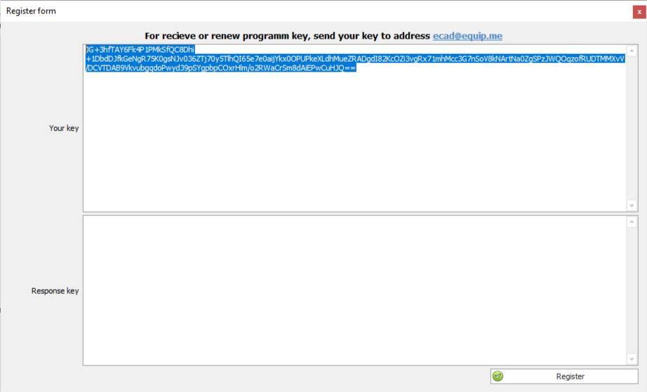
2.3.3
2.3.4
2.3.5
2.3.2
Note: The key is generated for a particular device; therefore, you have to obtain a key for each device you intend to use.
    - After the registration of the program key, go to the Service tab;
    - Select the Program Settings menu;
    - Enter the copied API key (see step 2.2.3) in the “Data Exchange API Key” field and click “Dealer portal Access Test Equip.me”.
    - Verify and, if necessary, set the folders as follows: “Program data storage folder”: C:\FileEquip\Files; and “Archive data download folder”: C:\FileEquip\Archives.
    - Go to the Common settings for AutoCAD;
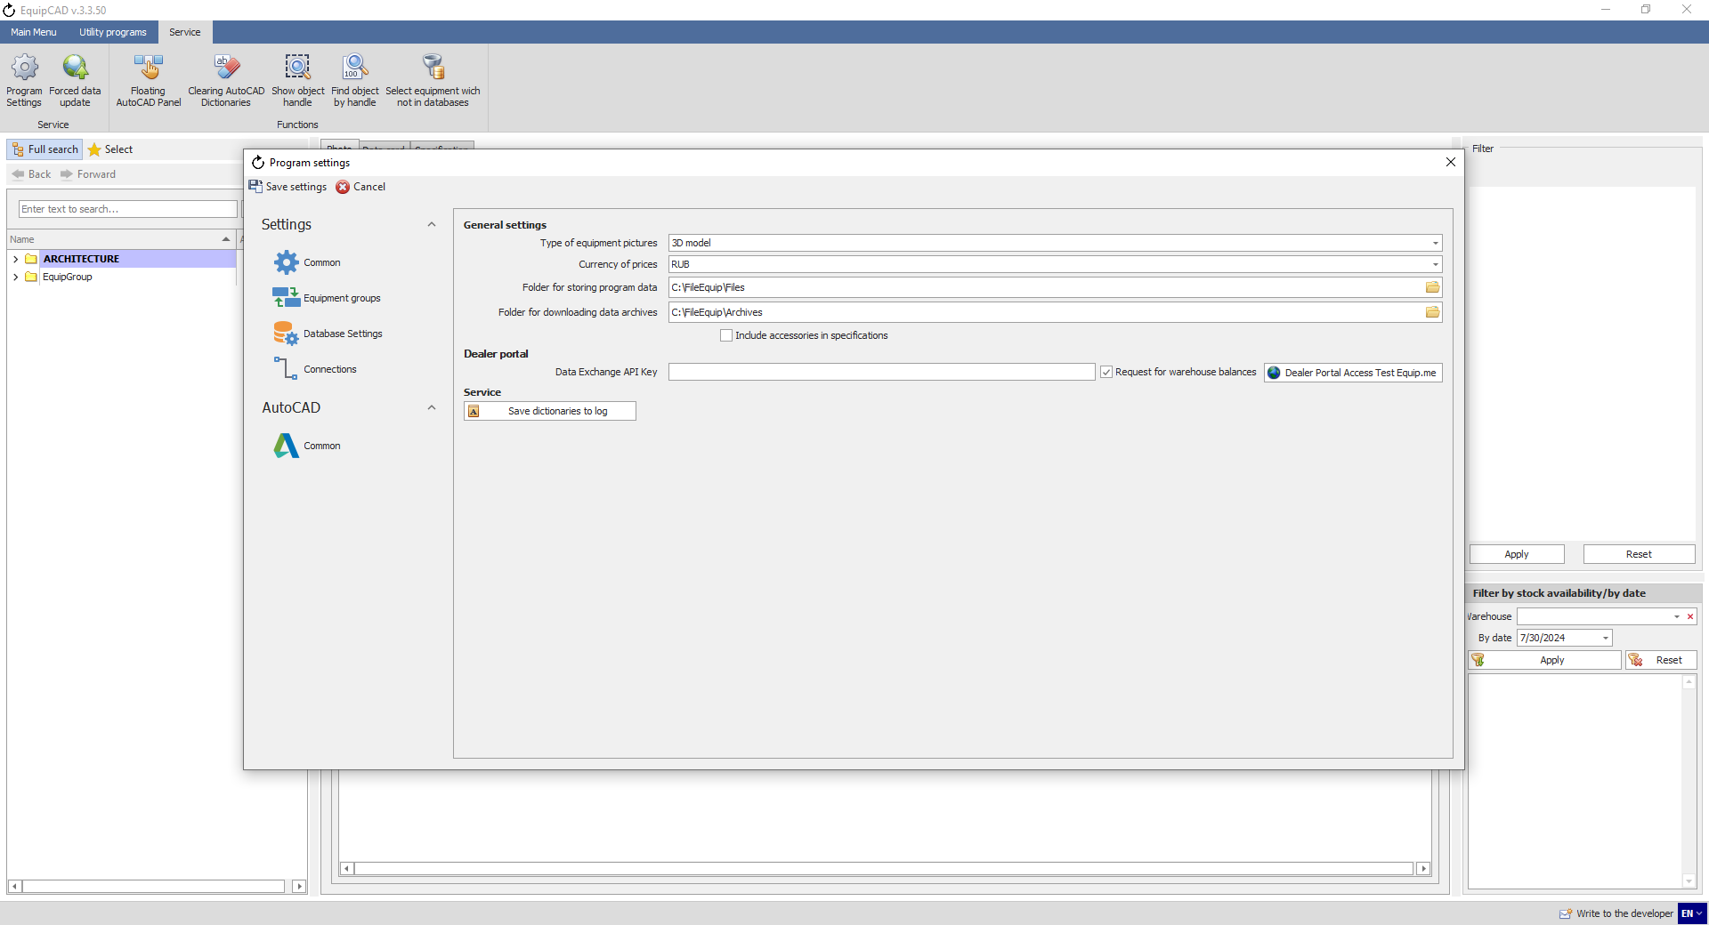
2.3.8
2.3.10
2.3.6
2.3.7
2.3.9
    - Choose the AutoCAD version you are planning to use and click “Connection test” (AutoCAD must be running);
    - Save the settings;
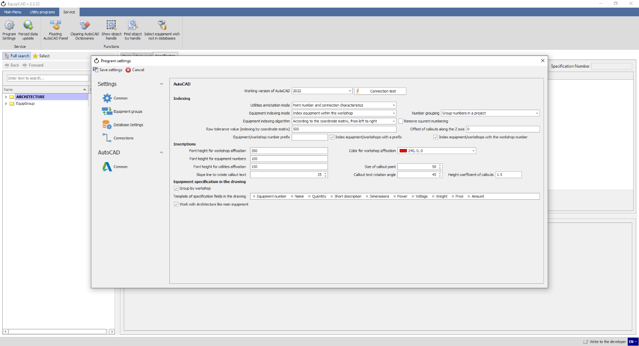
2.3.12
2.3.11

    - Close and restart EquipCaD. The block database upload will start. Wait until the upload is complete and the program runs. The upload takes a lot of time; therefore we recommend that you disable the sleep mode on your PC;
    - Once the uploads are complete, go to the Service menu and select Program Settings – Common;
    - Check the “Request for warehouse balances” box;
    - Choose the currency in the “Currency of prices” field;
    - Go to the Database Settings tab;
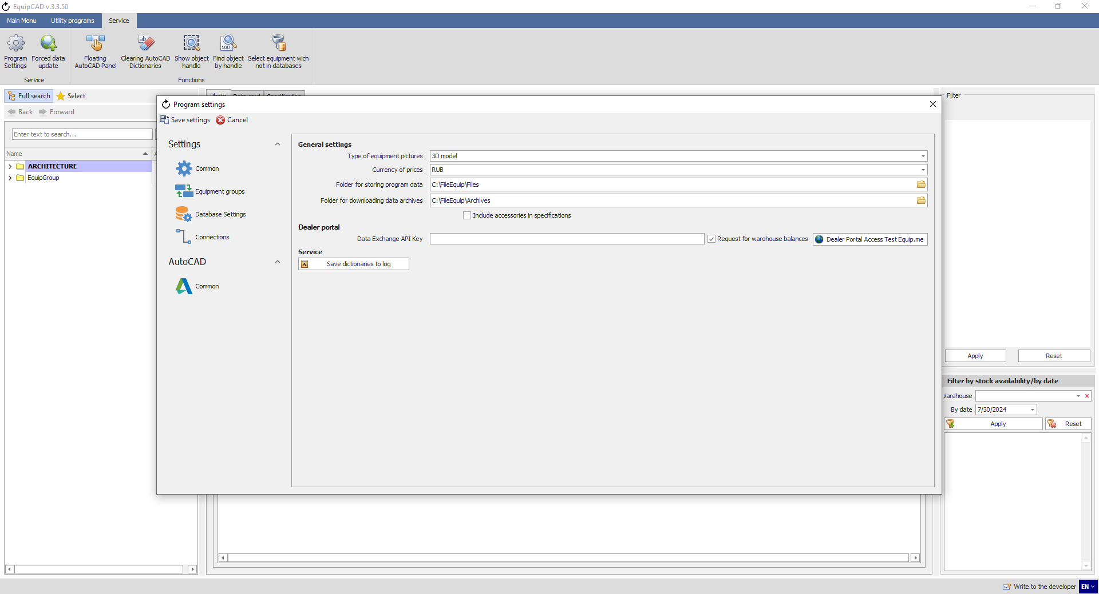
2.3.15
2.3.16
2.3.17
2.3.14
    - Check the “Work with the dealer portal” box;
    - Set the Price Coefficient (the mark-up amount);
    - Save the settings.
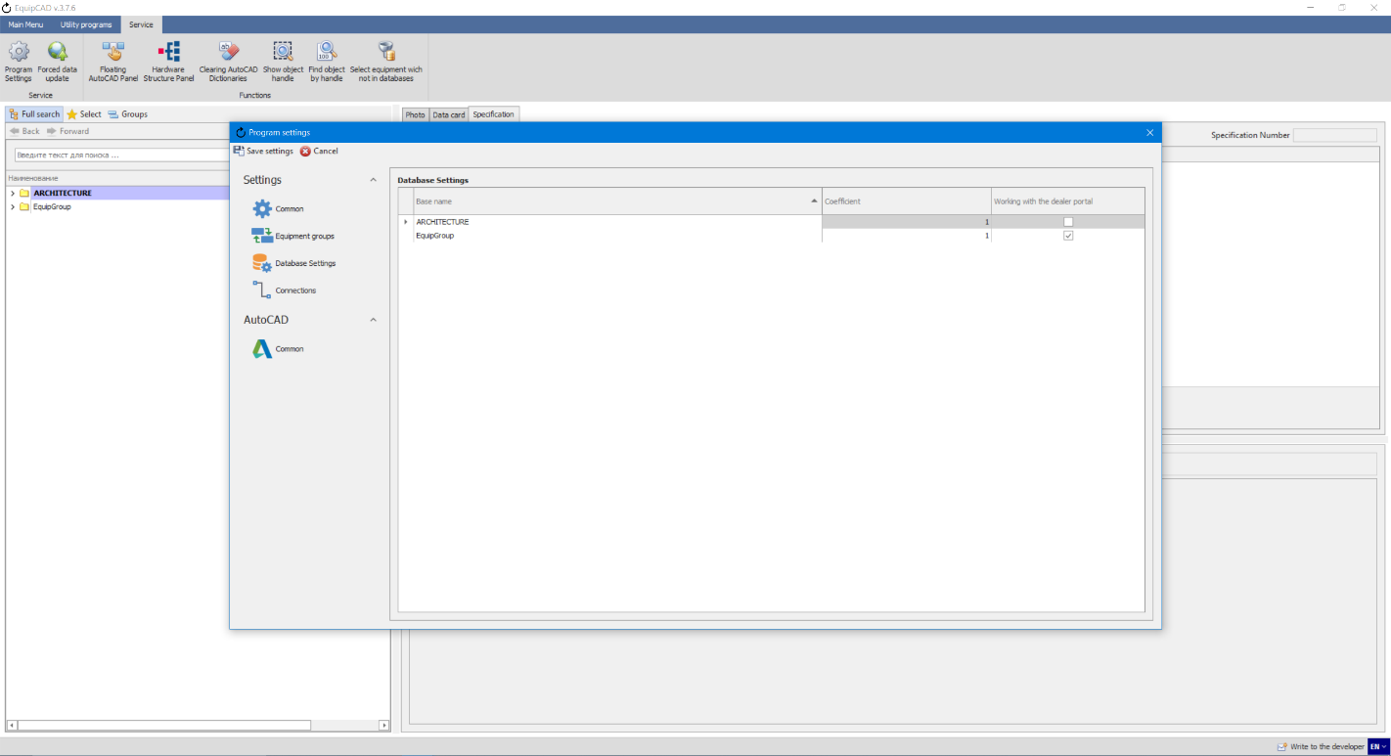
2.3.19
2.3.18
2.3.20
The program is ready to be run.
Note: The price resulting from a change in the price coefficient will be indicated in the program only. When a specification is displayed on the portal, the designer will get their individual dealer prices.

If you are using your old projects in the new version of the program, you should fist clear up AutoCAD dictionaries. After that, you will need to recreate workshops, numbers and utilities in your design.
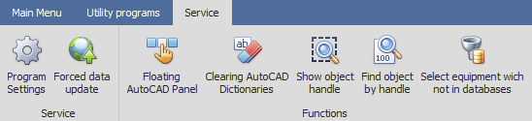

  - Updating the application
EquipCaD is updated automatically if connected to the Internet. There are two types of updates:

    - Standard update
With a standard update, EquipCaD will prompt you that an update is available when you run the program, and you can choose whether or not to install it.
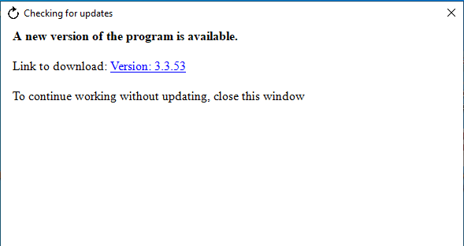

    - Critical update
If a critical update is available, EquipCaD will not run until the update is installed.
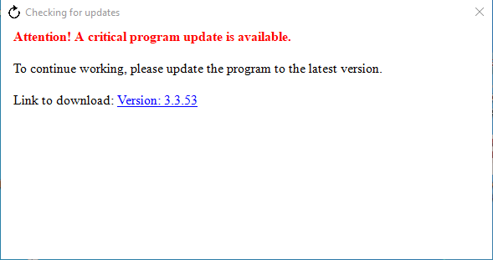
- Installing the Assembly Plan Template
For the convenience of users, EquipCaD has a designated template for the BCREATE command in AutoCAD for making assembly plans and printing out project drawings. The template includes the basic drawing settings, connection diagrams, and notes. The user can use the template as a basis and customize it to their specific requirements when working with projects.
  - Go to Technical Support on equipcad.com and download the DWT form file;
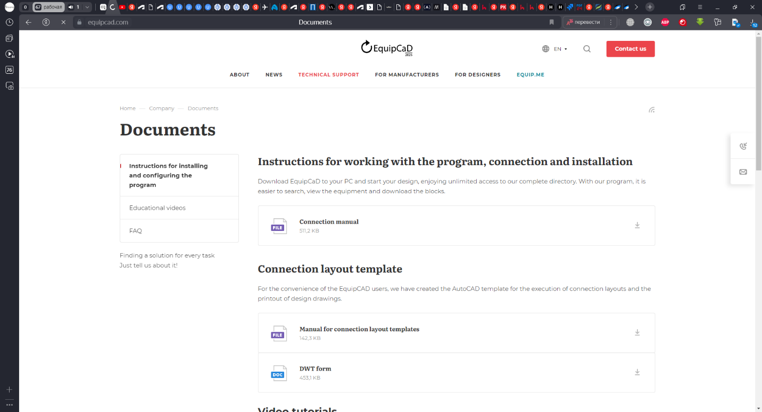
3.1

  - Before installing the template, go to the Control Panel on your PC;
  - Enter “file explorer” in the search line and open the File Explorer Options;
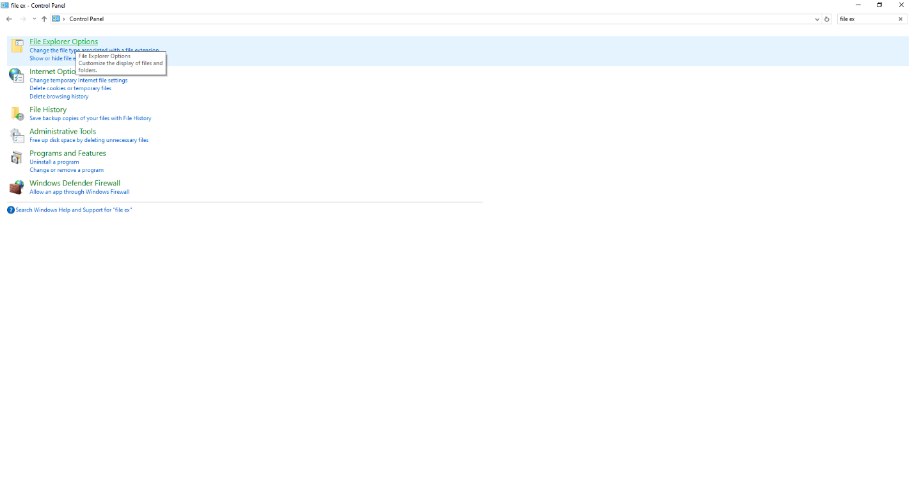
3.3

  - In the window that opens, go to the View tab;
  - Scroll down the list and select “Show hidden files and folders” under the “Show hidden files, folders and drivers” heading;
  - Click the Apply button;
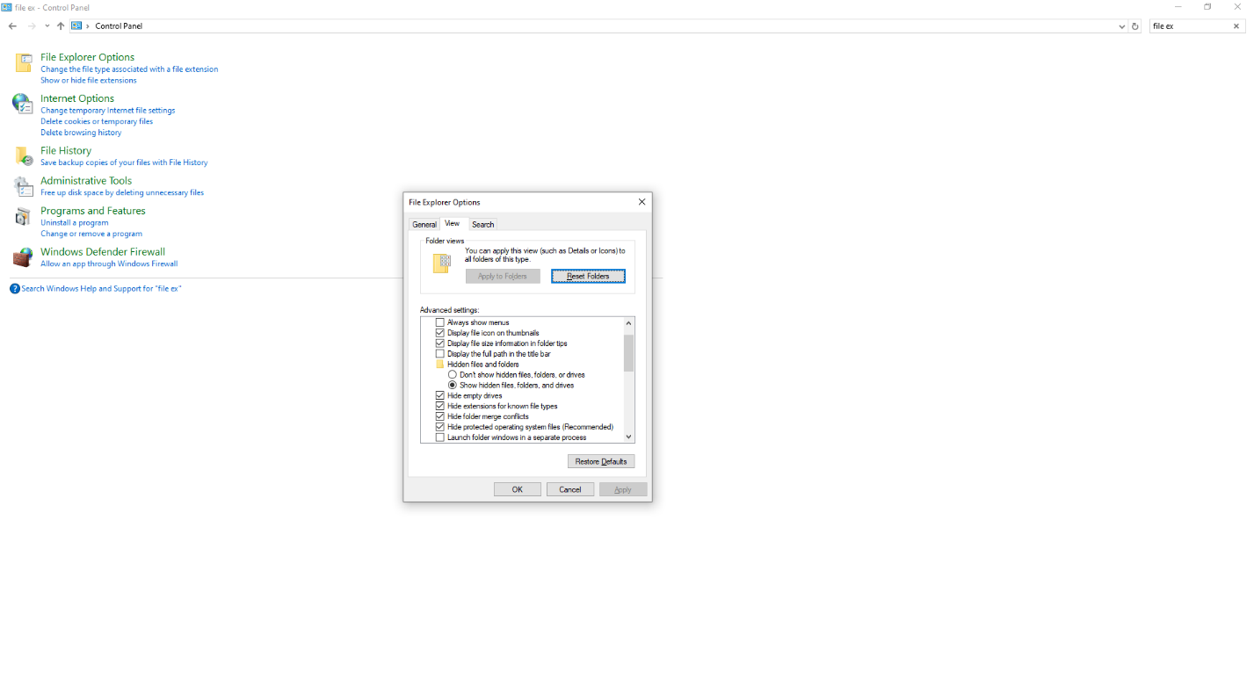
3.6
3.5
3.4

  - After the download is complete, move the DWT Template file to the C:\Users\“UserName”\AppData\Local\Autodesk\”Your AutoCAD version”\R24.1\”Your AutoCAD language”\Template folder;
  - Once the template is placed in the required folder, open AutoCAD, create a new drawing, and open the settings by right-clicking on the empty space of the drawing and selecting “Options” in the list that opens;
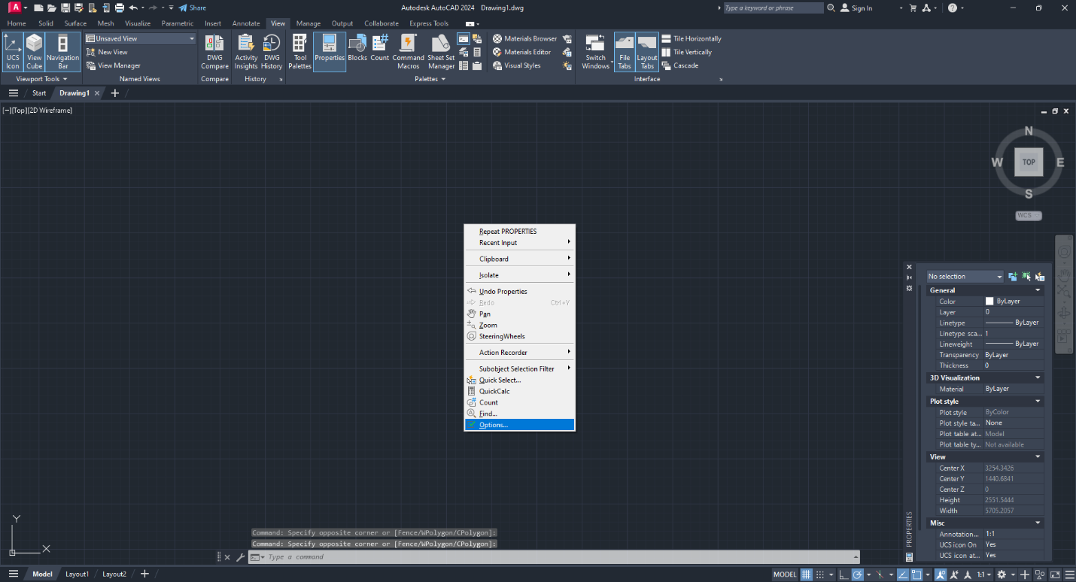
3.8
  - In the window that opens, go to the File tab, find “Template settings” in the list and open it with the “+” sign;
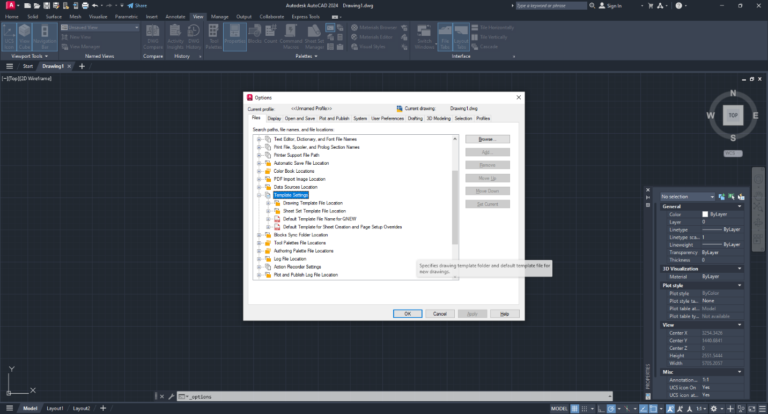
3.9

  - Then open “Drawing templates file location” and make sure that the specified path indicates the folder to which our assembly plan template was moved (if the path is different, click the Browse button and select the correct path);
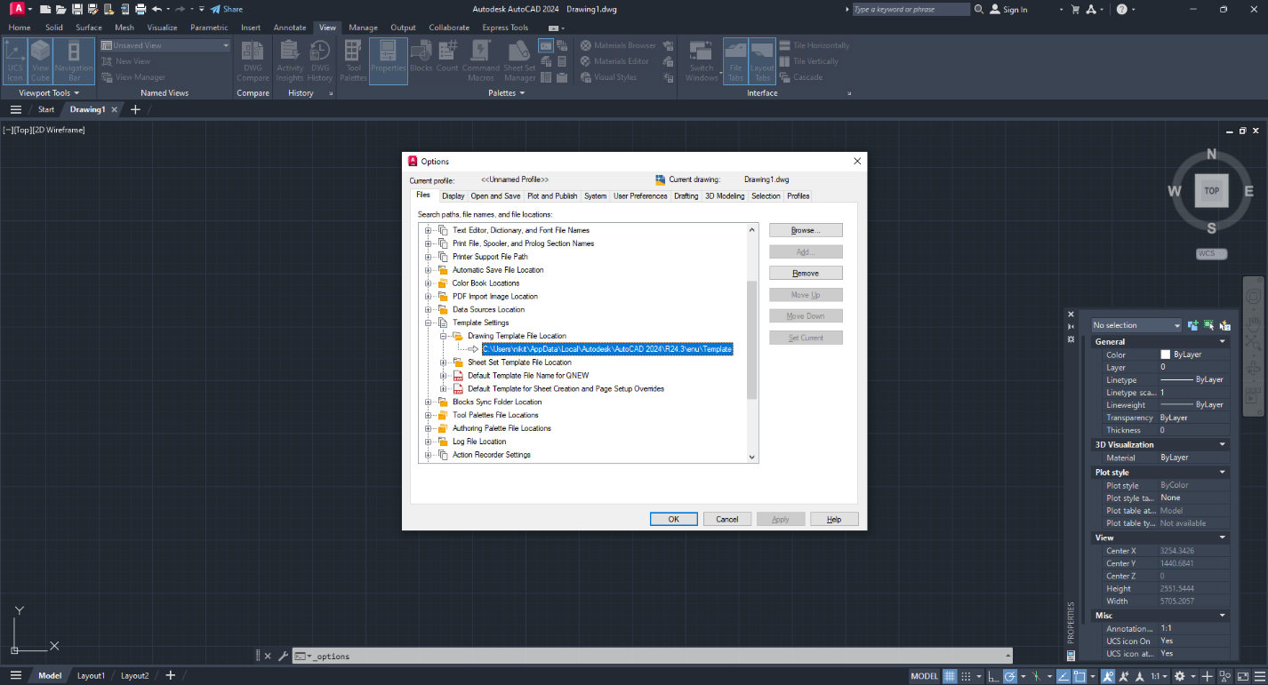
3.10

  - Next, open “Default Template File Name for QNEW” and click the Browse button;
  - In the File Selection window, select the file downloaded from our website and click the Open button;
  - In the Parameters window, click the Apply button;
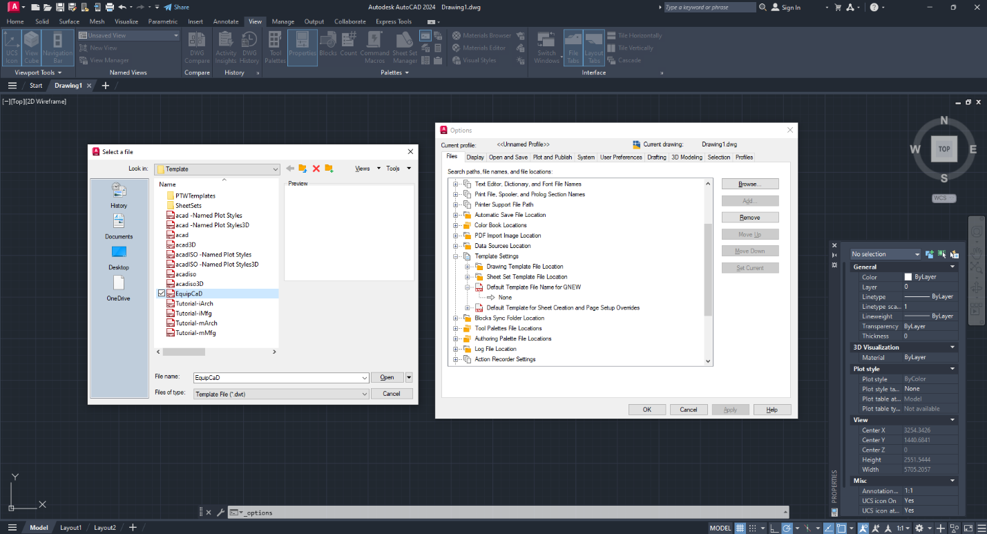
3.11
3.13
3.12

  - Once all of the above steps are complete, our assembly plan template will open when you create a new AutoCAD file;
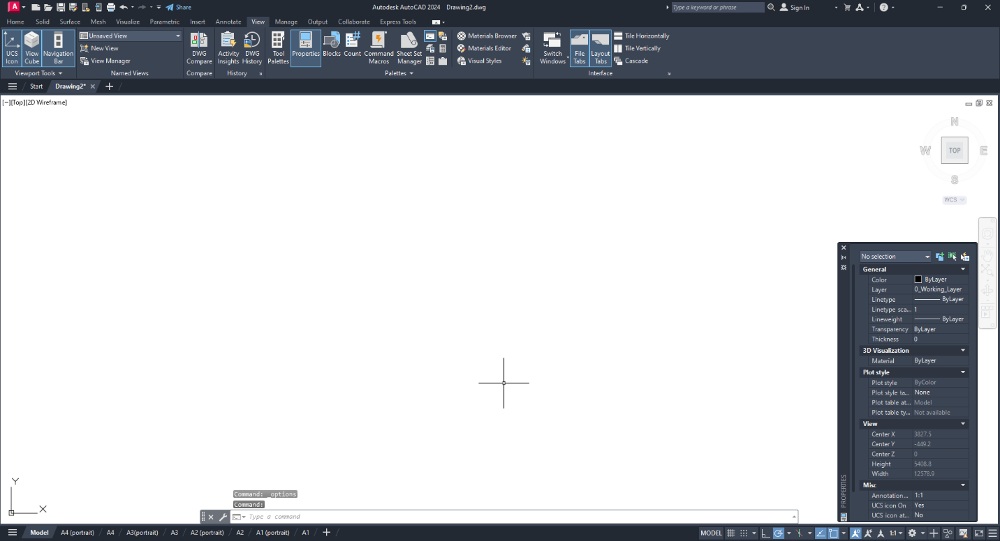

- Application structure
4.1 EquipCaD sections
4.2 EquipCaD tabs
4.3 Utility programs
4.4 Service
4.5 Write to the developer
4.6 Interface language change button

  - EquipCaD sections
Below are the explanations for the program’s Main Menu. It has the following sections:
    - Section 1: Structure
      - EquipGroup equipment.

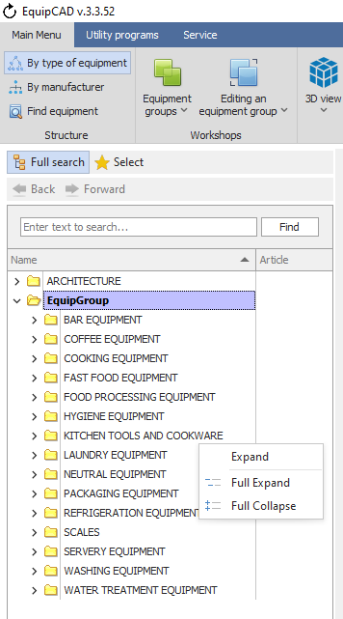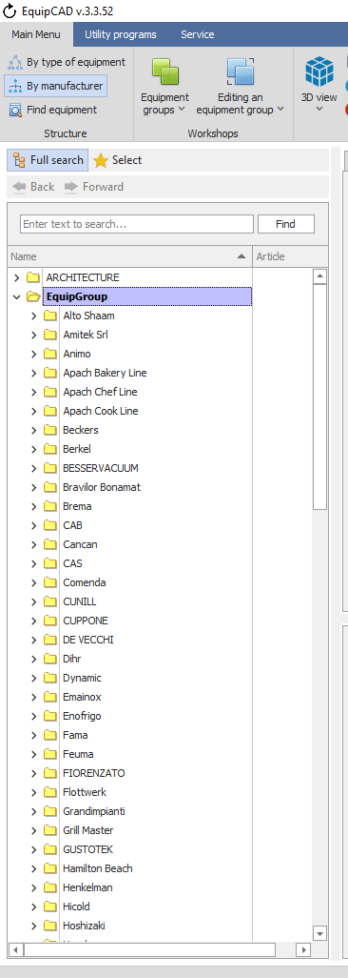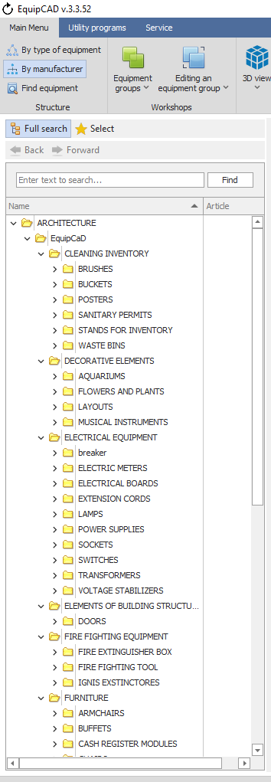
This section systemizes the entire equipment catalogue in EquipCaD by category, sub-category, sub-group, and list of manufacturers. When you select an equipment item by double-clicking its name or photo, it will be automatically added to your opened AutoCAD drawing.
You can unfold and fold both an individual group/sub-group and the whole tree by right-clicking on any group/sub-group in the tree.
The tree uses color designations of the type of purchase, gray color - "We do not carry", flesh color - "Assortment". The type of purchase "Assortment" is an additional assortment, created specifically for the EquipCaD program.
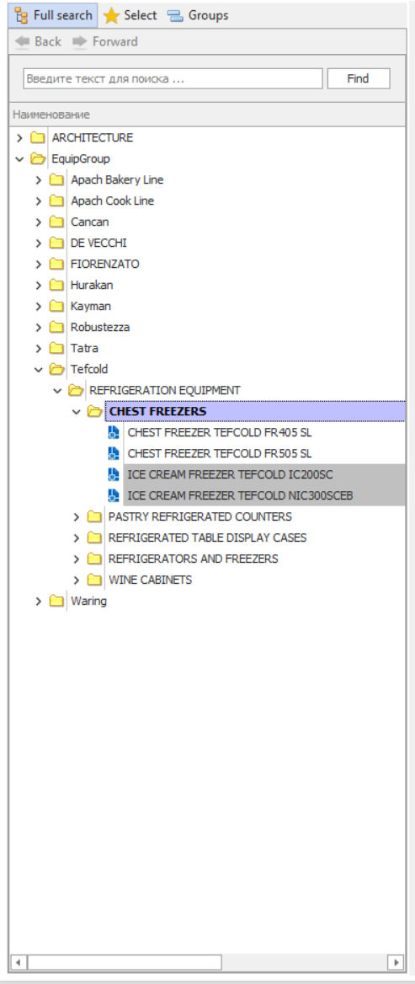

      - Architecture
The Structure also contains the Architecture folder.
The Architecture section is a catalogue of 3D models of various decorative, plumbing, fire-fighting, electrical and other components that can make your design more detailed and visually better. Besides, certain technical items may have connection points, and these will be shown by callouts for connections in the corresponding sections of assembly plans and on the drawing when the specification is displayed.
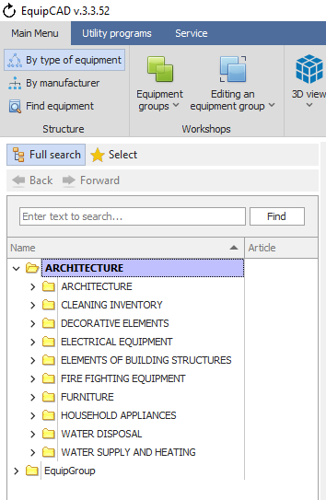
4.1.1.2

      - Favorites
The Select button allows you to access a list of equipment items that you have selected earlier.
In the Select list, you can group items by type of equipment and manufacturer.
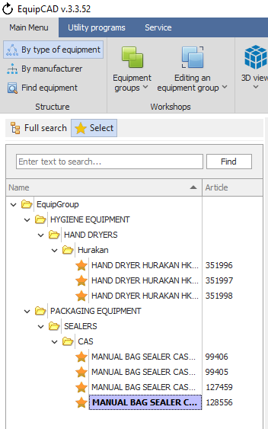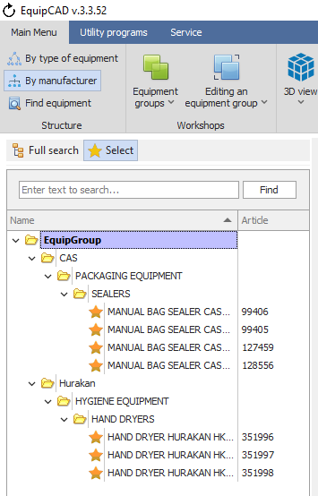
4.1.1.3

      - Groups
The "Groups" button allows you to go to the list of editable equipment groups; the user creates and fills each group with equipment independently; equipment groups can be inserted into the drawing as a whole.
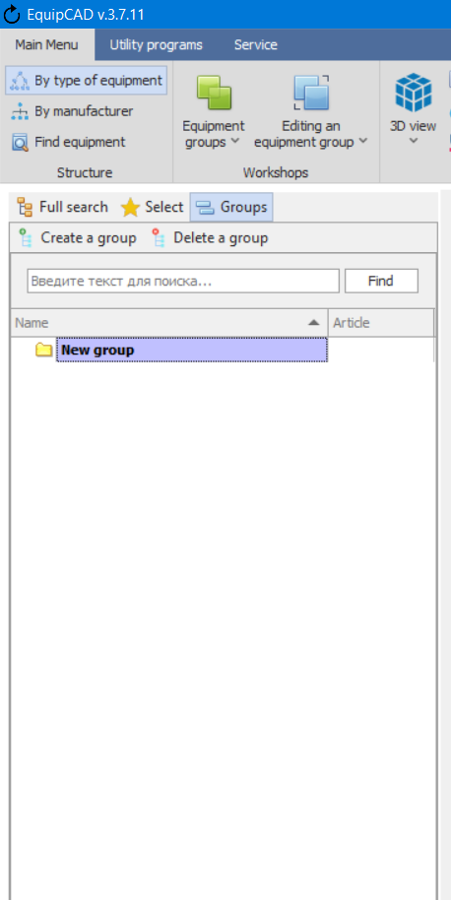
4.1.1.4

      - “Find equipment” button
The “Find equipment” button allows you to find the equipment items included in your project in the EquipCaD tree.
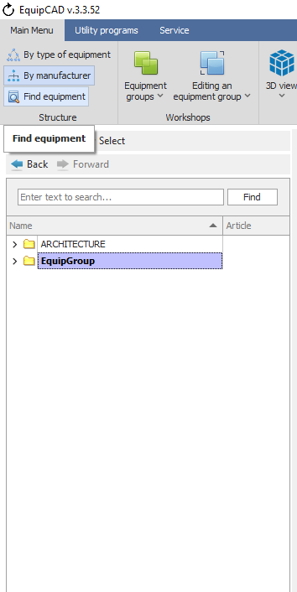
4.1.1.5

      - Back and Forward buttons
You can use the Back and Forward buttons to move to equipment items that you viewed earlier (up to 10 items).
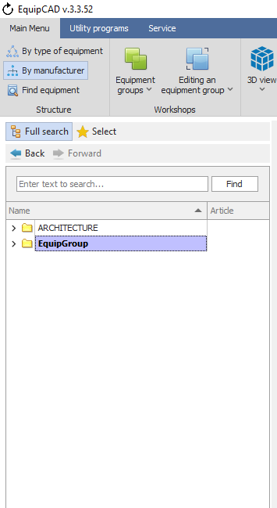
4.1.1.6

    - Section 2: Workshops
With the first button in the section, you can do the following:
- Create an equipment group;
- Delete an equipment group;
- Select an equipment group;
- Select an equipment with no group.
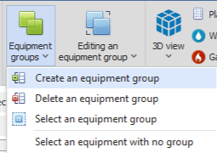

The second button in the section allows you to do the following:
- Add equipment to a group;
- Delete equipment from a group;
- Order of equipment groups and prefixes.
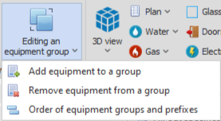

    - Section 3: Layers/View
The buttons of the section allow you to activate and deactivate layers linked to equipment.
Layers of utilities connection points are not active until they are set in your project on the “Equipment connection points” tab.
In the program settings, you can change the way section buttons are displayed.
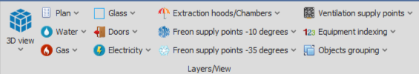

      - To change the display of the buttons in the Layers/View section, go to the Service tab;
      - Next, “Program settings”;
      - Next, check the boxes “Collapse layers into one button for the main window” and “Collapse layers into a single button for a floating panel”;
      - Then you need to click the “Save settings” button;
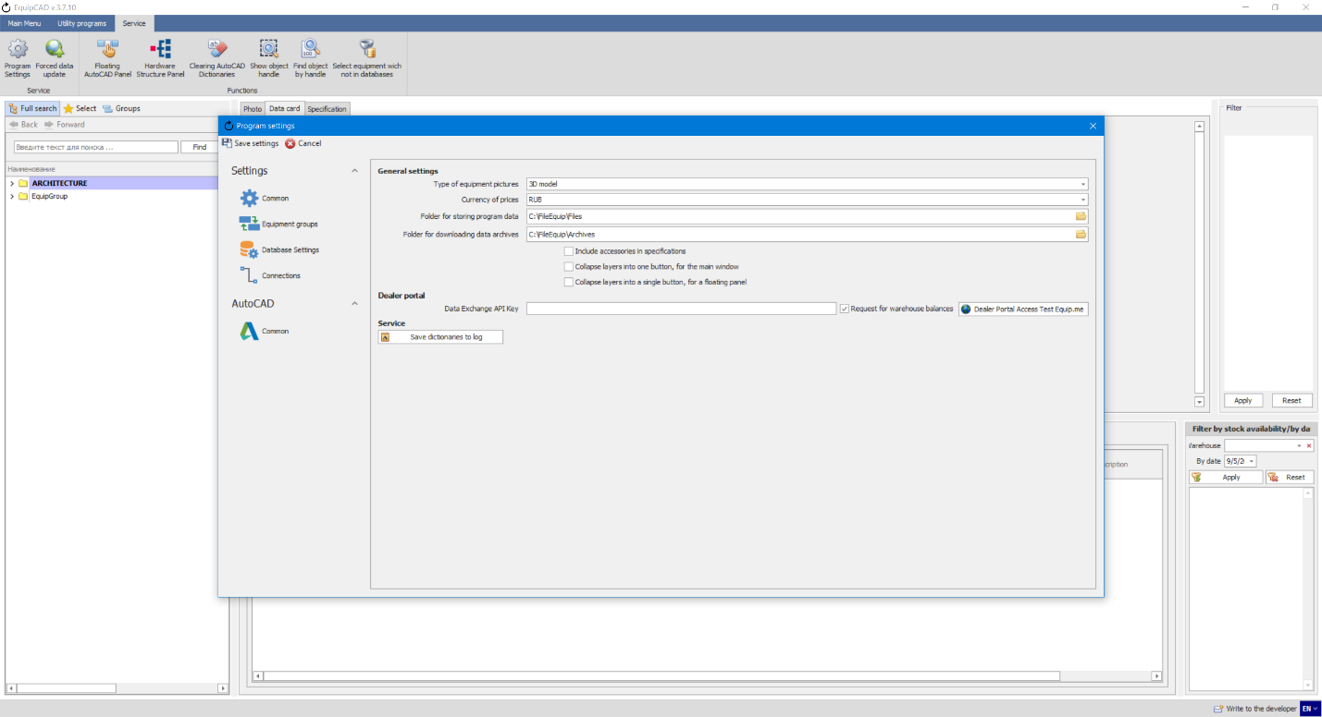
4.1.3.3
4.1.3.4
4.1.3.2
4.1.3.1

      - After this, in the main program window and in the floating panel, all buttons in the “Layers/View” section, except for “3D view” and “Object grouping”, will be displayed as a “Layers” button that opens a drop-down menu;
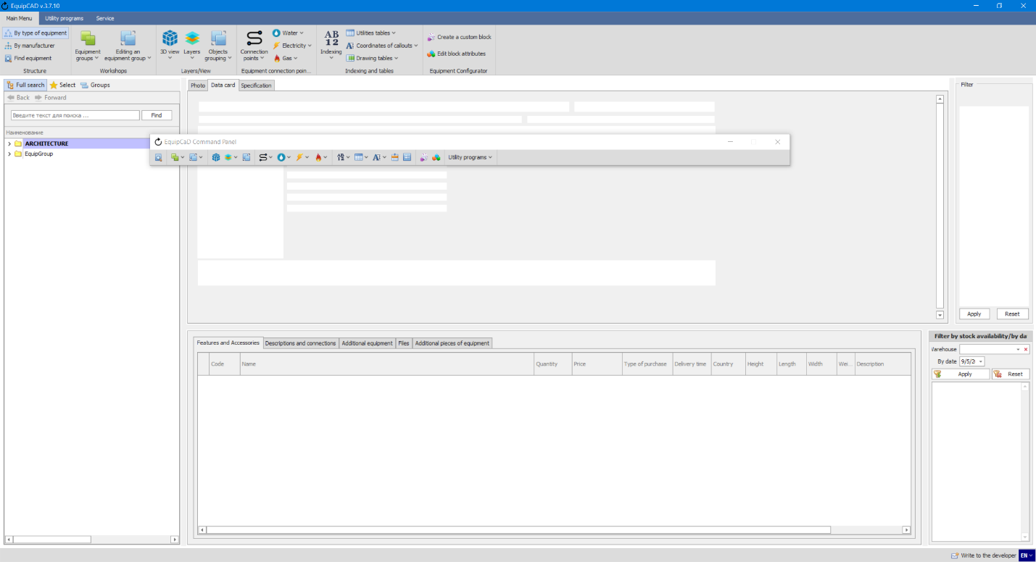

    - Section 4: Equipment connection points
With the buttons of the section you can put, add your own, edit, and remove connection points for utilities.
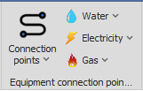

    - Section 5: Indexing and tables
The buttons of the section allow you to set and remove equipment indexing on the plan, create tables of utilities, save and delete coordinates of callouts, and include a specification table on the drawing and explication table.
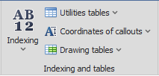

    - Section 6: Equipment Configurator
With the buttons of the section, you can create and edit custom blocks.
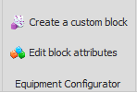

  - EquipCaD tabs
Below are the explanations for the program tabs.
Note: You can change the size of tabs by hovering the cursor over the gray line between them and moving it while keeping the left mouse button pressed.

    - “Photo” tab
The tab displays photographs of equipment in a selected sub-category. Depending on the program settings, either a photo or a 3D slide of equipment will be displayed.
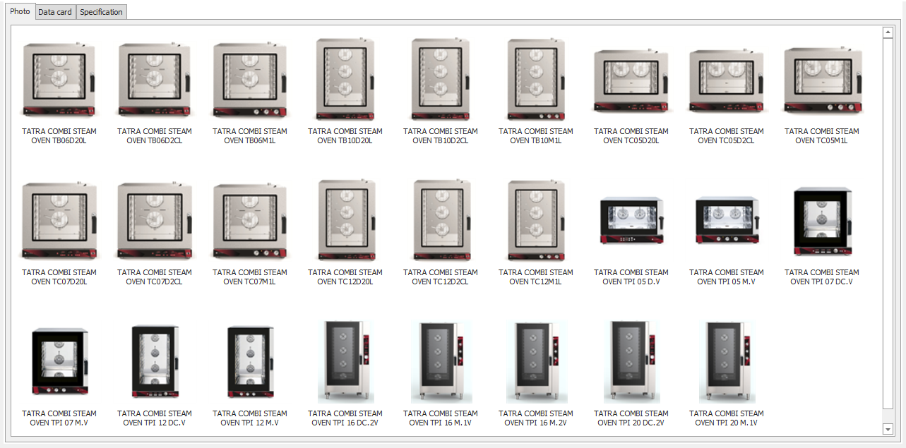
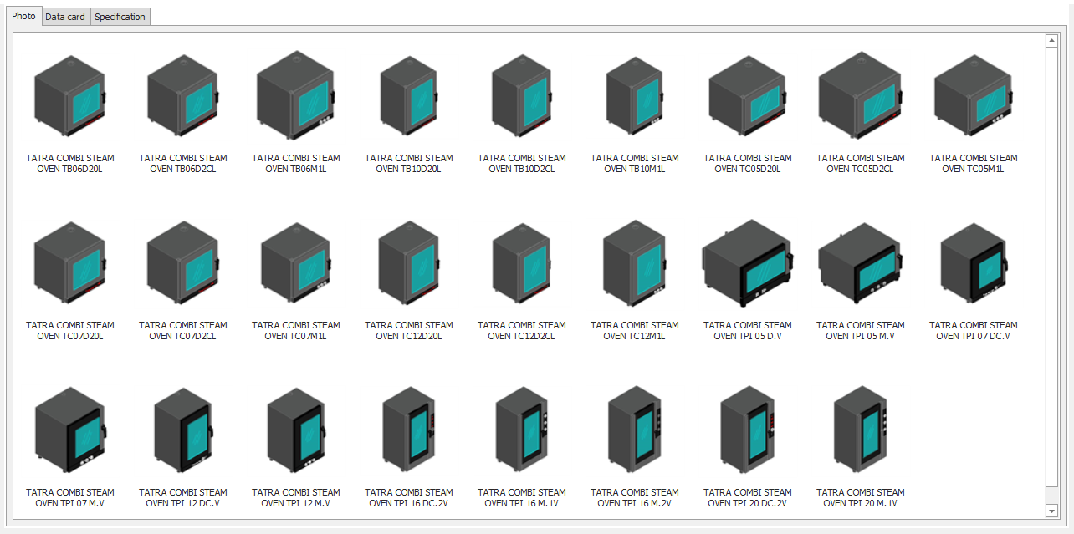

      - To change the display settings, go to the Service tab;
      - Then select the Program Settings menu;
      - Choose either “Photo” or “3D model” in the “Type of equipment pictures” field;
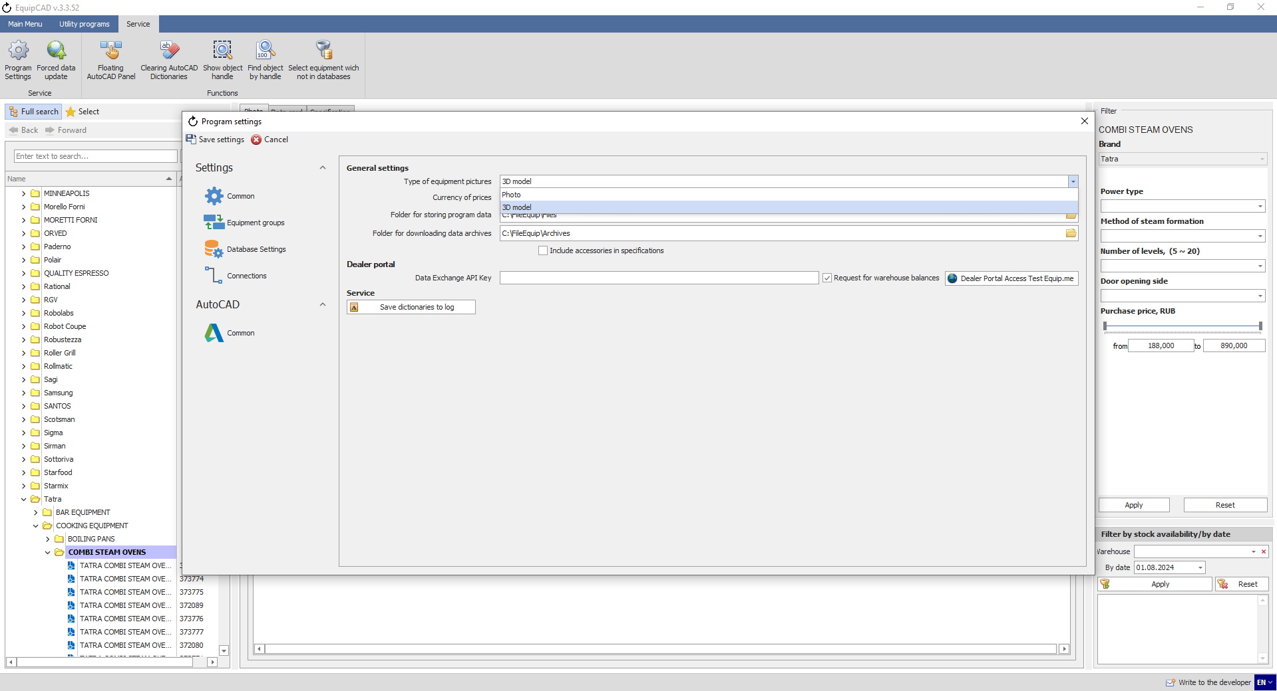
4.2.1.3
4.2.1.1
4.2.1.2

    - “Data card” tab
The tab displays a photograph or a 3D model (depending on the setting selected in paragraph 4.2.1.3, if “3D model” is selected, then the model will be displayed on the “Photo” tab, and the equipment photograph on the “Card” tab, and vice versa), a description, the main characteristics of the selected product, and also contains a link to the product card on the equip.me portal.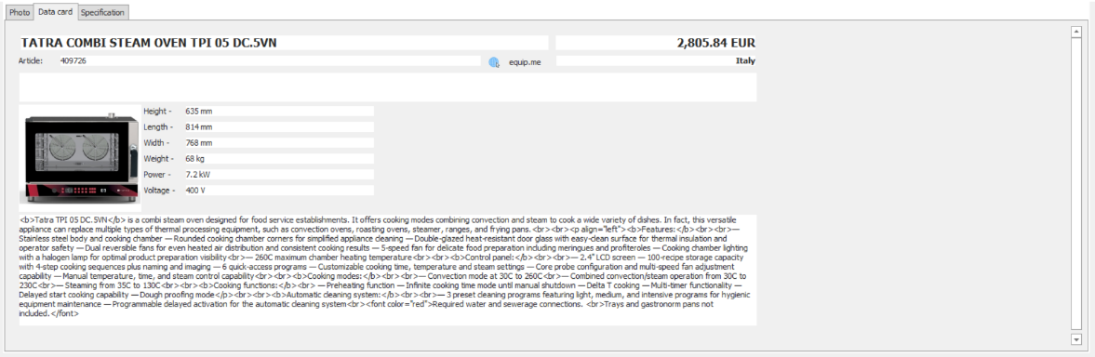

      - When you click on the “equip.me” button, a browser will open with a card of the selected product.
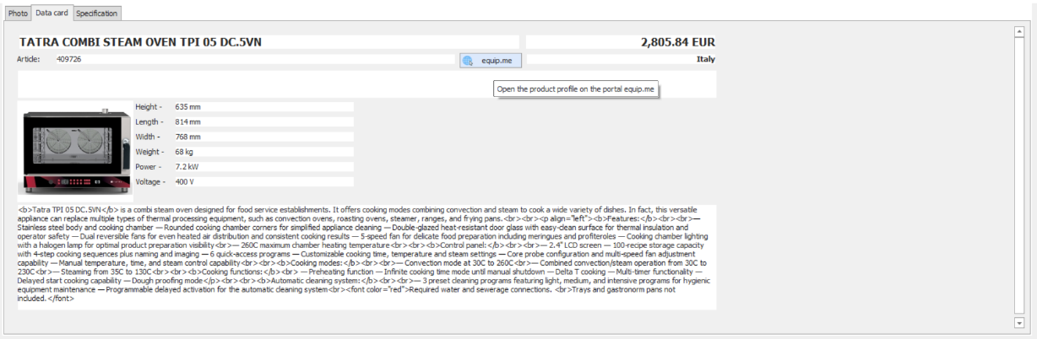
4.2.2.1
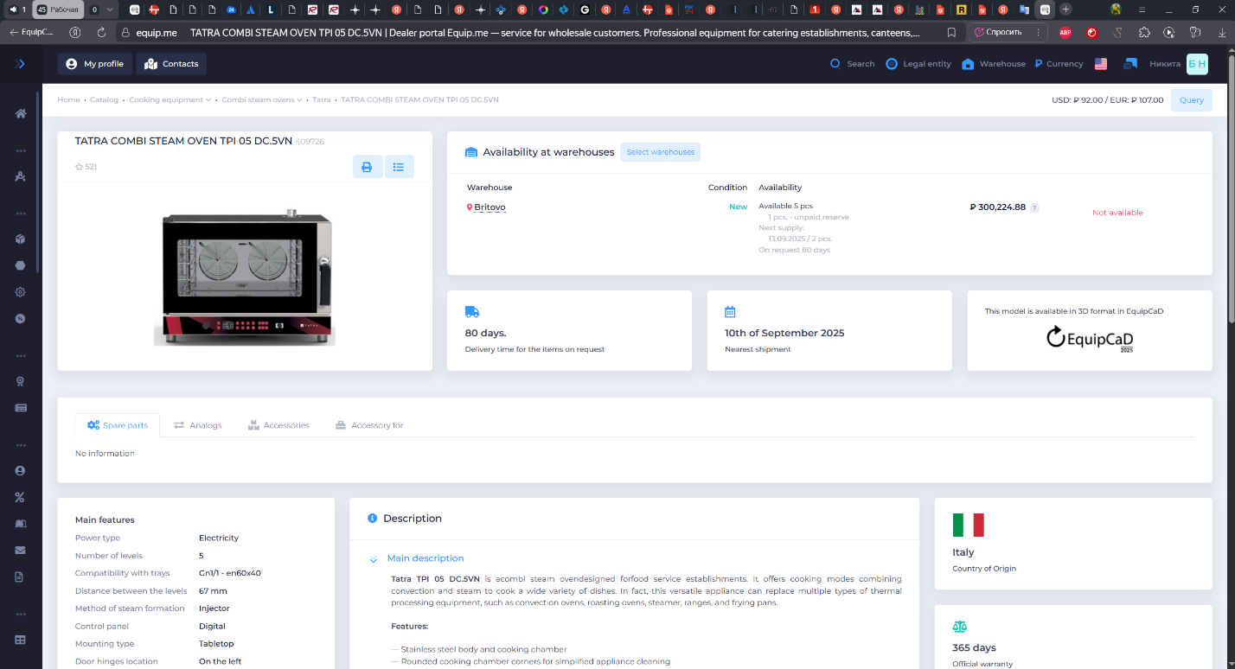

    - “Specification” tab
This is a tab for working with the specification.

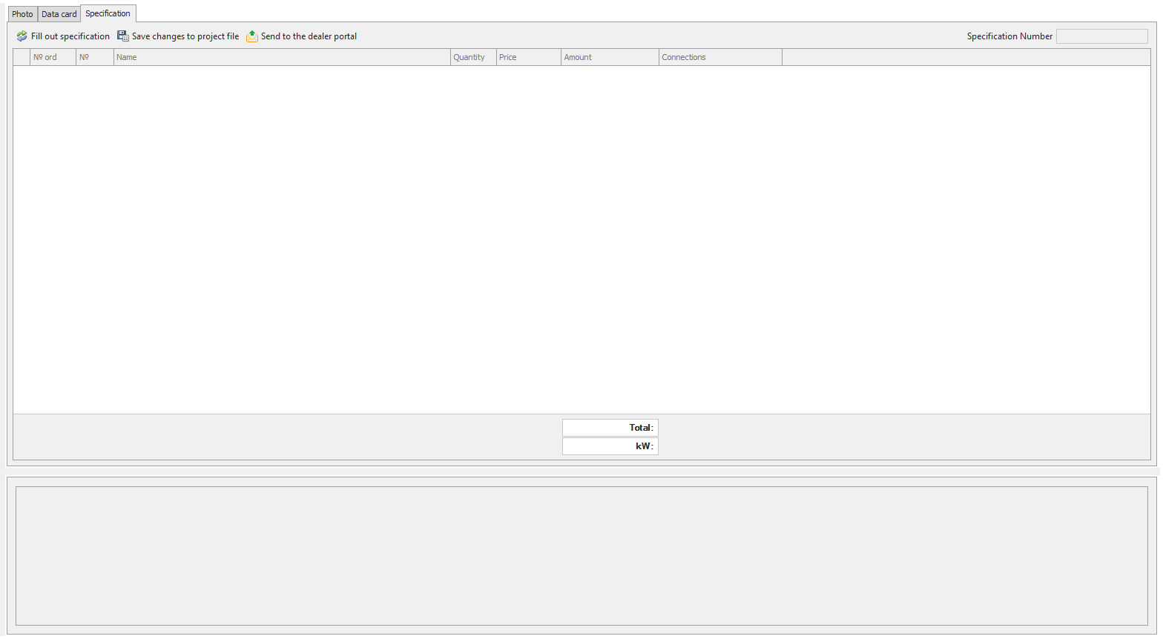

    - “Filter” tab
The tab allows you to select equipment with certain features.
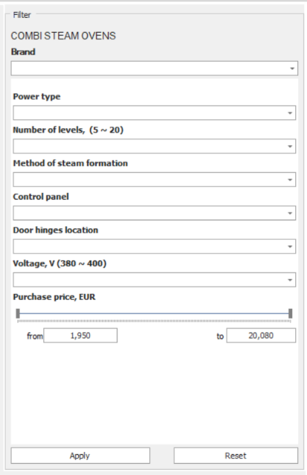

    - “Features and accessories” tab
The tub provides more details about the selected item.
It also lists necessary accessories for the selected item, which will be automatically displayed in the table when filling out the specification if the correspondent setting is chosen. Accessories have no 3D models.
A line at the bottom of the program window shows a description of the selected equipment item.
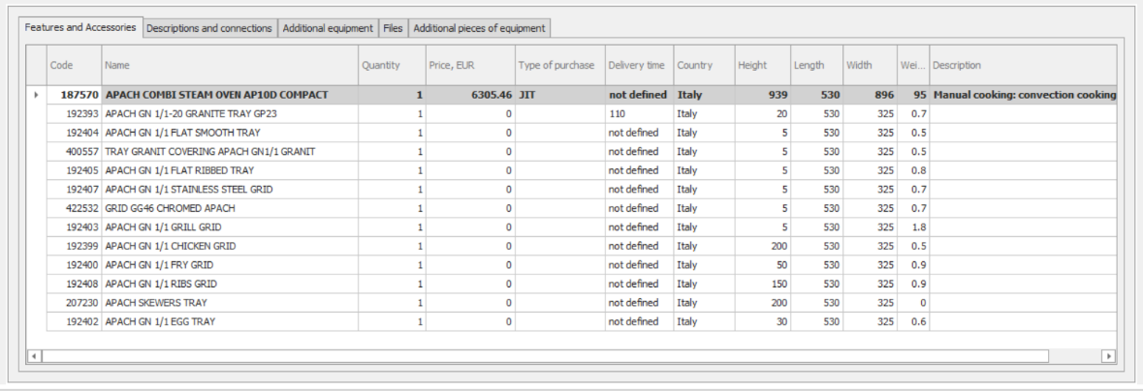

    - “Descriptions and connections” tab
The tab lists all the possible connections for the selected item and a more detailed description of it.
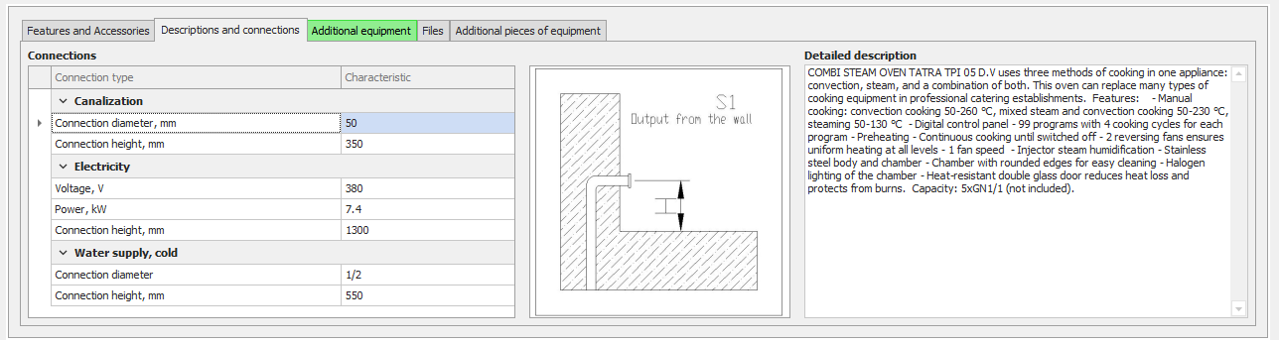

    - “Additional equipment” tab
The tab lists additional equipment for the selected item. Additional equipment is available as 3D models and can be included in your project.
When additional equipment is available, the tab is highlighted in green.
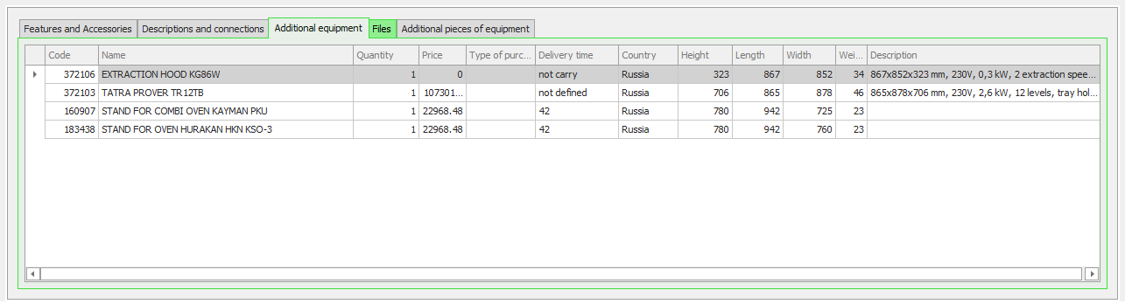

    - “Files” tab
The tab keeps the files with information for the selected item.
When files are available, the tab is highlighted in green.
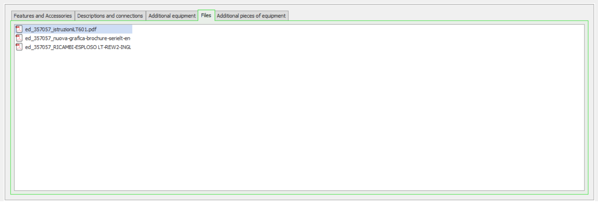

    - “Additional pieces of equipment” tab
The tab lists components of equipment that can be included and moved separately from the basic model, such as doors for refrigerators and external units for split systems.
When additional parts are available, the tab is highlighted in green.
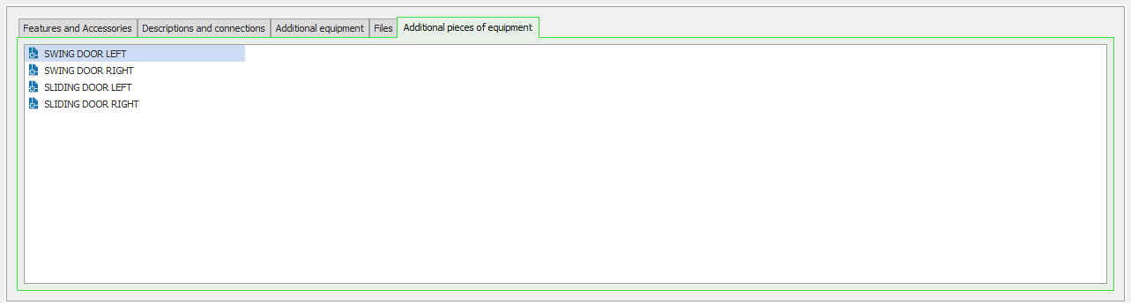

    - “Filter by stock availability/by date” tab
The tab shows the quantity of the selected product available at each warehouse.
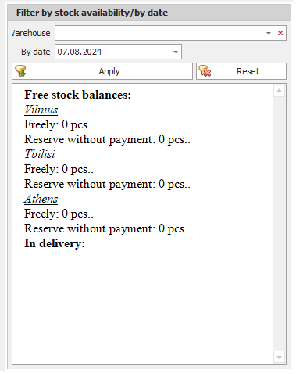

  - Utility programs

The Utilities tab allows you to show/hide the name of the equipment on the drawing and hide equipment without specific connection callouts (water/electricity/gas) and return it to the working layer, also automatically build callouts along a given line, and also remove 3D from the drawing.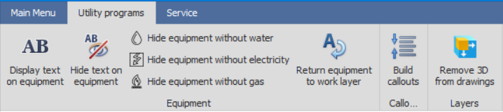

  - Service

The "Service" tab allows you to access the program settings, force a block database update, enable the floating panel, enable the equipment tree panel, clear AutoCAD dictionaries, show the object's Handle, find an object by Handle, and select equipment that is not in the databases.
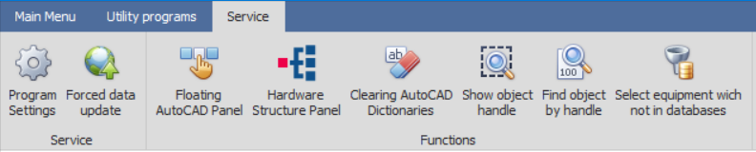
    - Floating panel
The floating panel is intended to facilitate the use of the application. It allows you to use EquipCaD buttons without switching to the program itself.
The floating panel pops up over all the home screen windows and includes all of the EquipCaD sections and utility programs.

    - Hardware structure panel
The equipment tree panel is an EquipCaD tree in the form of a separate panel that opens on top of all windows and allows you to access the equipment catalog without switching to the main program window. At the bottom of the panel there is a picture of the equipment and a short description.
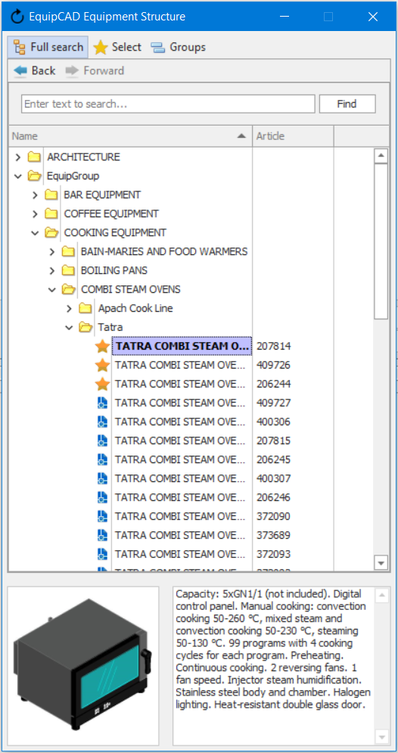

Note: In the event the floating panel is not displayed, go to the folder where EquipCaD is installed and find the “EquipCAD (Reset configuration of windows)” shortcut in the folder to reset the floating panel configuration and it will be displayed correctly the next time you run the application.

  - Write to the developer
The “Write to the developer” button is a means of feedback for informing us of any program errors and your expectations.
    - Clicking the “Write to the developer” button opens a special form. Enter your full name, email address for response, the subject of your message, and problem description (if any equipment is selected, its name will be automatically included in the message subject);
    - Send your message by clicking the corresponding button.
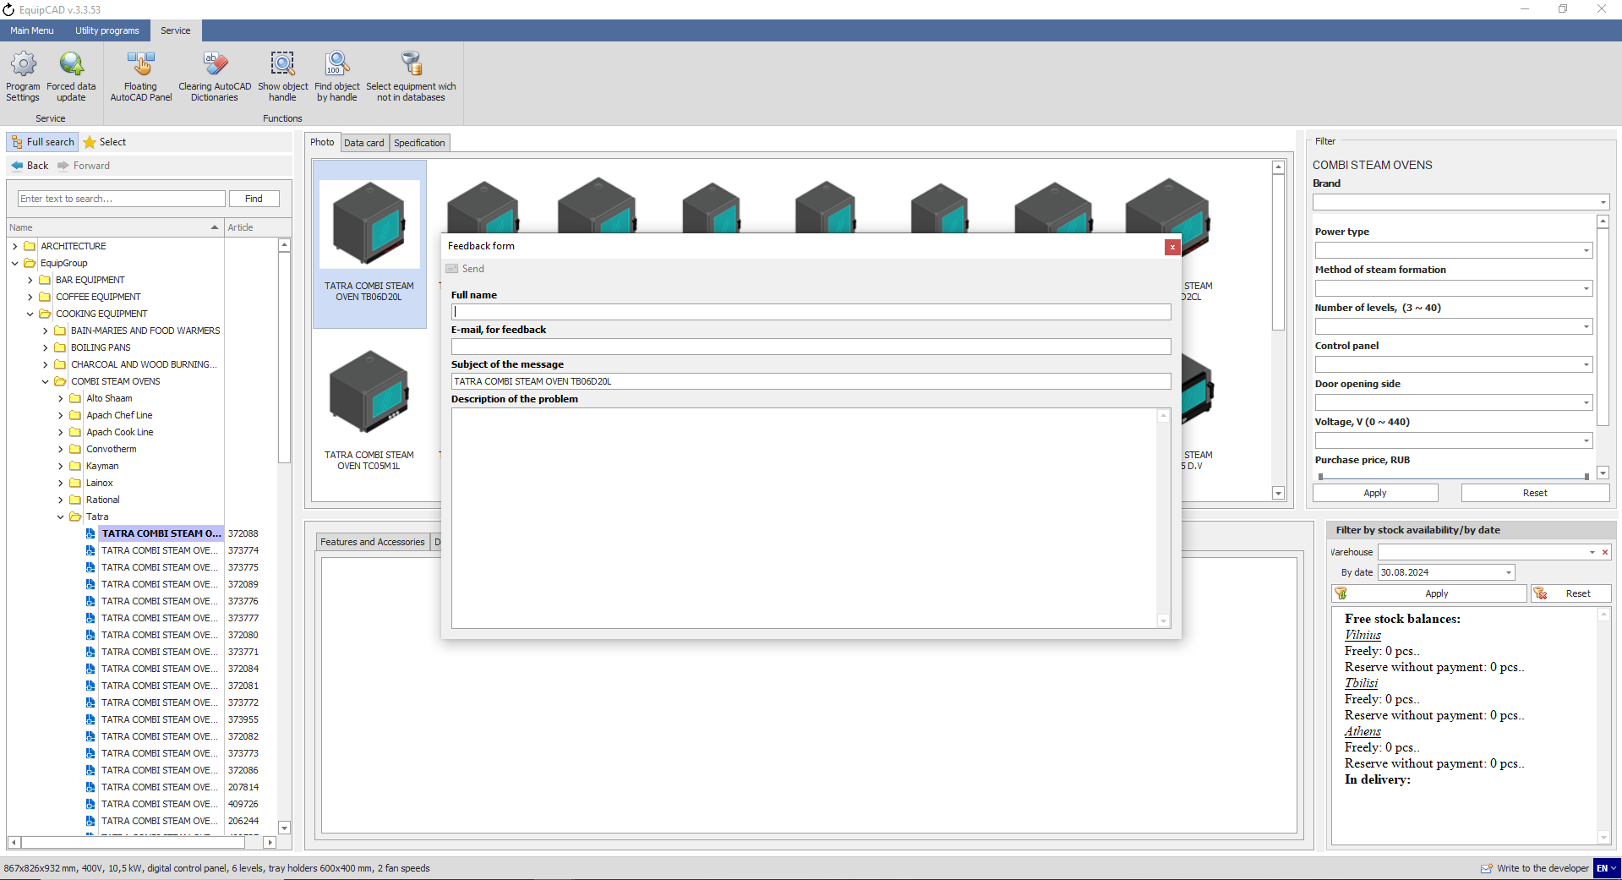
4.5.2
4.5.1
Note: In the event you have selected any equipment item before clicking the “Write to the developer” button, the name of the equipment will be automatically included in the message subject. You cannot send the message if no problem description is provided.

  - Interface language change button

    - A button for changing the program interface language was added to the right of the “Write to the developer” button;
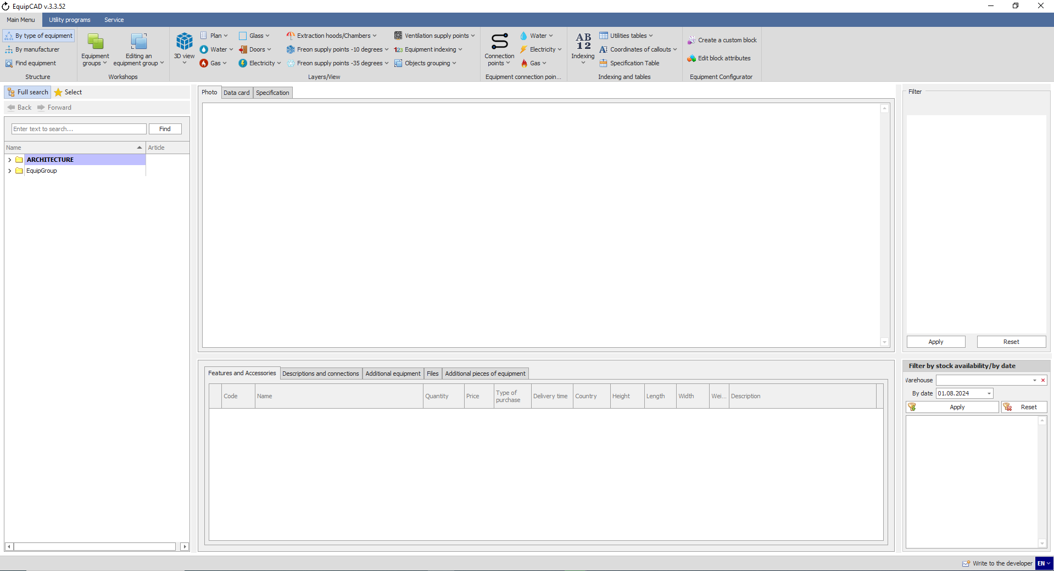
4.6.1

    - Clicking it opens a menu with language codes;
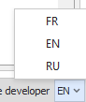

    - Once the language is selected, you will see a message saying, “To change the language, you need to restart the program”;
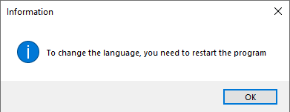

    - After the restart, you will see the interface fully translated.
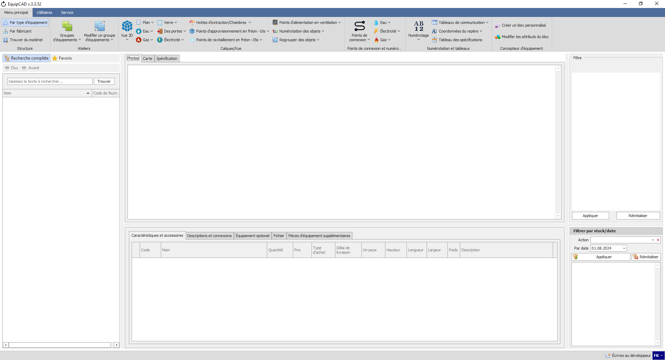

- Layers
5.1 3D view
5.2 Plan
5.3 Glass
5.4. “Water”, “Gas”, “Electricity”, “Freon supply points – 10 degrees”, “Freon supply points – 35 degrees”, “Ventilation supply points”, “Equipment indexing”
5.5. Doors
5.6. Extraction hoods/Chambers
5.7. Objects grouping
5.8. Projection
5.9. Symbols

  - 3D view
The “3D view” button allows you to enable and disable the 3D graphic presentation of equipment;
5.1
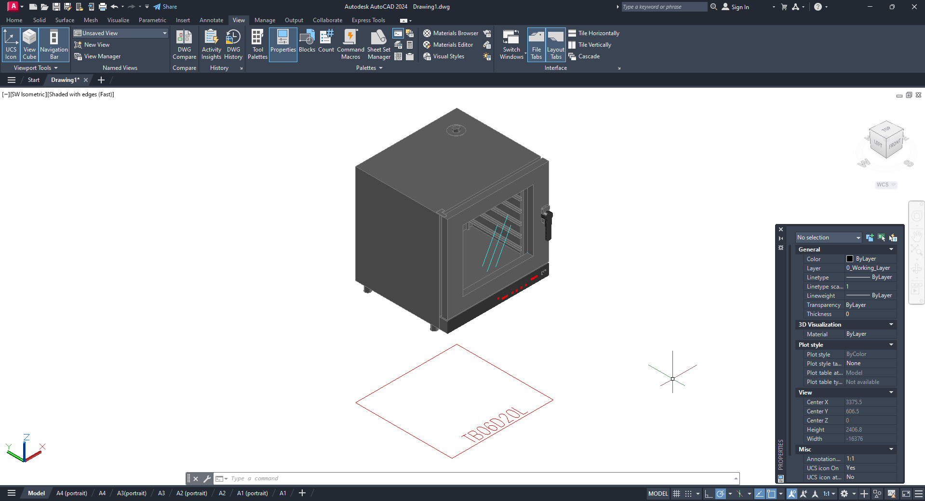

  - Plan
Using the “Plan” button, you can turn on and off the 2D projection of equipment dimensions;
5.2
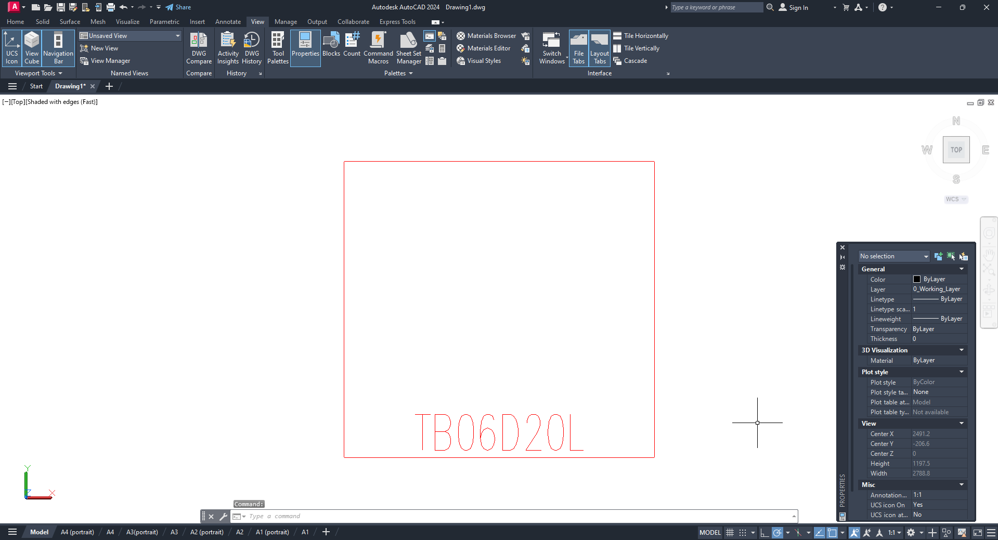

  - Glass
The “Glass” button enables and disables transparent elements of models (it is recommended to use it in combination with the 3D layer);
5.3
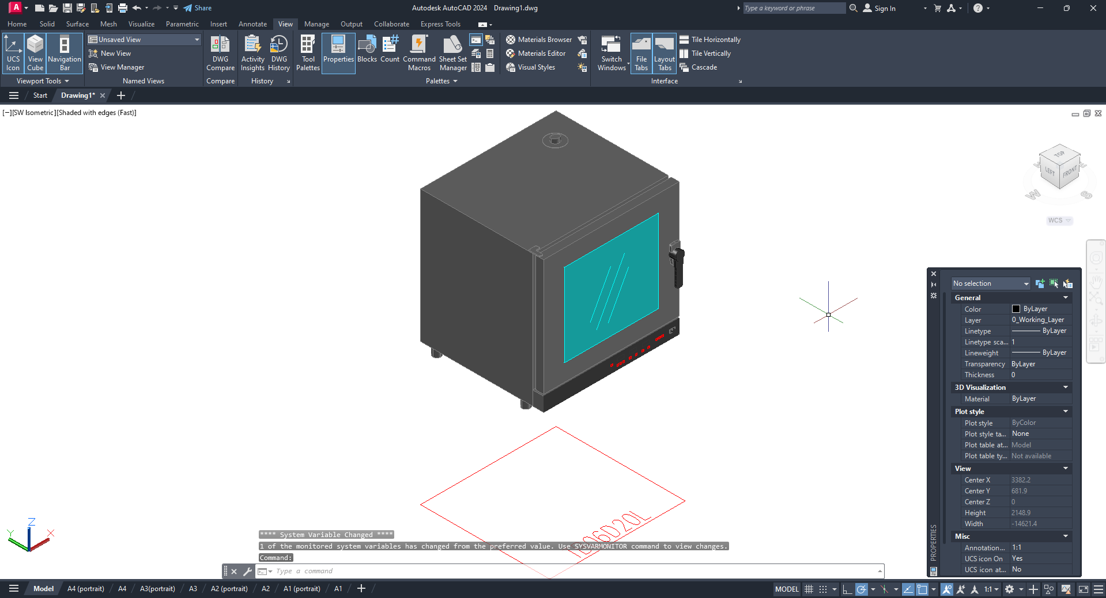

  - “Water”, “Gas”, “Electricity”, “Freon supply points – 10 degrees”, “Freon supply points – 35 degrees”, “Ventilation supply points”, “Equipment indexing”
These buttons allow you to enable and disable the corresponding connection points and their callouts after they have been set (it is recommended to use these in combination with the Plan layer);
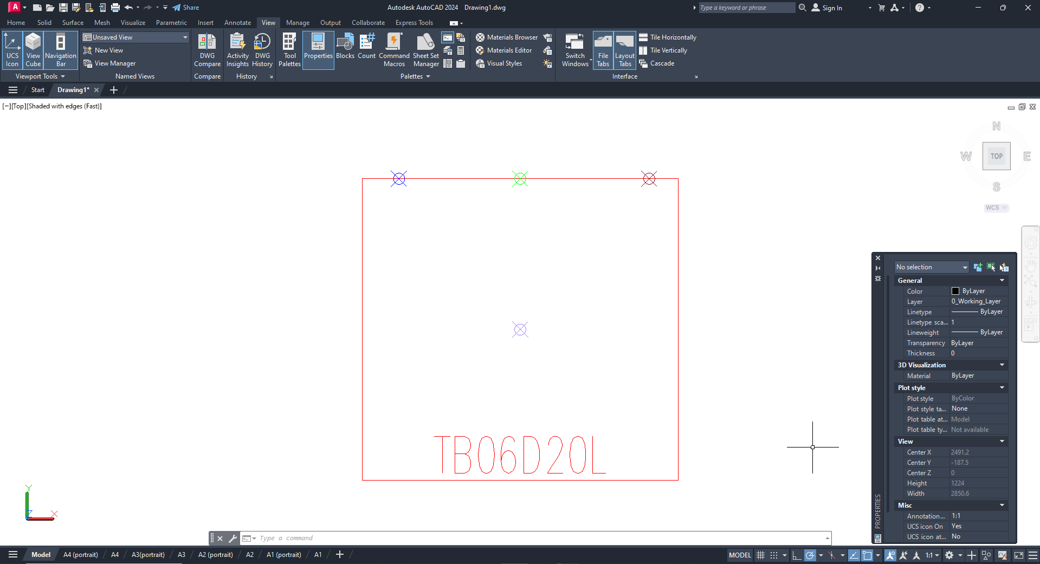

  - Doors
With this button, you can enable and disable 2D projections of doors, drawers and technical gaps (it is recommended to use it in combination with the Plan layer);
5.5
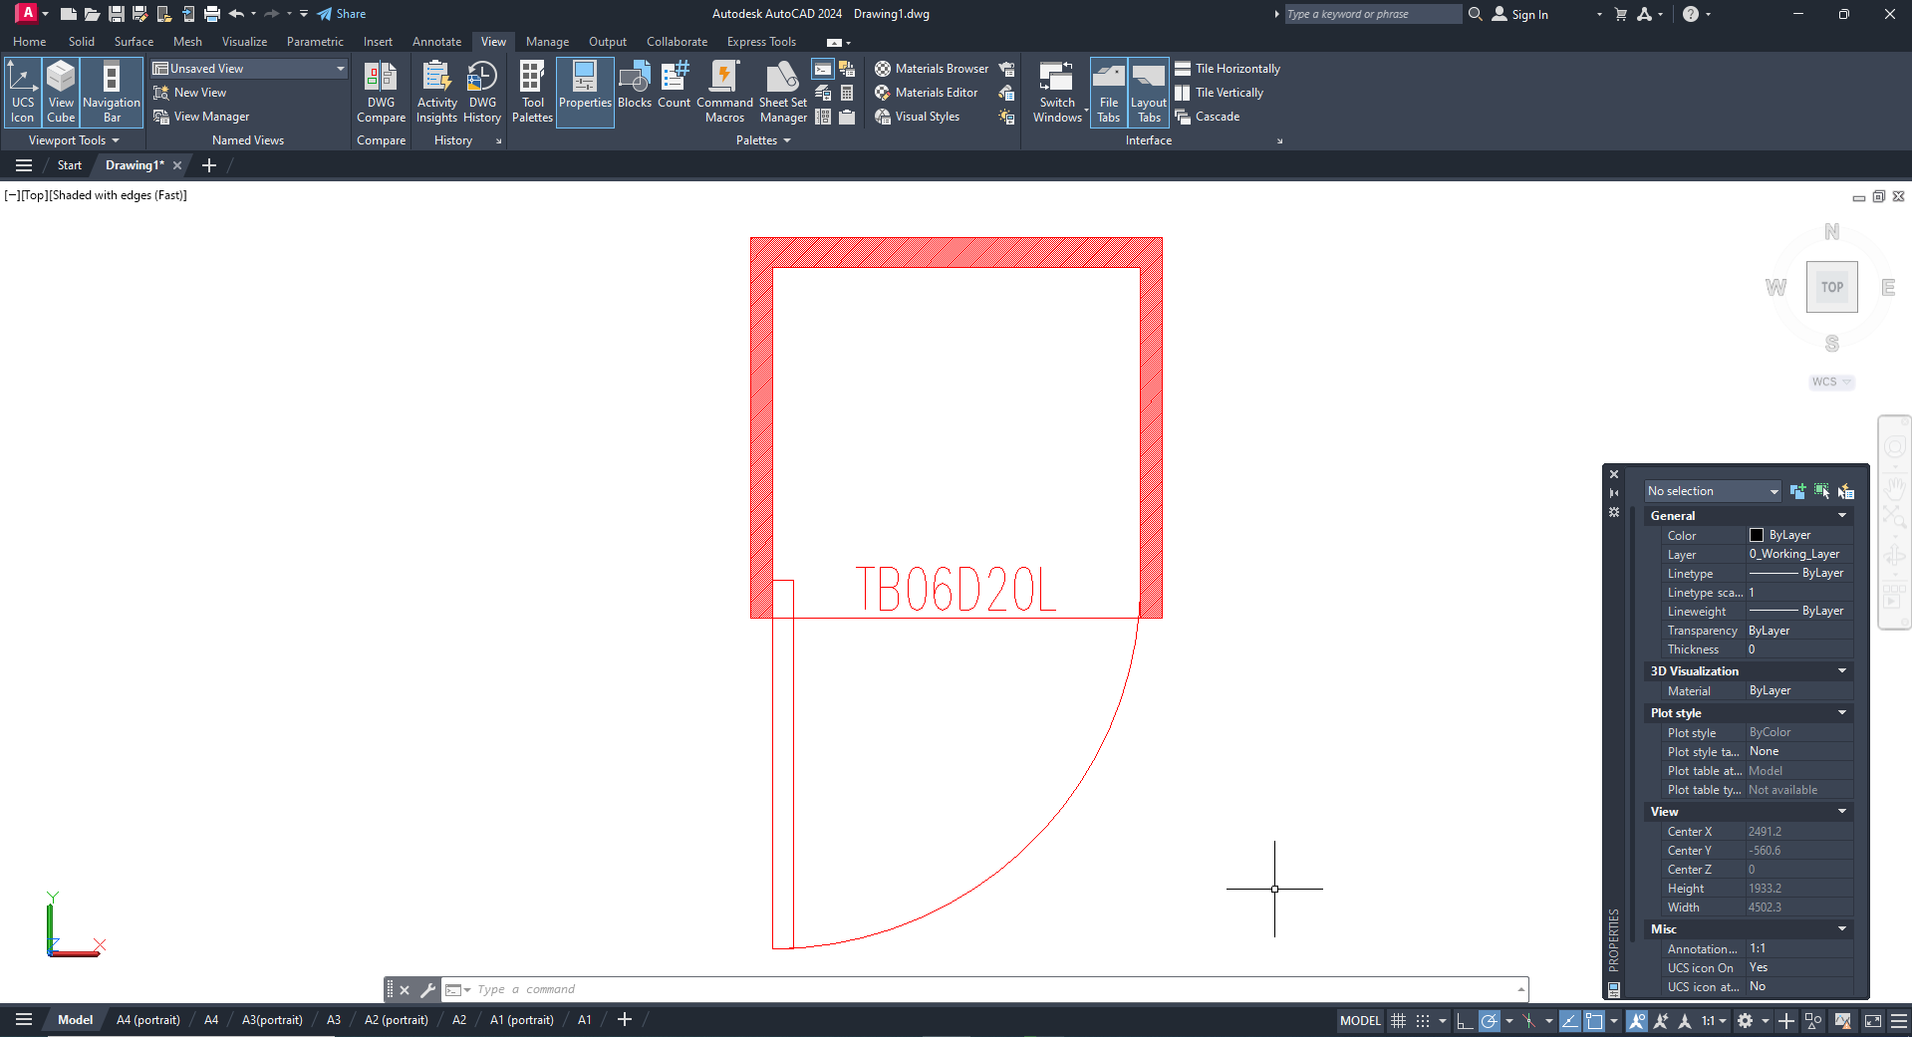

  - Extraction hoods/Chambers
This button enables and disables the 3D representation or dotted frame of extraction hoods and refrigeration chambers;
5.6
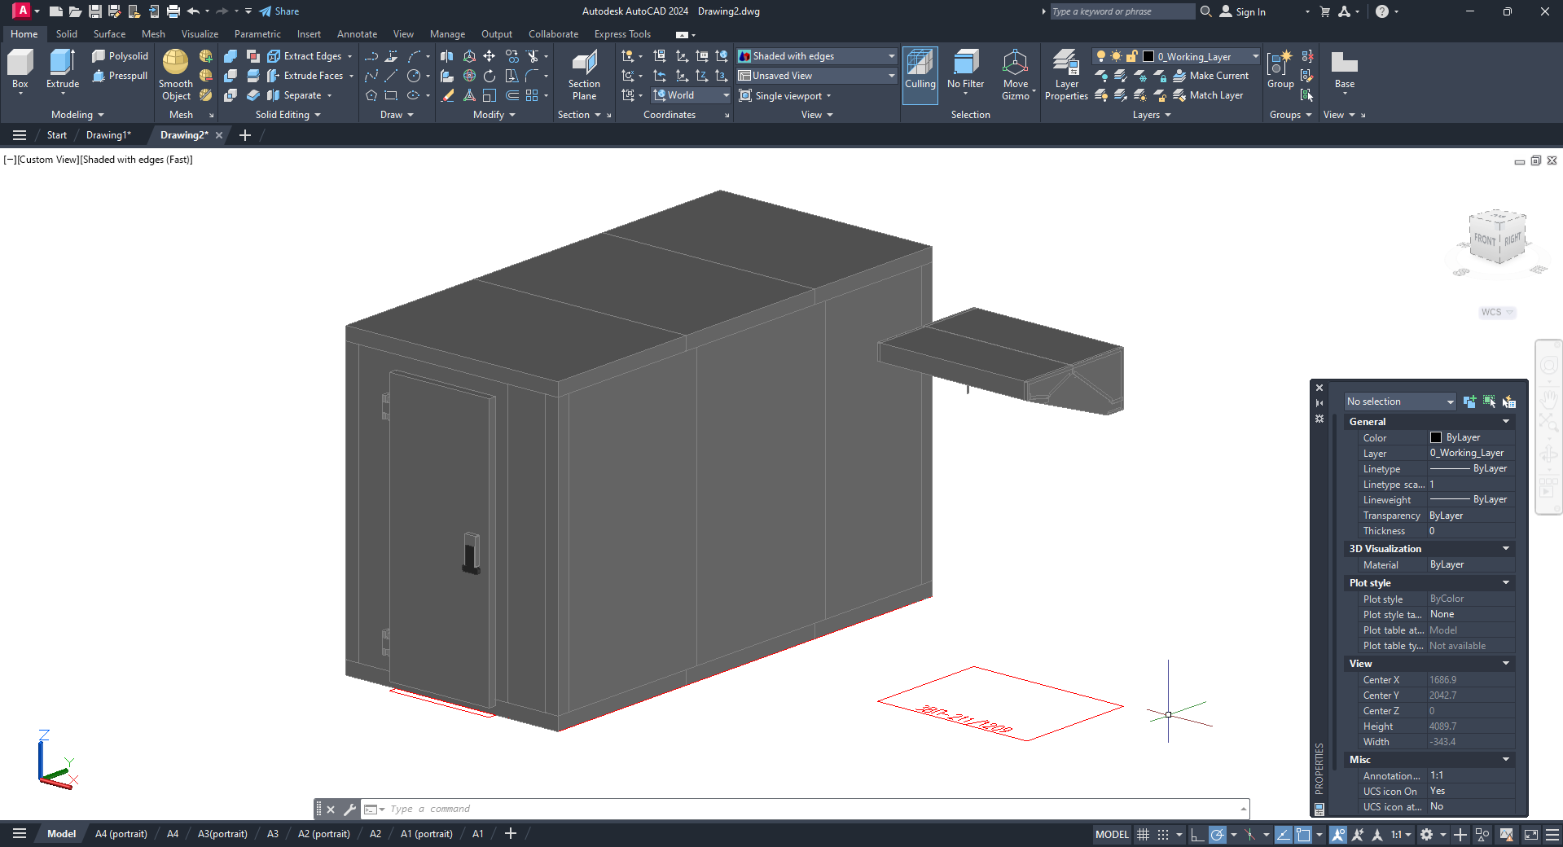
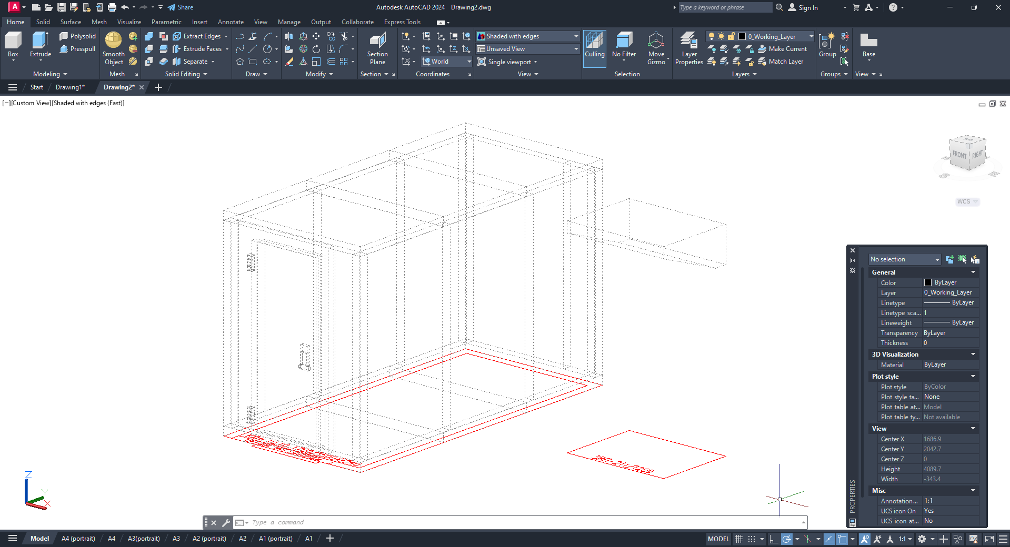

  - Objects grouping
This button allows you to enable and disable the grouping of equipment model and related callouts (with the grouping enabled, when you select a model, all the callouts that relate to it will also be selected);
5.7
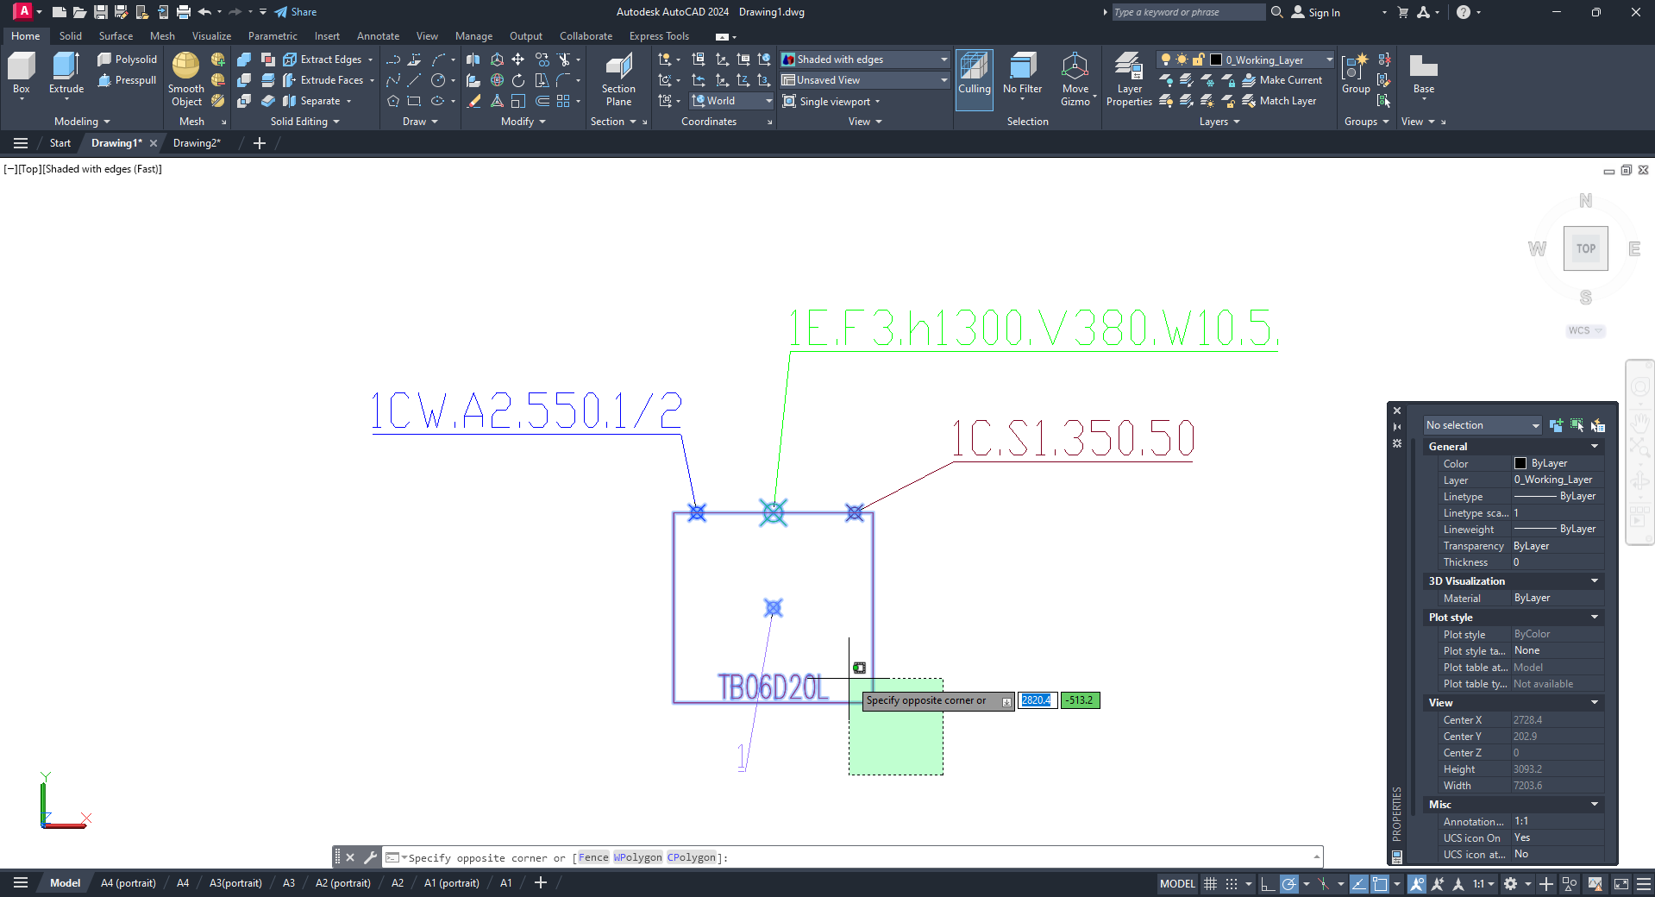
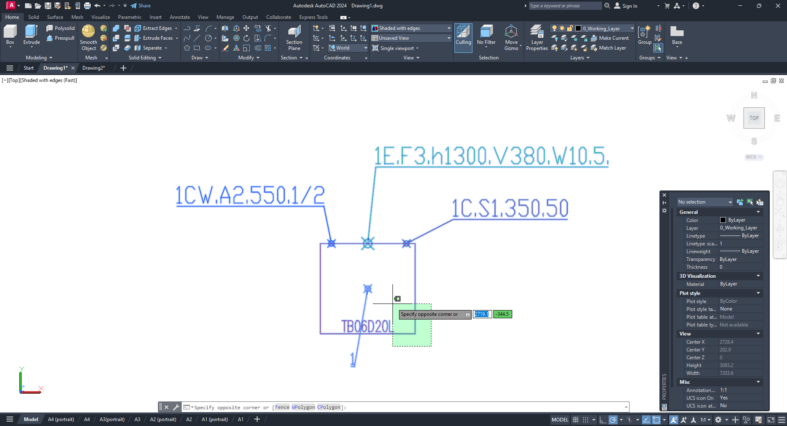

  - Projection
This button allows you to turn on and off the flat projection of the equipment;
5.8
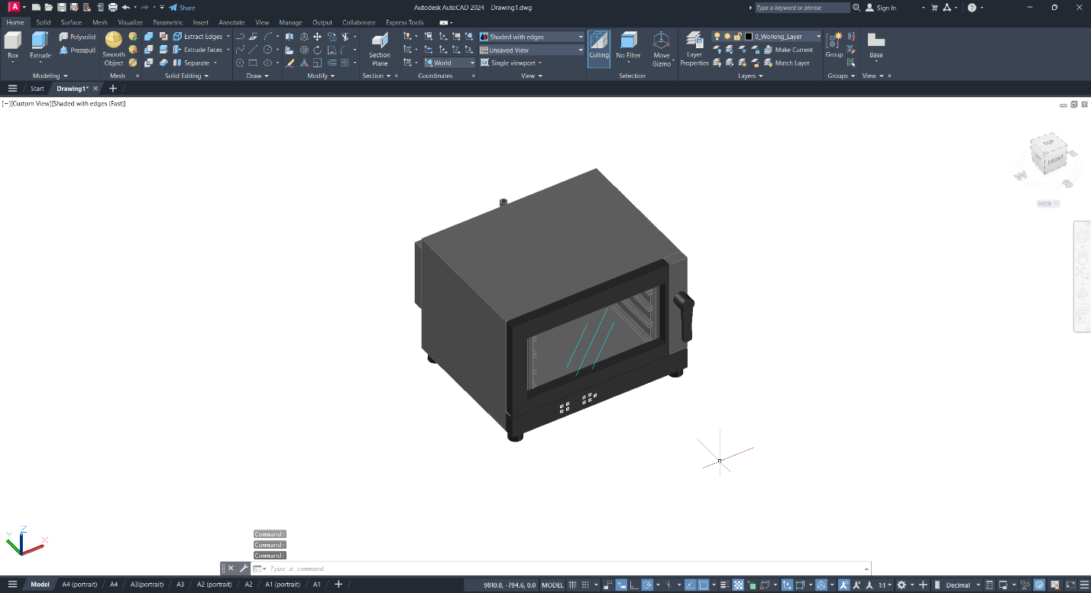
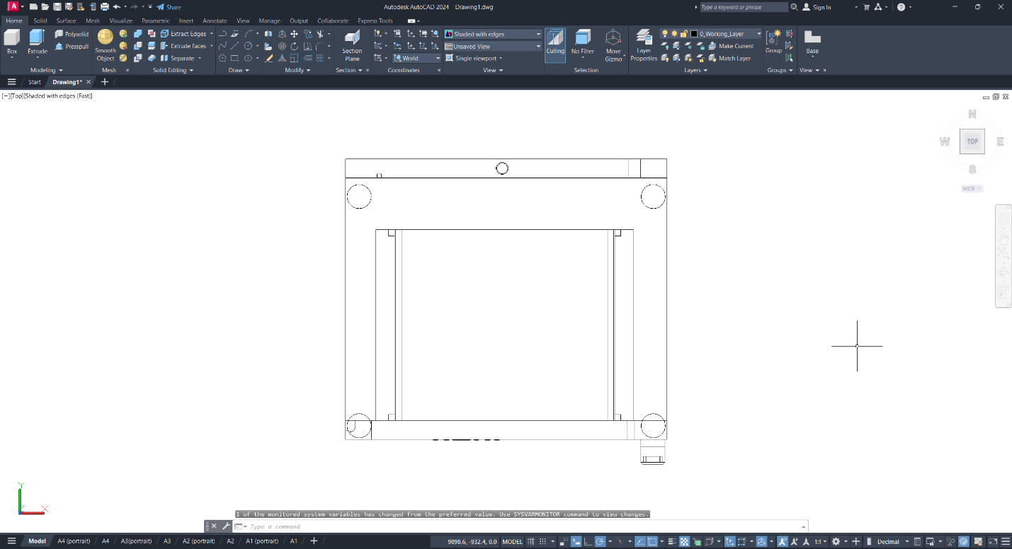

  - Symbols
This button allows you to enable and disable the equipment category symbols;
5.9
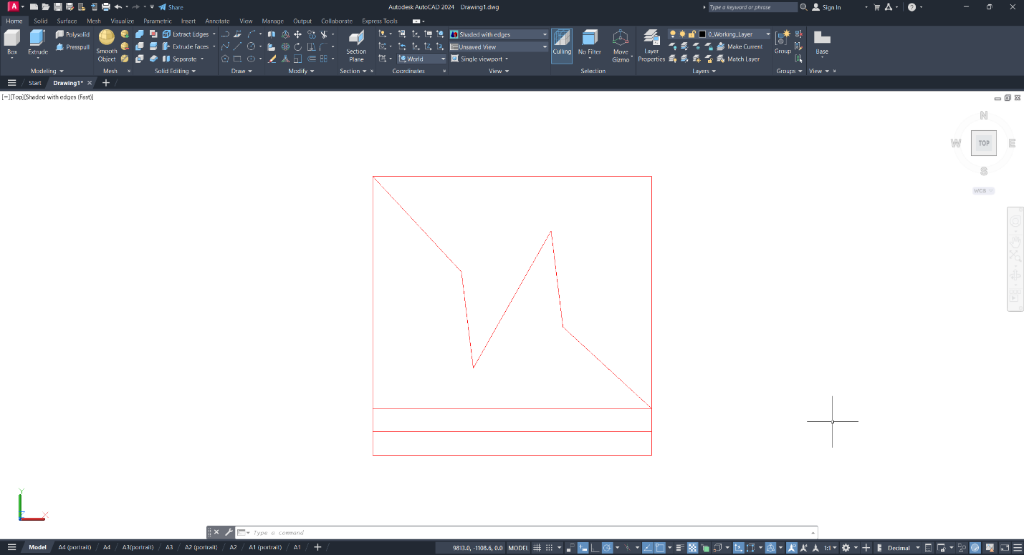

- Selecting equipment
6.1 Before you start
6.2 Selecting equipment in the Structure section
6.3 Searching for equipment
6.4 Selecting equipment by characteristics
6.5 Selecting by available stocks
6.6 Brand Access Request
6.7 Placing equipment in a project
6.8 Placing additional equipment parts in a project
6.9 Searching for equipment added to a project
6.10 Choosing additional equipment and accessories
6.11 Favorites
6.12 Groups

  - Before you start
Before you start EquipCaD, start AutoCAD and open a new drawing; otherwise EquipCaD will produce the following warnings and you will not be able to work with it:
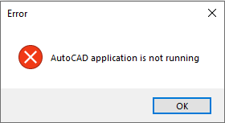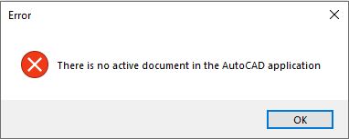
AutoCAD environment settings do not affect the operation of EquipCaD. Equipment in the library is drawn in millimeters. Drawing units must also be set in millimeters.
  - Selecting equipment in the Structure section
In the Structure section, equipment is grouped by type and manufacturer.
    - If you select grouping “by type of equipment”, the tree will first display categories (bar, equipment, coffee equipment, cooking equipment, etc.), then sub-categories (bar equipment accessories, blenders, cold drink dispensers, etc.), and sub-groups for some sub-categories, and then list the brands whose equipment is available in the selected sub-category/sub-group;
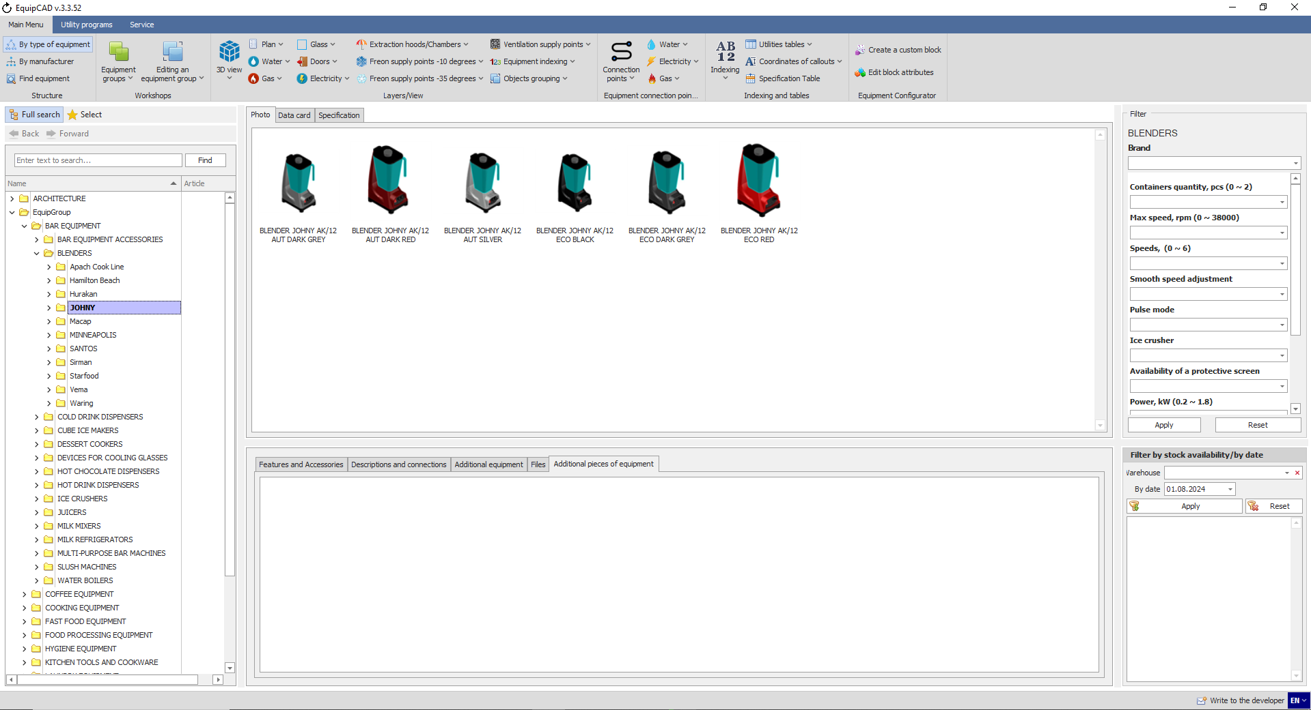
6.2.1

    - If you select grouping “by manufacturer”, the tree will first display brands, then categories (cooking equipment, food processing equipment, refrigeration equipment, etc.), and sub-groups for some sub-categories, and then list sub-categories of sub-groups for some sub-categories (convection ovens, cooking equipment accessories, deck ovens, etc.);
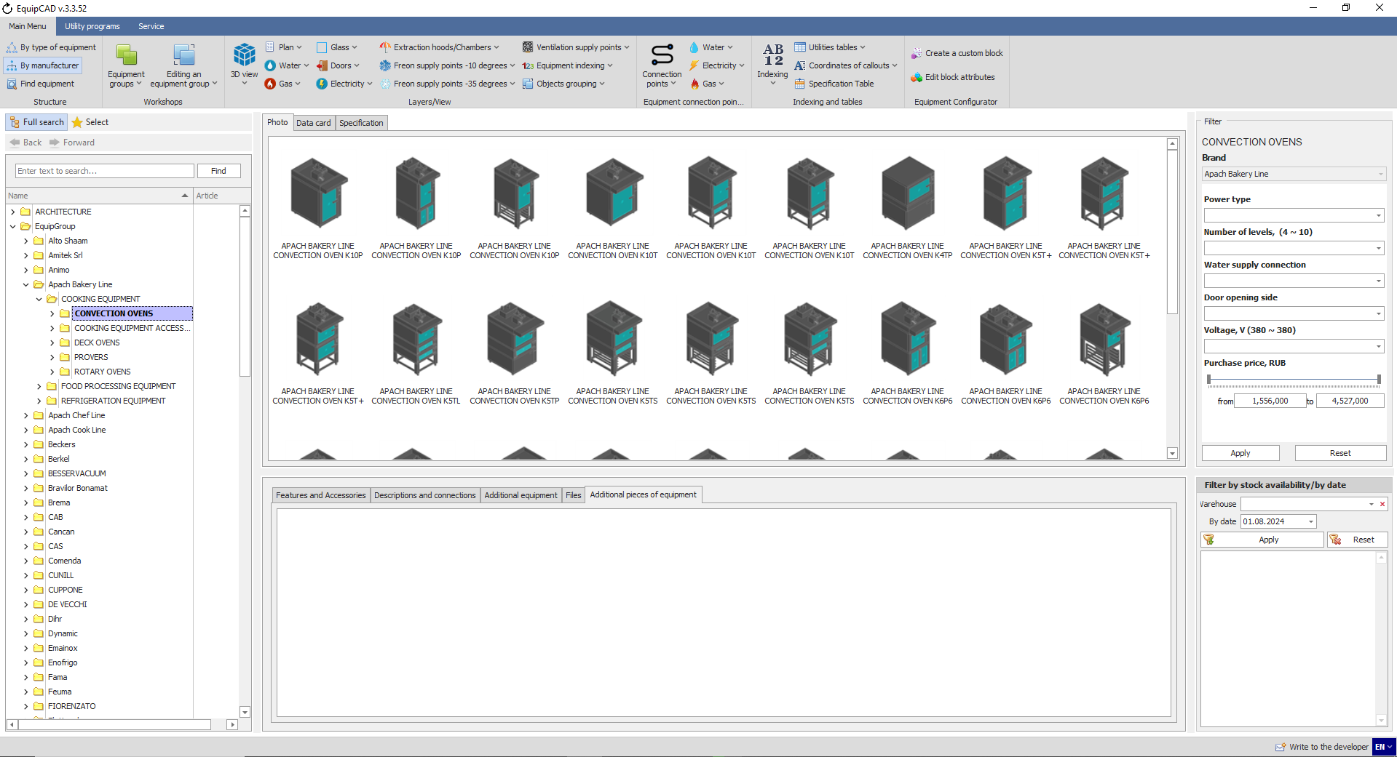
6.2.2

  - Searching for equipment

    - Searching for equipment by name
You can search for equipment by name in the line at the top of the tree. Categories that have no equipment matching your search query will be hidden from the tree. The search works with any equipment grouping.
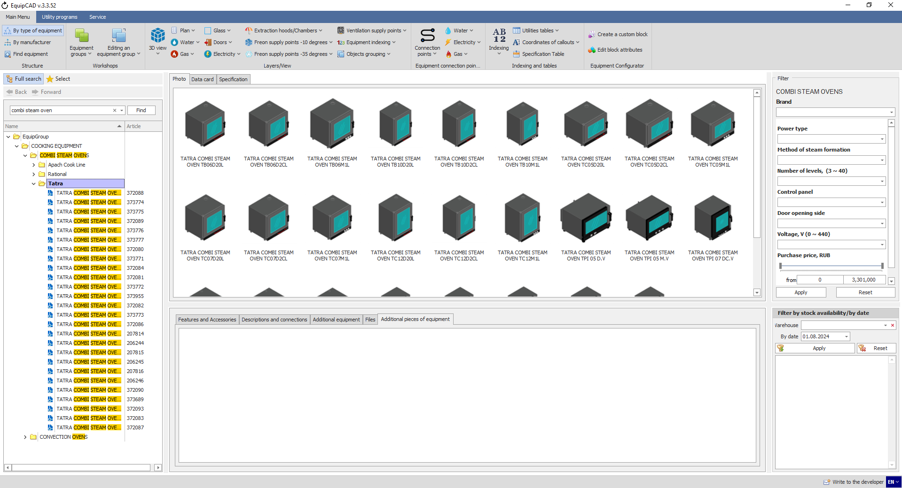
6.3.1

    - Searching for equipment by article number
You can also search for equipment by its article number.
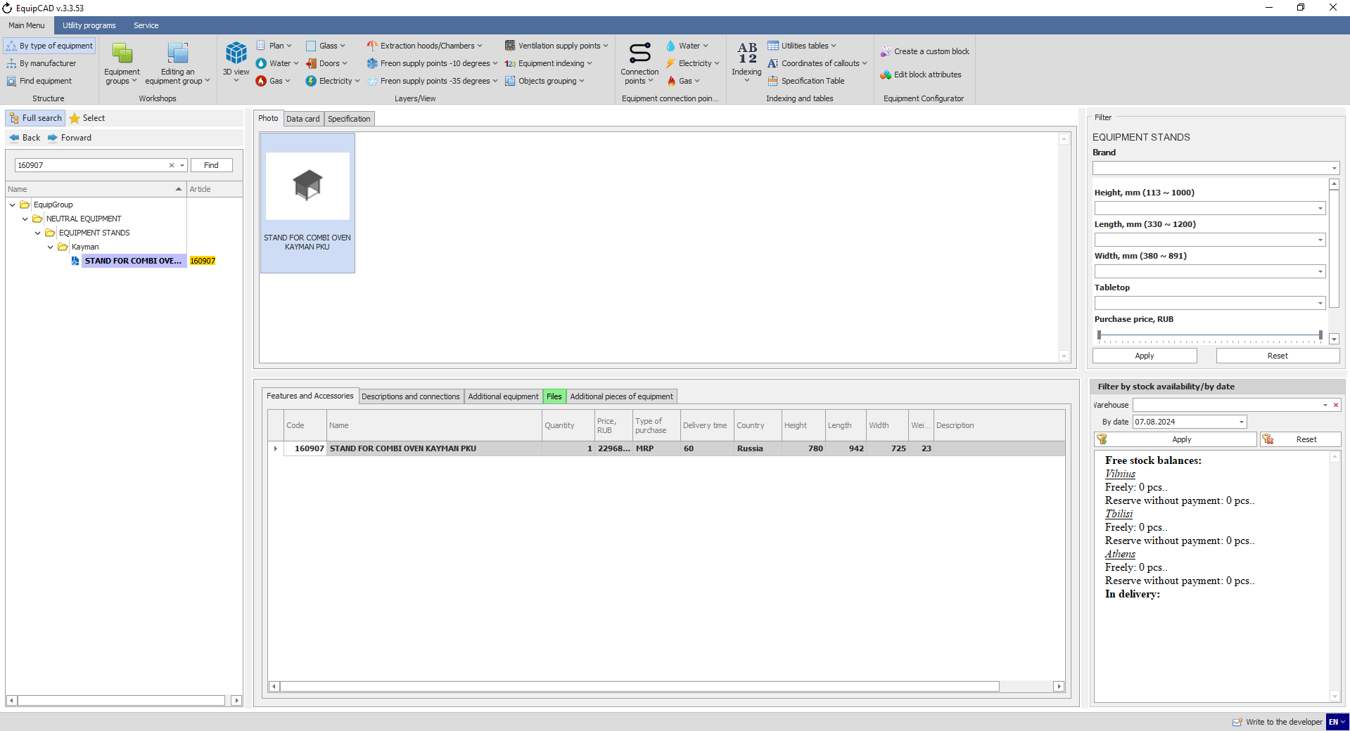
6.3.2

    - Search history
You can use the Back and Forward buttons to switch to equipment items that you selected earlier.
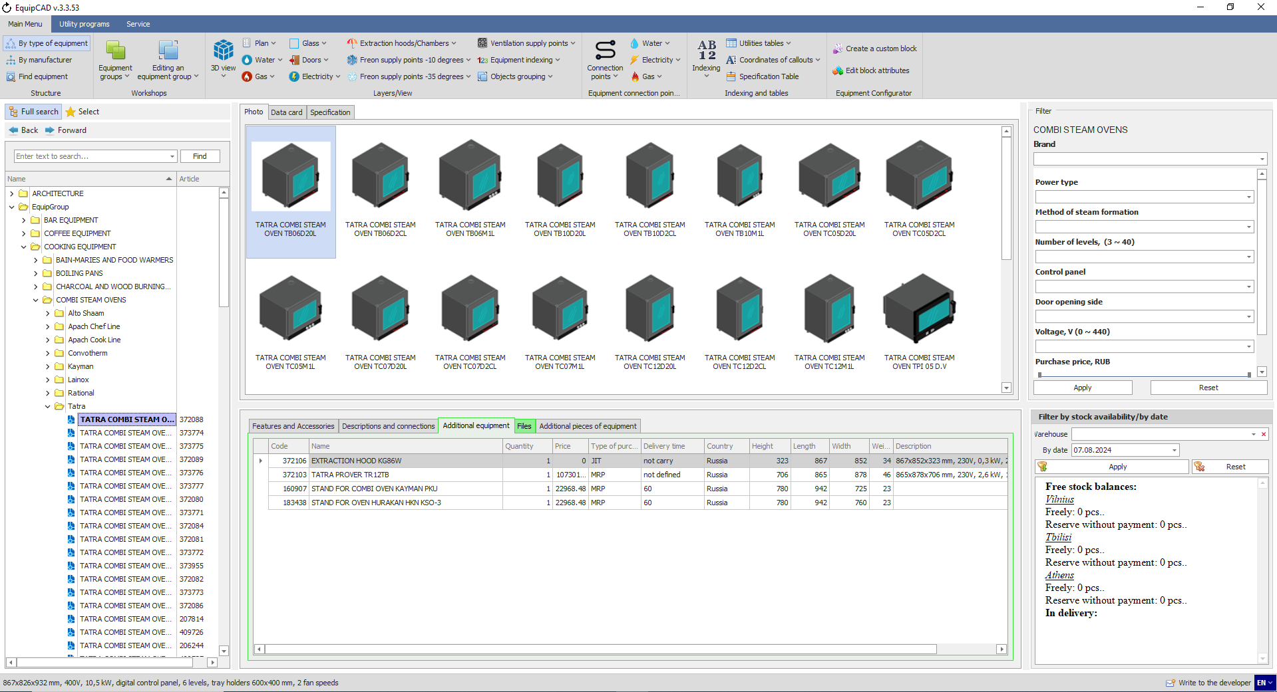
6.3.3

If you keep the Back/Forward button pressed, the search history will appear.
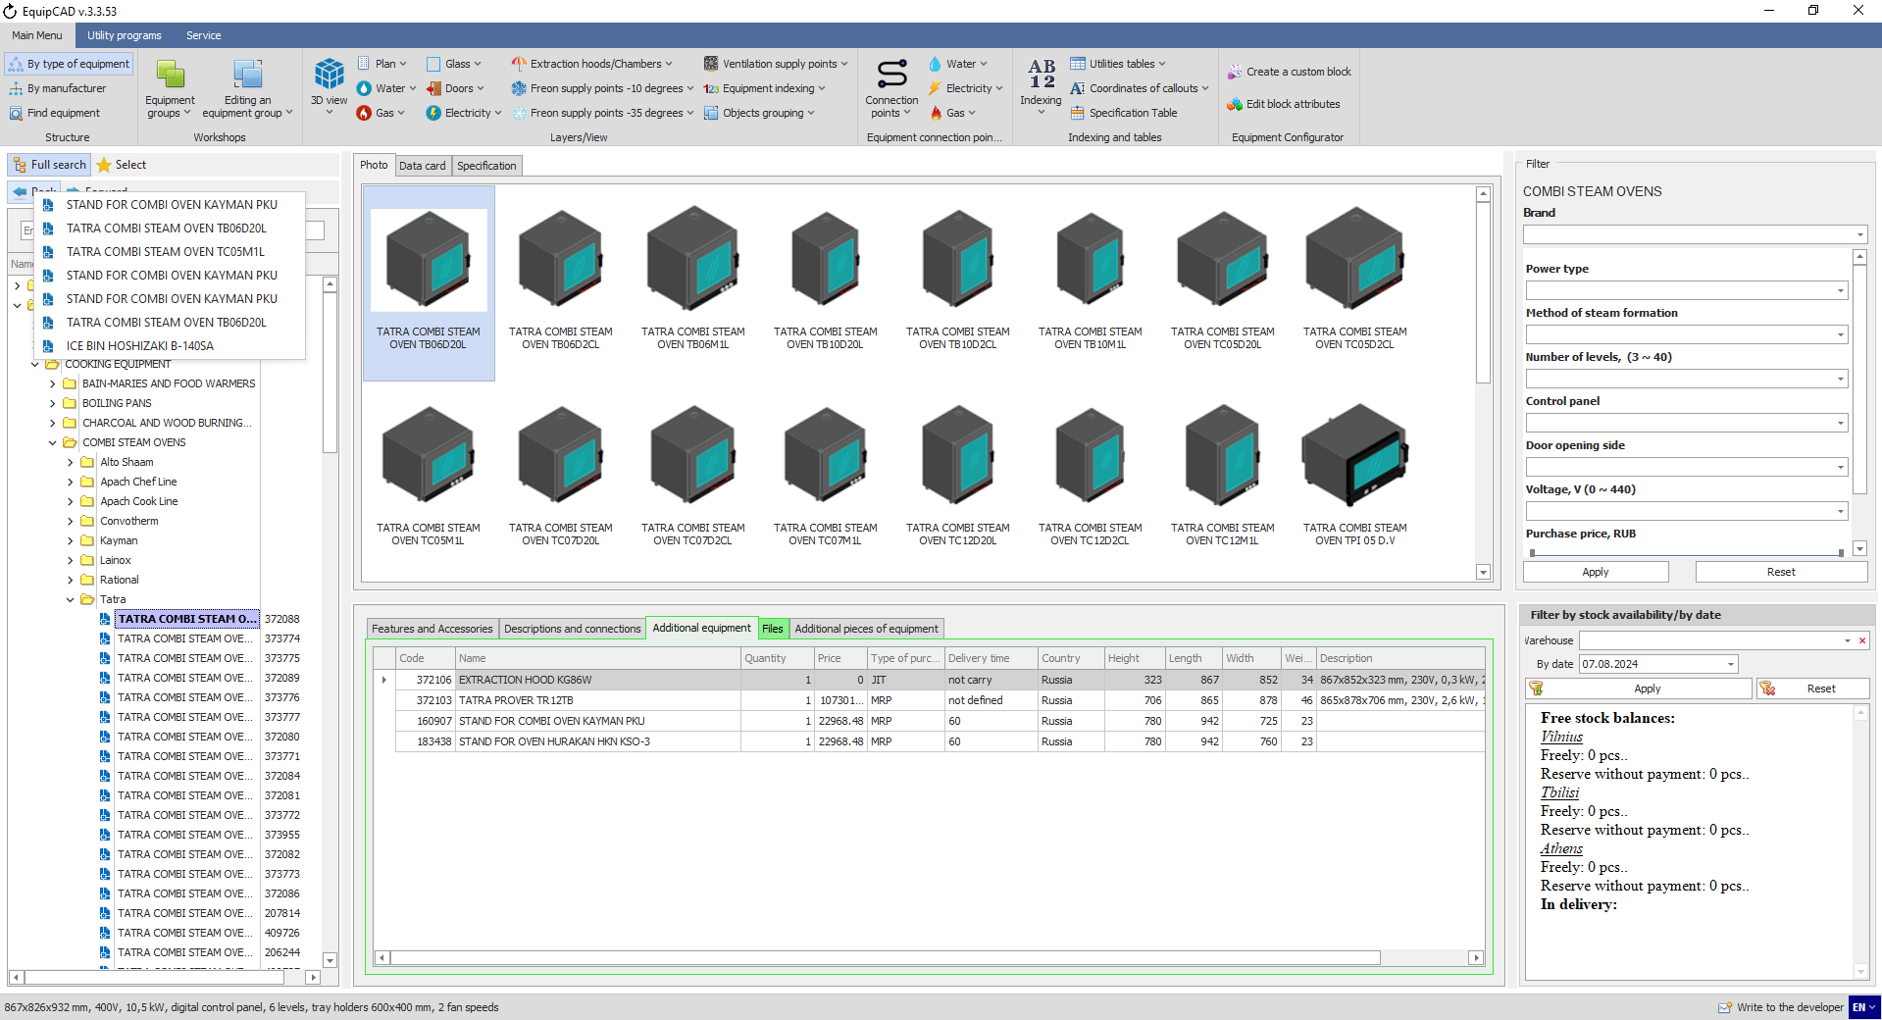
6.3.3

  - Selecting equipment by characteristics
The Filter tab allows you to select equipment with desired characteristics in a particular sub-category.
    - To select equipment, go to the sub-category you need (for example, steam equipment – combi steamers);
    - Select your desired characteristics for a combi steamer (for example, connection type: electricity; steam generation method: injector; number of levels: 10; voltage: 380) and click the Apply button;
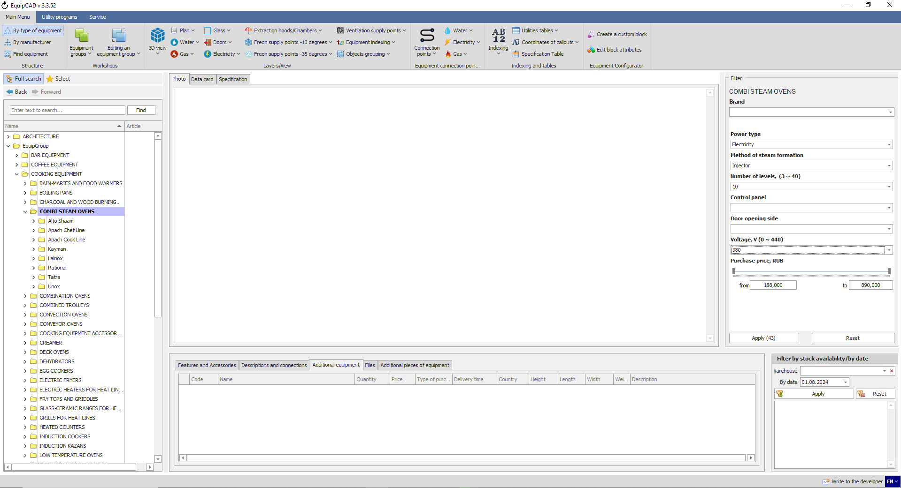
6.4.2
6.4.1

    - This will leave only the Tatra brand in the tree, and by opening it, we will see three combi steam ovens that meet our requirements;
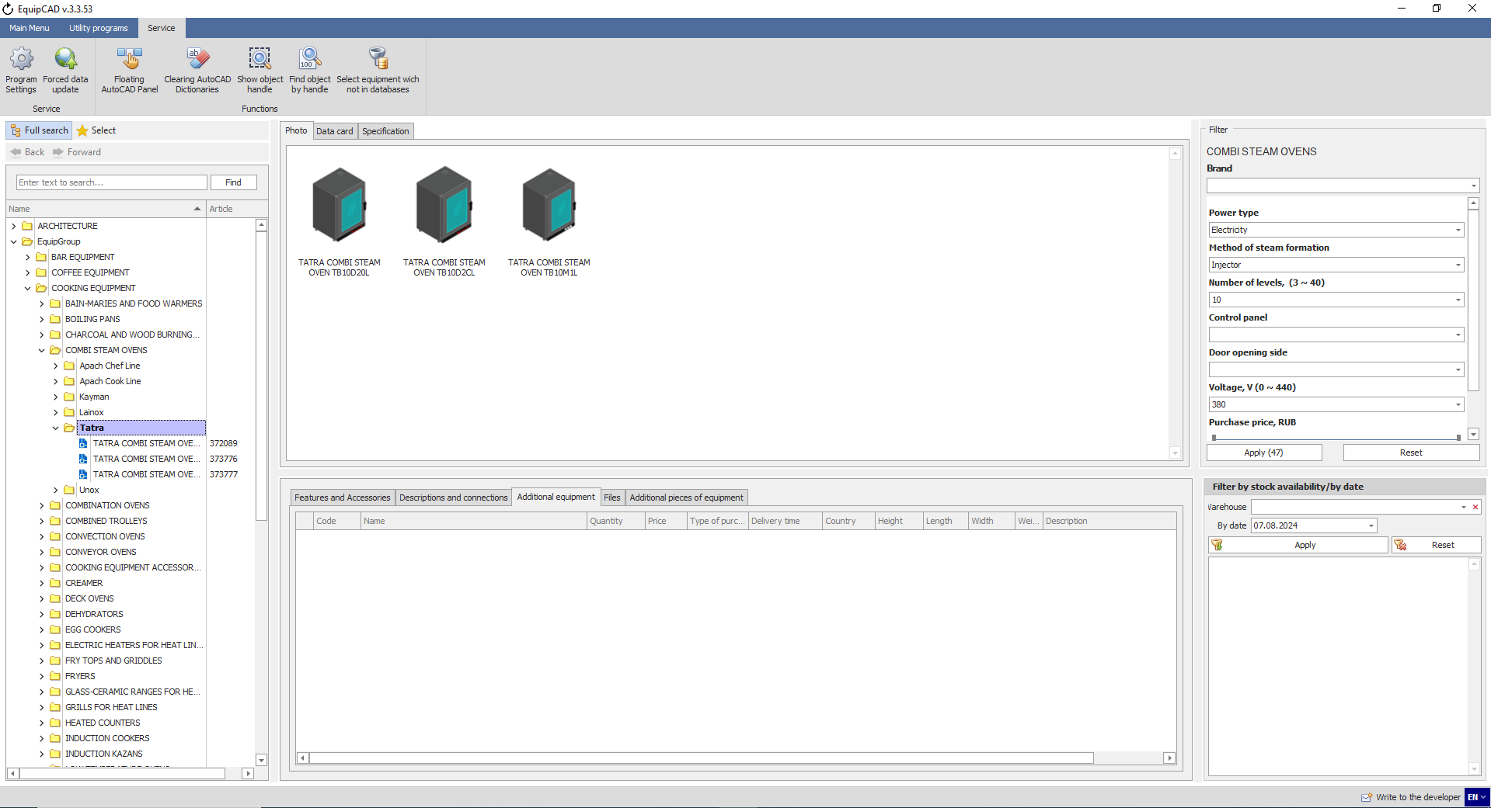
6.4.3

  - Selecting by available stocks
By using the “Filter by stock availability/by date”, you can select equipment that is available in stock at a specific warehouse or will be available by your desired date. The filter operates similarly to the search in section 6.3, removing from the tree those equipment items that do not match the request.
    - To sort by stock availability, select the desired warehouse from the list;
    - Select the date (or leave the current one);
    - Click the Apply button;
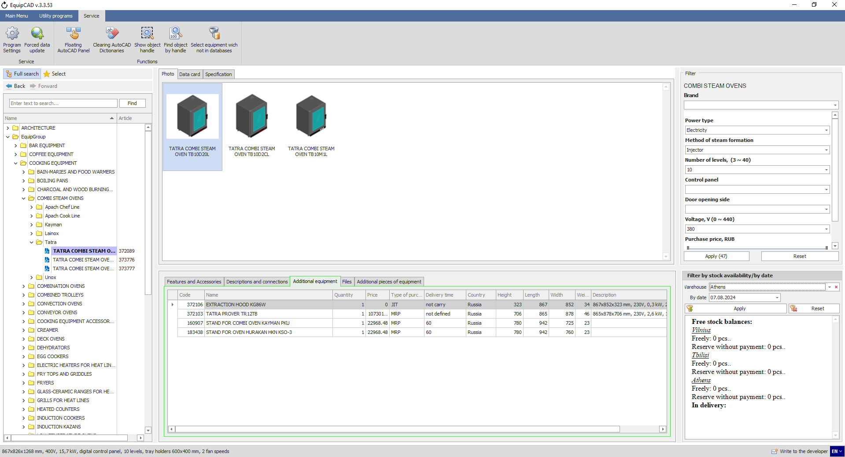
6.5.2
6.5.3
6.5.1
When a specific equipment item is selected, the tab will show the quantity available at warehouses.
When working with a project, it is not recommended to use this filter for a selected warehouse, since it limits the ability to select equipment from the entire program catalogue.

  - Brand Access Request
Access to some brands in the program can be obtained by a special additional request, in this case the icon to the left of the equipment name will be pale blue, to gain access to the brand you must perform the following steps.

    - Right-click on the equipment name;
    - In the context menu, select “Request full access”;

    - In the window that opens, you must enter your full name, email, phone number and organization; the “Additional Information” field is not required;
    - Then click the "Request access" button;

  - Placing equipment in a project
When arranging equipment, you must enable the “Plan” layer and disable the “3D view” layer (see sections 5.1 and 5.2).
    - To place equipment in your project, double-click the left mouse button on the desired equipment in the tree or tab;
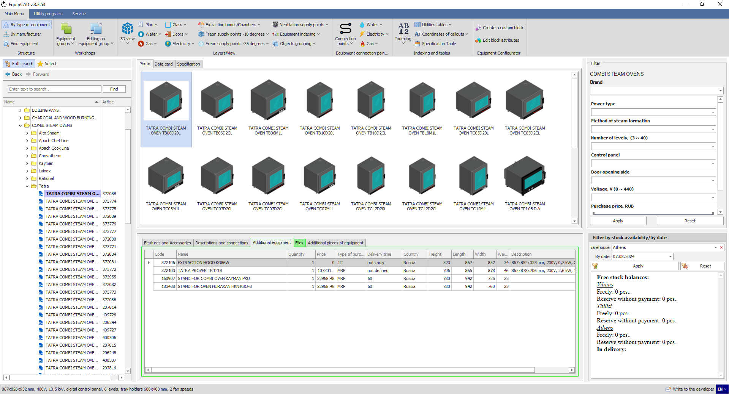
6.7.1

    - The program will switch to the last active AutoCAD document in which you will have to select the starting point for inserting equipment and its rotation angle;
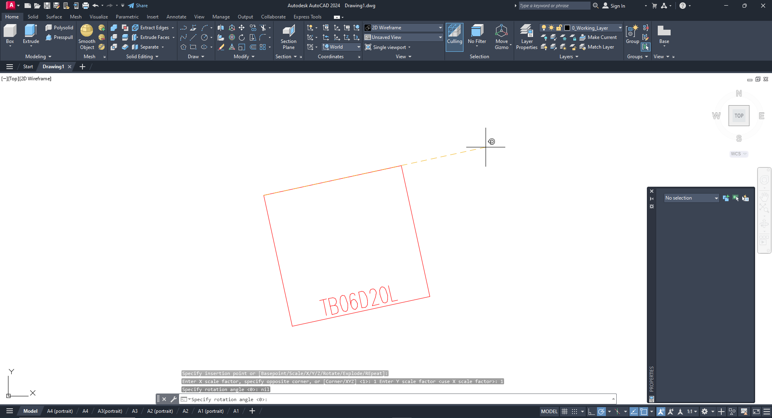
In the Plan layer, equipment is represented as the outer contour of the equipment and its name.
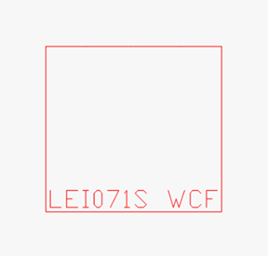
When run, the program automatically returns to the selection of equipment in the Structure menu. Further selection of equipment for your project is done in a similar manner.

  - Placing additional pieces of equipment

    - To place additional pieces of equipment, place the main equipment in the drawing as described in section 6.6 and go to the “Additional pieces of equipment” tab;
    - Choose the desired additional part and double-click it;
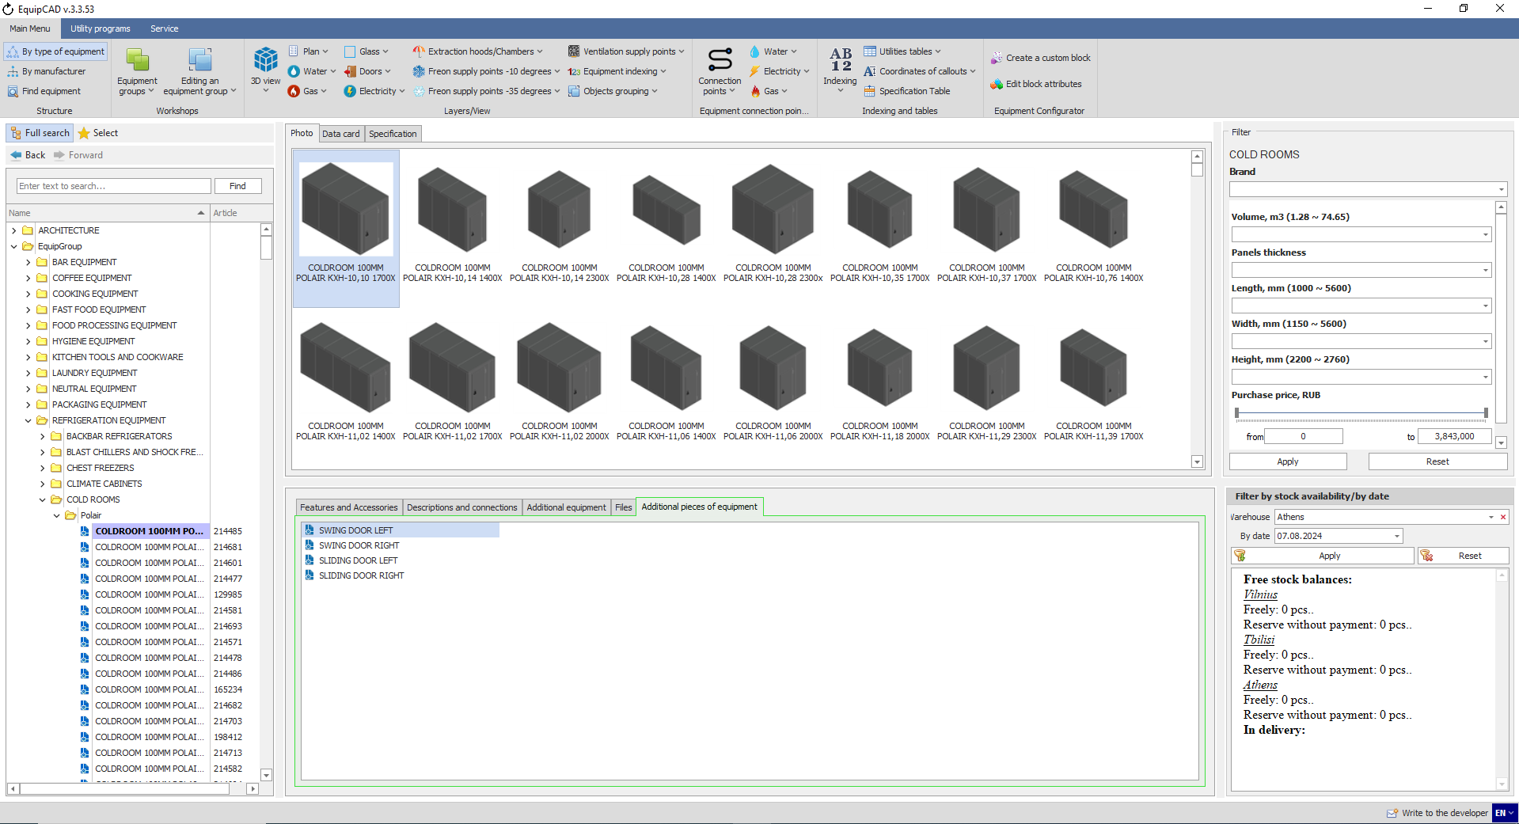
6.8.1
6.8.2

    - Once the additional pieces of equipment is selected, the program will inform you that you need to select the equipment item to which you want to add the additional part;
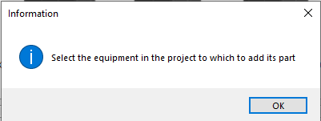

    - After the confirmation, the program will switch to an active AutoCAD document where you need to select the equipment item to which you want to add the additional part;
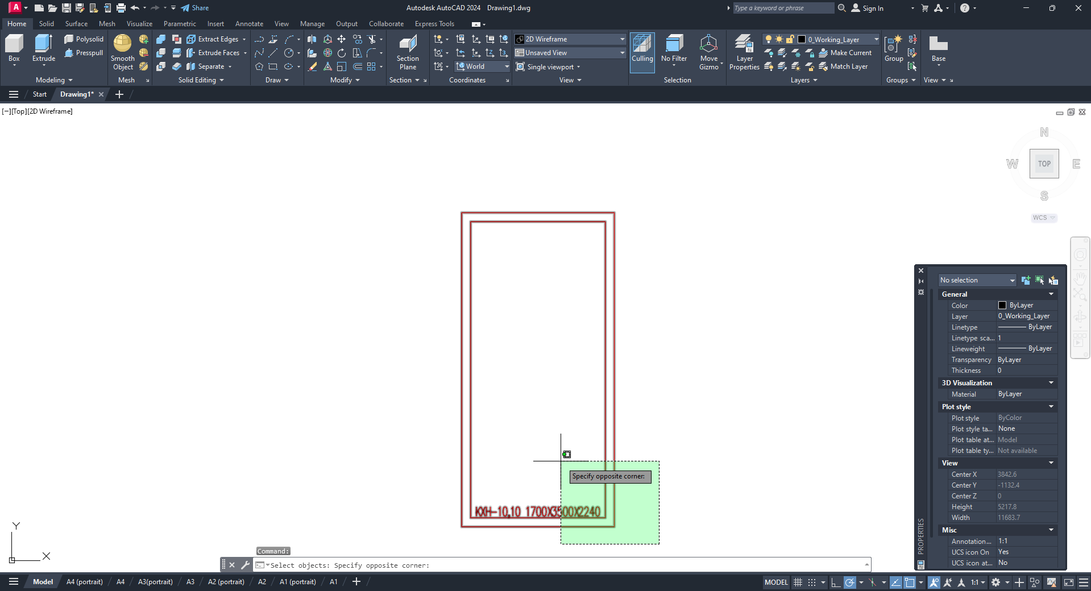

    - When the equipment is selected, the program will inform you that the additional part has been placed at the point of insertion of the main block and you will need to move it to the right position by yourself;
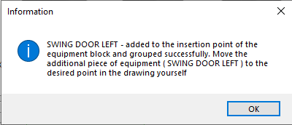
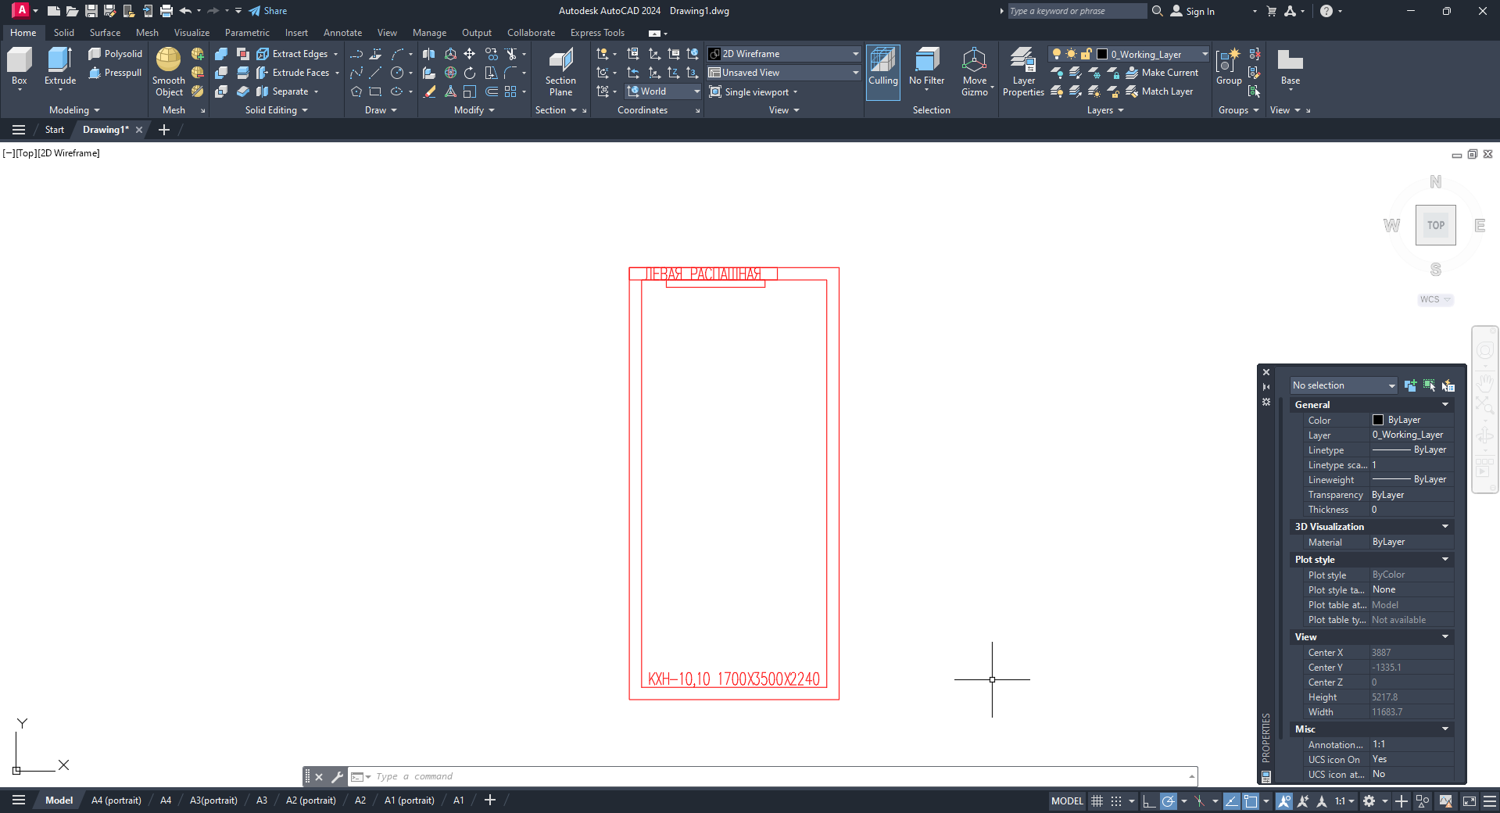

    - Let’s move the door of a cold room to a random position.
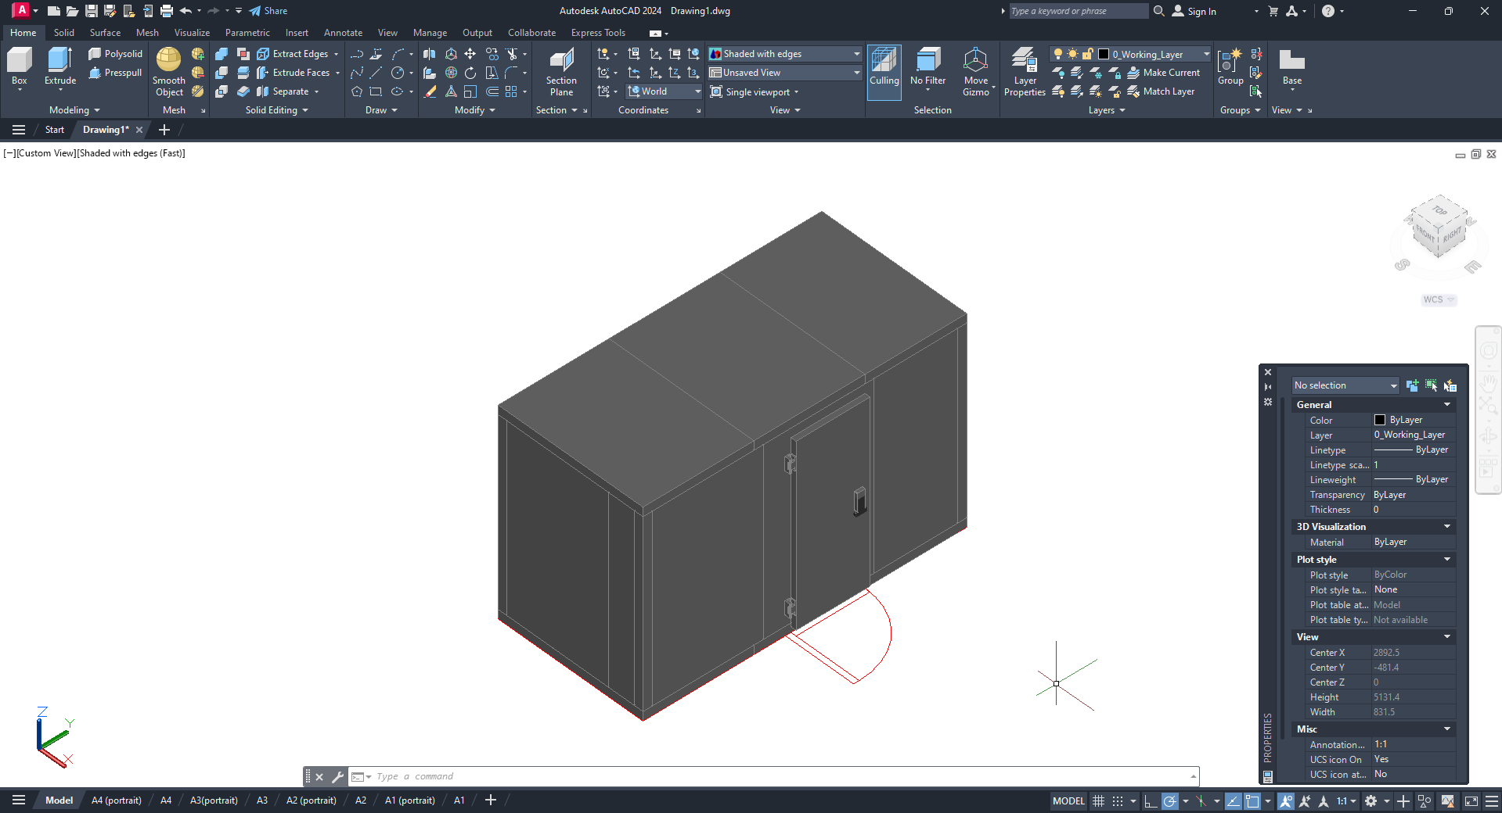

Note: Additional equipment parts are automatically combined into a group with the main equipment items; they are not included in the specification and are not indexed.

  - Searching for equipment added to a project

    - To search the EquipCaD tree for an equipment item already added to your project, go to the Structure menu and click the “Find equipment” button;
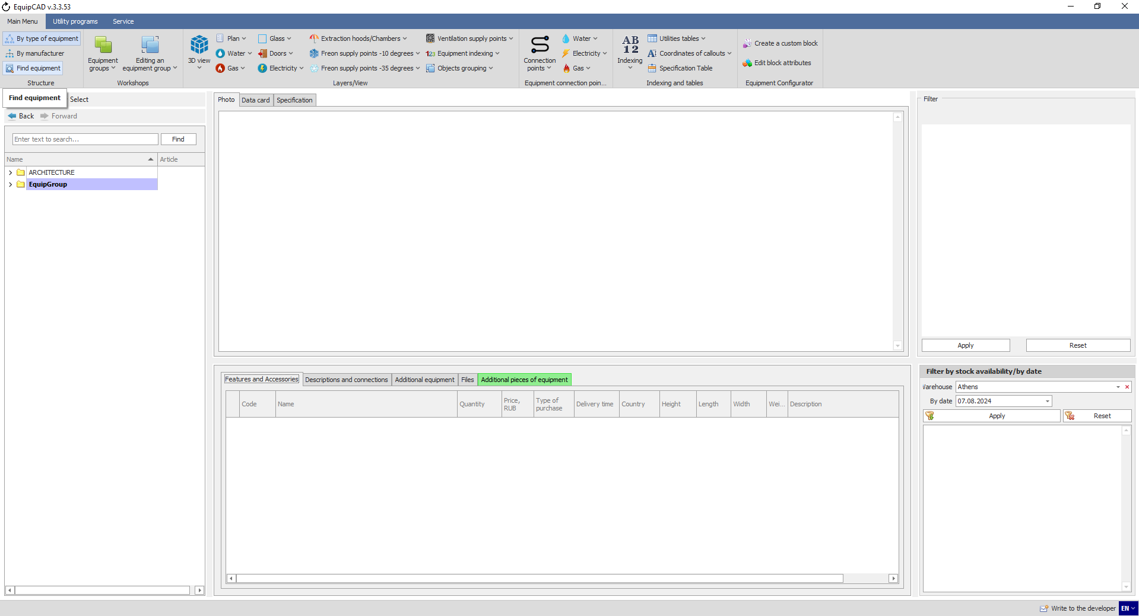
6.9.1

    - When the program has automatically switched to AutoCAD, select the equipment to be searched for in the tree by highlighting it, and confirm your choice by pressing the right mouse button or Enter/Space key;
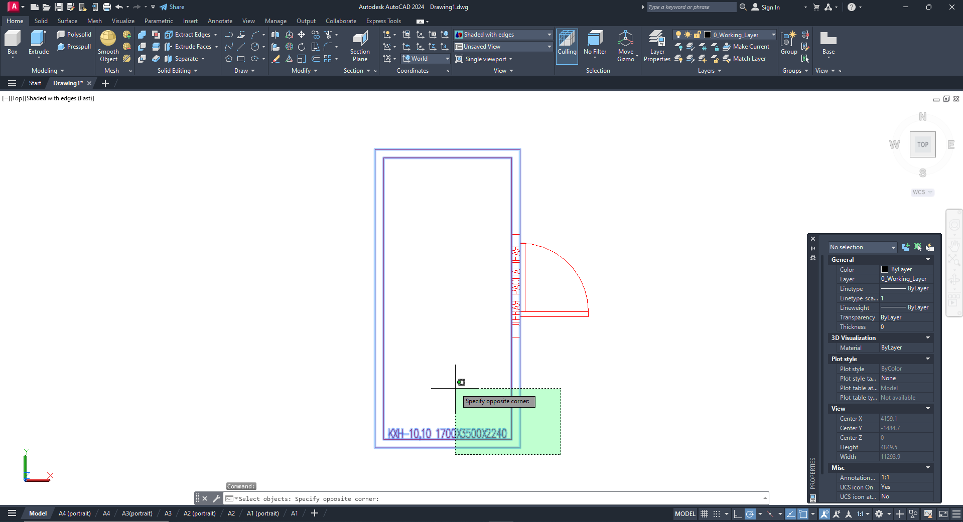
The program will then switch to EquipCaD which will display the equipment item you have selected in your project.
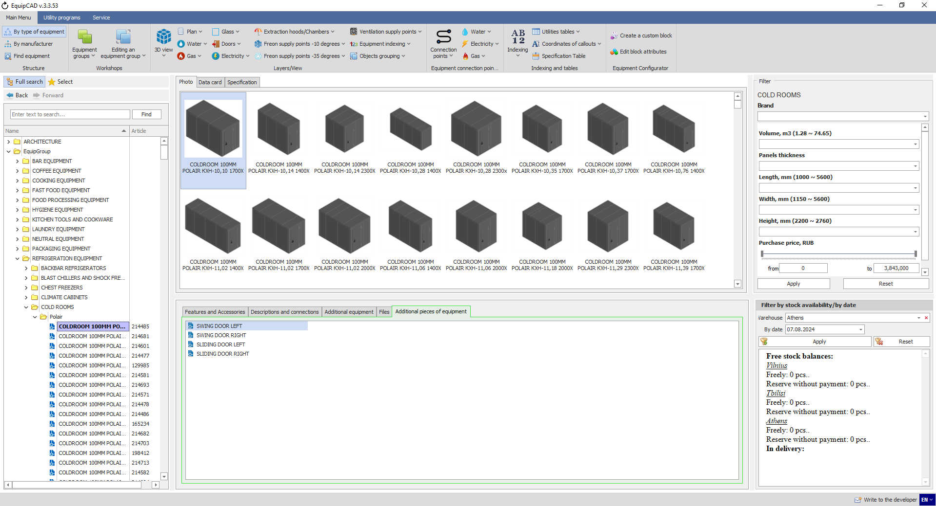

  - Choosing additional equipment and accessories

    - Select the “Additional equipment” tab and choose the desired items for the selected product;
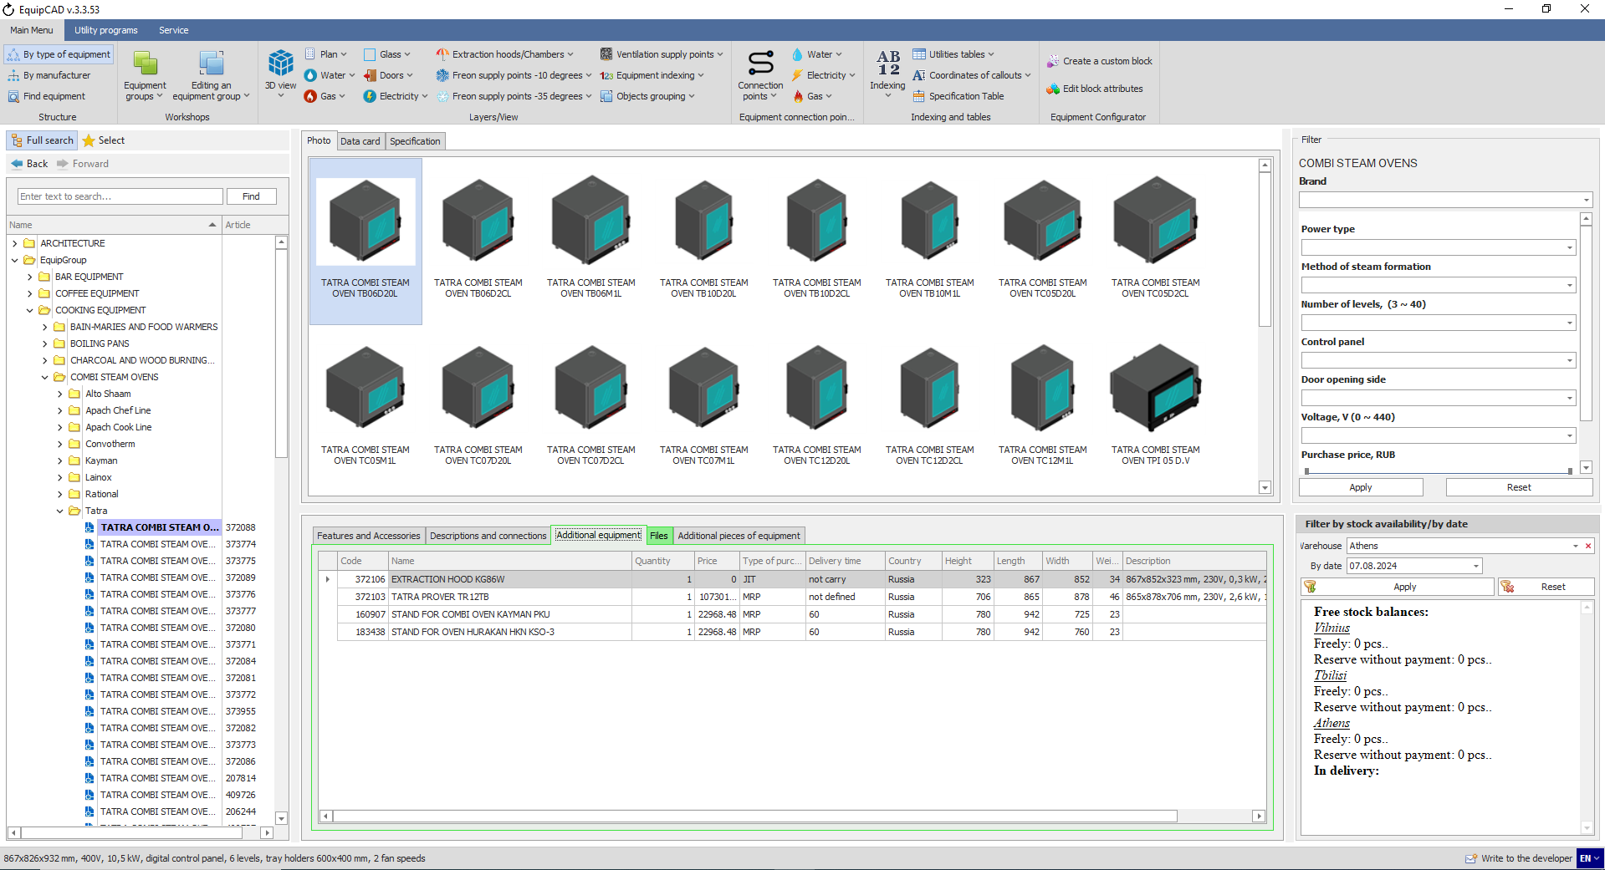
6.10.1

    - Right-click the desired equipment to open the context menu and select “Paste to AutoCAD”;
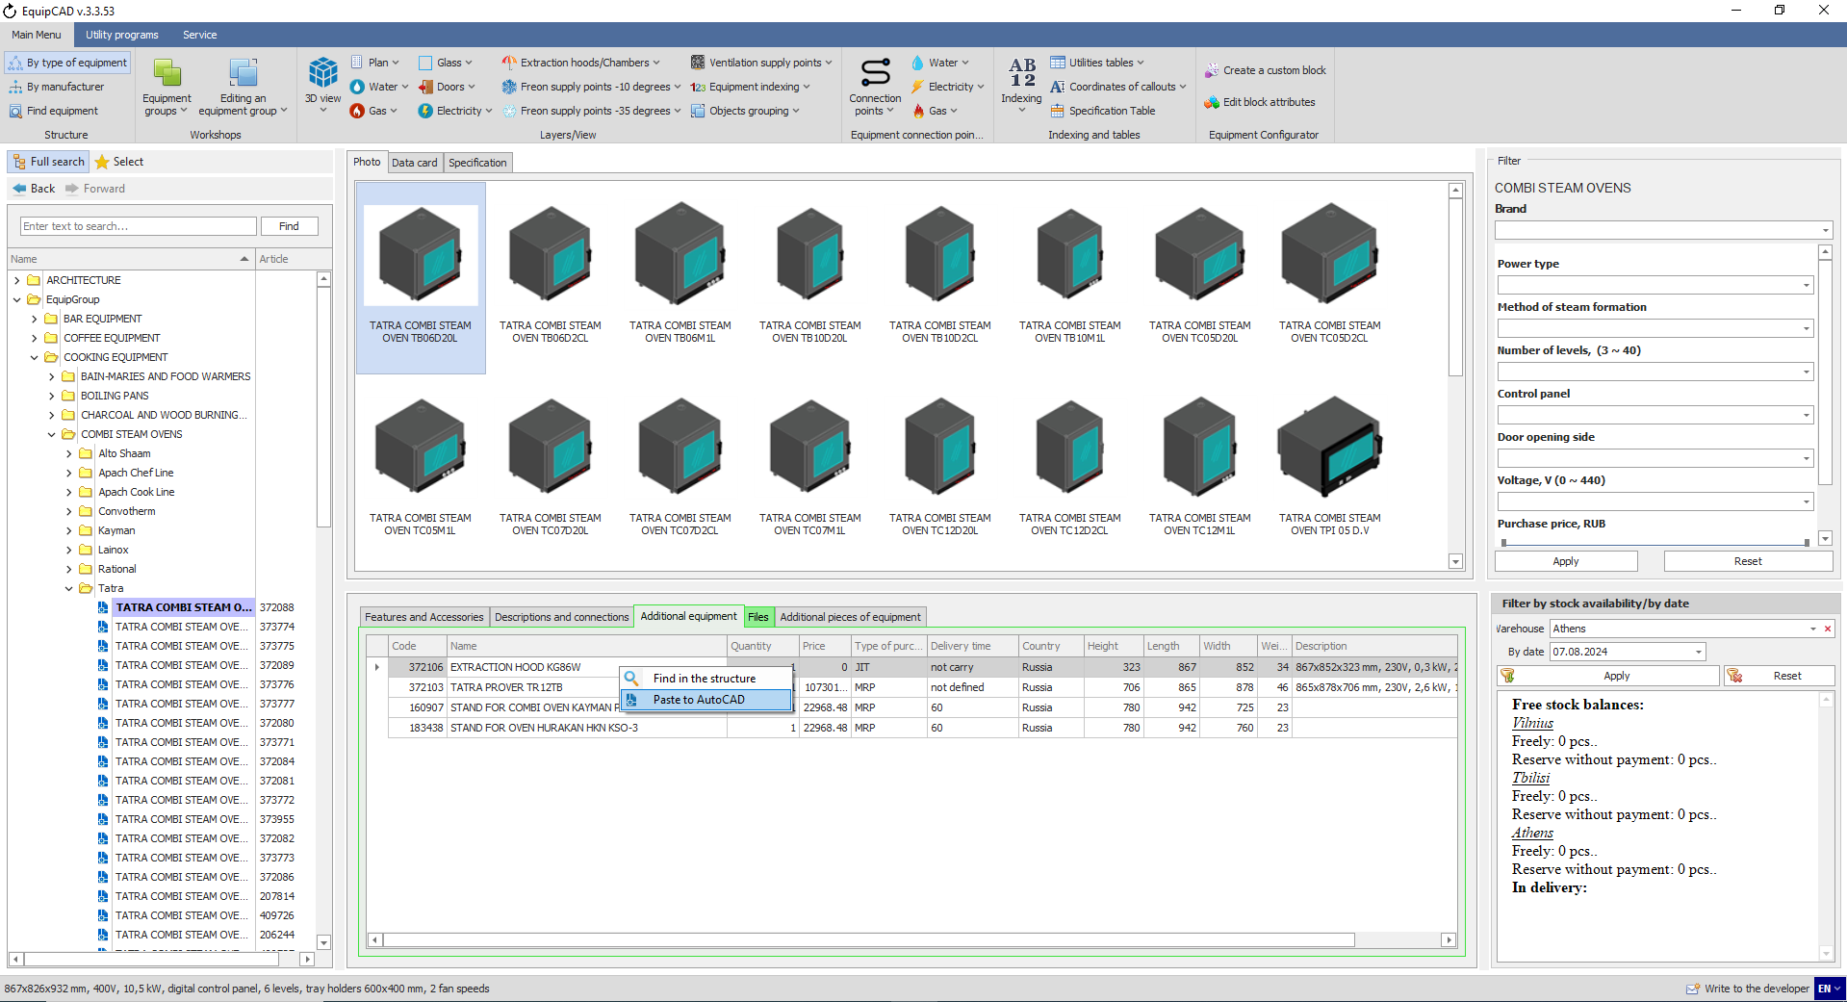
6.10.2
Place the equipment on your drawing in the manner similar to that described in section 6.7.

    - By selecting “Find in the structure”, you can view the item, read its description and then add it to your project by a double click;
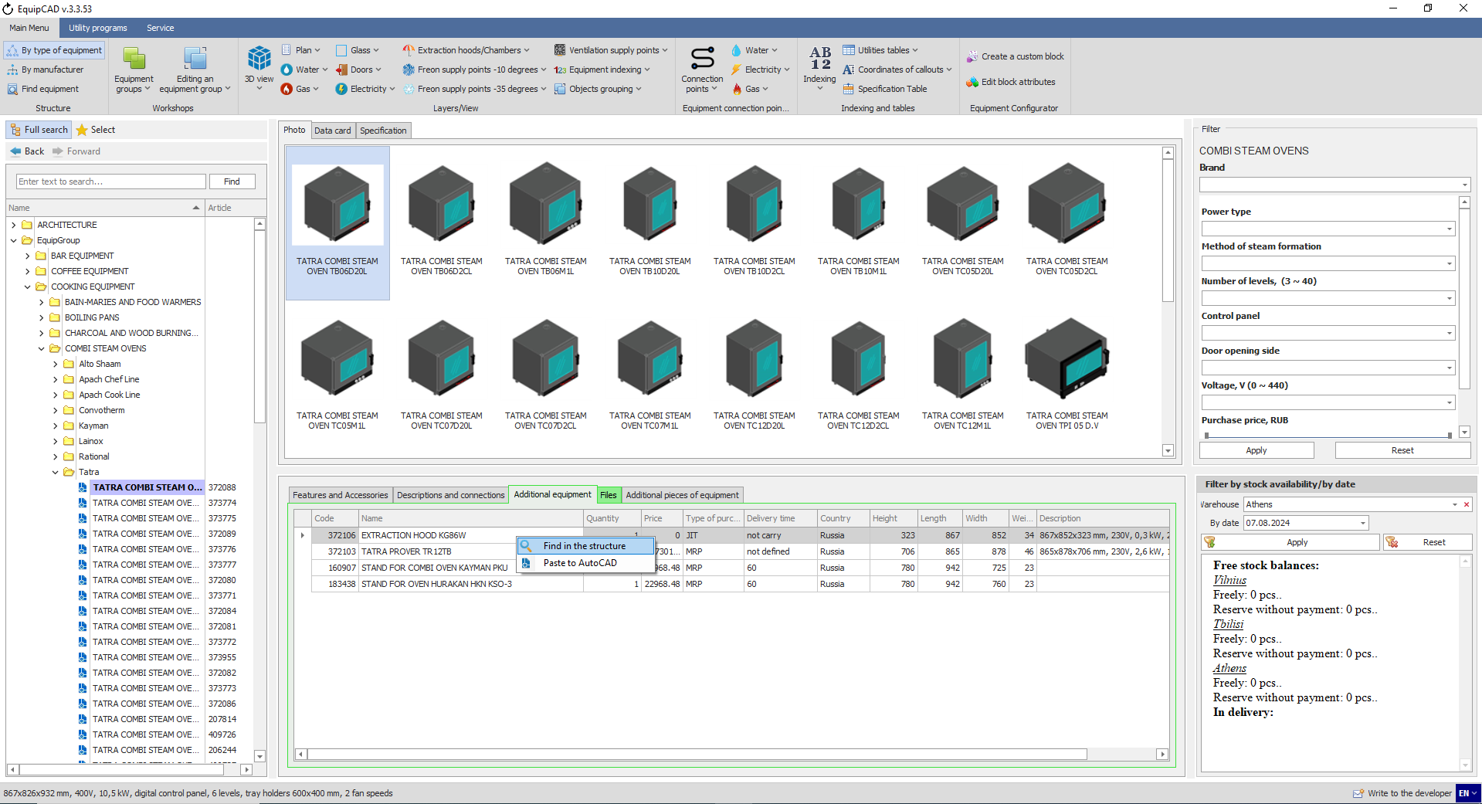
6.10.3
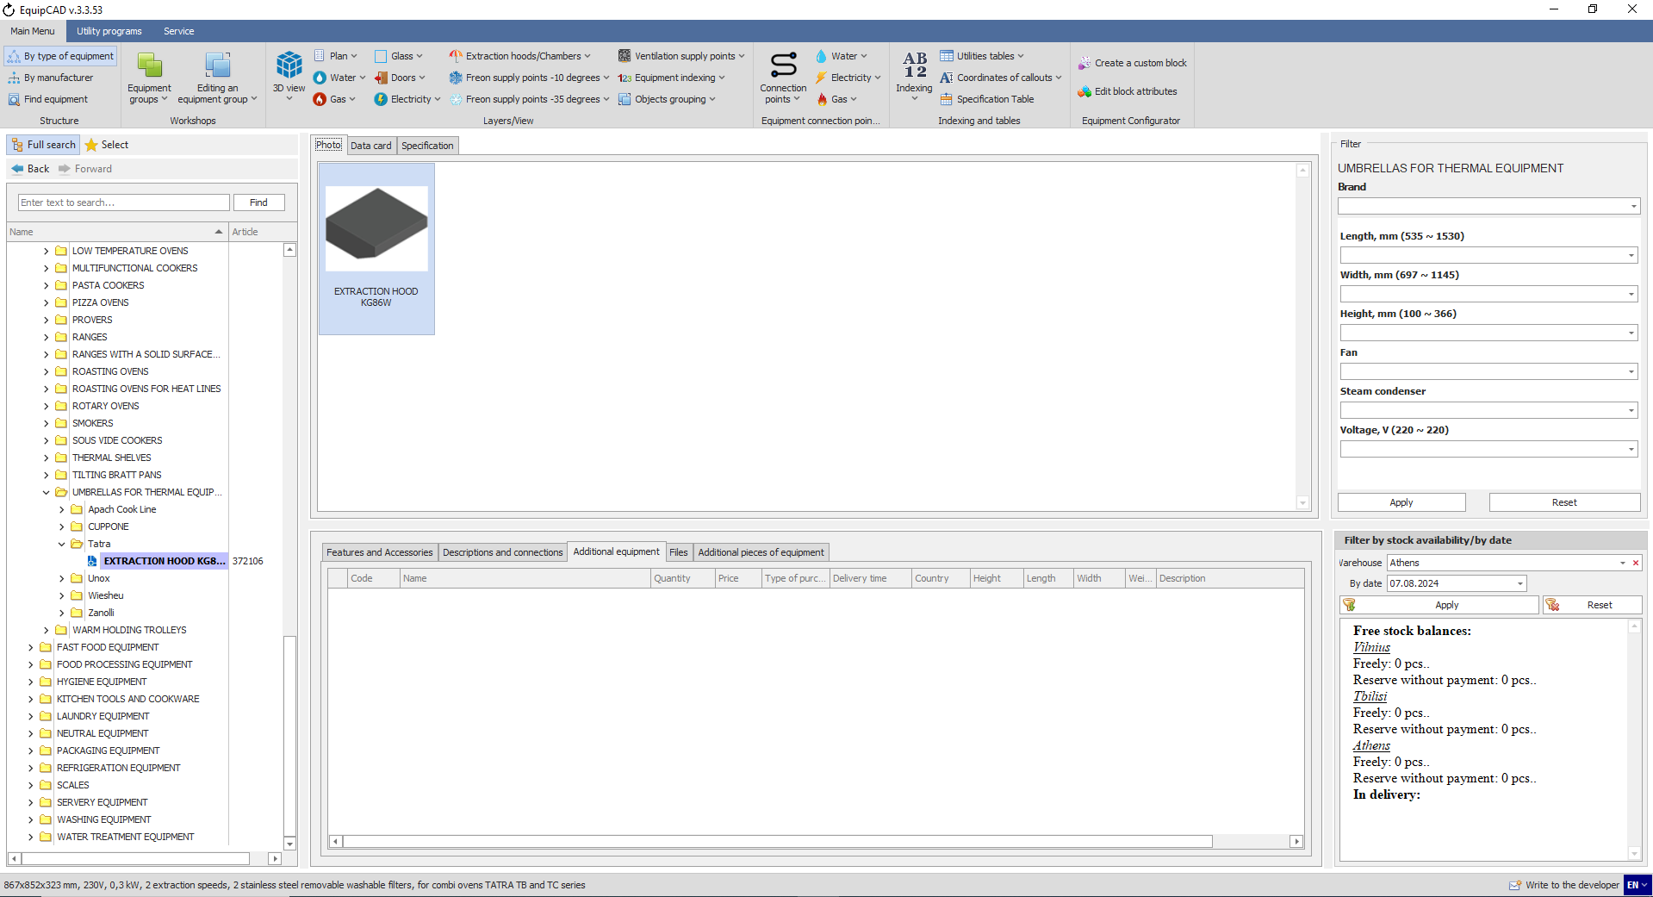

    - Accessories for the selected equipment will be automatically added to the specification.
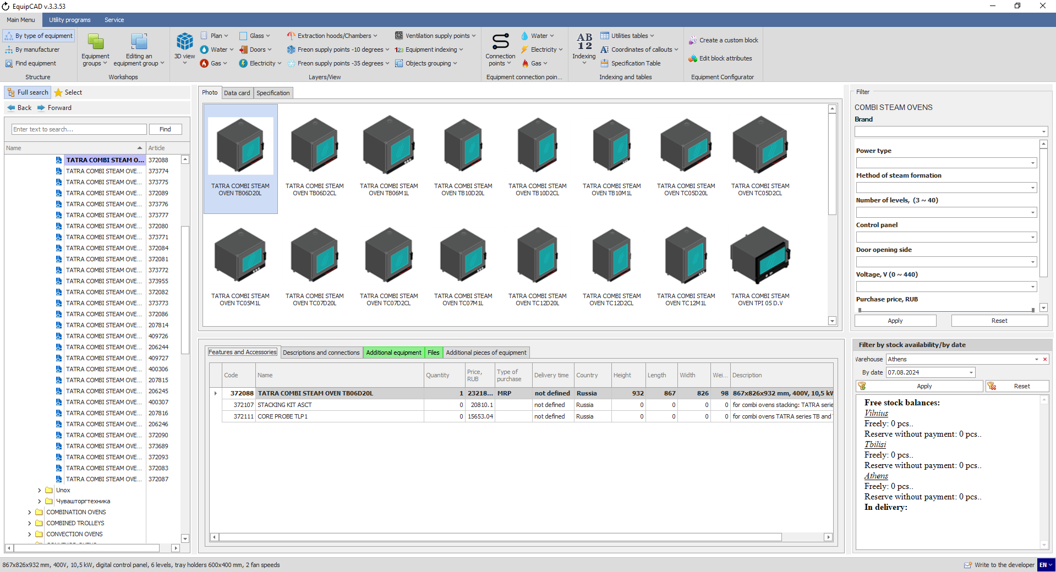
6.10.4

  - Favorites

    - To add equipment to the Favorites list, right-click on the equipment name in the tree and select “Add to Favorites” from the context menu;
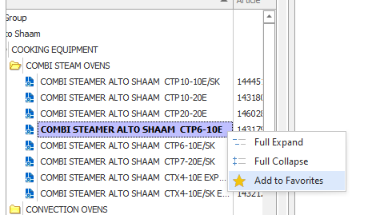
6.11.1

    - This will change the icon to the asterisk symbol for the Favorites and the equipment that was added to favorites will be moved to the top of the list (the next time the program is launched);
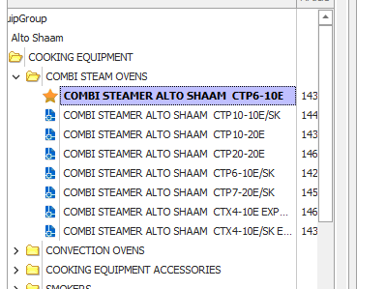
6.11.2
Note: To remove an item from the Favorites list, follow the steps similar to those listed for adding: right-click on the equipment name in the tree and select “Delete from Favorites” from the context menu.

  - Groups

    - To create a group of equipment, you need to go to the group tab;
    - Then click the "Create a group" button;
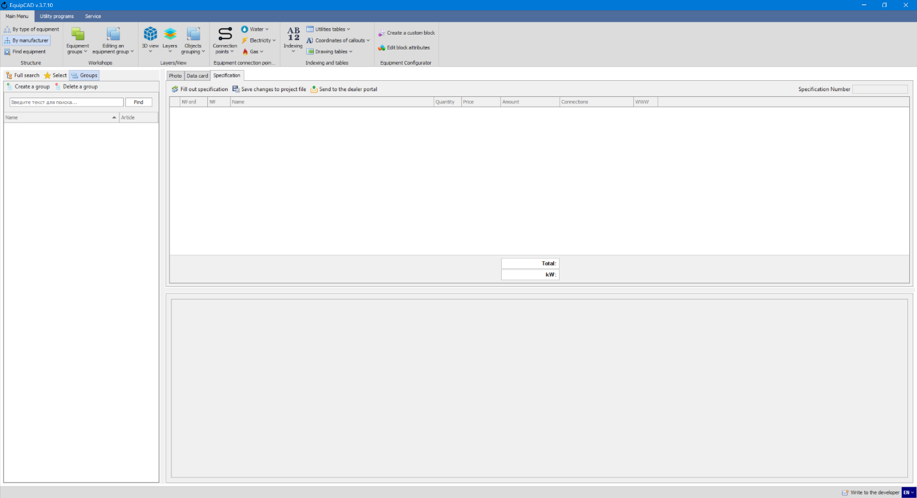
6.12.2
6.12.1

    - After this, a new group with an editable name will be created in the tree window;
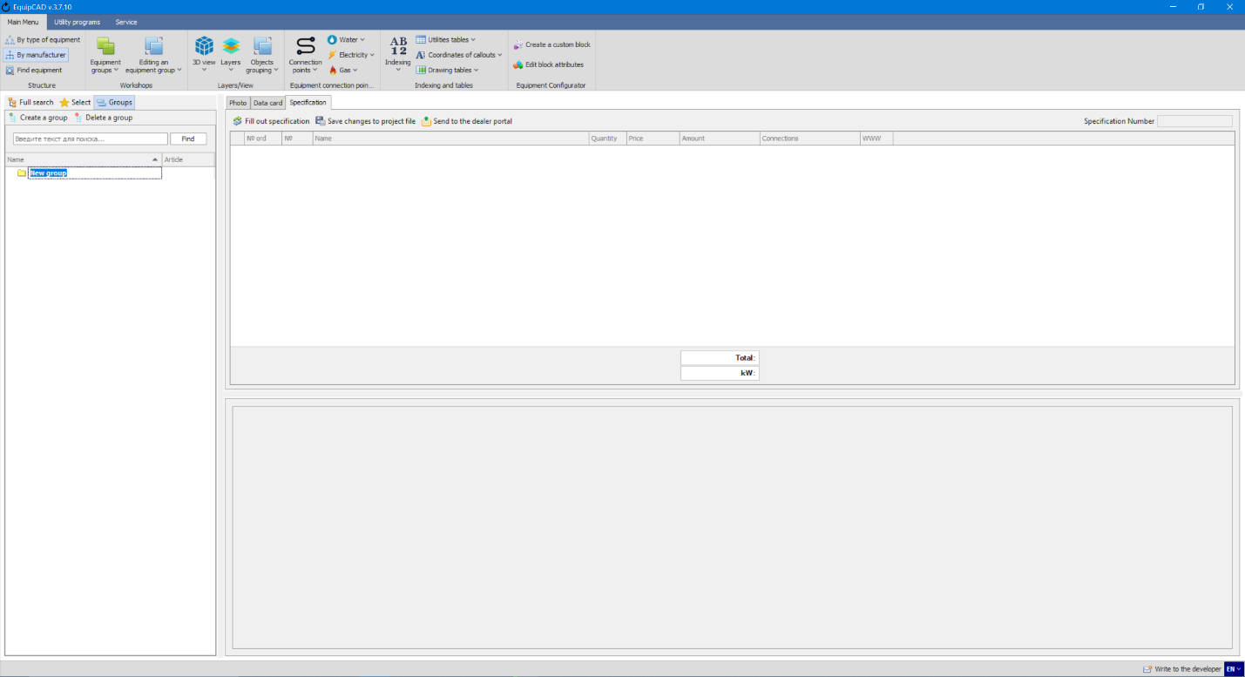
6.12.3

    - To delete a created group, select the desired group, then click the “Delete group” button and confirm in the pop-up window that you really want to delete this group;
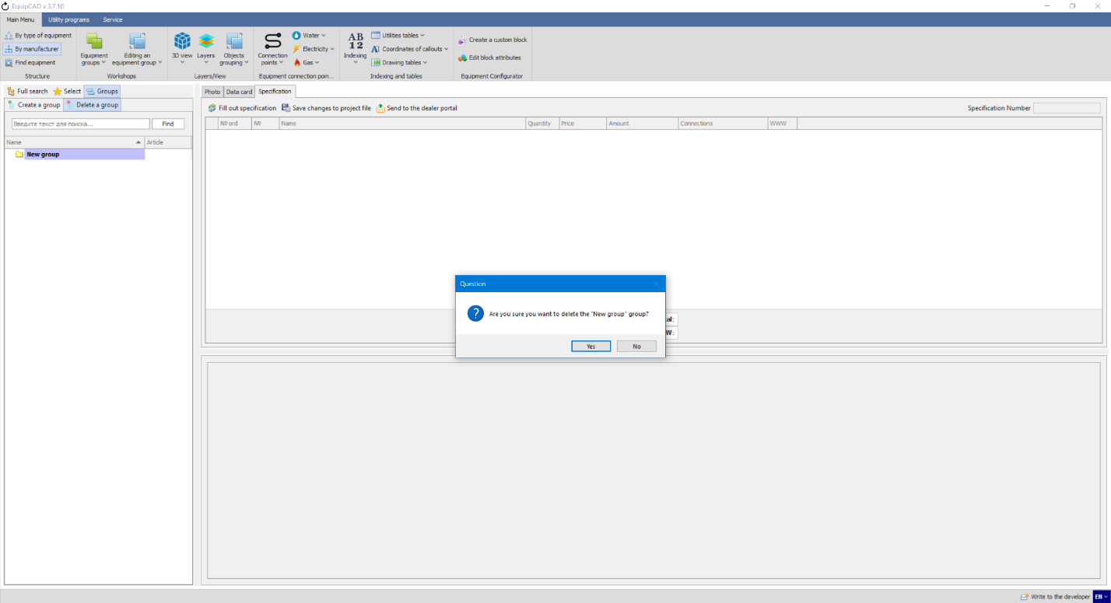
6.12.4

    - To add equipment to the created group, you need to right-click on the name of the desired item in the main tree window and select “Add to group” in the context menu;
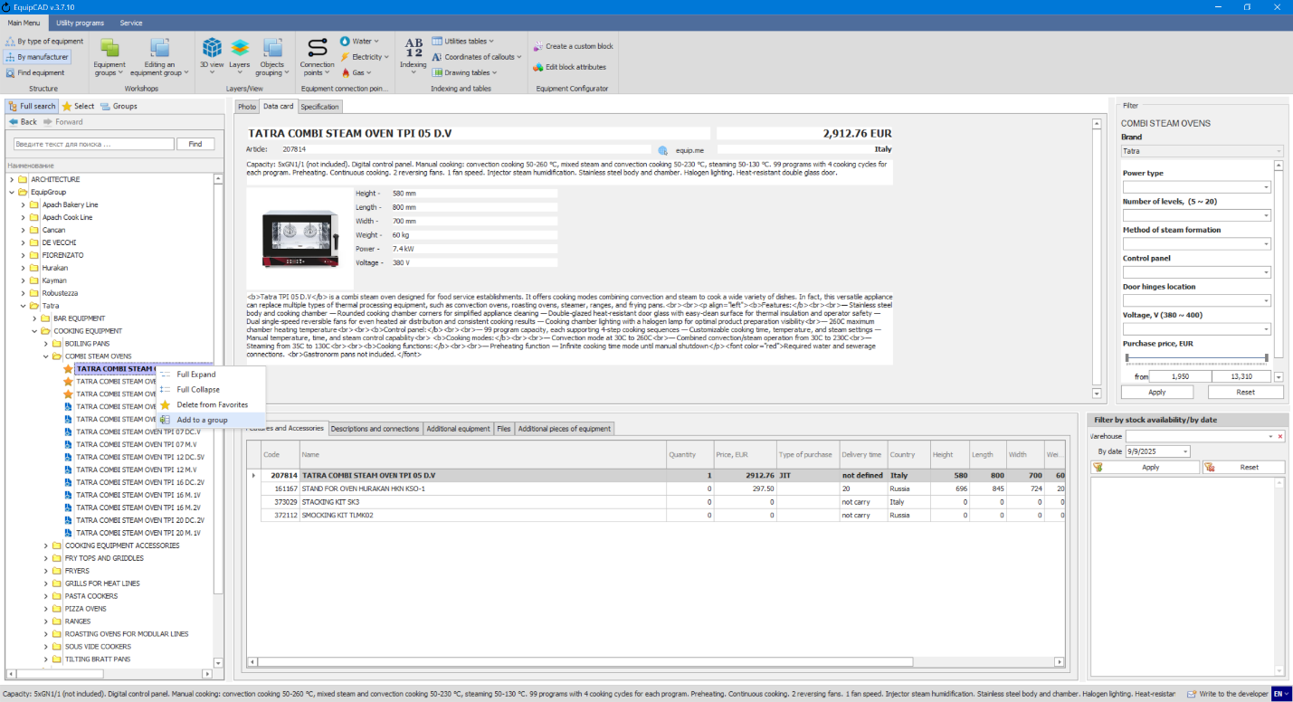
6.12.5

    - After this, a window will open with a list of created groups, in which you need to select the group to which you want to add equipment and click the "Select" button;
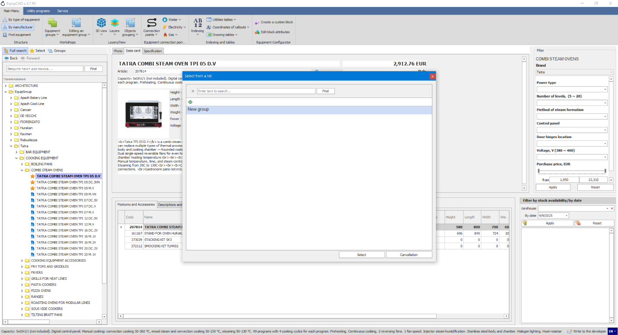
6.12.6
As an example, let's add several combi steamers to our group.
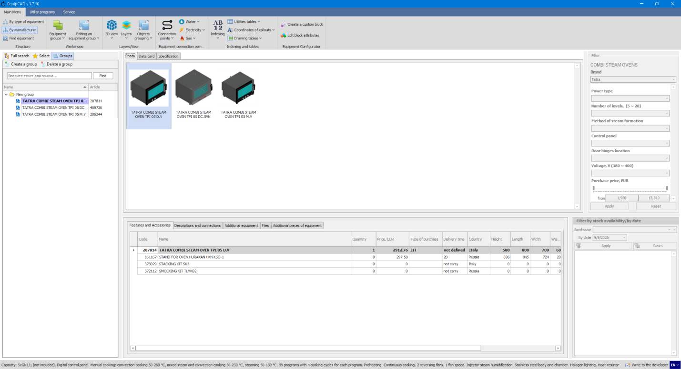

    - To remove equipment from a group, in the “Groups” tab, right-click on the name of the equipment and select “Delete” from the context menu;
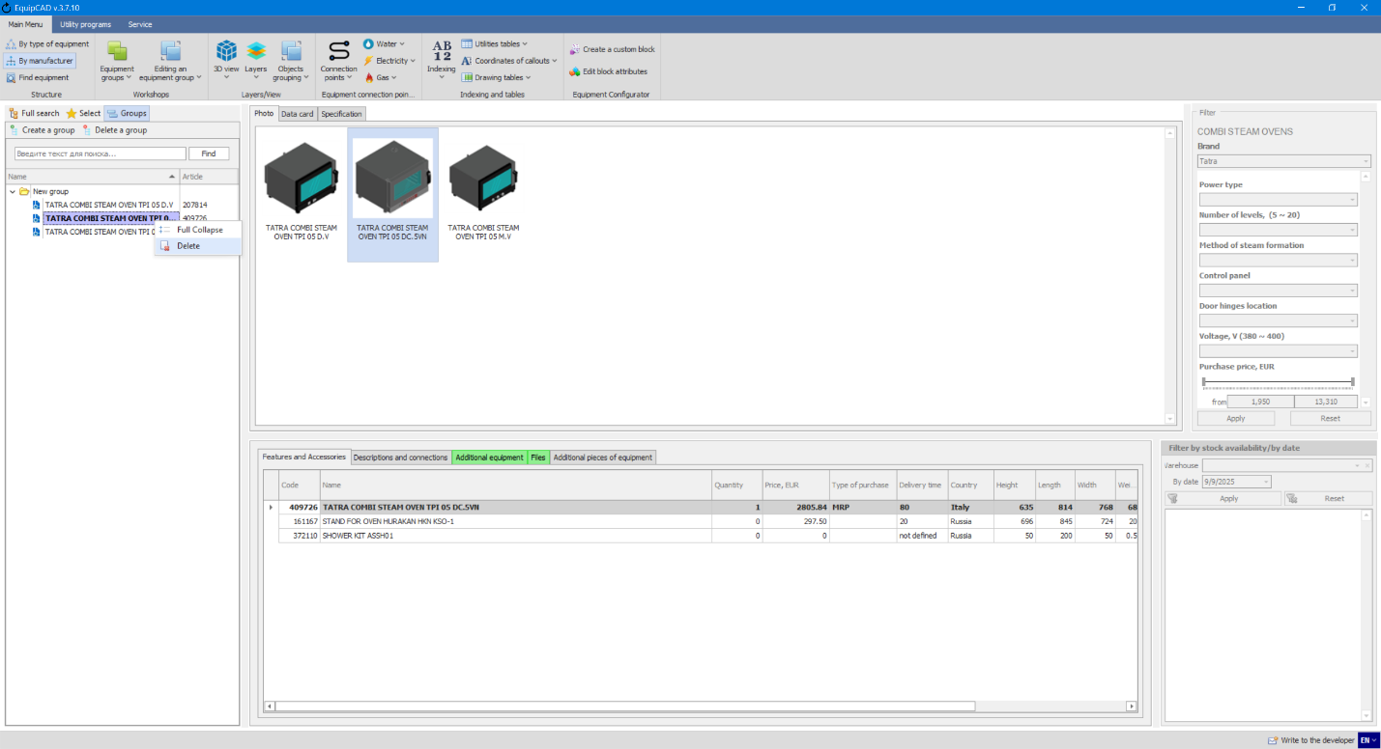
6.12.7

    - To add a group to a drawing, right-click on the group and select “Insert into project” from the context menu;
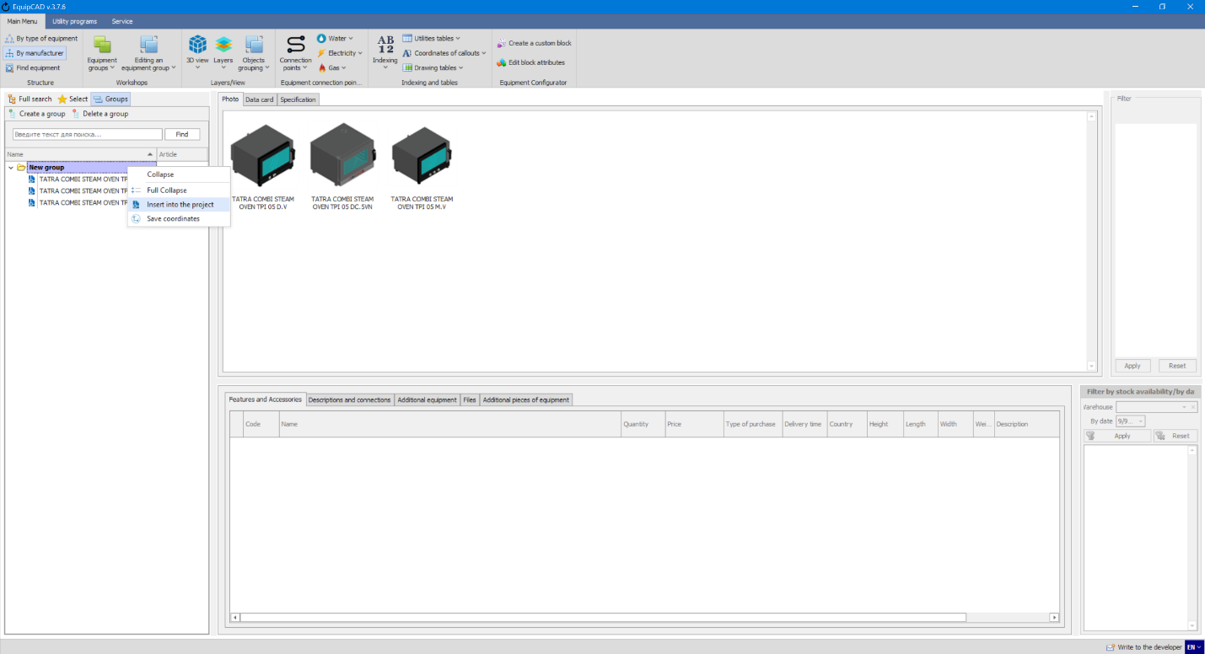
6.12.8

    - After this, the program will automatically switch to AutoCAD, where you will need to select an insertion point for the group;
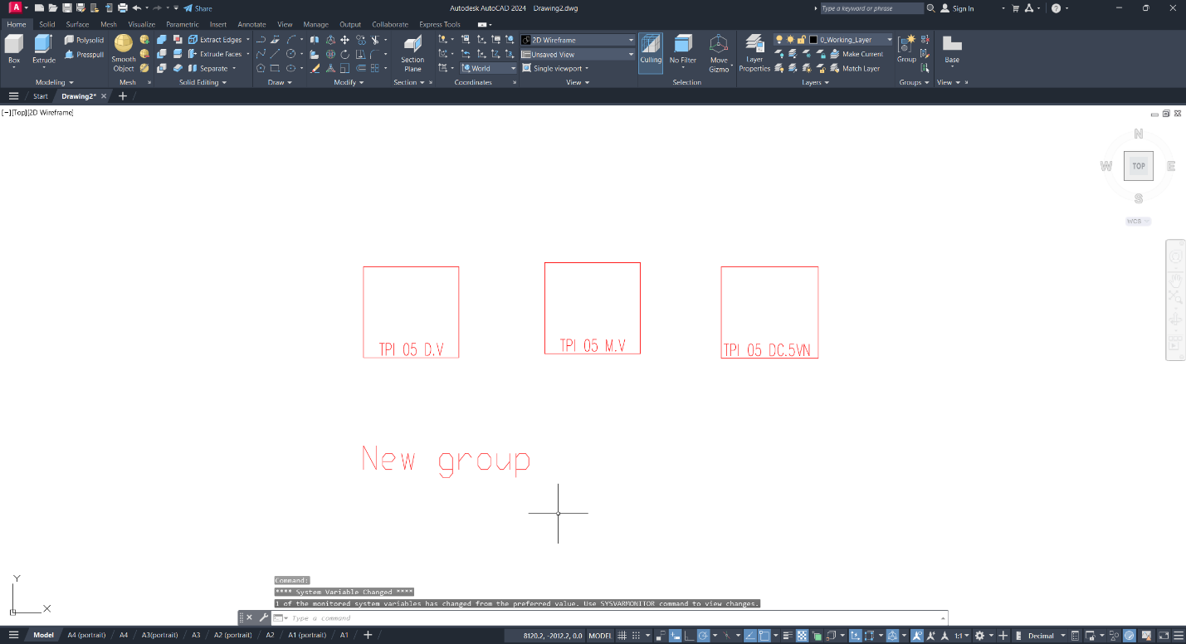
After inserting a group, a workshop is automatically created with the group name and all the equipment that is included in this group.
By default, equipment from the group is transferred to the drawing in a line.

    - To change the default equipment layout, you must arrange the equipment as desired;
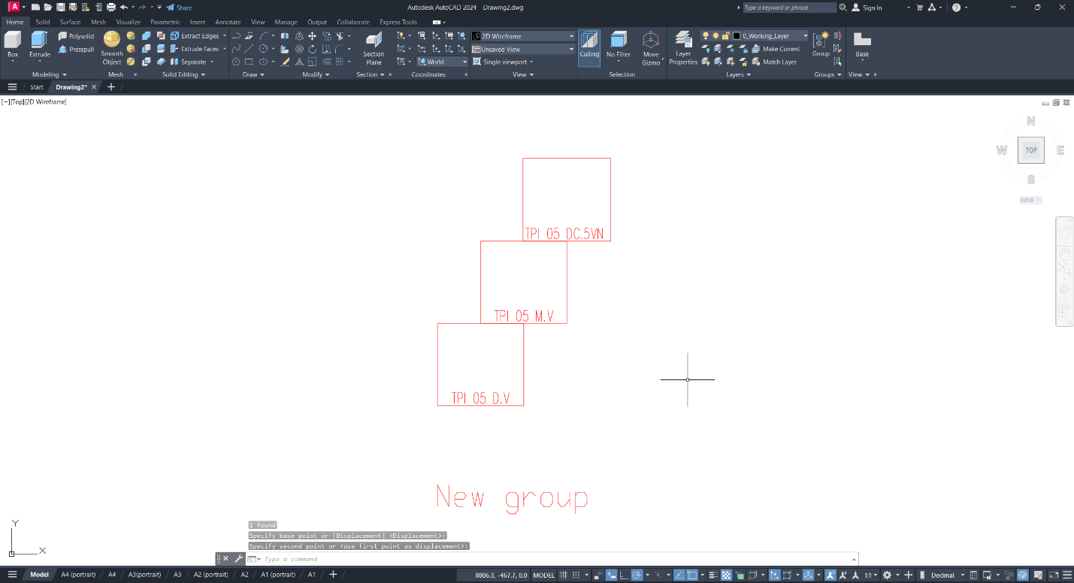

    - Then right-click on the desired group and select “Save coordinates” from the context menu;
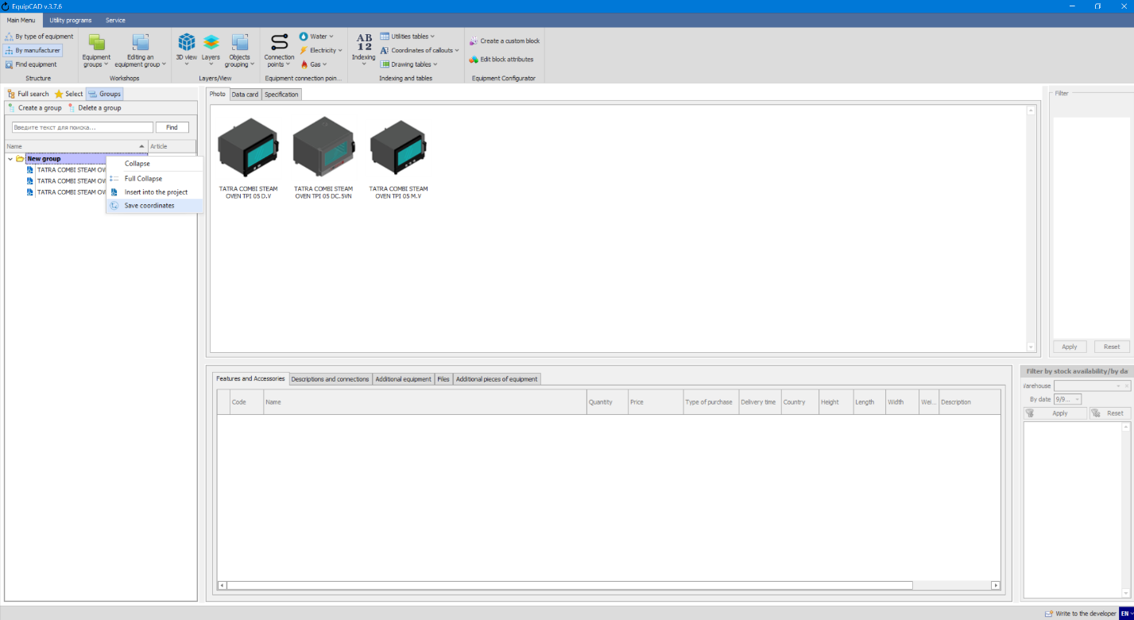
After saving the coordinates, the next time you insert a group, the equipment will line up as it was saved.
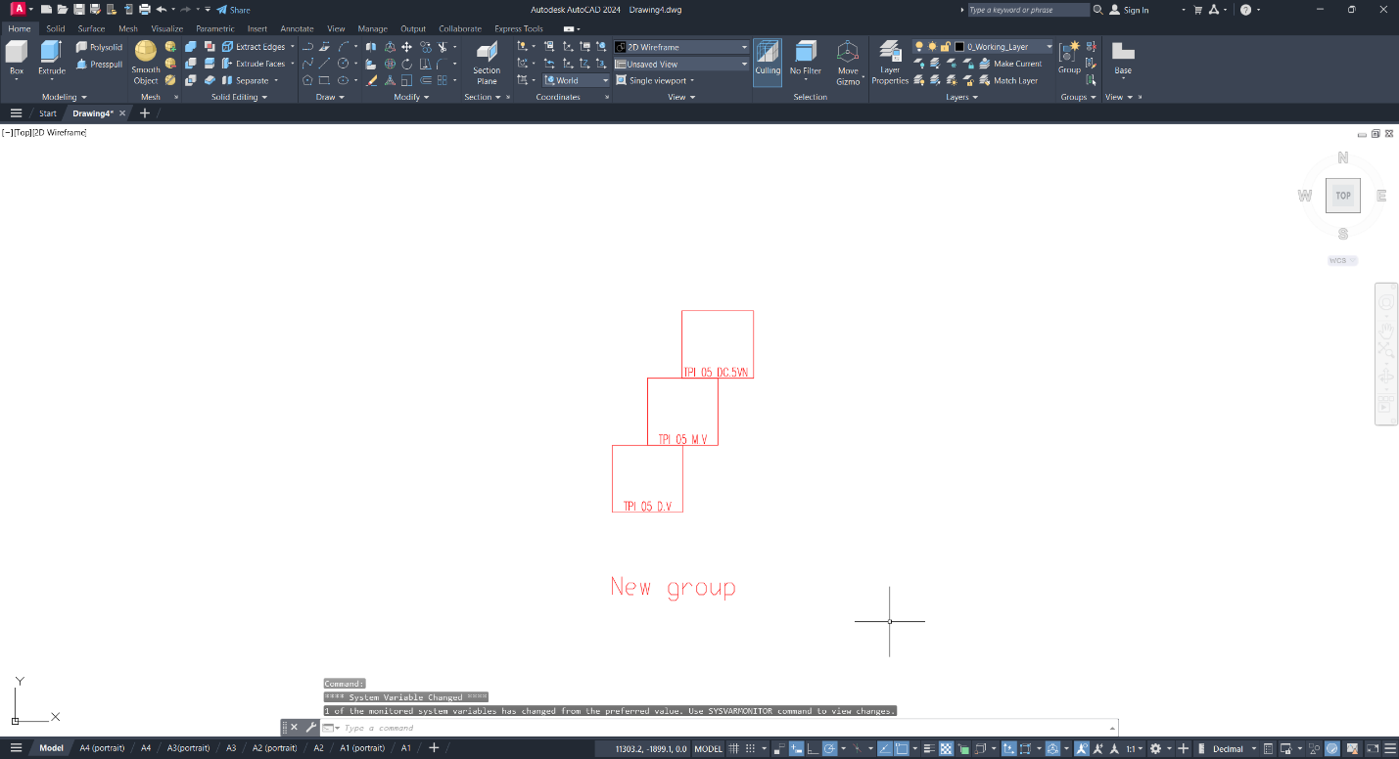

- Equipment Configurator
7.1 Creating a custom block
7.2 Editing custom block attributes

  - Creating a custom block
The custom block allows for creating and using equipment that is not available in the EquipCaD database with parameters that can be included in the specification.

    - First, insert or create an equipment outline (or an outline and a 3D model) in the AutoCAD drawing and make sure that the scale of the inserted model corresponds to that of the drawing;
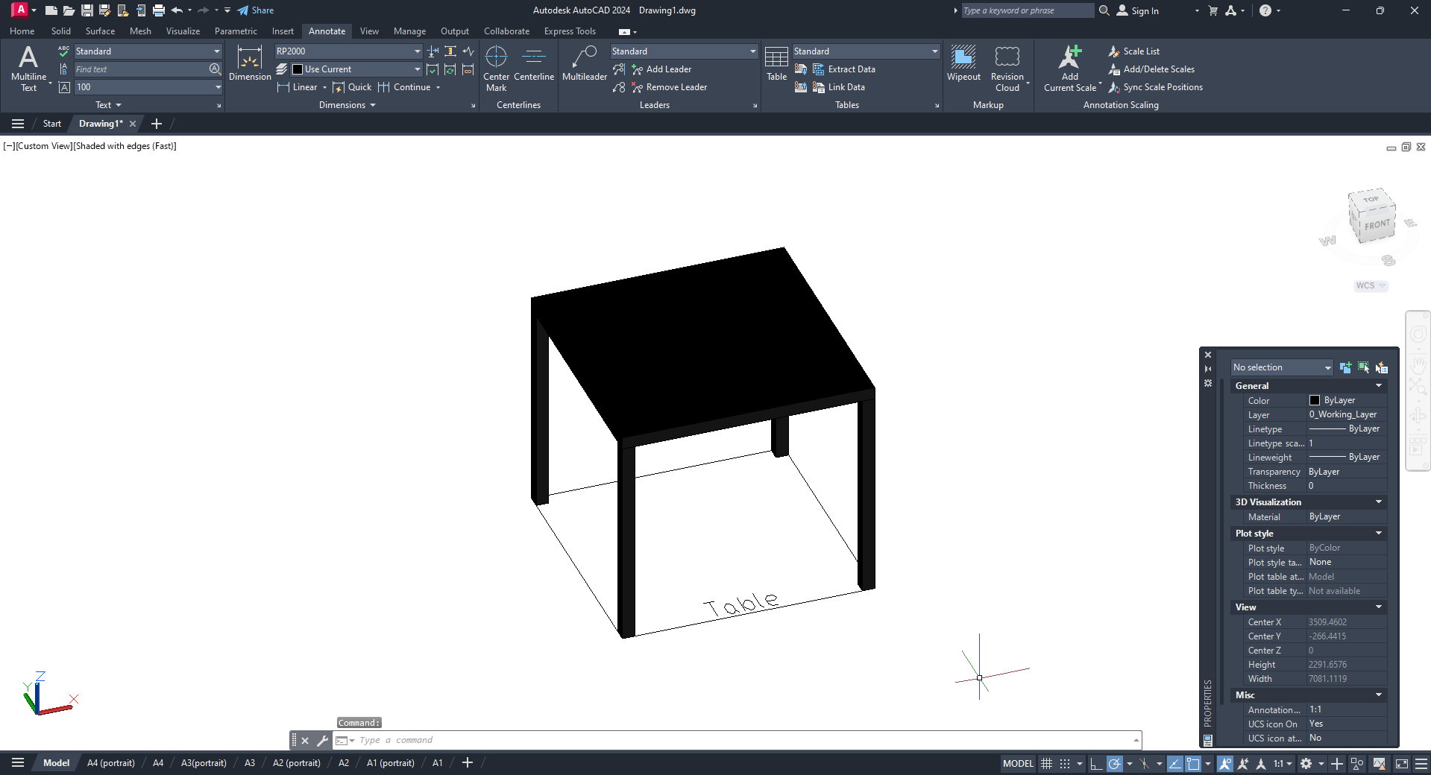

    - A prerequisite for adding a custom block is drawing a rectangular outline using a line or polyline representing the outer dimensions of the equipment item to be placed on the Plan layer. Optionally, you can also add the equipment name on the Plan layer;
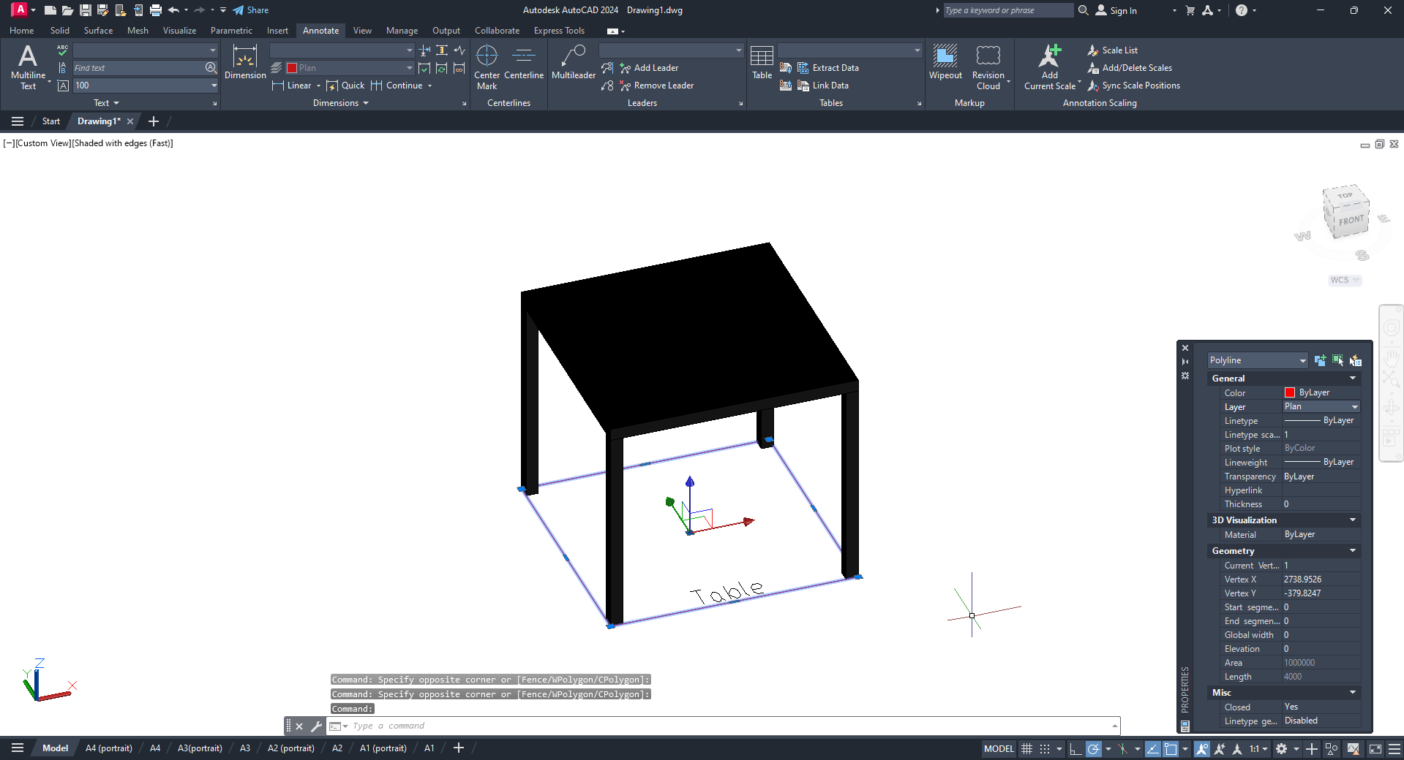
7.1.2
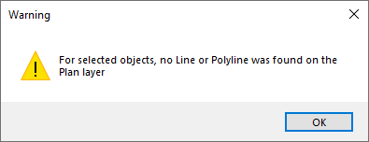
Requirements for the Plan layer: layer color: red/number 1; name: “Plan”.
Requirements for the equipment name: text color: ByLayer; text font height: 100; font style: Standard; font: txt.shx; width factor: 0.65; element type: Text. Multiline text: Not allowed.
If a 3D model is available, it should be placed on the 3D layer. Requirements for the 3D layer: layer color: number 8; layer name: “3d”.

    - To add your own custom block to a project, click the “Create a custom block” button in the Equipment Configurator menu, select the equipment outline on the Plan layer (and the 3D model, if any), and press the right mouse button or Enter/Space key.
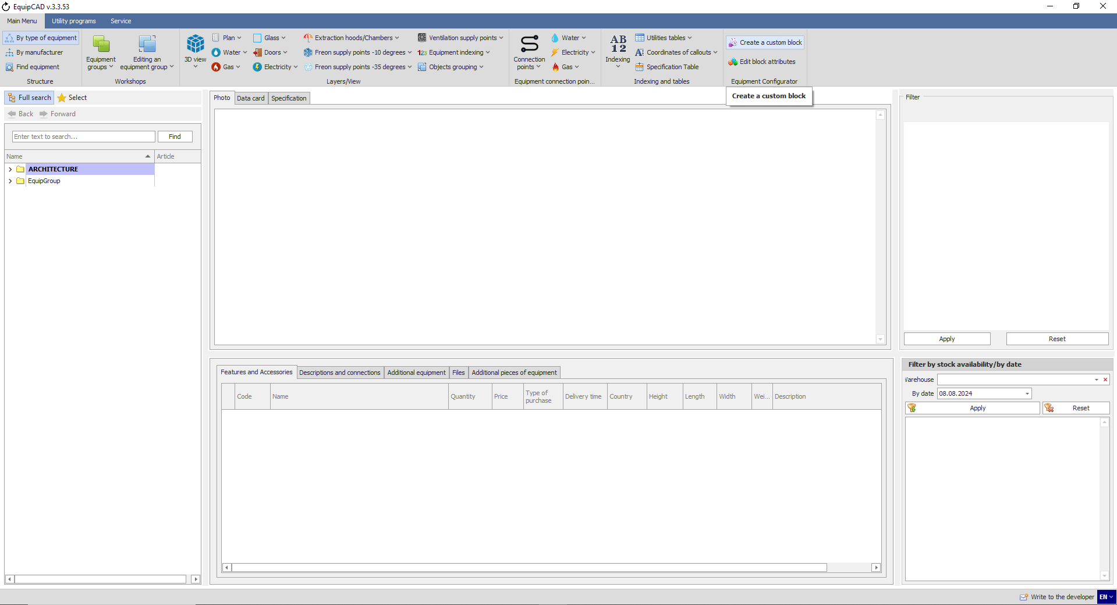
7.1.3
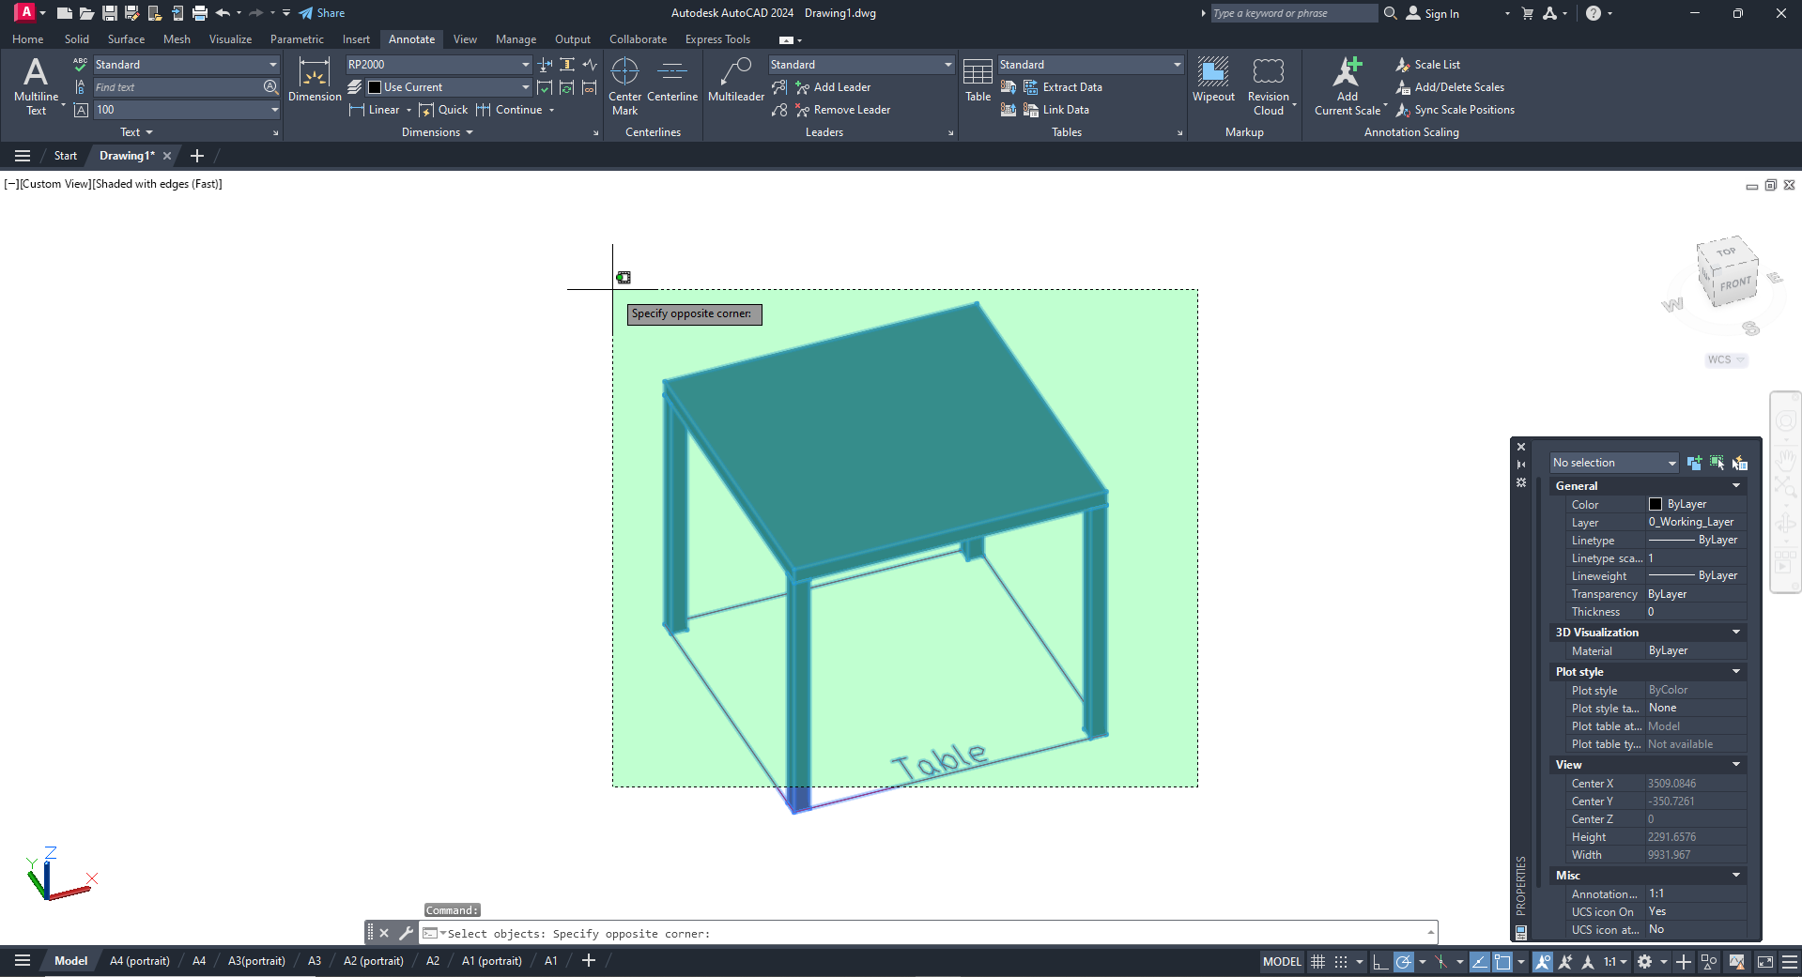

    - In the window that opens, enter the block attributes and click the Save button. The name is the only mandatory attribute, but it is recommended to enter all the attributes in order to get a correct description in the specification.
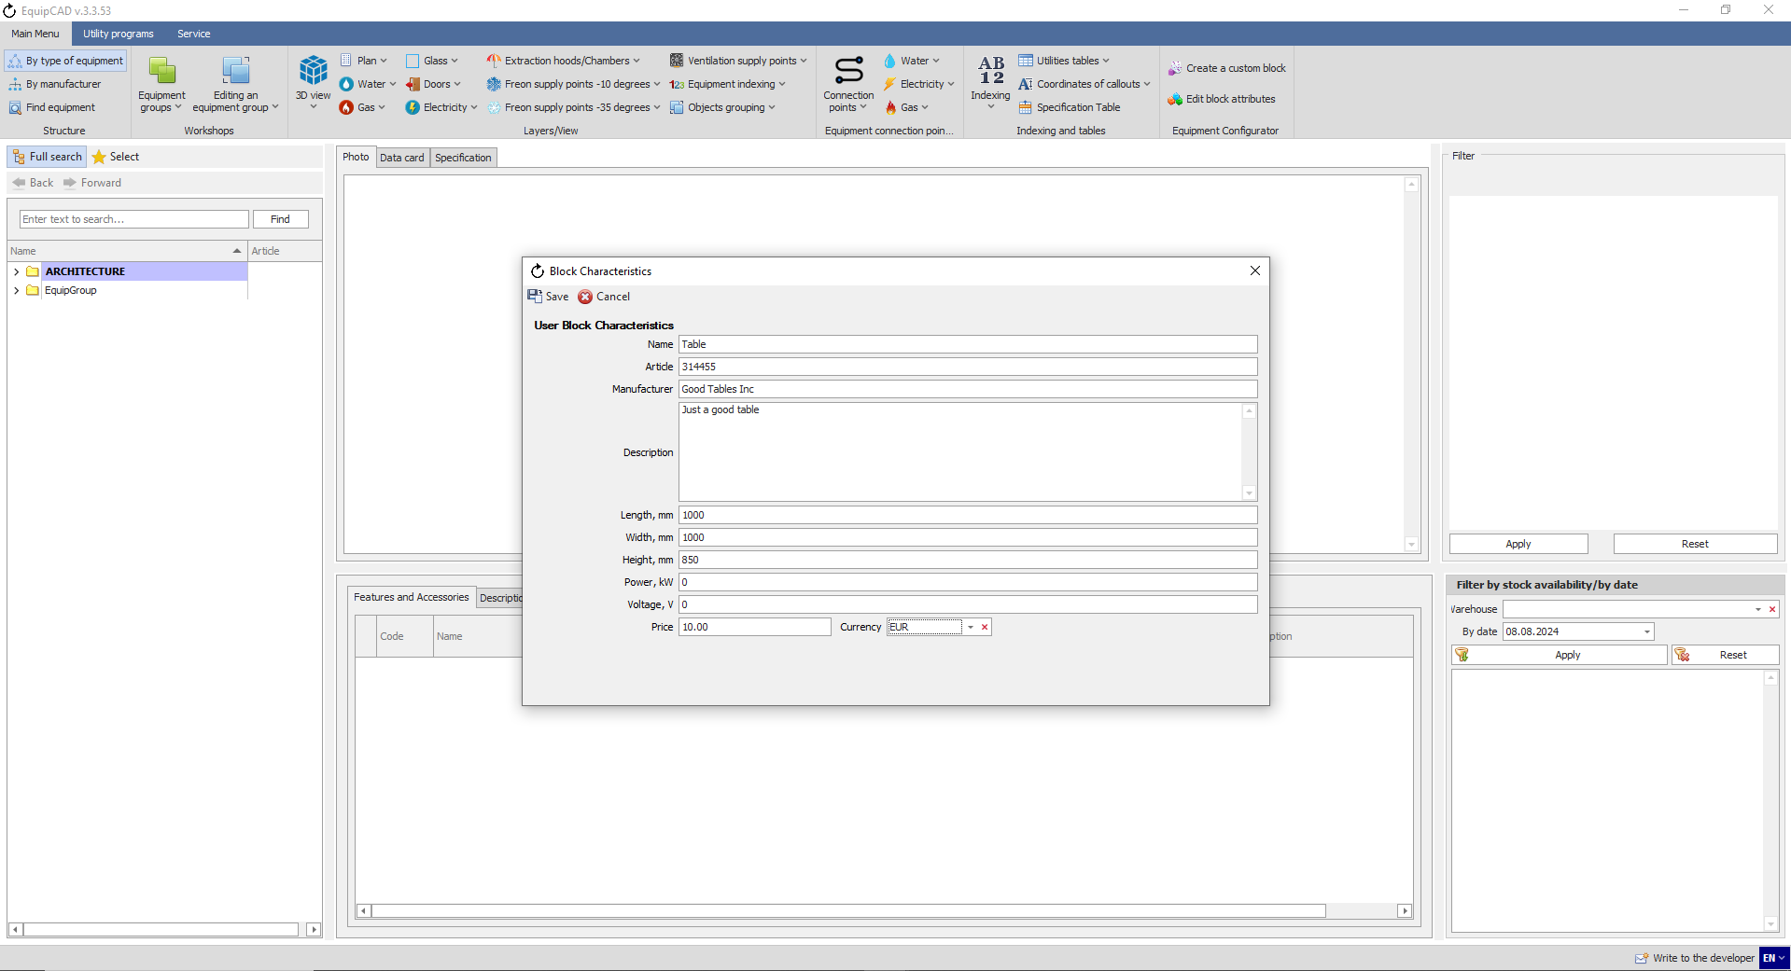
Recommended
Required
Once the attributes of the block are saved, it can be saved in a separate drawing or used in other projects.

  - Editing custom block attributes

    - To editing attributes of your own custom block in the project, click the “Edit block attributes” button in the Equipment Configurator menu, select the block, and press the right mouse button or Enter/Space key.
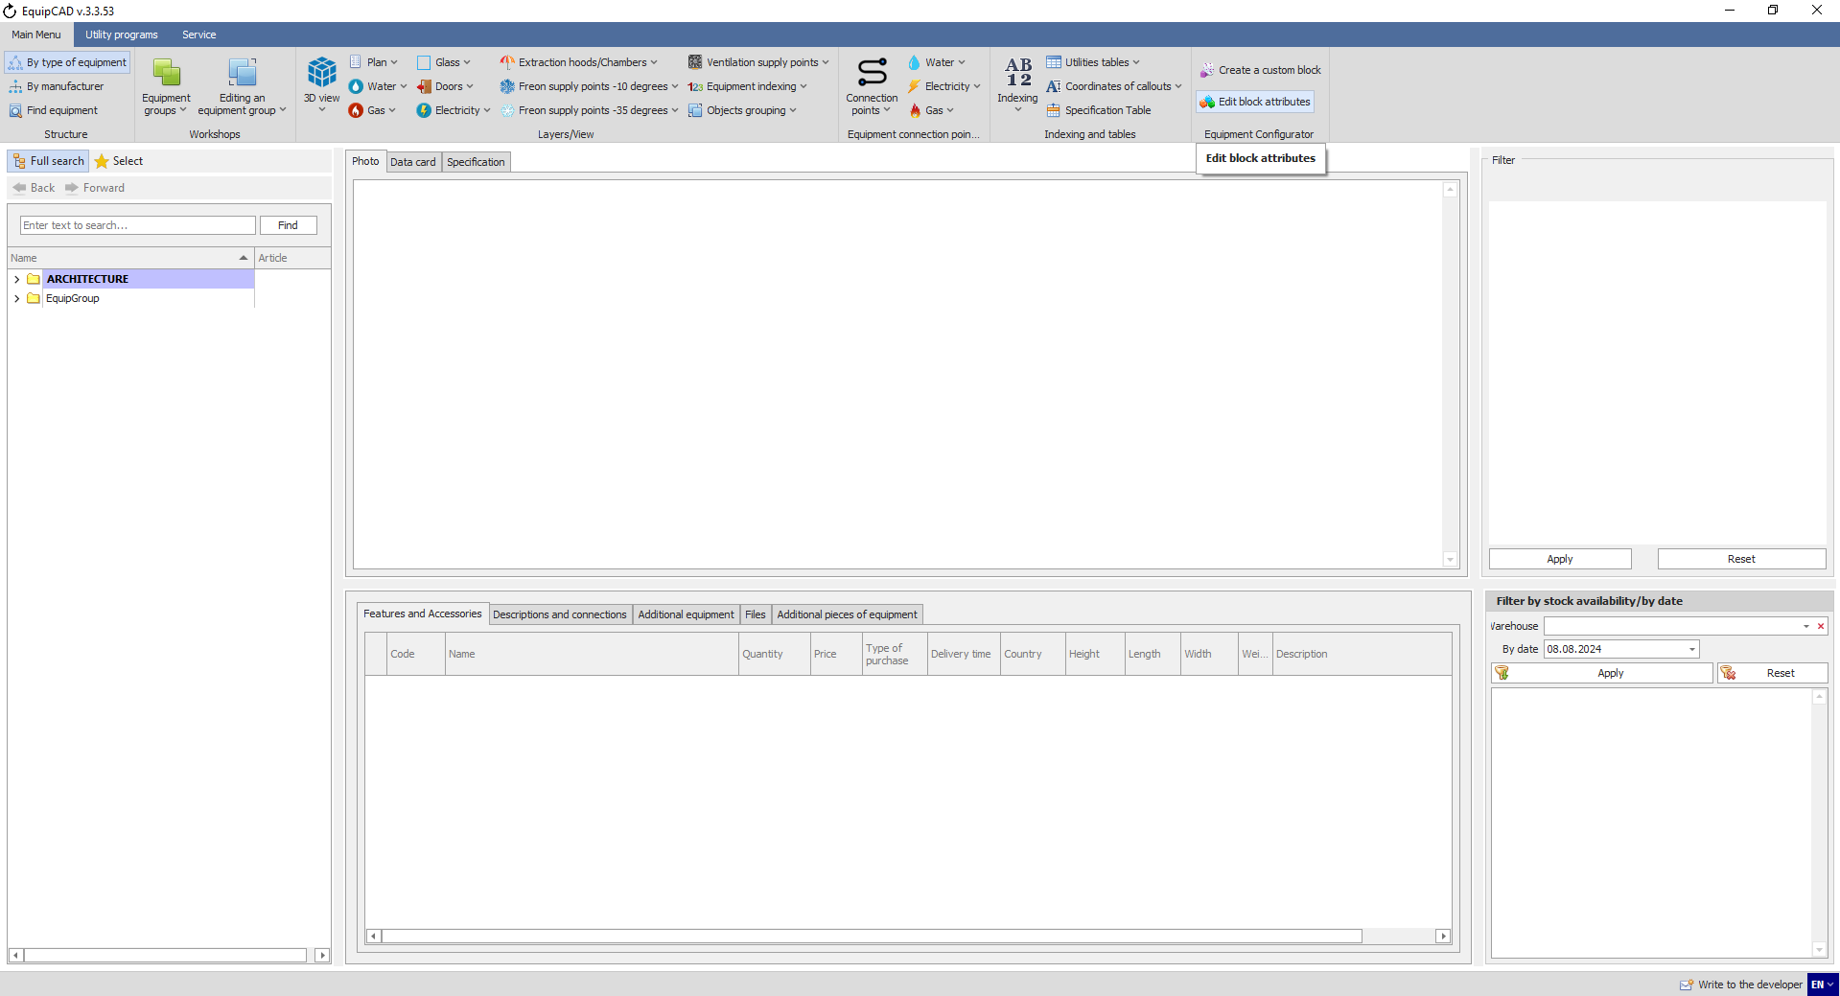
7.2.1
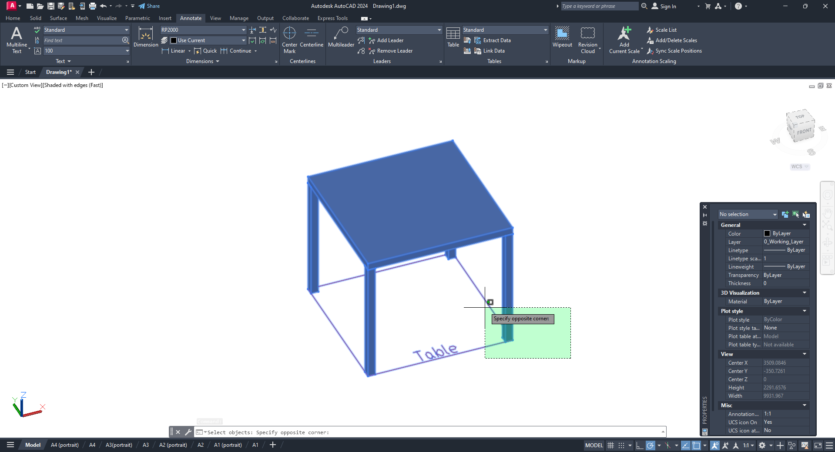

    - The block attributes window will open. Change the price and click the Save button;
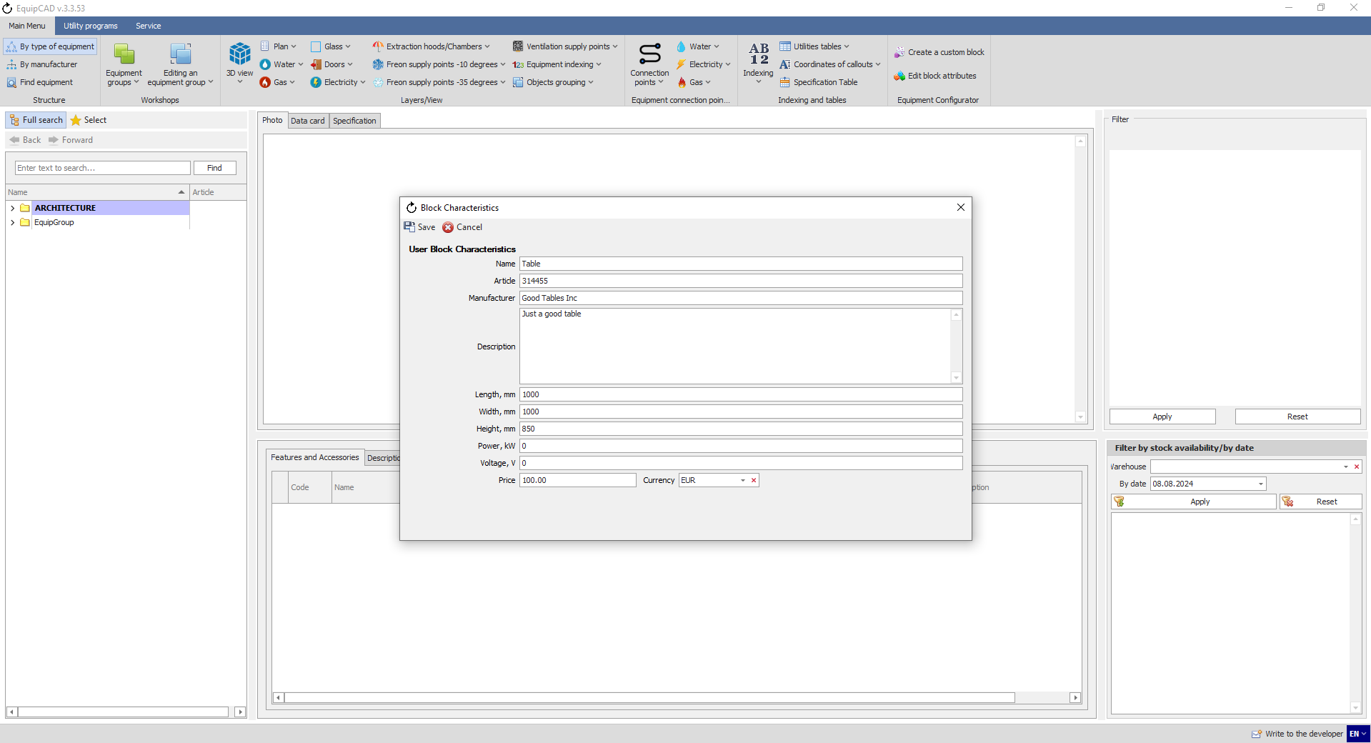

- Workshops
8.1 Creating and deleting workshop names in the program settings
8.2 Creating and deleting workshops in the program menu
8.3 Creating workshops in a project
8.4 Deleting workshops in a project
8.5 Selecting a workshop in a project
8.6 Selecting equipment without a group
8.7 Adding equipment to a workshop
8.8 Deleting equipment from a workshop

  - Creating and deleting workshop names in the program settings
In the program settings, you can pre-define names of workshops to be used later.
    - To generate the names of the workshops used, go to the Service tab;
    - Then click the Program Settings button;
    - In the window that opens, go to the “Equipment groups” tab;
    - To create a new name for a workshop, click the “Add a group” button;
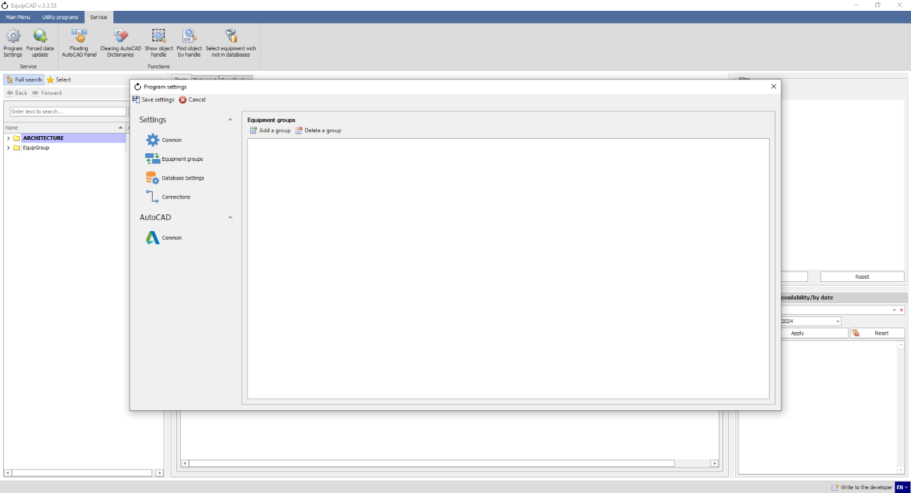
8.1.2
8.1.1
8.1.4
8.1.3

    - In the window that opens, enter the workshop name and click the OK and Save buttons;
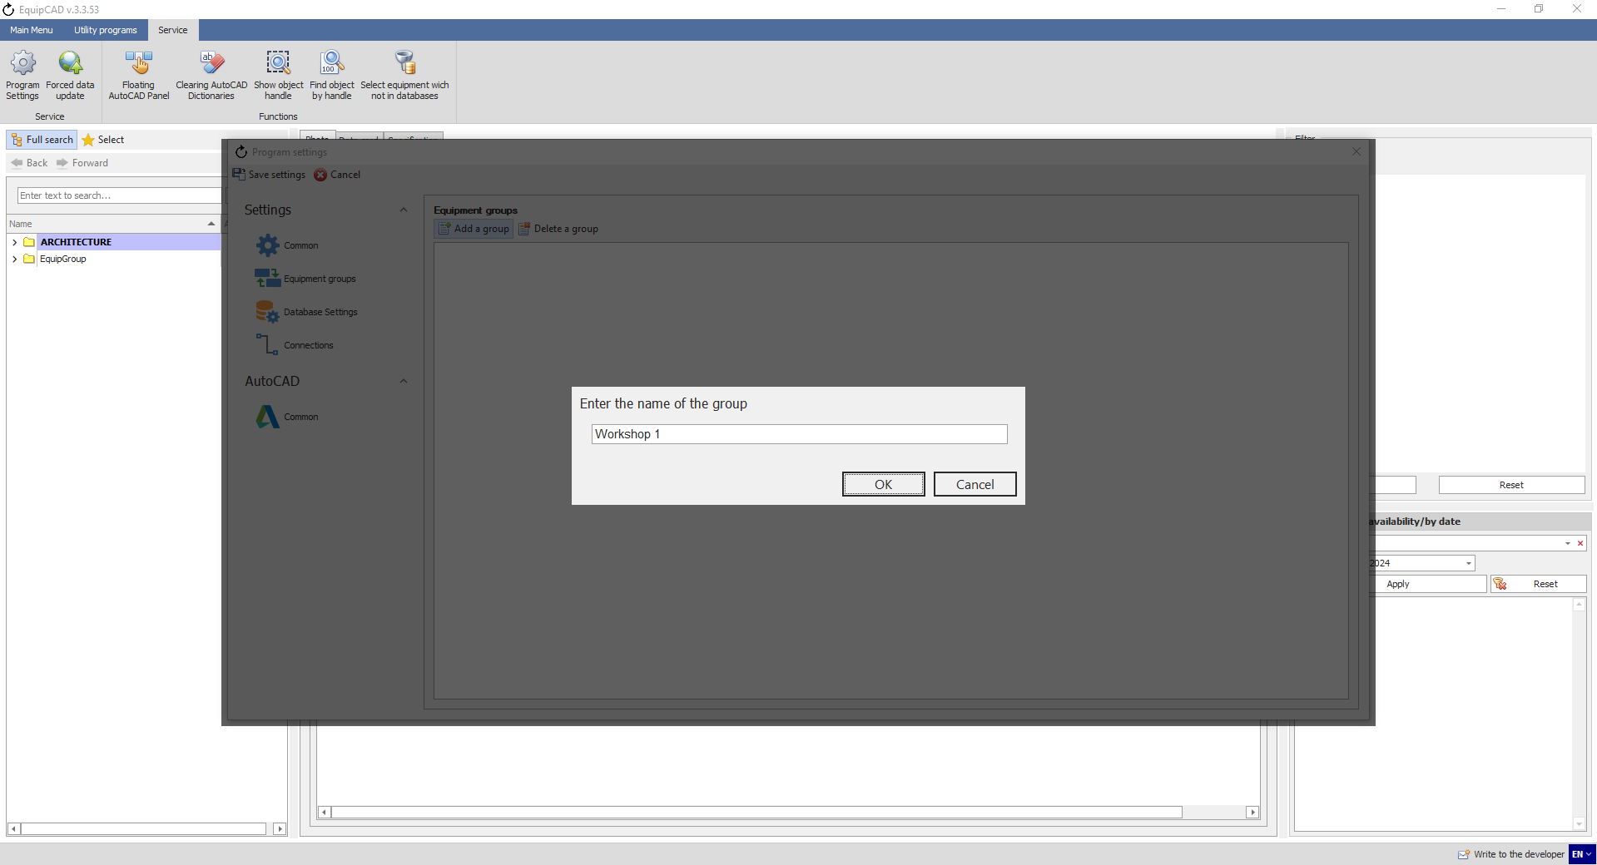
8.1.5
Let’s create a few workshop names.

    - To delete a workshop name, select it by left-clicking, click the “Delete a group” button and confirm the deletion;
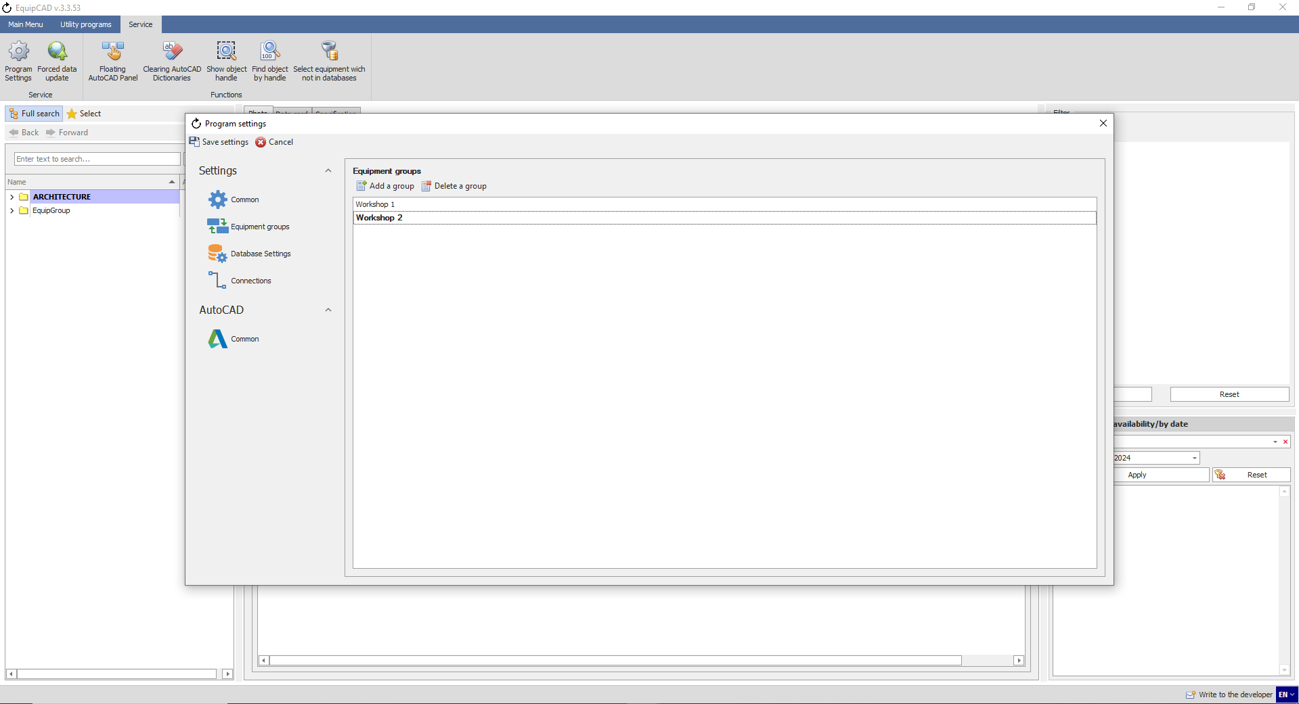
8.1.6
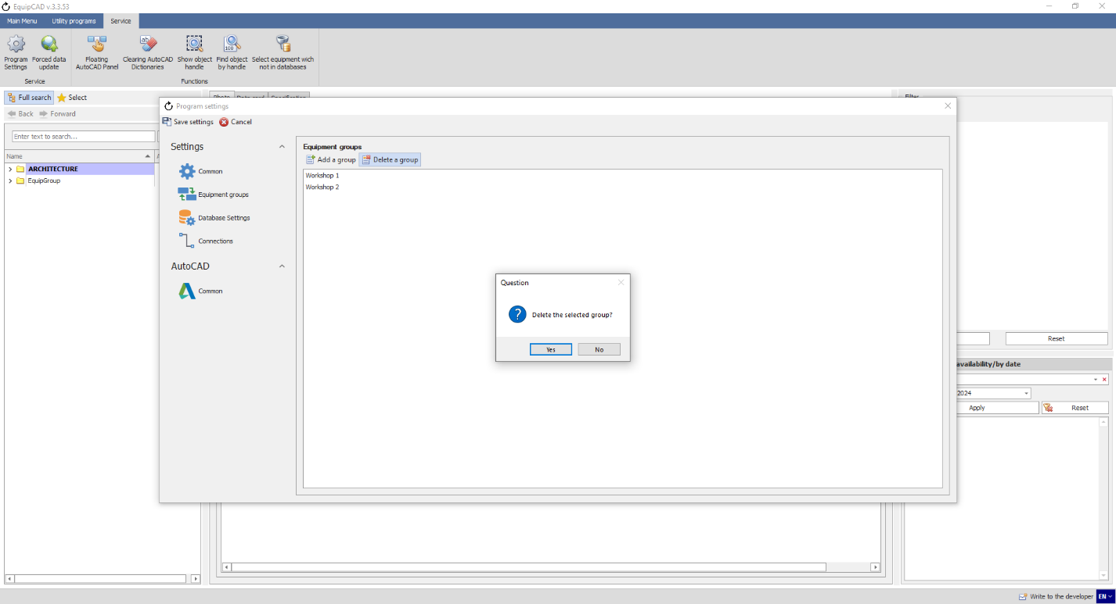
This allows you to delete the workshop name from the program.

  - Creating and deleting workshops in the program menu
In the program menu, you can both create and delete workshop names and create workshops in a project.
    - To generate names for the workshops used in your project, click the “Equipment groups” button in the Workshops menu;
    - Select “Create an equipment group” in the drop-down menu;
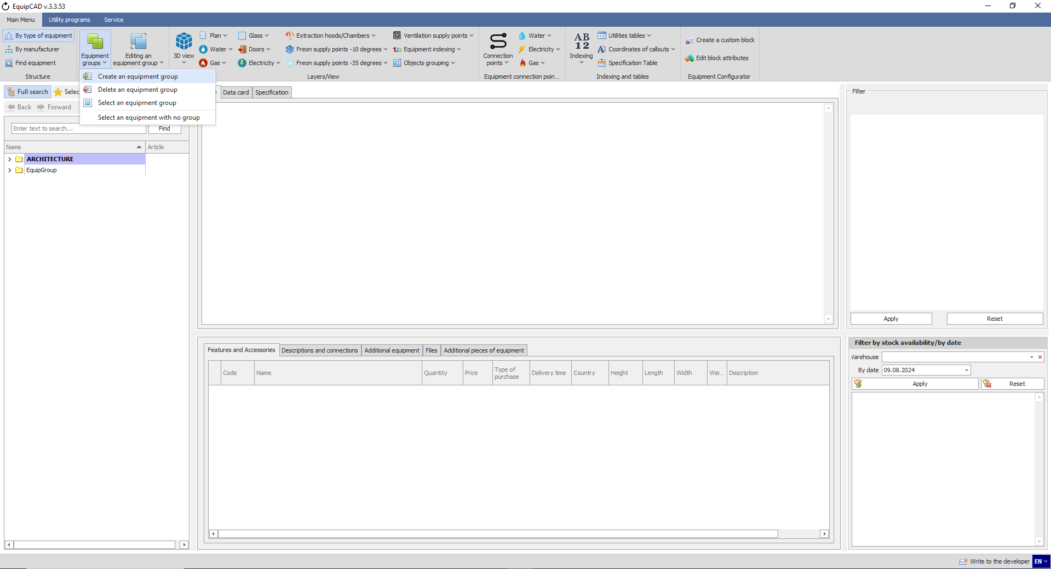
8.2.2
8.2.1

    - In the window that opens, click the “Add a group” button;
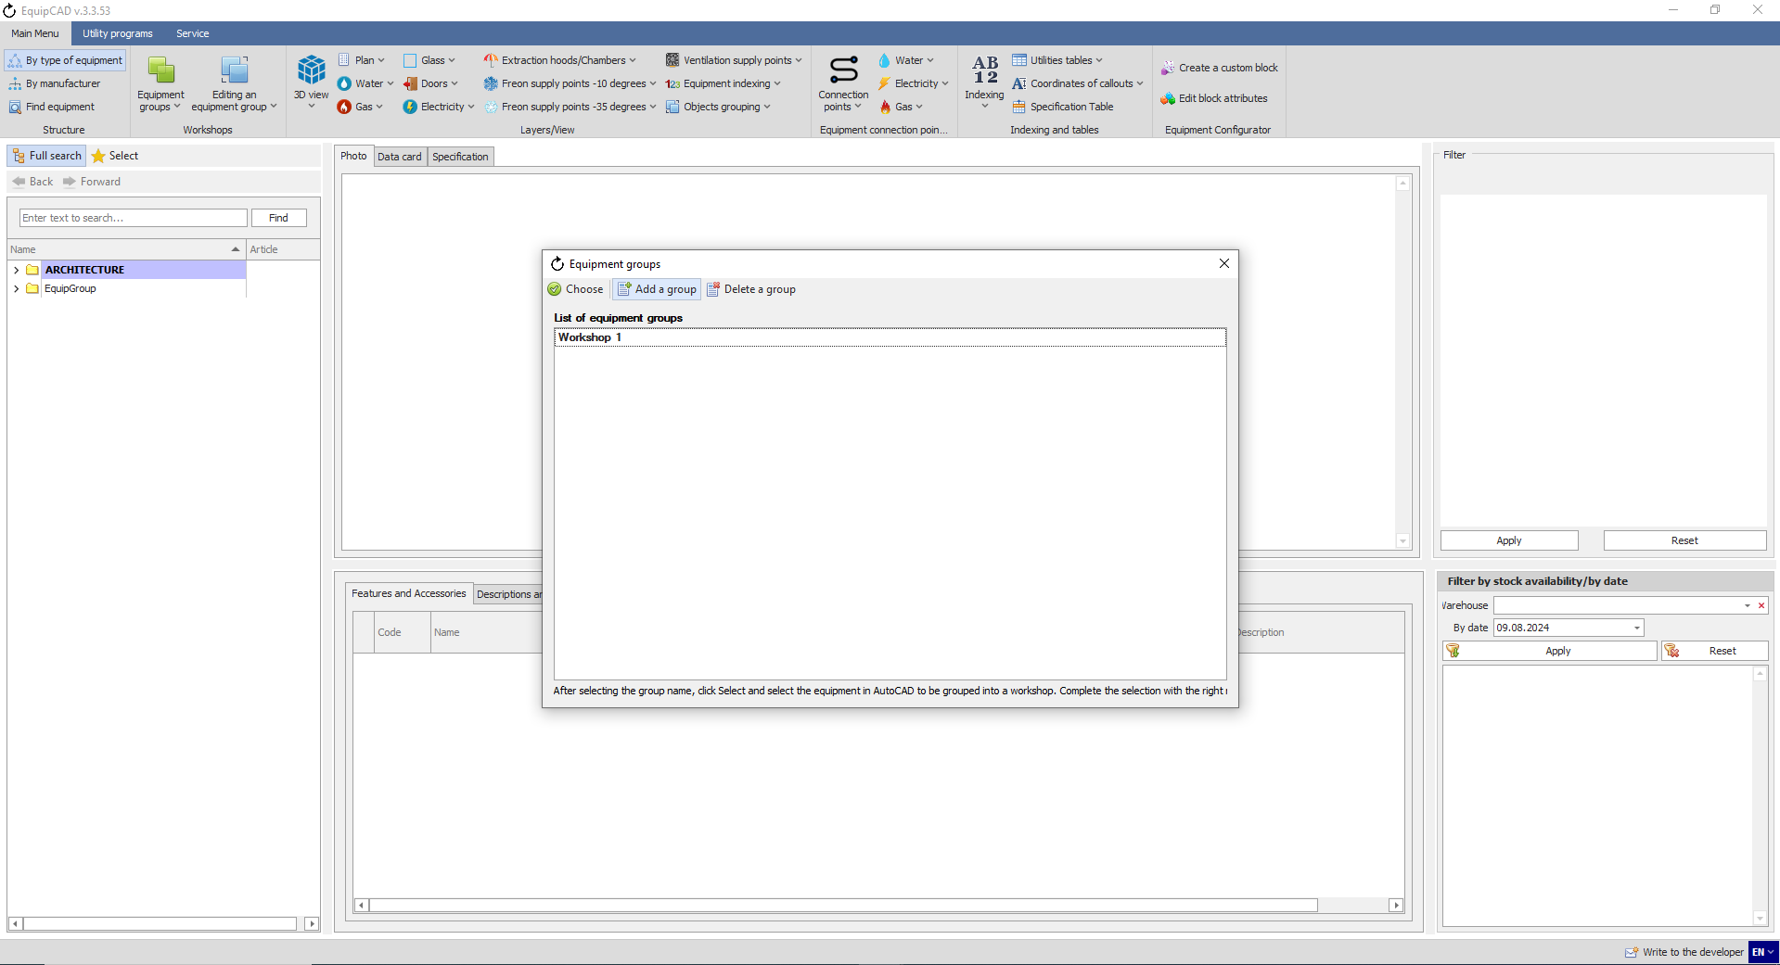
8.2.3

    - In the field that opens, enter the workshop name and click the OK button;
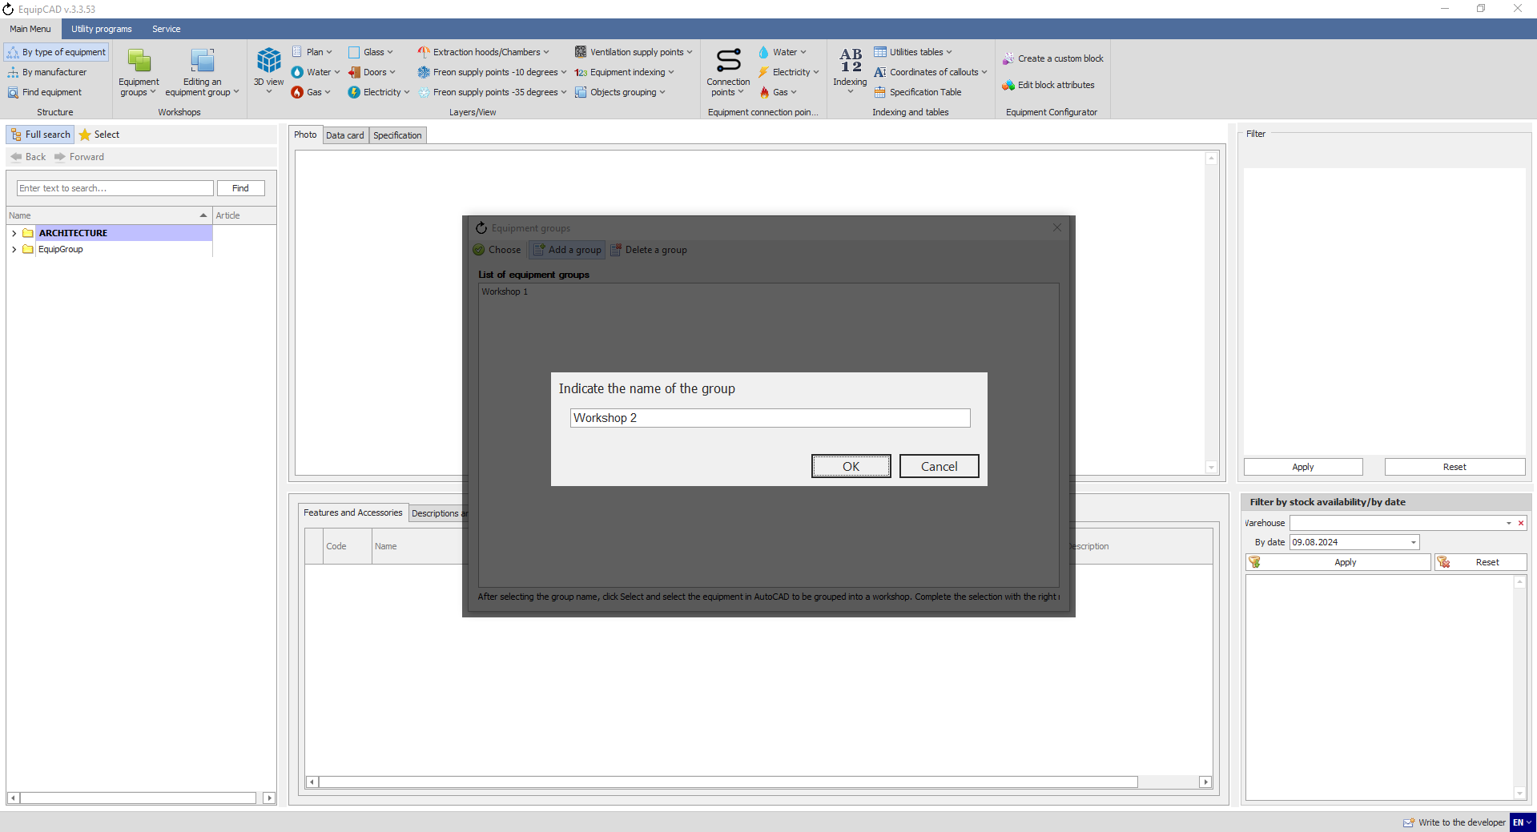
8.2.4
For example, let’s create a few workshop names.

    - To delete a workshop name from the program, select it by left-clicking, click the “Delete a group” button and confirm the deletion;
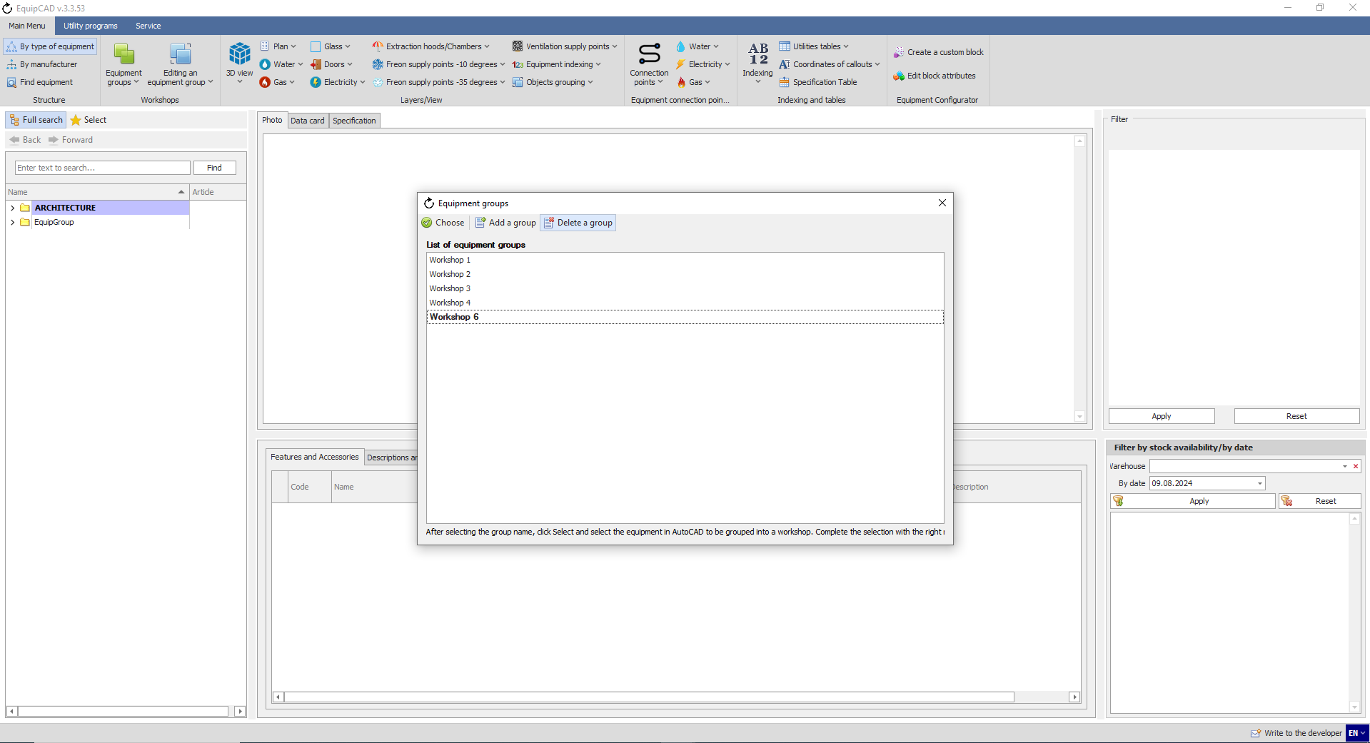
8.2.5
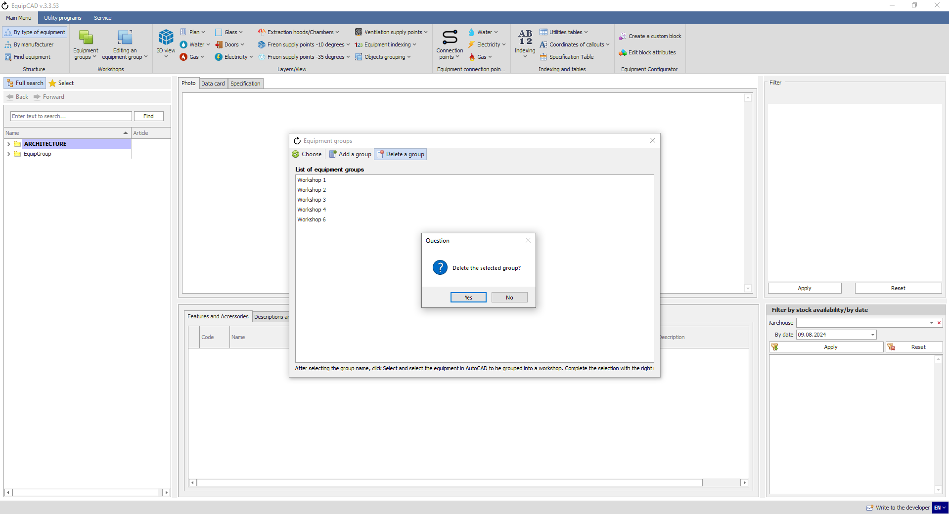

  - Creating workshops in a project
To create workshops, you should first place equipment on the drawing.
    - To create a workshop in a project, click the “Equipment groups” button in the Workshops menu;
    - Select “Create an equipment group” in the drop-down menu;
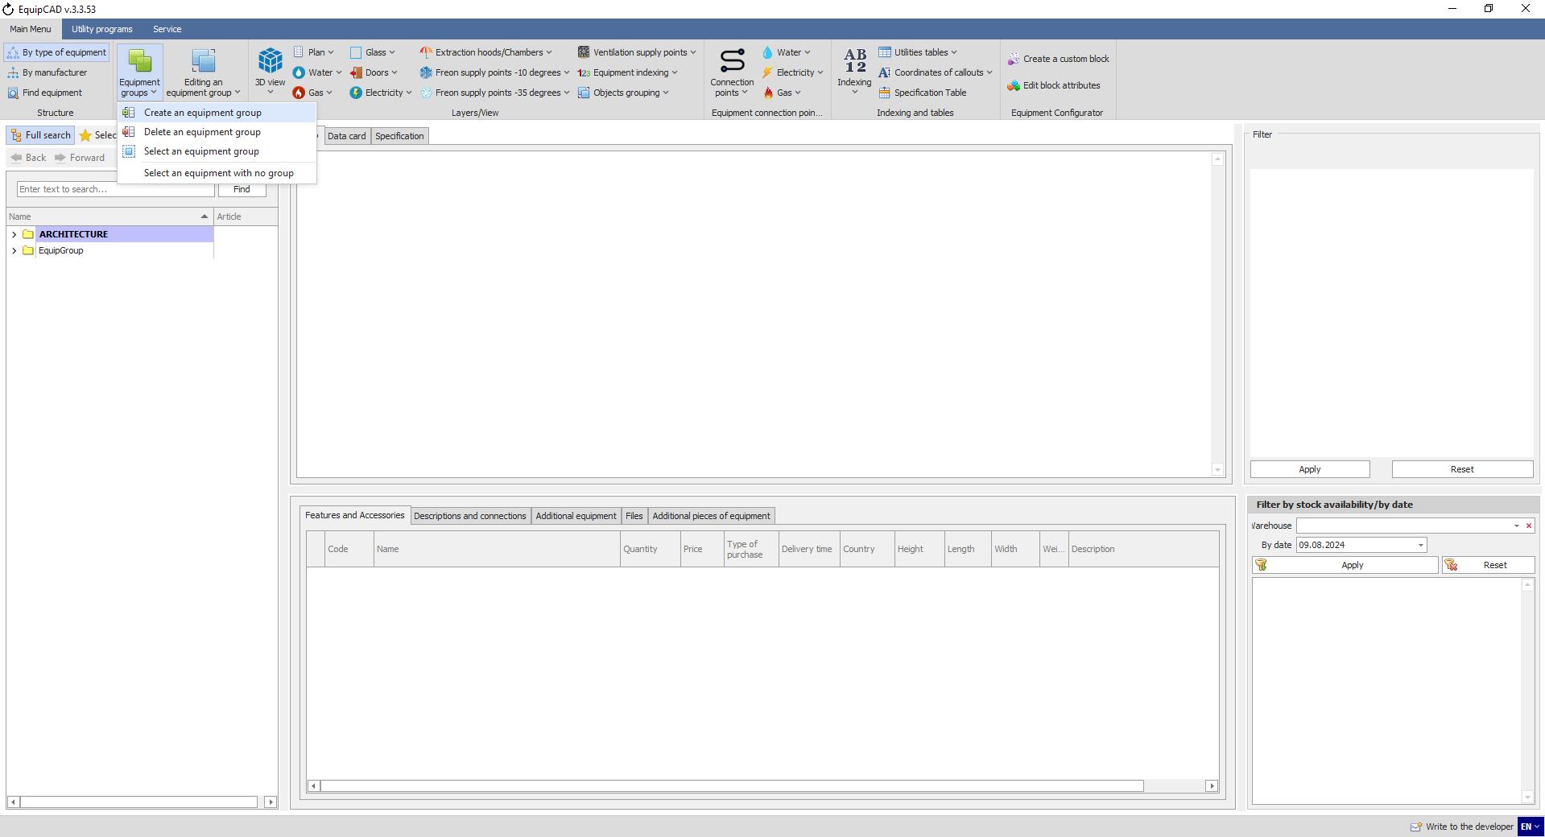
8.3.2
8.3.1

    - In the window that opens, select the required workshop name and click the Select button;
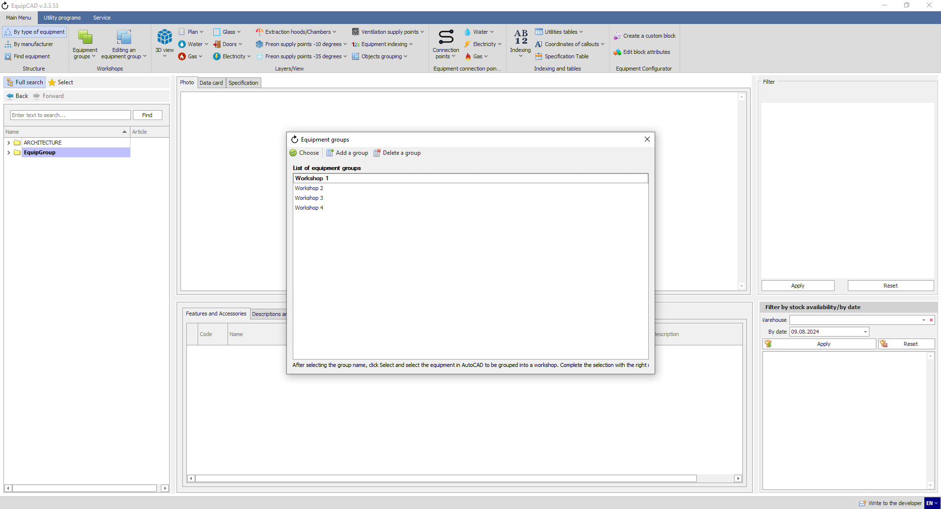
8.3.3

    - When the program has automatically switched to AutoCAD, select the equipment to be placed in the workshop by highlighting it, confirm your choice by pressing the right mouse button or Enter/Space key, and then place the name of the workshop;
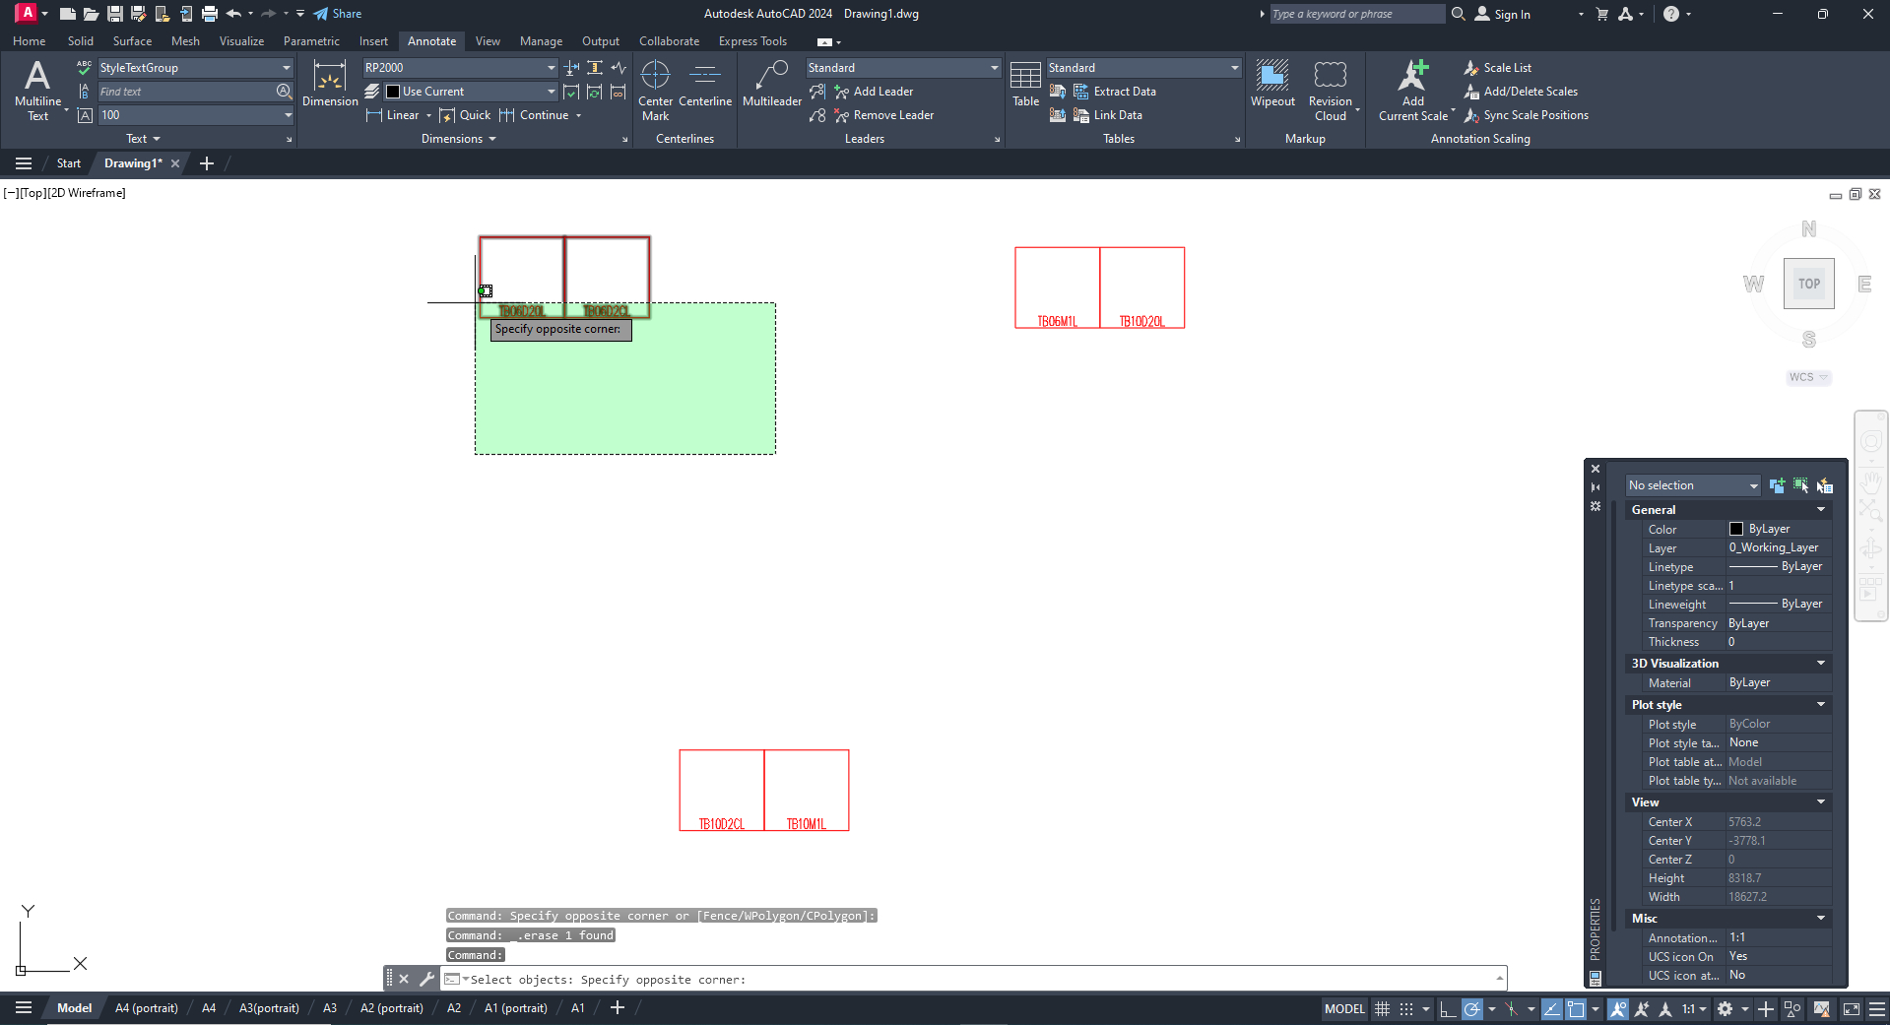
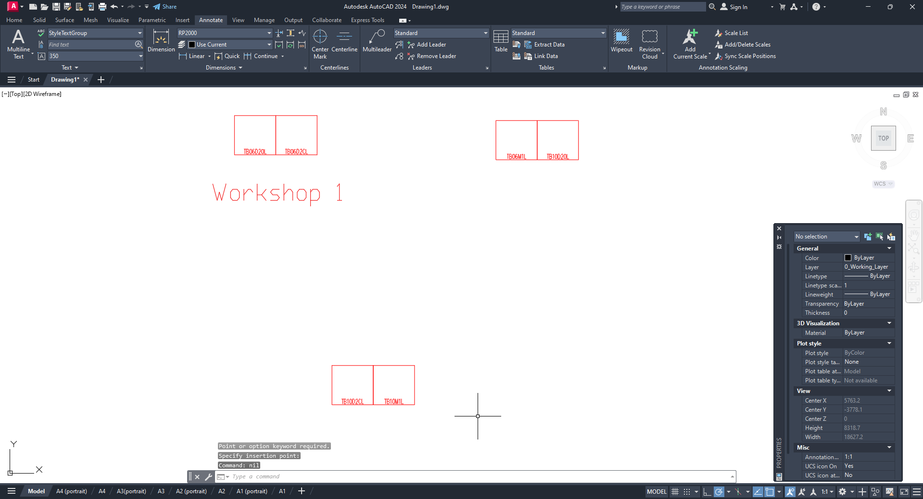
Let’s create three workshops.

The text size and color of the workshop name can be defined in the settings.
    - To do this, go to the Service tab;
    - Then select the Program Settings menu;
    - Go to the “Common settings for AutoCAD” tab;
    - Choose “Font height for workshop affixation”;
    - Choose “Font color for workshop affixation”;
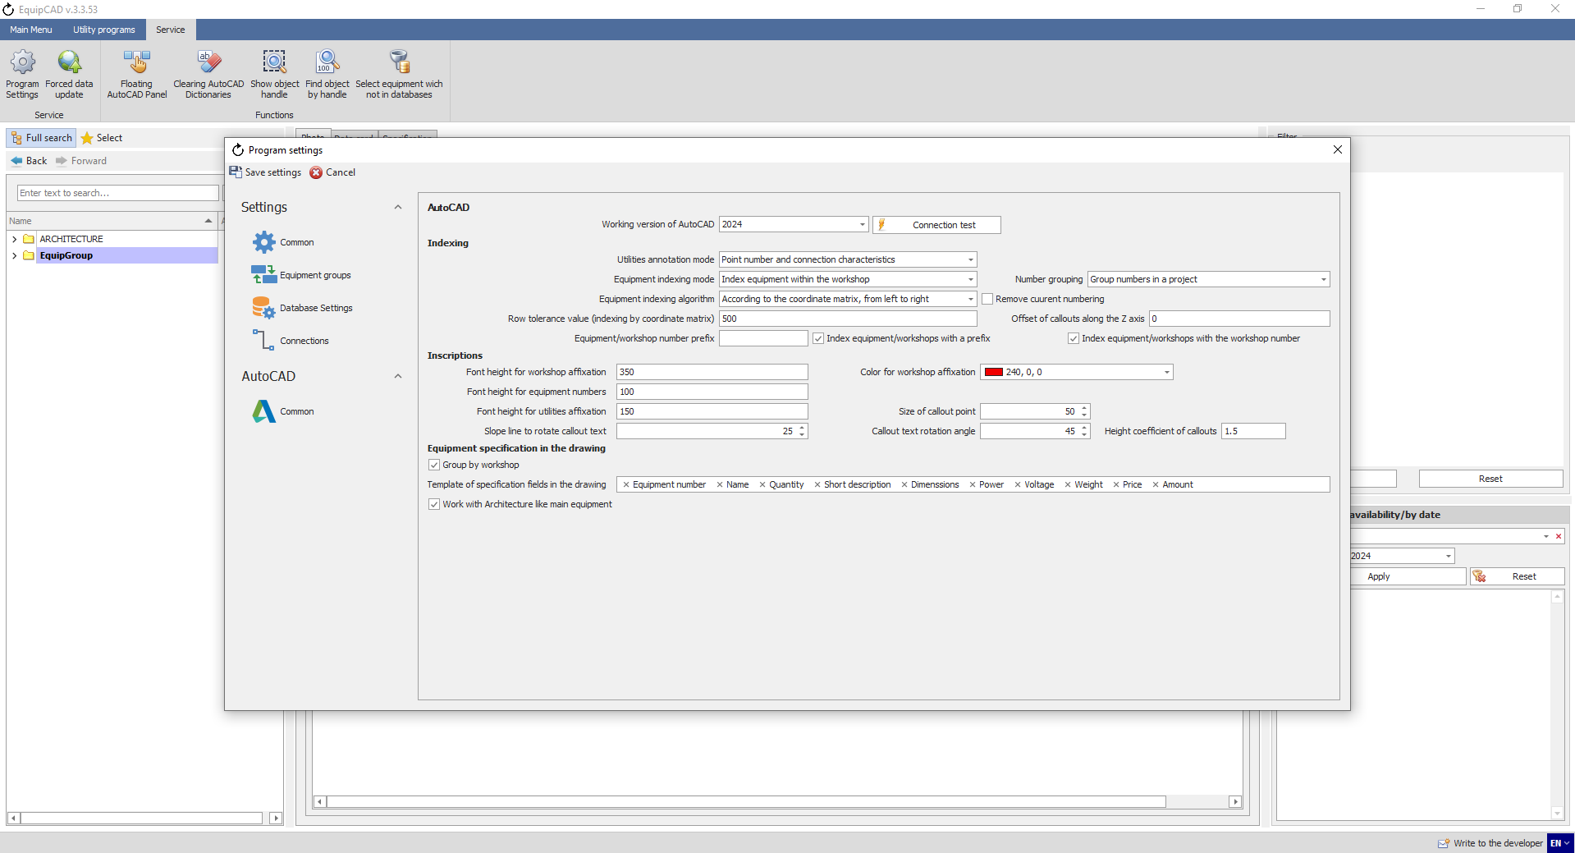
8.3.8
8.3.6
8.3.7
8.3.9
8.3.5

  - Deleting workshops in a project
This method is designed to delete one or more workshops from a particular project. The methods described in steps 8.1.6 to 8.2.5 are intended for deleting workshop names from EquipCaD.
    - To delete one or more workshops from a project, click the “Equipment groups” button in the Workshops menu;
    - Select “Delete an equipment group” in the drop-down menu;
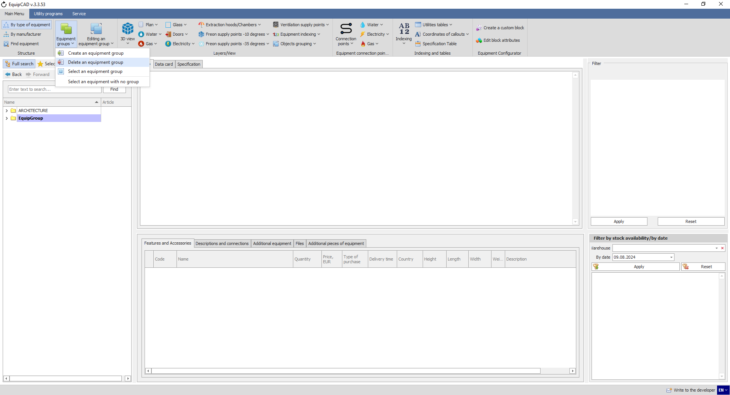
8.4.2
8.4.1

    - In the window that opens, select the desired workshop(s) and click the Select button;
    - You can also calculate the quantity of equipment available in each workshop;
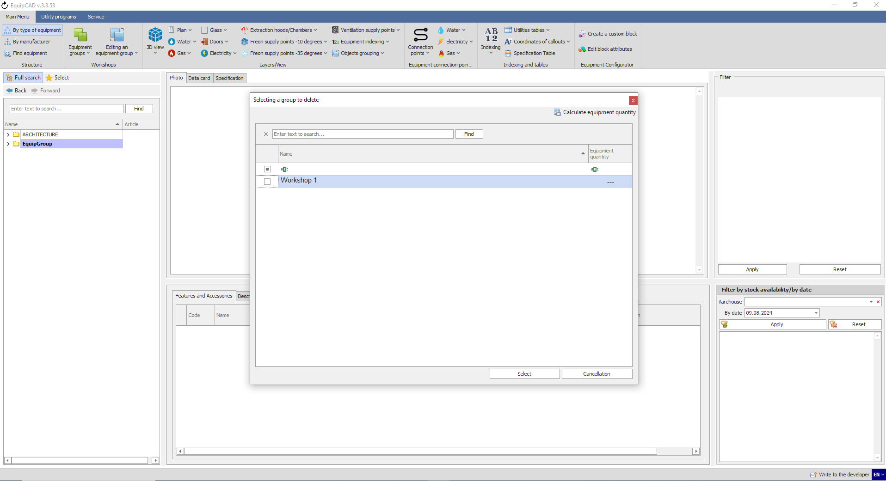
8.4.4
8.4.3
The window only displays the workshops created in the project.
This window has a search tool that will help you to find a workshop you need;
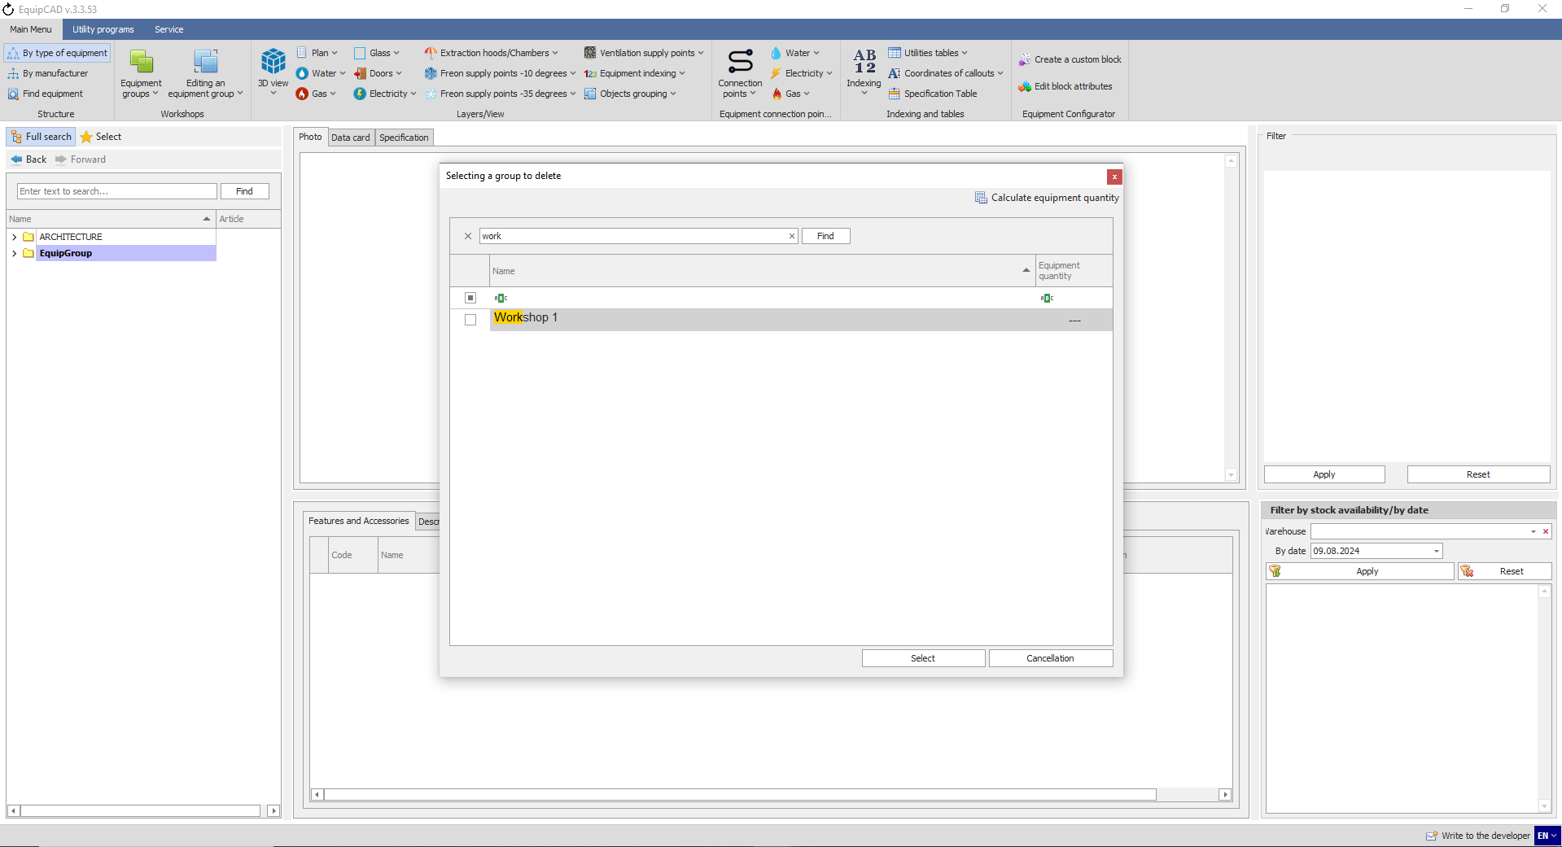
Note: Deleting workshops in a project is equivalent to deleting an equipment group in the program; when a workshop is deleted, the equipment available in it is not deleted. In a project, workshop names should be deleted separately.

  - Selecting a workshop in a project

    - To select a workshop in a project, click the “Equipment groups” button in the Workshops menu;
    - Choose “Select an equipment group” in the drop-down menu;
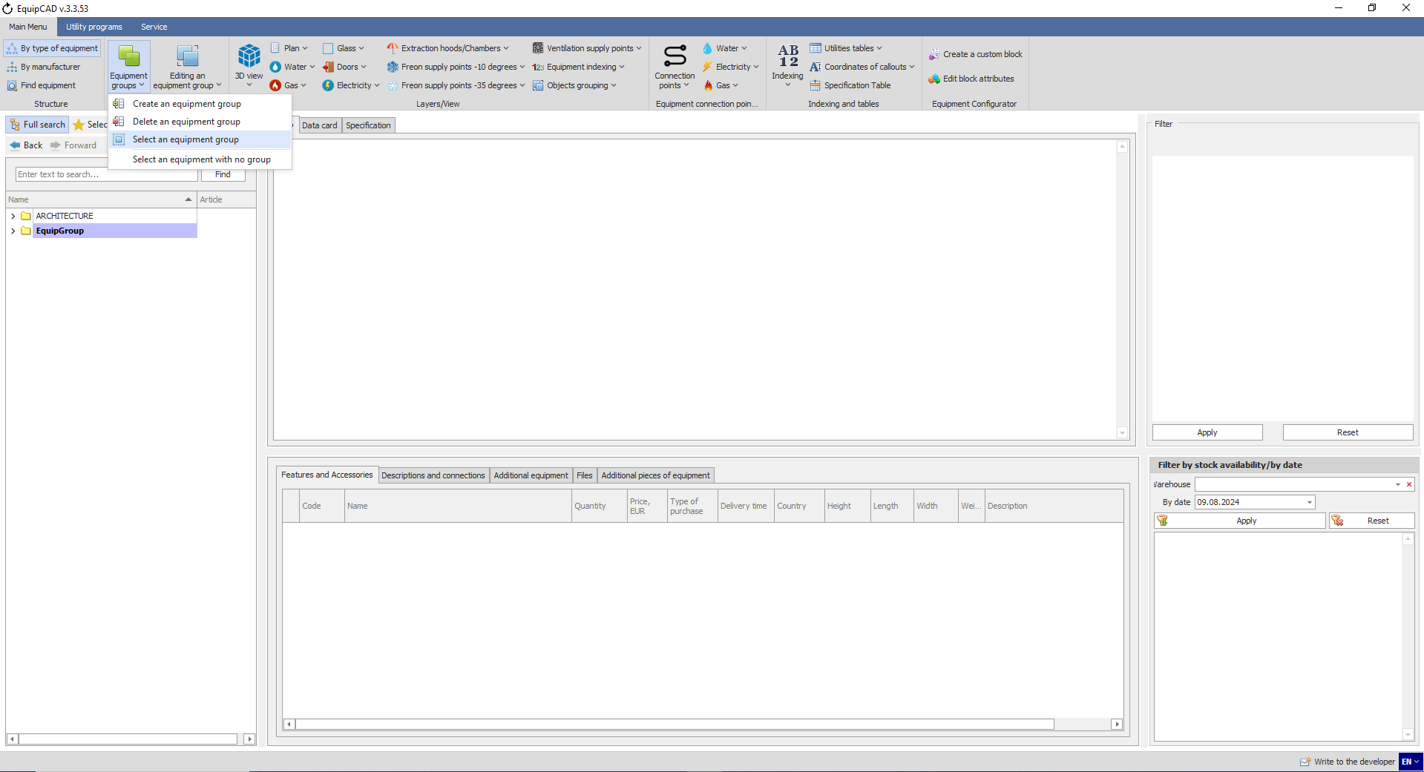
8.5.1
8.5.2

    - In the window that opens, choose the desired workshop and click the Select button;
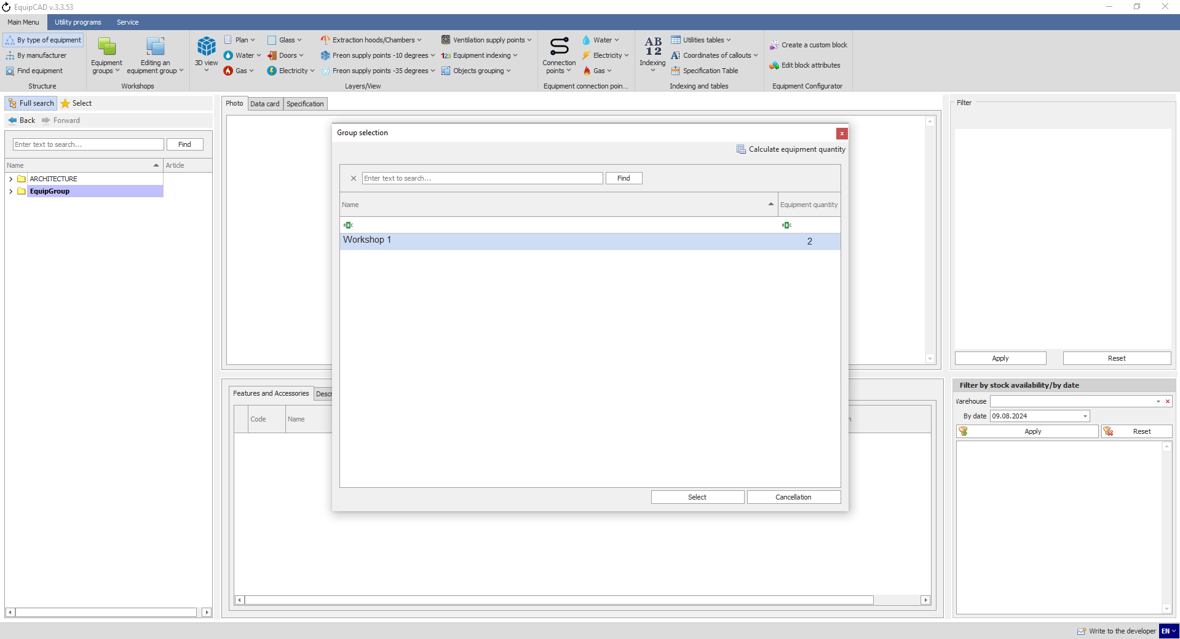
8.5.3
The program will switch to AutoCAD and select the chosen workshop.
Here, you will also find a search tool as in the workshop deletion window.
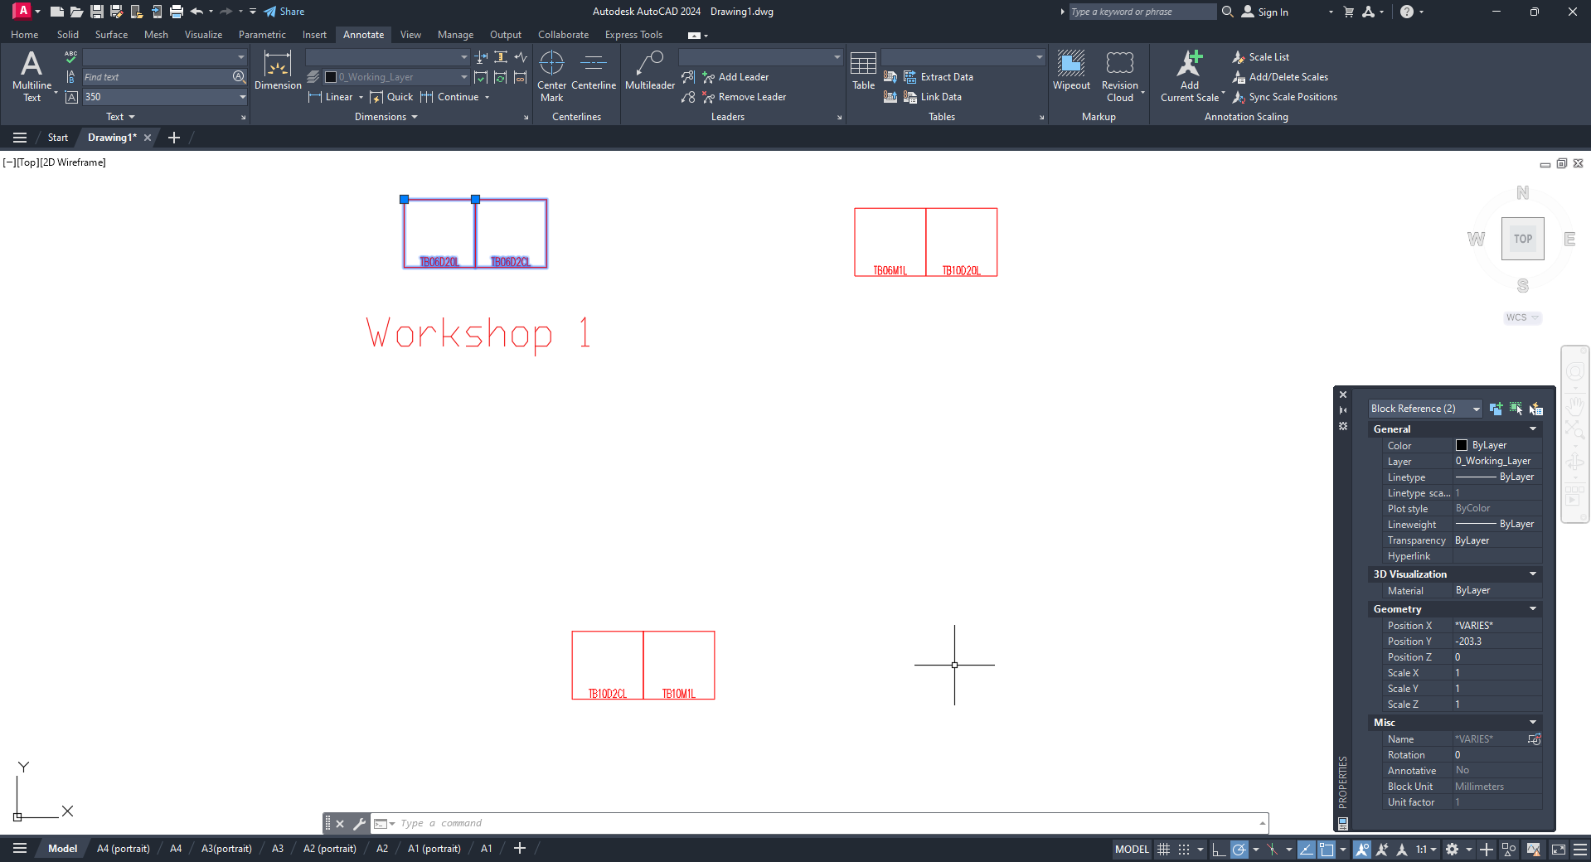

  - Selecting equipment without a group

    - To select equipment without a group, click the “Equipment groups” button in the Workshops menu;
    - Choose “Select an equipment with no group” in the drop-down menu;
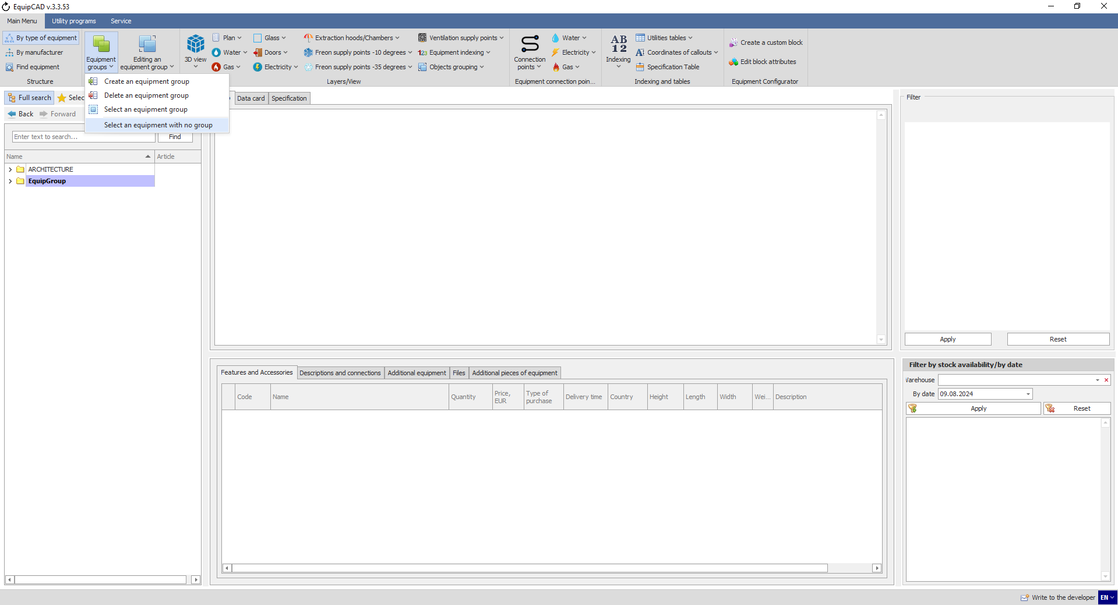
8.6.2
8.6.1
The program will switch to AutoCAD and select the equipment items that do not belong to any workshop.
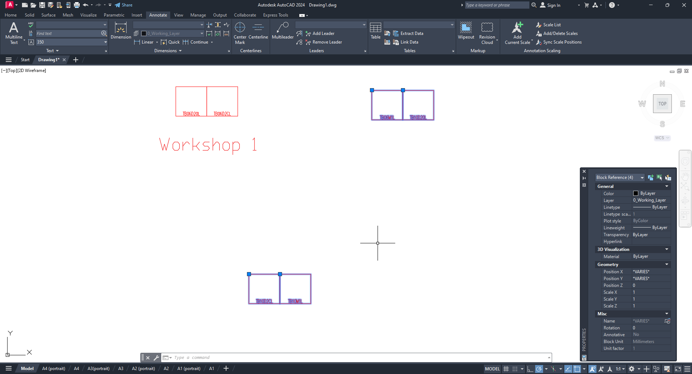

  - Adding equipment to a workshop

    - To add equipment to a workshop, click the “Editing an equipment group” button in the Workshops menu;
    - Select “Add equipment to a group” in the drop-down menu;
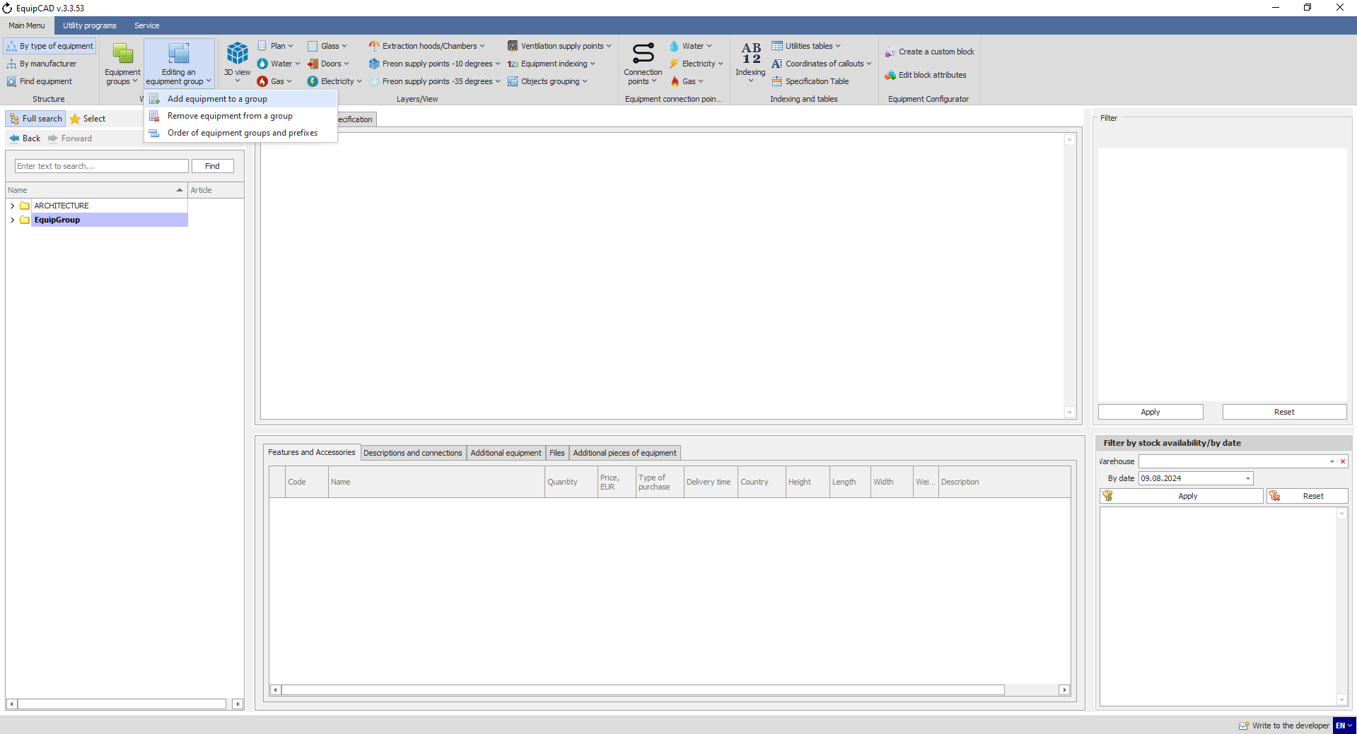
8.7.2
8.7.1

    - In the window that opens, select the desired workshop and click the Select button;
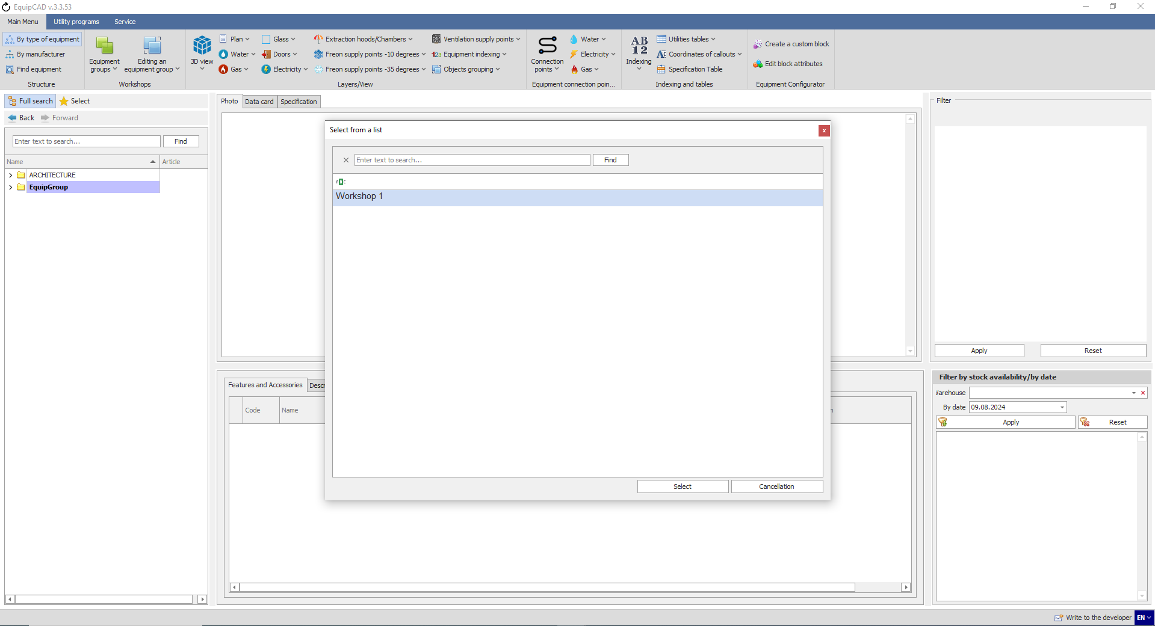
8.7.3

    - When the program has automatically switched to AutoCAD, select the equipment to be added to the workshop by highlighting it, and confirm your choice by pressing the right mouse button or Enter/Space key;
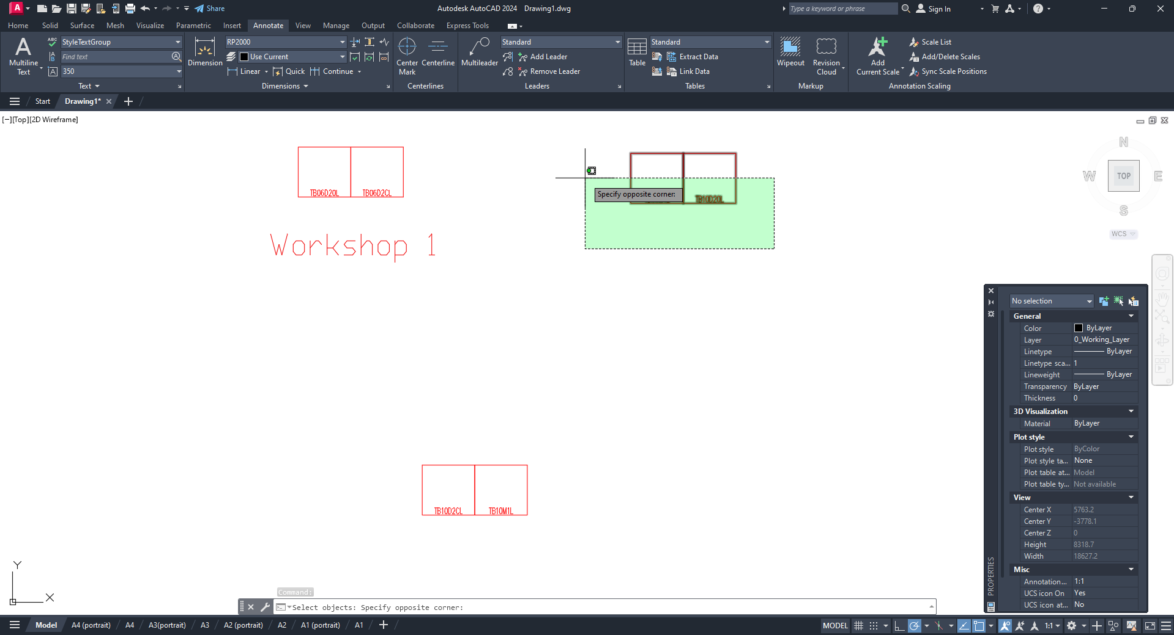
Let’s check changes in workshop 1 using the highlighting.
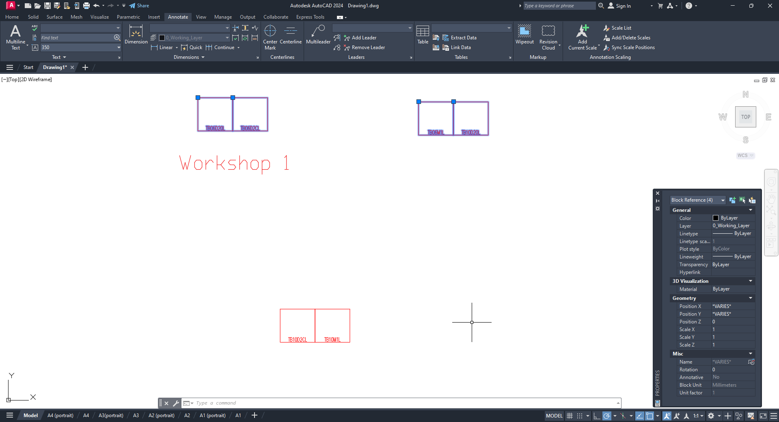

  - Deleting equipment from a workshop

    - To remove equipment from a workshop, click the “Editing an equipment group” button in the Workshops menu;
    - Select “Remove equipment from a group” in the drop-down menu;
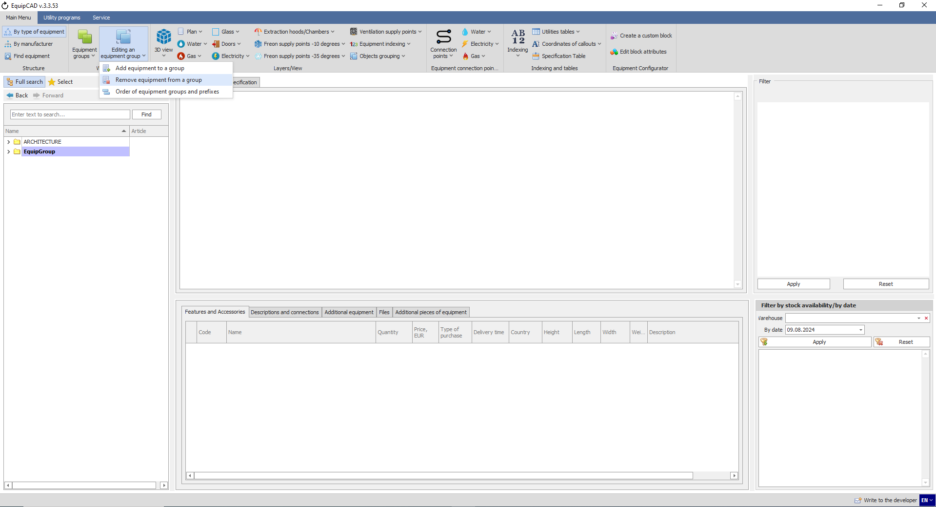
8.8.2
8.8.1

    - In the window that opens, select the desired workshop and click the Select button;
8.8.3

    - When the program has automatically switched to AutoCAD, select the equipment to be deleted from the workshop, and confirm your choice by pressing the right mouse button or Enter/Space key;
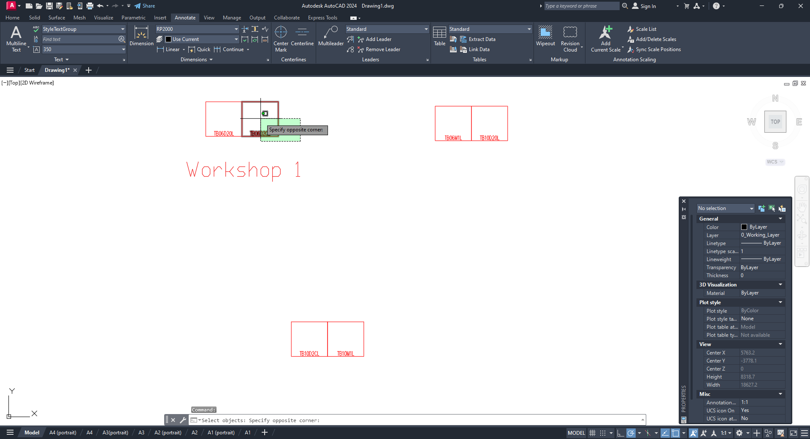
Let’s check changes in workshop 1 using the highlighting.
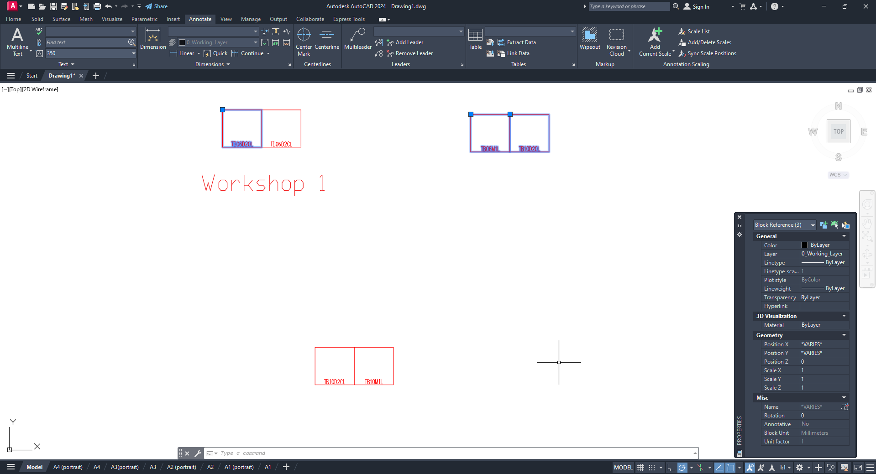

- Equipment indexing and callout coordinates
9.1 Equipment indexing
9.2 Indexing settings
9.3 Editing indexing
9.4 Saving and deleting callout coordinates

  - Equipment indexing
Before indexing equipment, it is to be placed in workshops.
    - To index equipment, click the “Indexing” button in the “Indexing and tables” menu;
    - Select “Add indexing” in the drop-down menu;
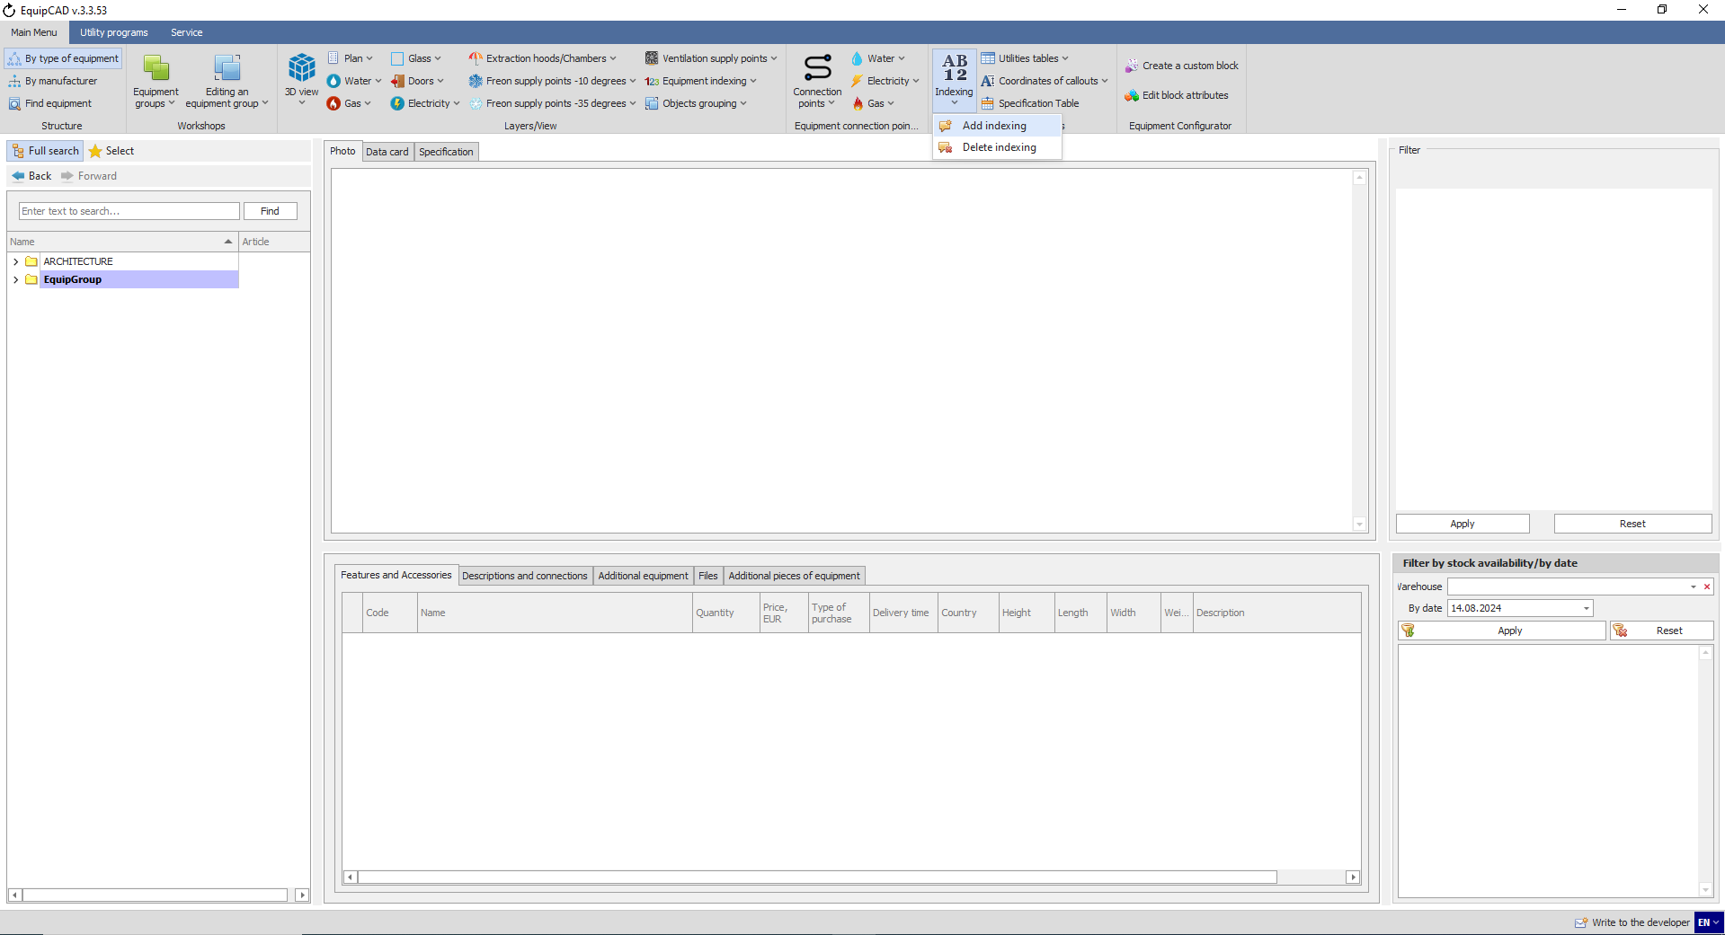
9.1.2
9.1.1
In large projects, indexing takes time.

    - Once the indexing is complete, the program will inform you accordingly and automatically switch to AutoCAD;
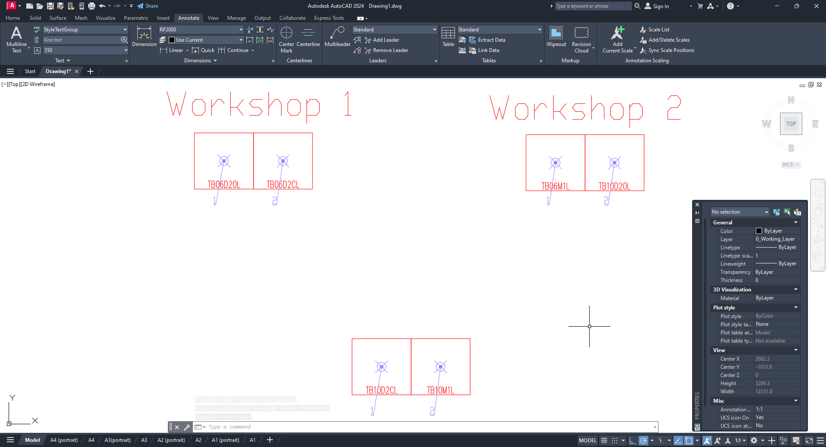

    - To delete indexing, click the “Indexing” button in the “Indexing and tables” menu;
    - Select “Delete indexing” in the drop-down menu;
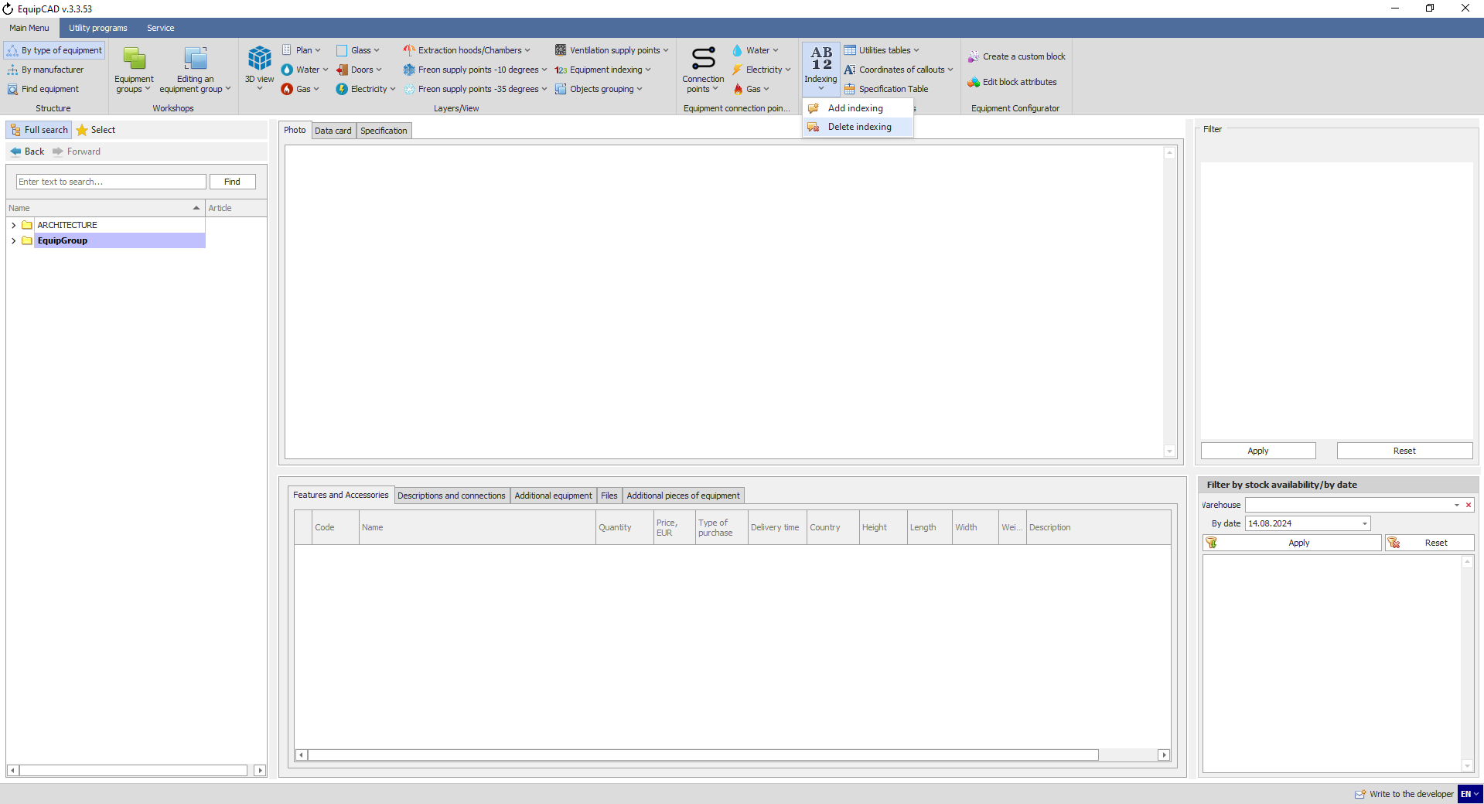
9.1.5
9.1.4

    - After that, the program will ask, “Are you sure you want to delete indexing callouts?” and “Do you want to save callouts coordinates?”
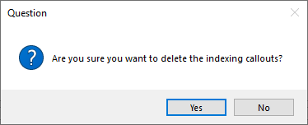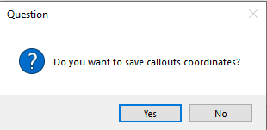
Then the indexing callouts will be deleted.
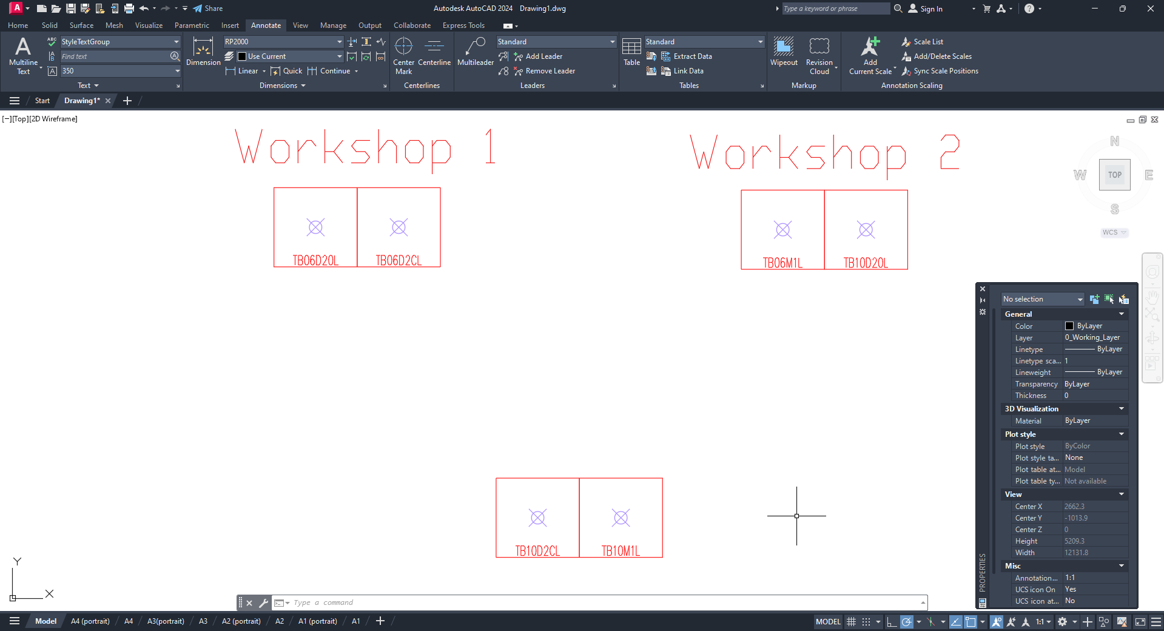

  - Indexing settings
In the program settings, you can choose the desired equipment indexing mode and algorithm.
    - Go to the Service tab;
    - Select the Program Settings menu;
    - Go to the general settings for AutoCAD;
    - With the “Equipment indexing mode” setting, you can choose whether equipment indexing will be done by workshop or continuously for the entire project;
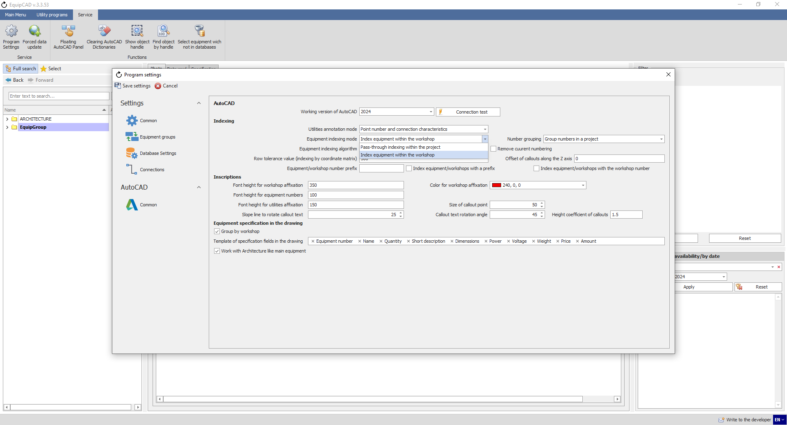
9.2.4
9.2.1
9.2.3
9.2.2

In case of indexing within a workshop (see step 9.1.6), indexing begins anew for each workshop and any equipment outside the workshop is indexed separately according to the “Equipment indexing algorithm”.

In case of pass-through indexing, equipment is assigned numbers according to the “Equipment indexing algorithm” within workshops (for example, workshop1: numbers 1, 2, 3; workshop2: numbers 4, 5, 6; etc.).
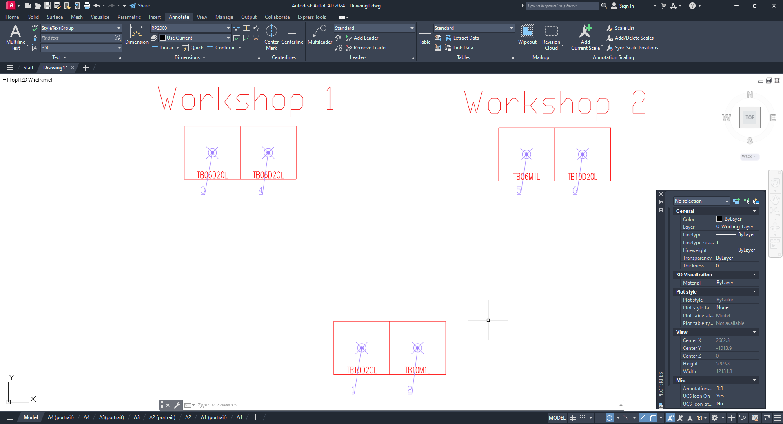

    - With the “Equipment indexing algorithm” setting, you can choose whether equipment indexing will be done according to the coordinate matrix or alphabetically by equipment name;
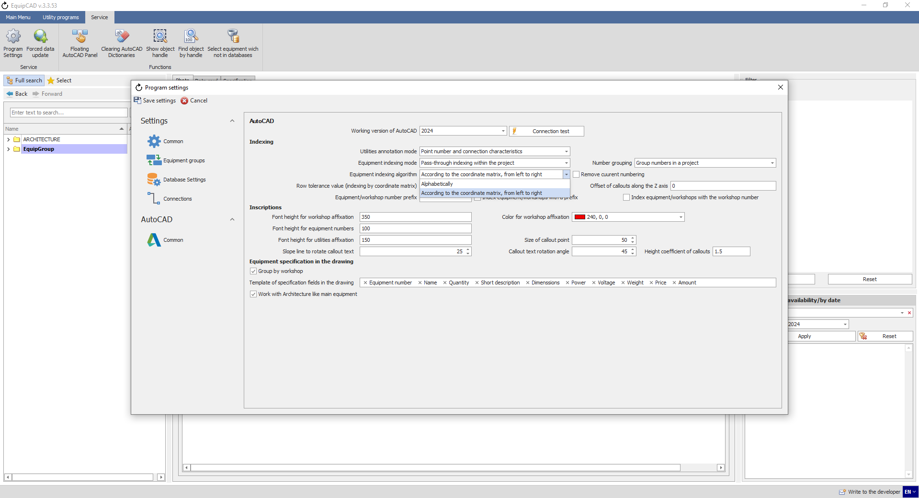
9.2.5

The indexing algorithm according to the coordinate matrix (see step 9.2.4) assigns numbers based on the workshop position according to AutoCAD coordinates (from left to right, then from bottom to top).

The alphabetical indexing algorithm assigns numbers according to the alphabetical order of equipment names.
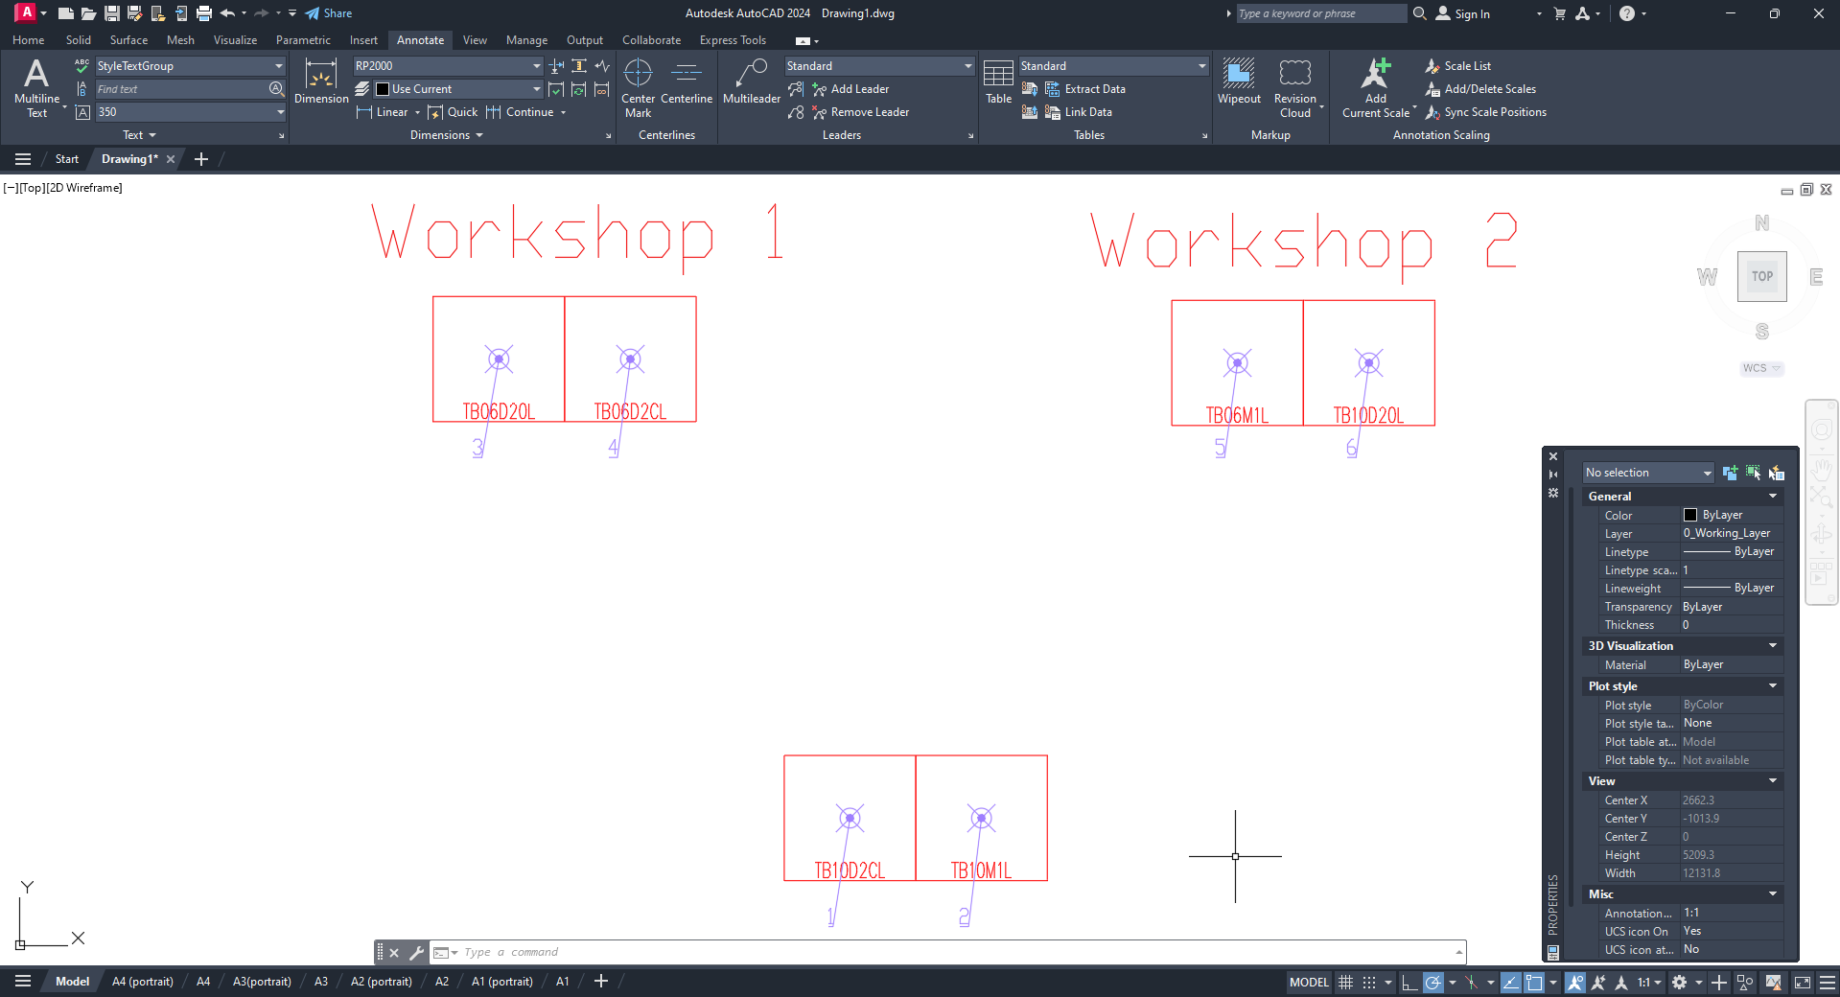

    - The “Number grouping” setting is responsible for assigning identical numbers to identical equipment items and allows you to choose between the following options: do not group numbers; group numbers within a project (assigning identical numbers to identical equipment items throughout the project); group numbers within a workshop (assigning identical numbers to identical equipment items within each workshop);
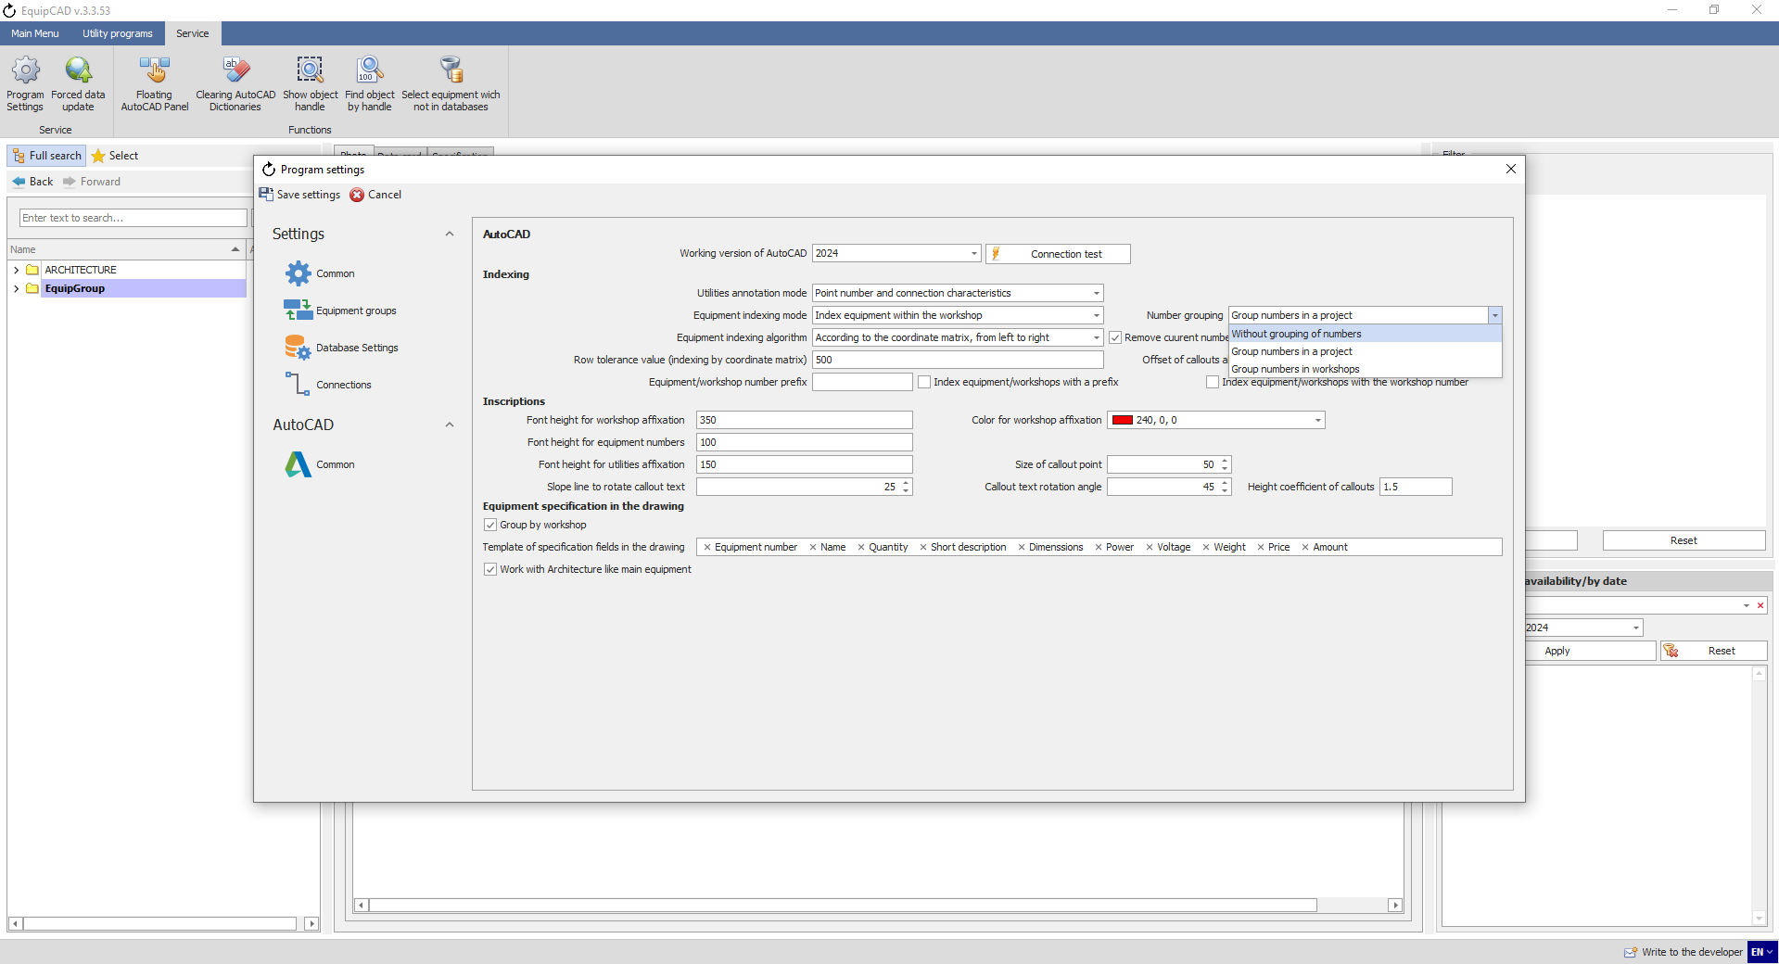
9.2.6
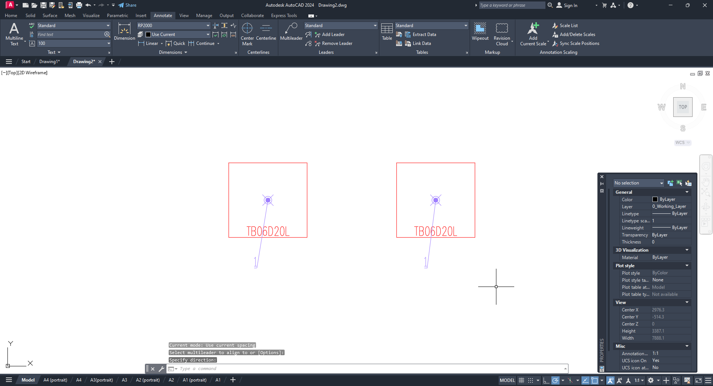

    - The “Font height for equipment numbers” setting allows for changing the size of numbers;
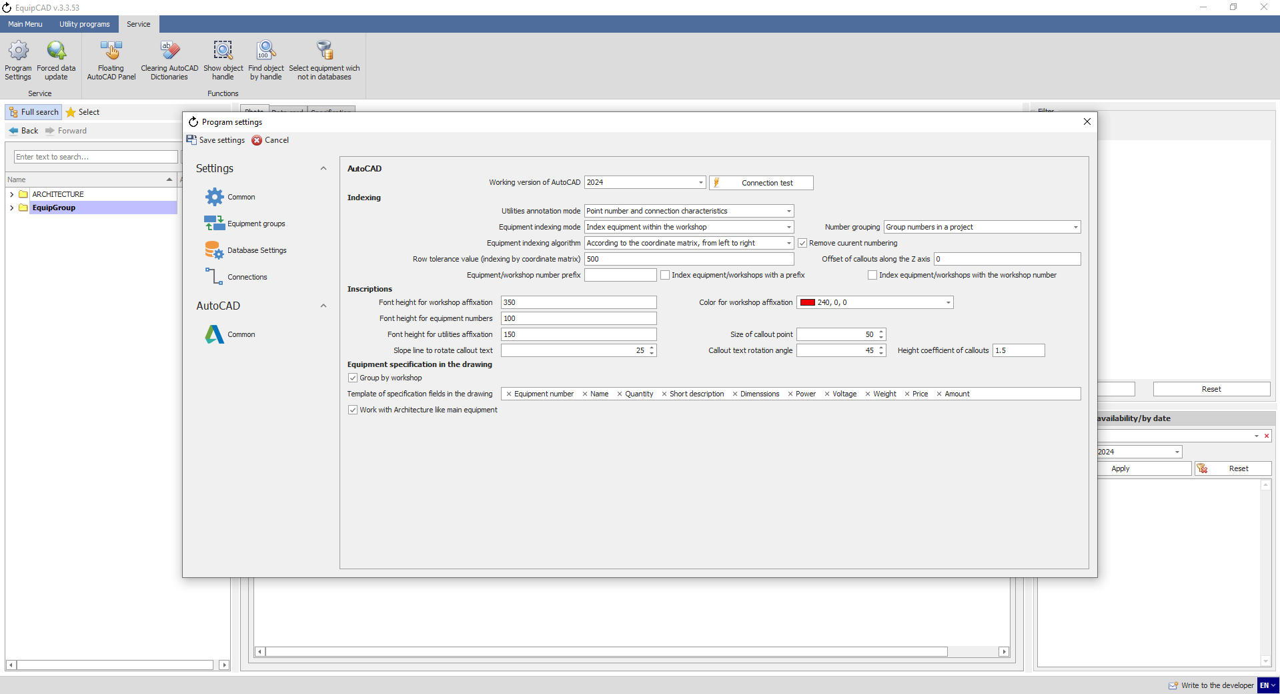
9.2.7
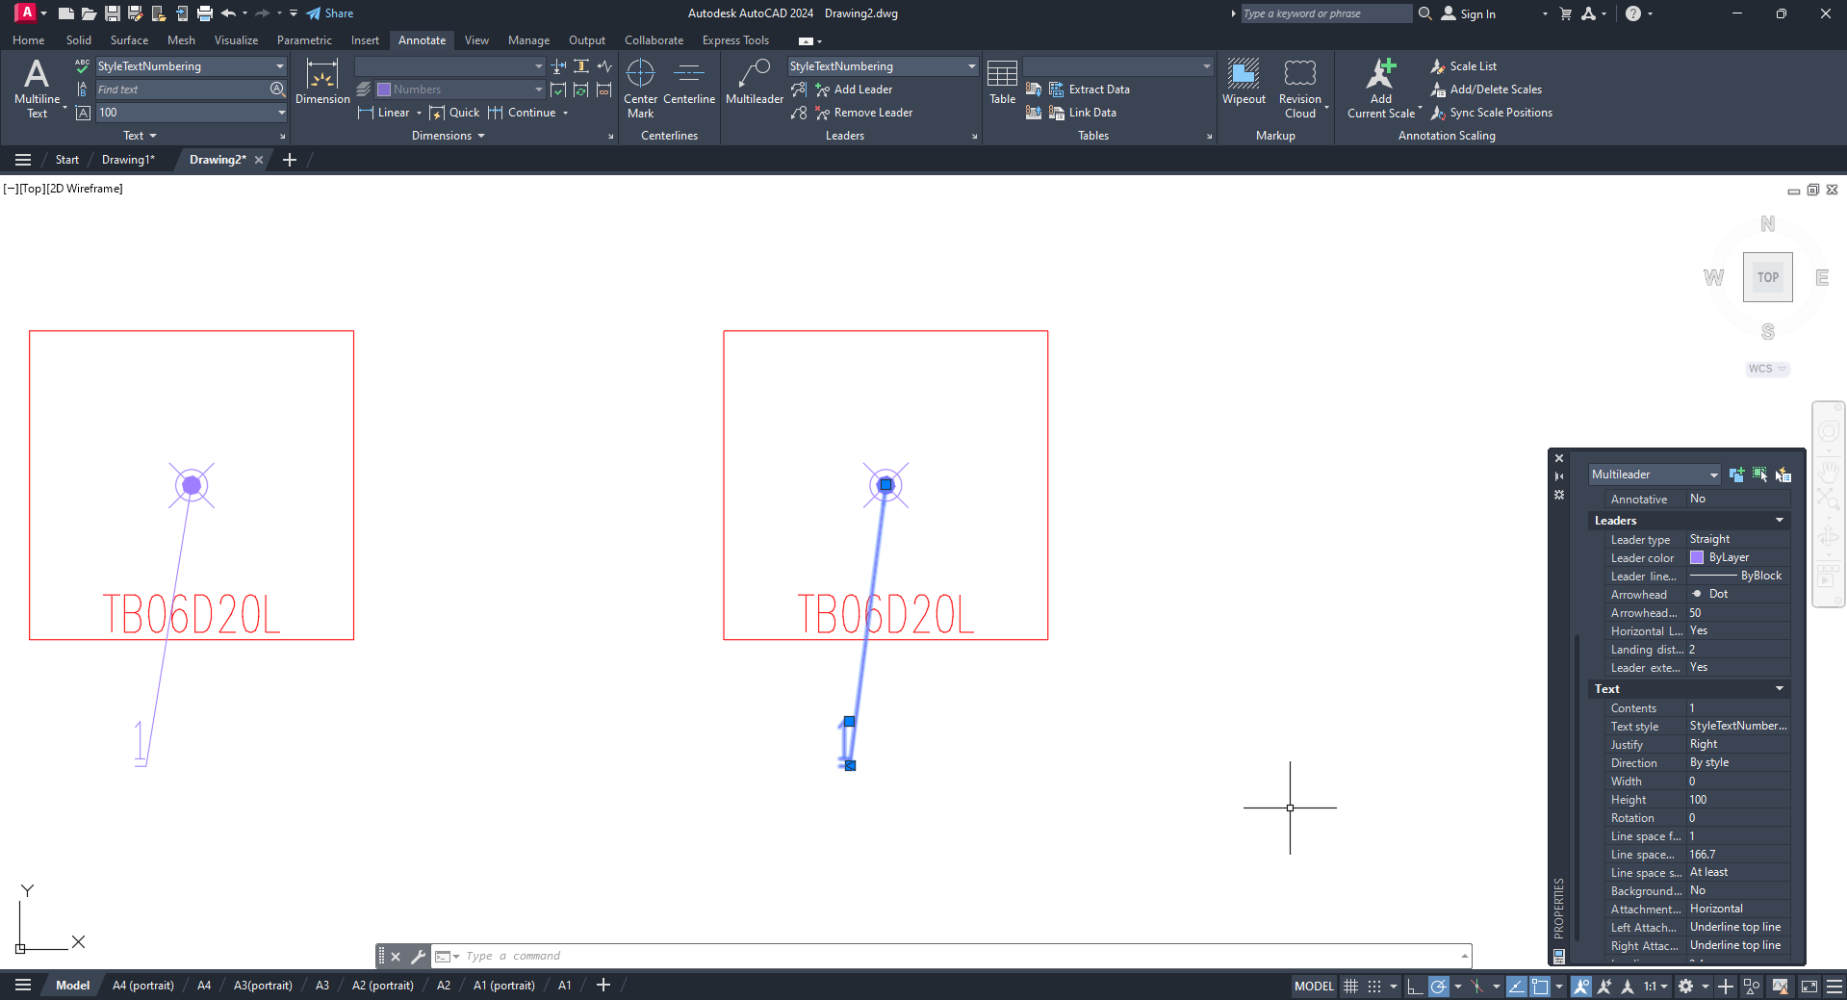
9.2.7

    - The program also allows you to set the height of a line based on which indexing according to the coordinate matrix will be arranged;
Note: Indexing according to the coordinate matrix is arranged on a line-by-line basis from top to bottom and from left to right in lines.
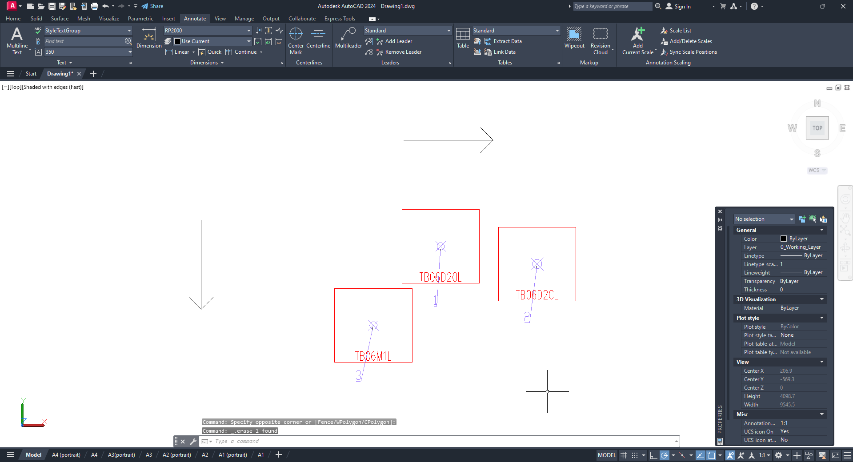

    - To set the line height, go to the “General settings for AutoCAD” (in the same manner as in step 9.2.3); the parameter is called “Row tolerance value (indexing by coordinate matrix)”;
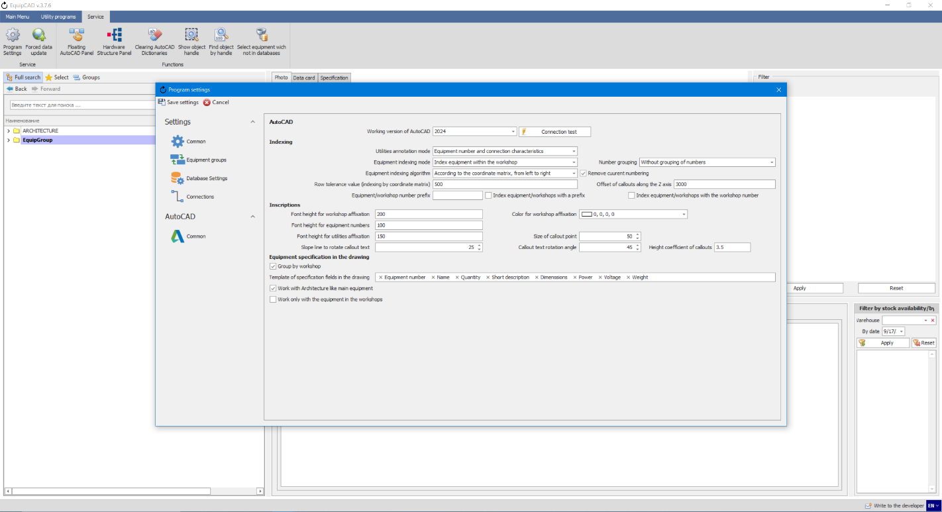
9.2.9

    - By way of example, let’s consider indexing three Tatra combi steam ovens: TB06D20L, TB06D2CL and TB06M1L. Since the coordinates of the indexing points (the purple dots) for TB06D20L and TB06D2CL along the Y axis differ by 200 mm, they are positioned in the same line, and since the coordinates of TB06D20L along the X axis are less than those of TB06D2CL, it is assigned number “1”, and TB06D2CL is assigned number “2”. The Y-coordinates of TB06D20L and TB06M1L differ by 880; therefore, TB06M1L is considered to be in another line and is assigned number “3”, regardless of the fact that its X-coordinates are less than those of TB06D20L;
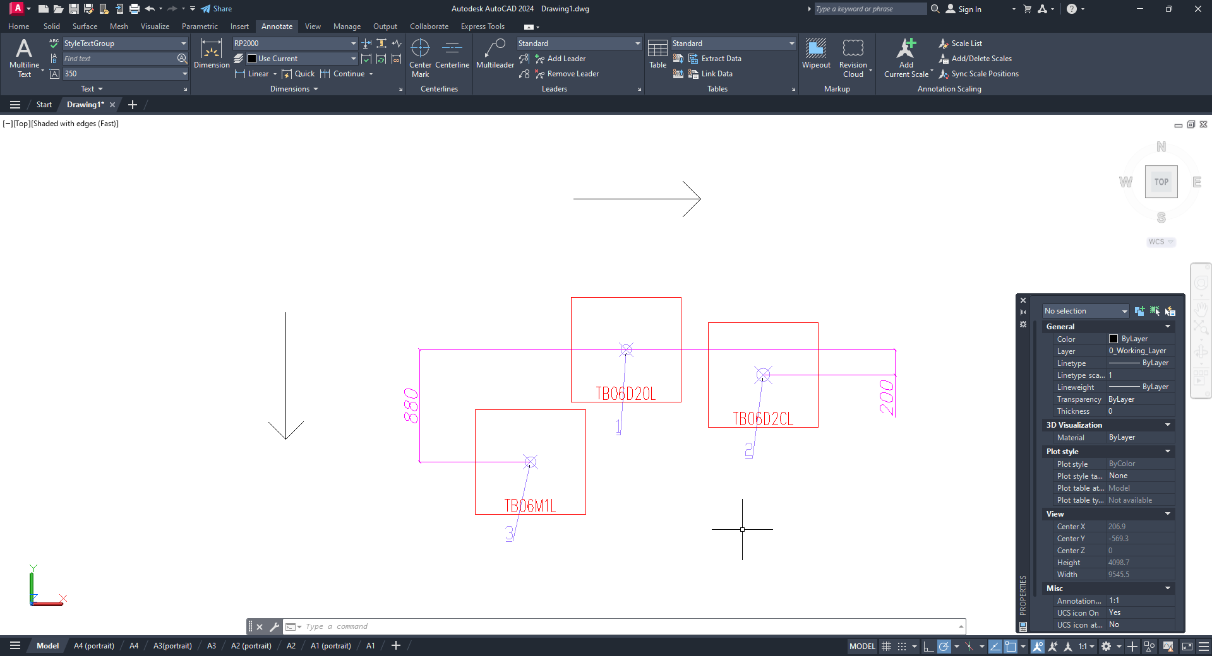

    - If we change the “Row tolerance value” by 1,000 and do indexing anew, we will see that numbers have changed and number “1” is now is assigned to TB06M1L as its X-coordinates are less than those of the other models in the line;
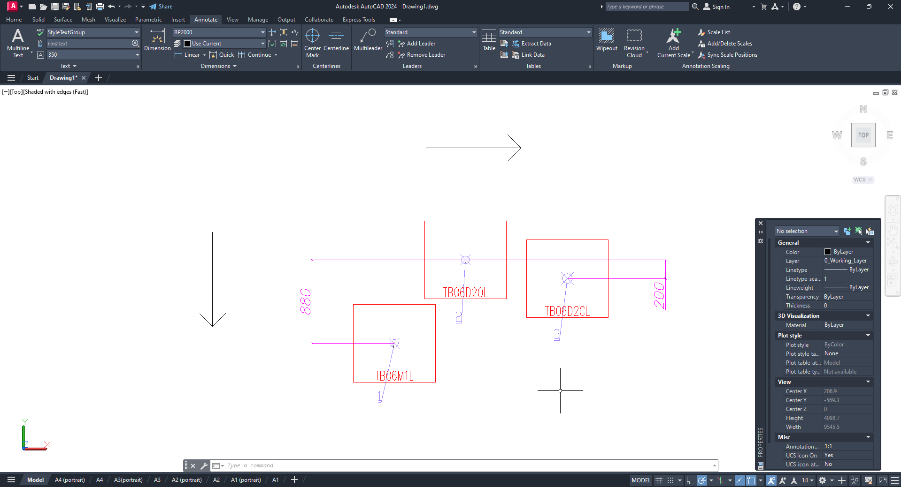

    - To demonstrate the operation of prefixes and workshop indexing, let’s add four equipment items to the drawing and create three workshops, leaving one equipment item without a workshop;
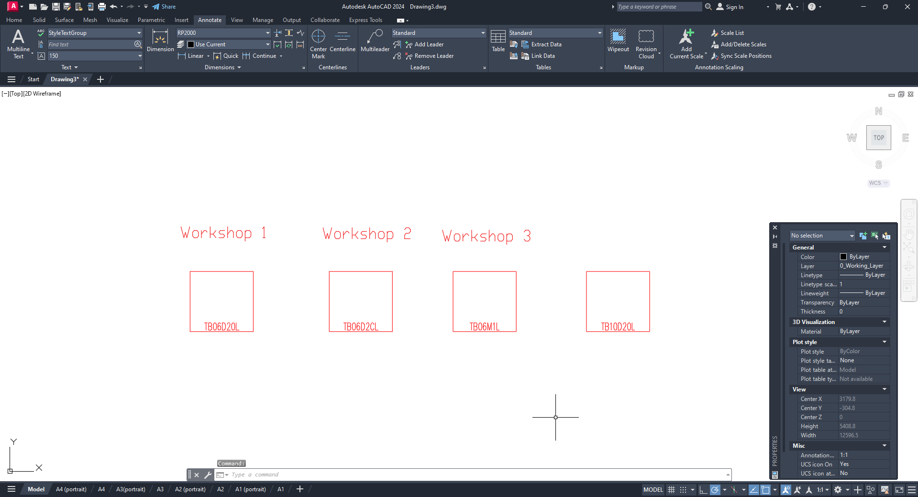
    - To add prefixes to workshops, click the “Editing an equipment group” button;
    - Then click the “Order of equipment groups and prefixes” button;
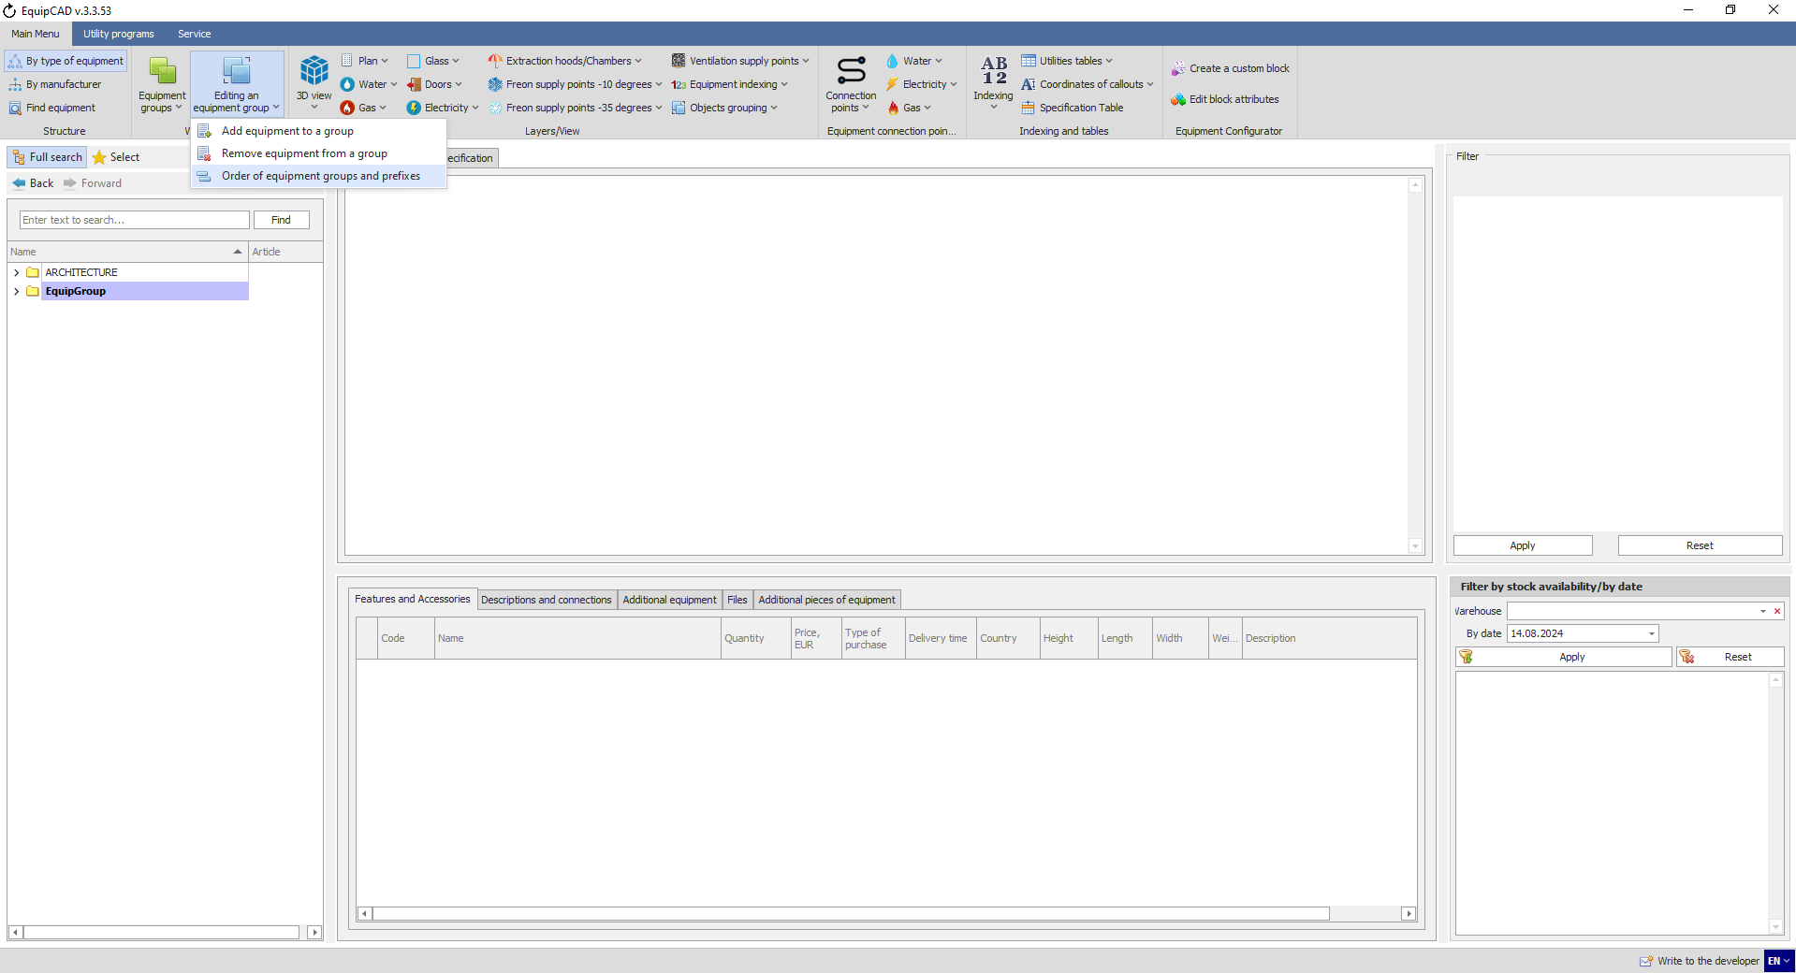
9.2.14
9.2.13

    - In the window that opens, define prefixes for two workshops under the “Group prefix” column header and click the Save button;
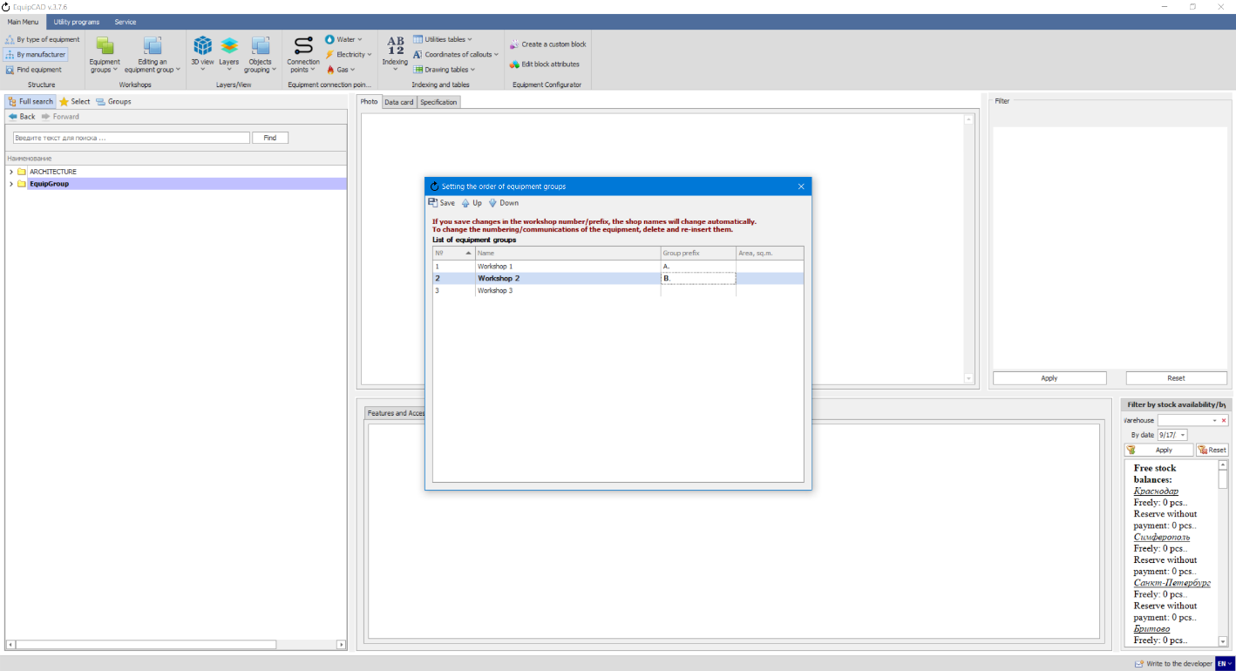
9.2.15
Note: Before saving prefixes, you must leave the field for entering prefixes. You can do this by clicking anywhere in the “Order of equipment groups and prefixes” window.

    - You can add a prefix to the equipment number or workshop name on the drawing and in the specification using the “Equipment/workshop number prefix” field;
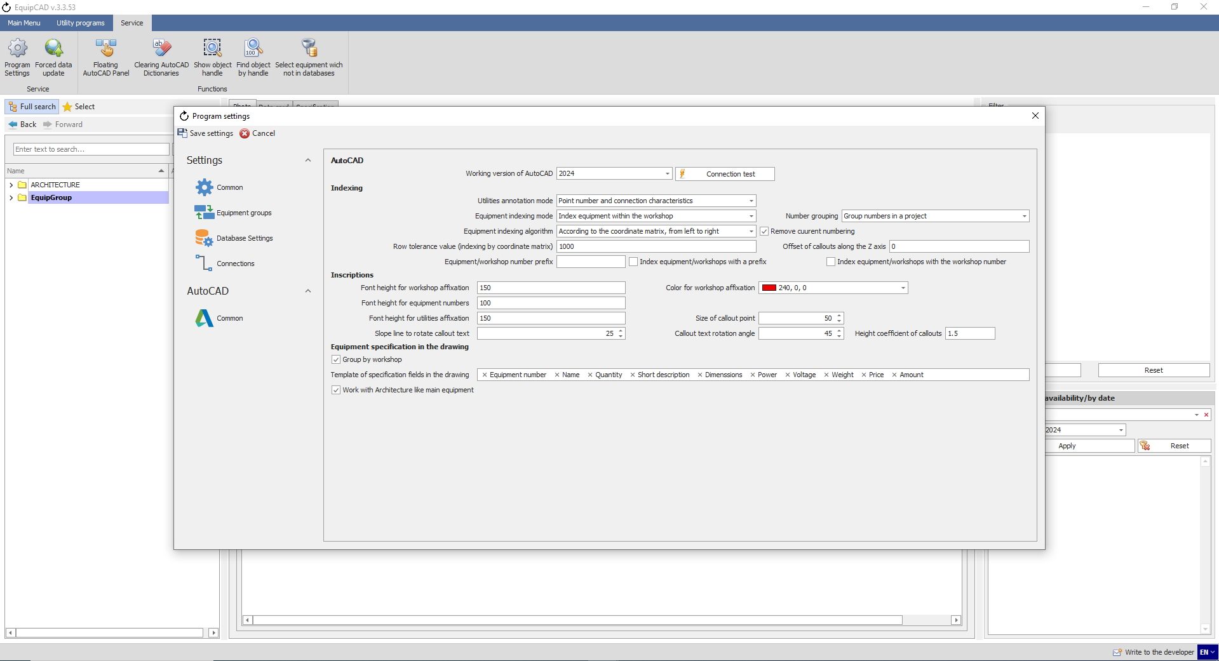
9.2.16
Note: The prefix will be assigned to those workshops that have not been assigned a prefix in the “Order of equipment groups and prefixes” menu and those equipment items that are not included in the workshop.

    - The “Index equipment/workshops with a prefix” setting allows you to enable and disable a prefix for equipment numbers and workshop names;
9.2.17

    - The “Index equipment/workshops with the workshop number” setting allows you to enable and disable a workshop number for equipment numbers and workshop names;
9.2.18

    - Let’s enter “EXAMPLE_” in the “Equipment/workshop number prefix” field and enable the “Index equipment/workshops with a prefix” setting;
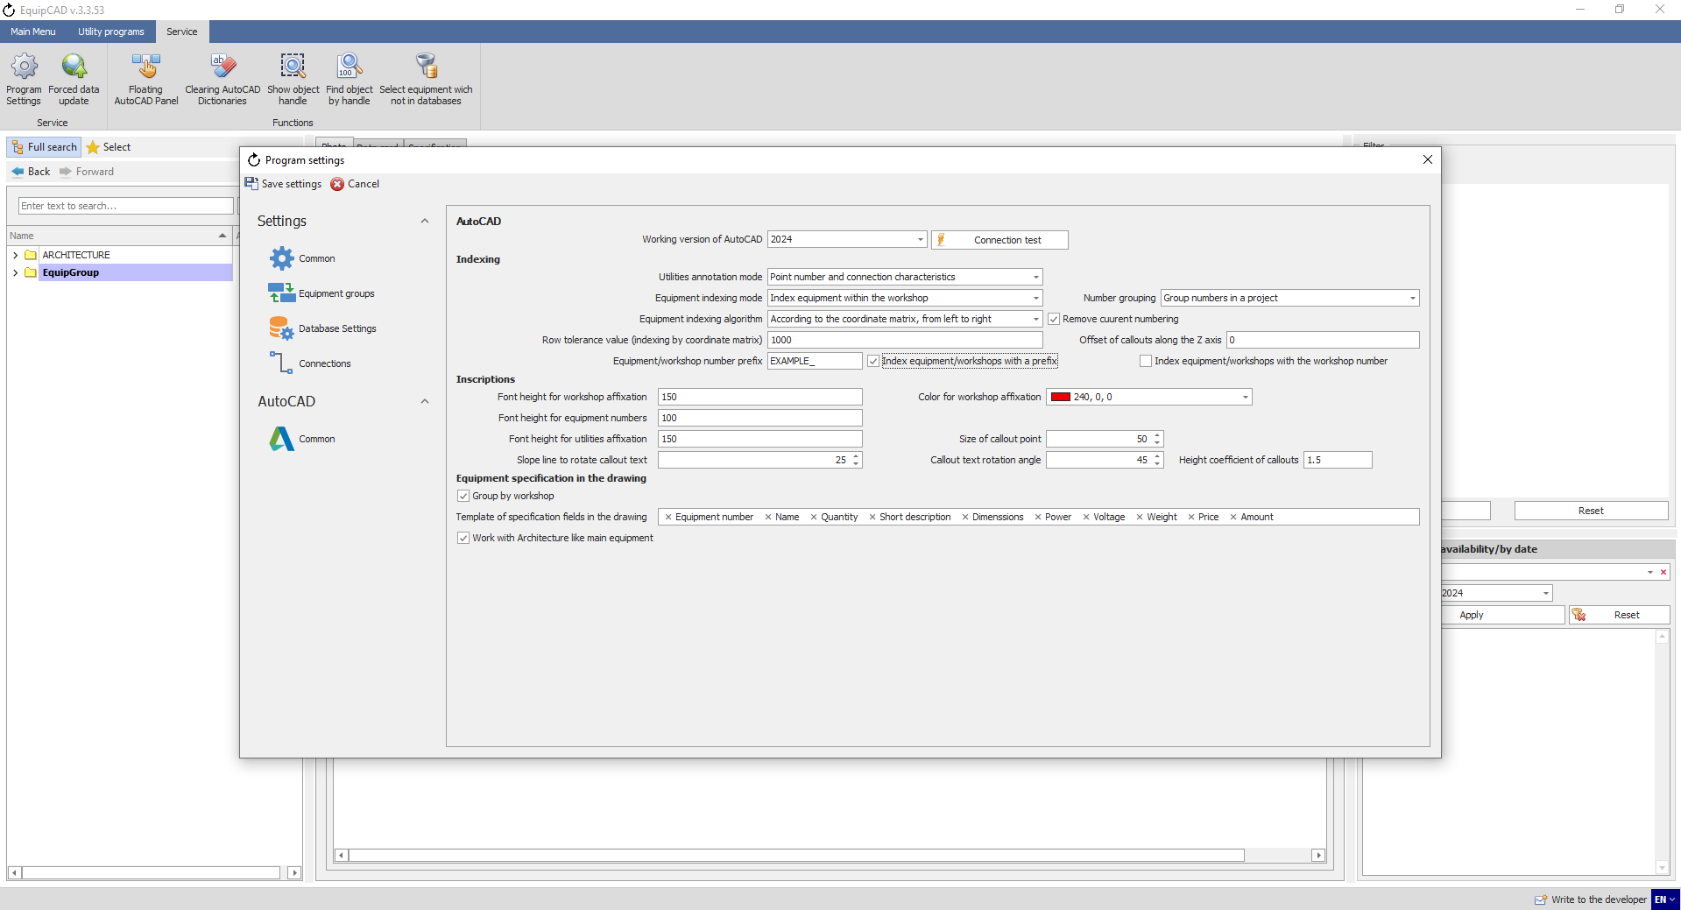
9.2.19

    - After the indexing has been done, the prefixes we defined in step 9.2.15 will be added to the workshop names and equipment numbers in the first two workshops, while the third workshop and equipment without a workshop will be assigned the prefix from step 9.2.19;
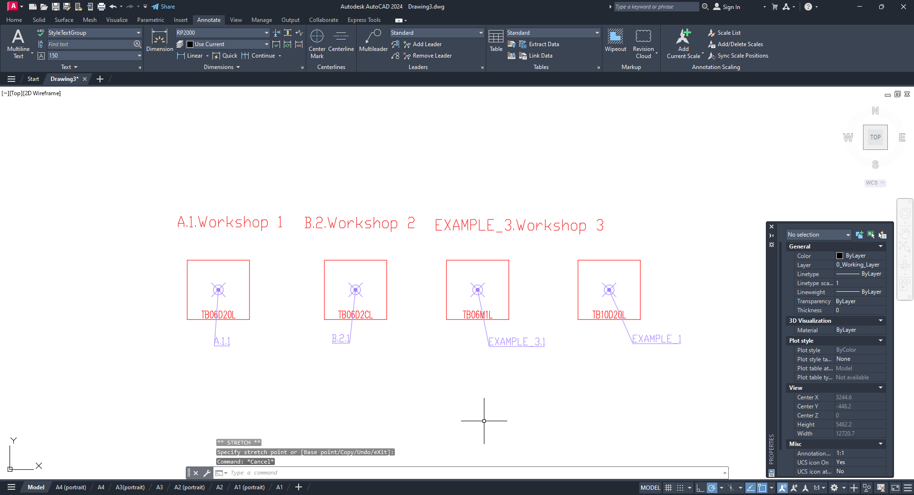

    - Then we enable the “Index equipment/workshops with the workshop number” setting and do the indexing again;
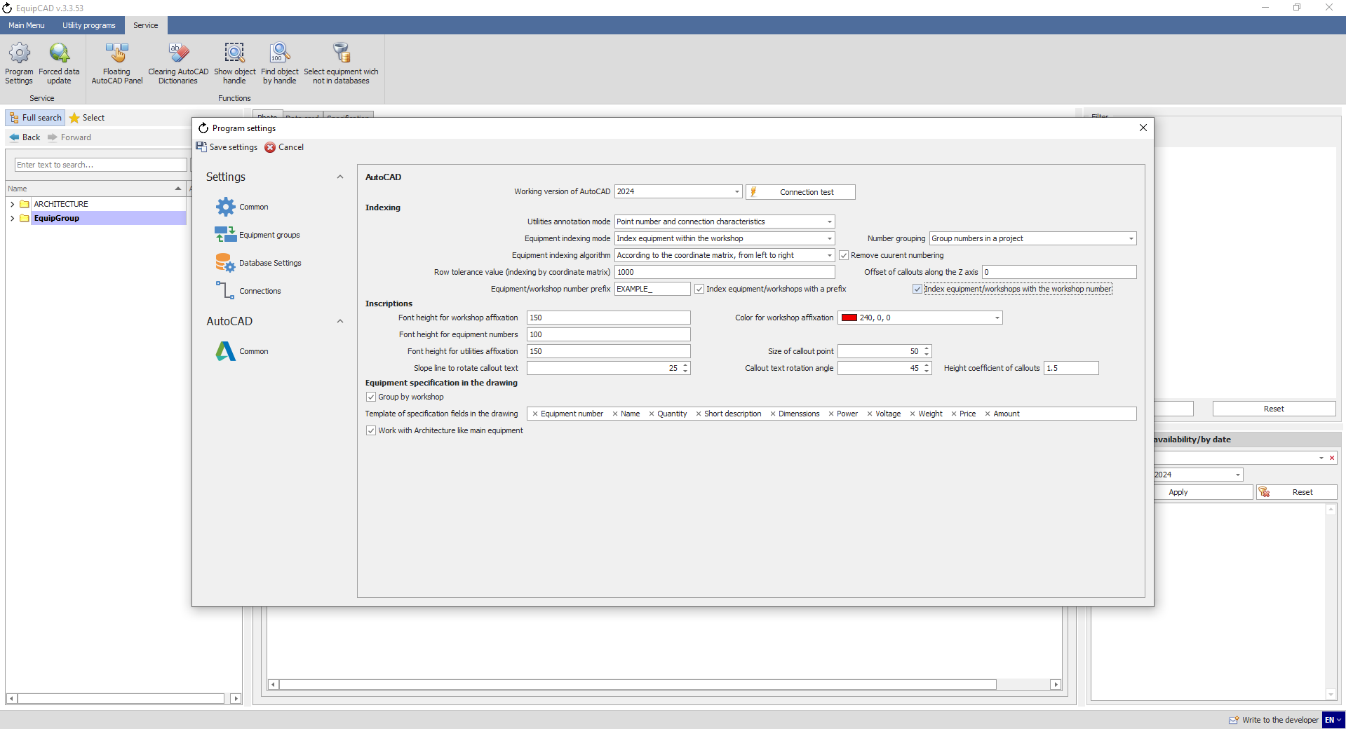
9.2.21
As can be seen, the workshop number has been added to the names of workshops and equipment numbers.

    - Prefixes and workshop numbers are also displayed in the specification in the corresponding EquipCaD tab, on the equip.me portal and in Excel.
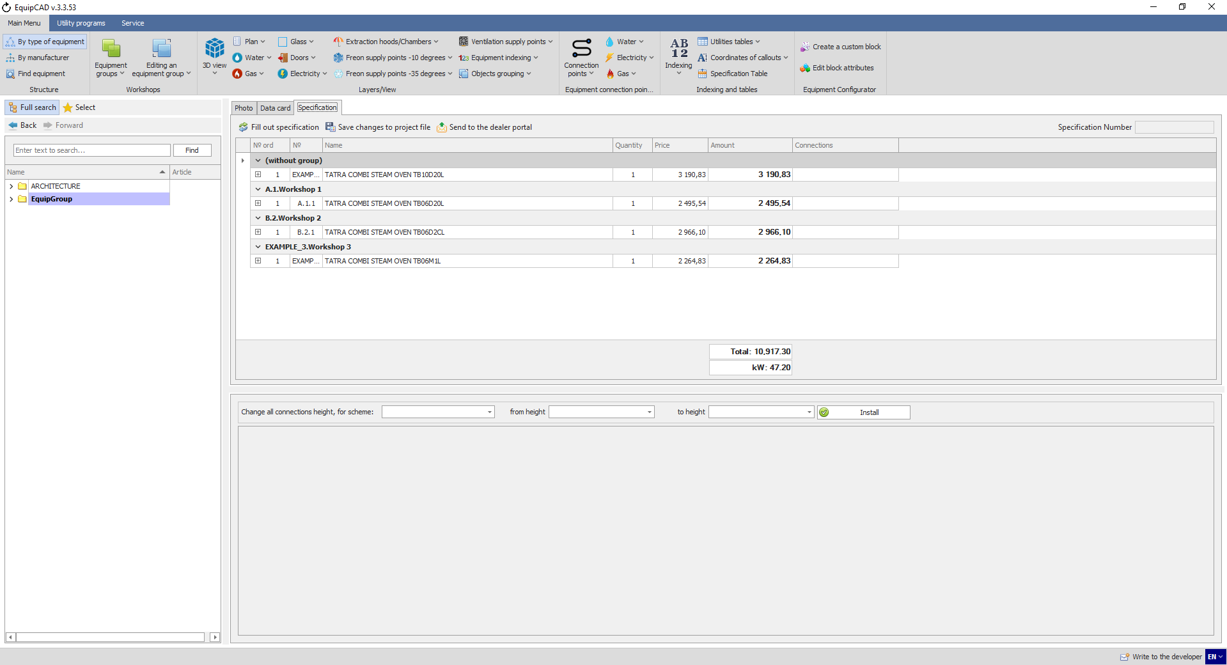

    - With the “Remove current numbering” setting, you can choose whether the equipment indexing will be recalculated every time it is re-assigned or it will continue the current numbering, filling in the missing numbers;
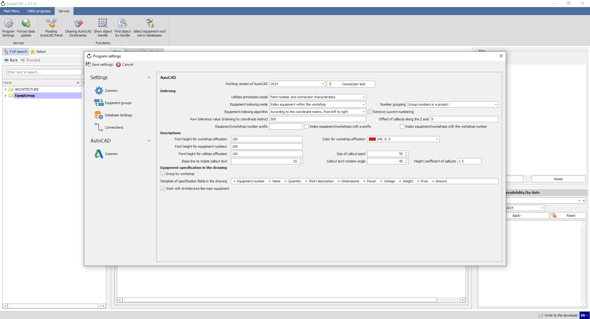
9.2.23
    - To demonstrate this, let’s place a few equipment items on the drawing and do the indexing (the indexing algorithm: according to the coordinate matrix);
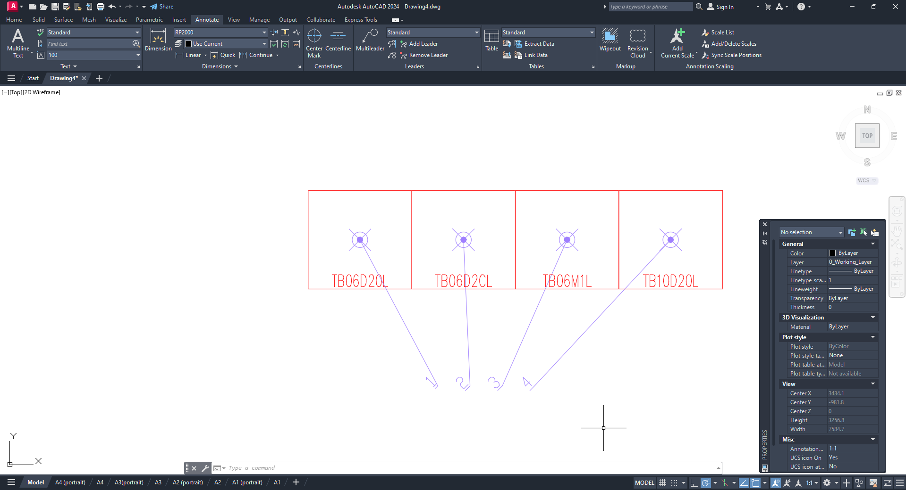

    - Let’s enable the “Remove current numbering” setting, add another equipment item in the beginning and do the indexing again;
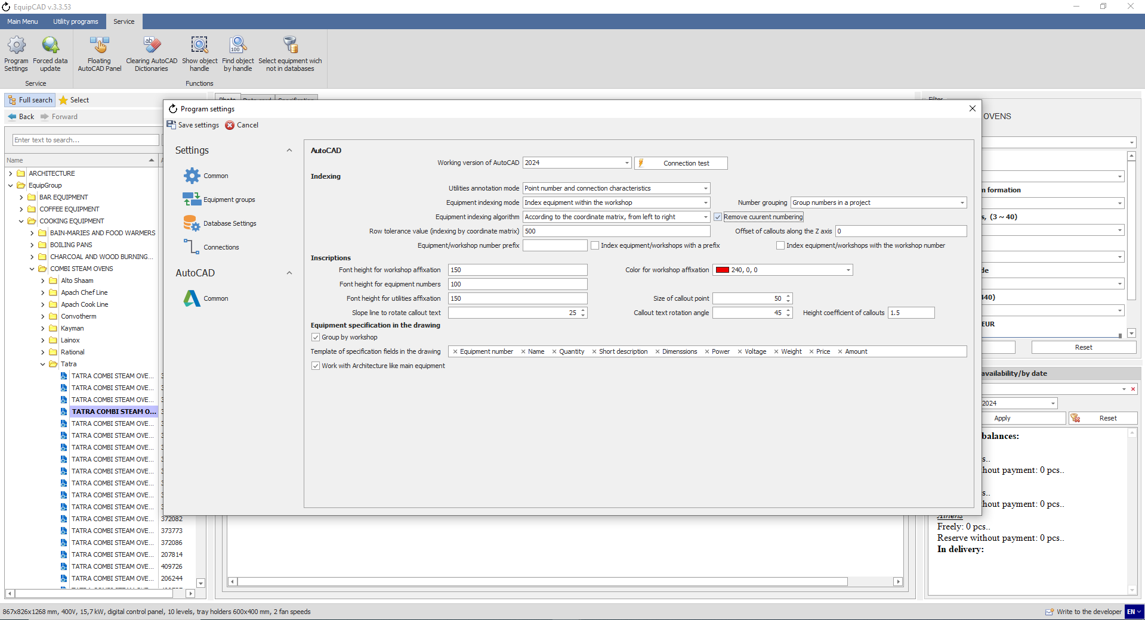
9.2.25
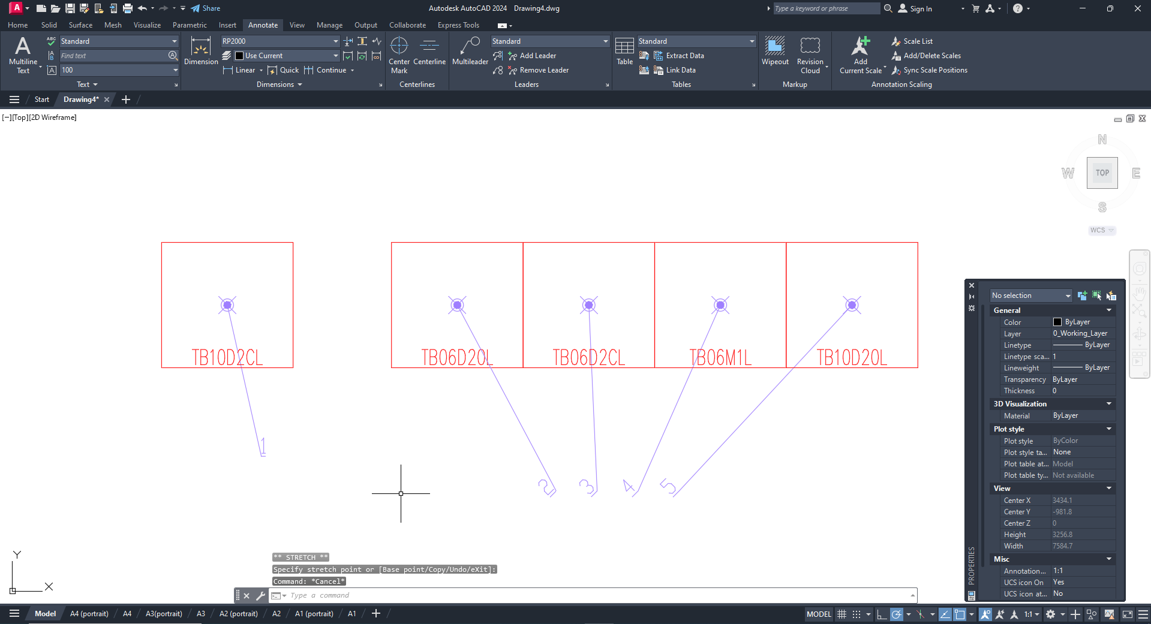
As we used the indexing algorithm according to the coordinate matrix, the new equipment item will have number “1” as it stands to the left of the rest.
    - Let’s disable the “Remove current numbering” setting, delete equipment number “4”, add another equipment item in the beginning and do the indexing again;
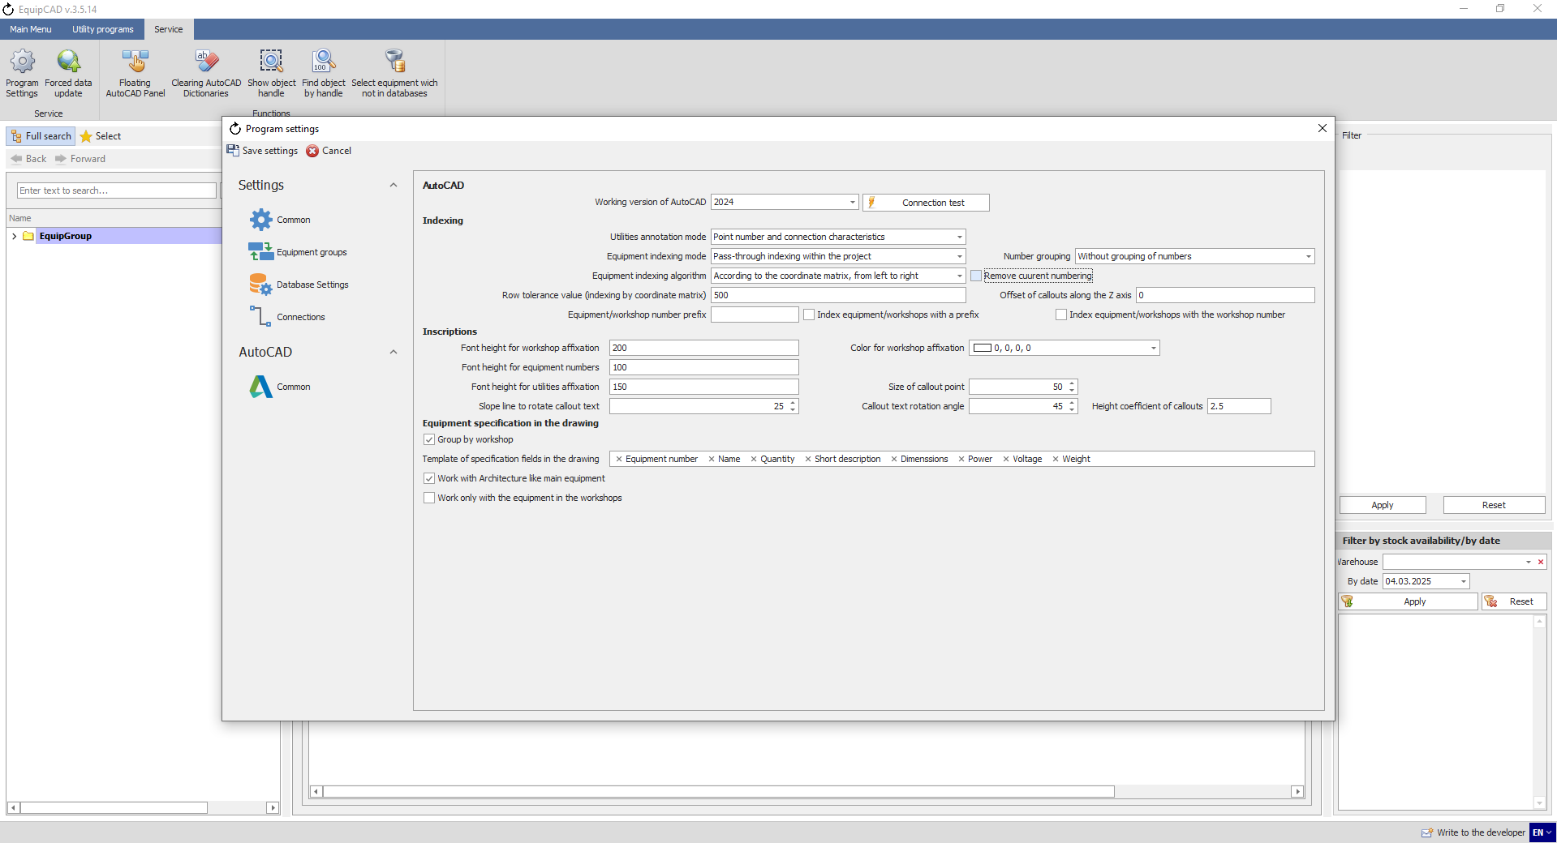
9.2.26
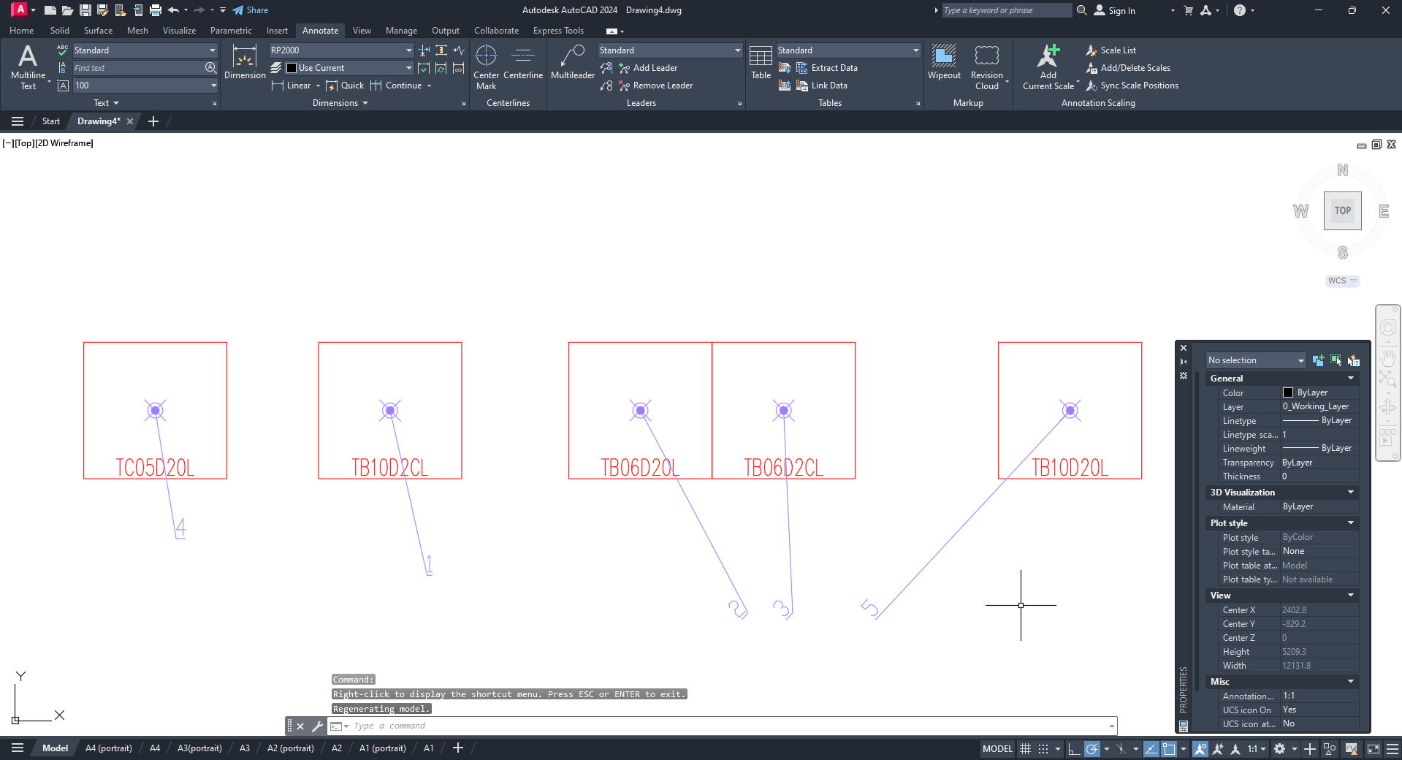
As the “Remove current numbering” setting is disabled, the equipment items that have been indexed keep their numbers, while the new equipment item has been assigned the missing number “4”.

  - Editing indexing

    - To edit the numbering, you need to enter the numbering;
    - Then fill out the specification;
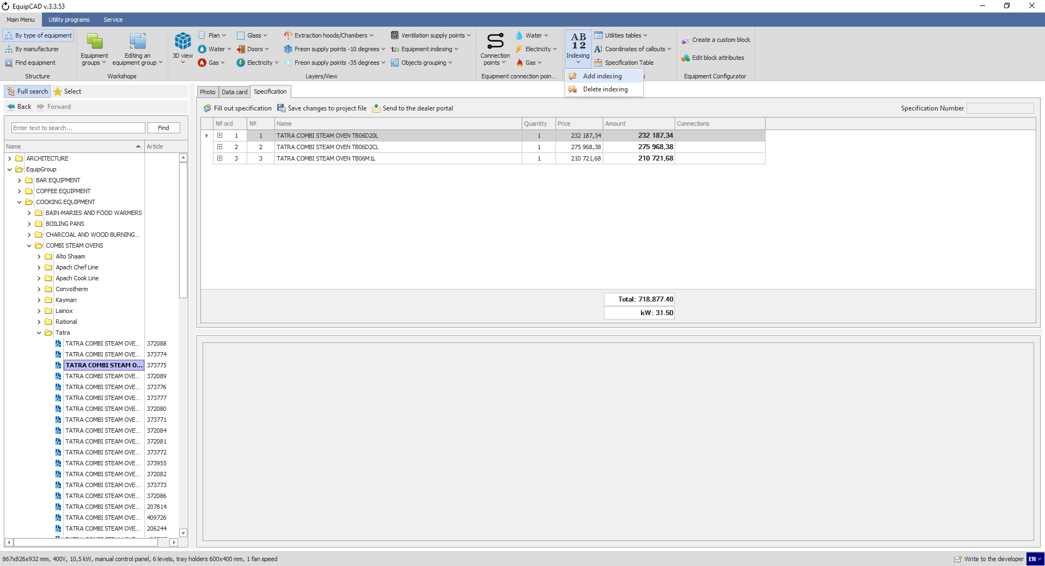
9.3.2
9.3.1
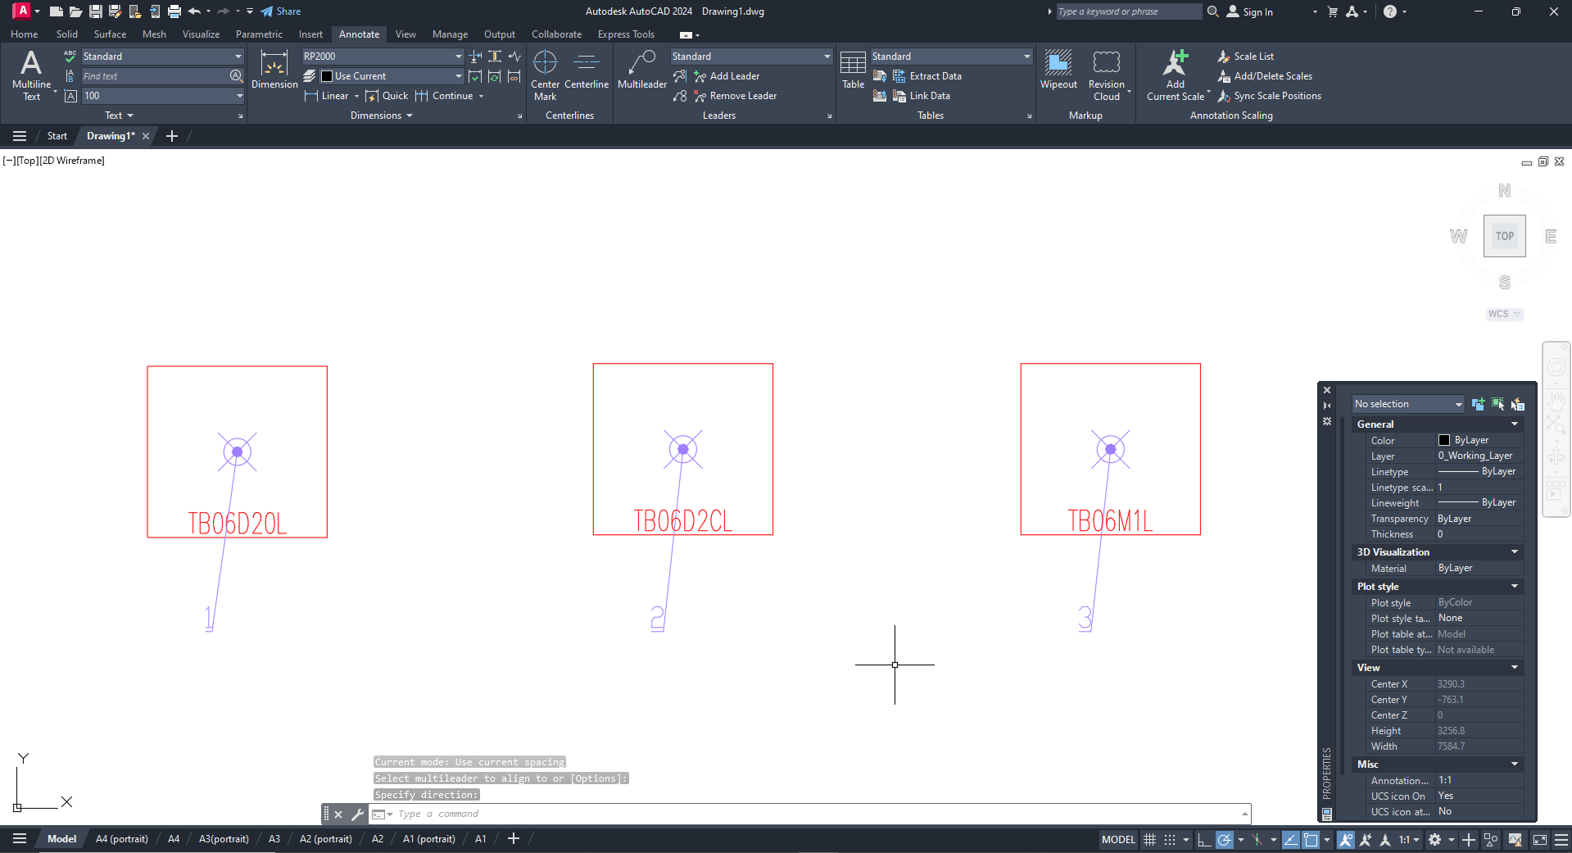

    - Using the "№." field on the "Specification" tab, you can edit the equipment number in the project, and using the "№ ord" field, you can edit the order in which the equipment will be located in the specification;
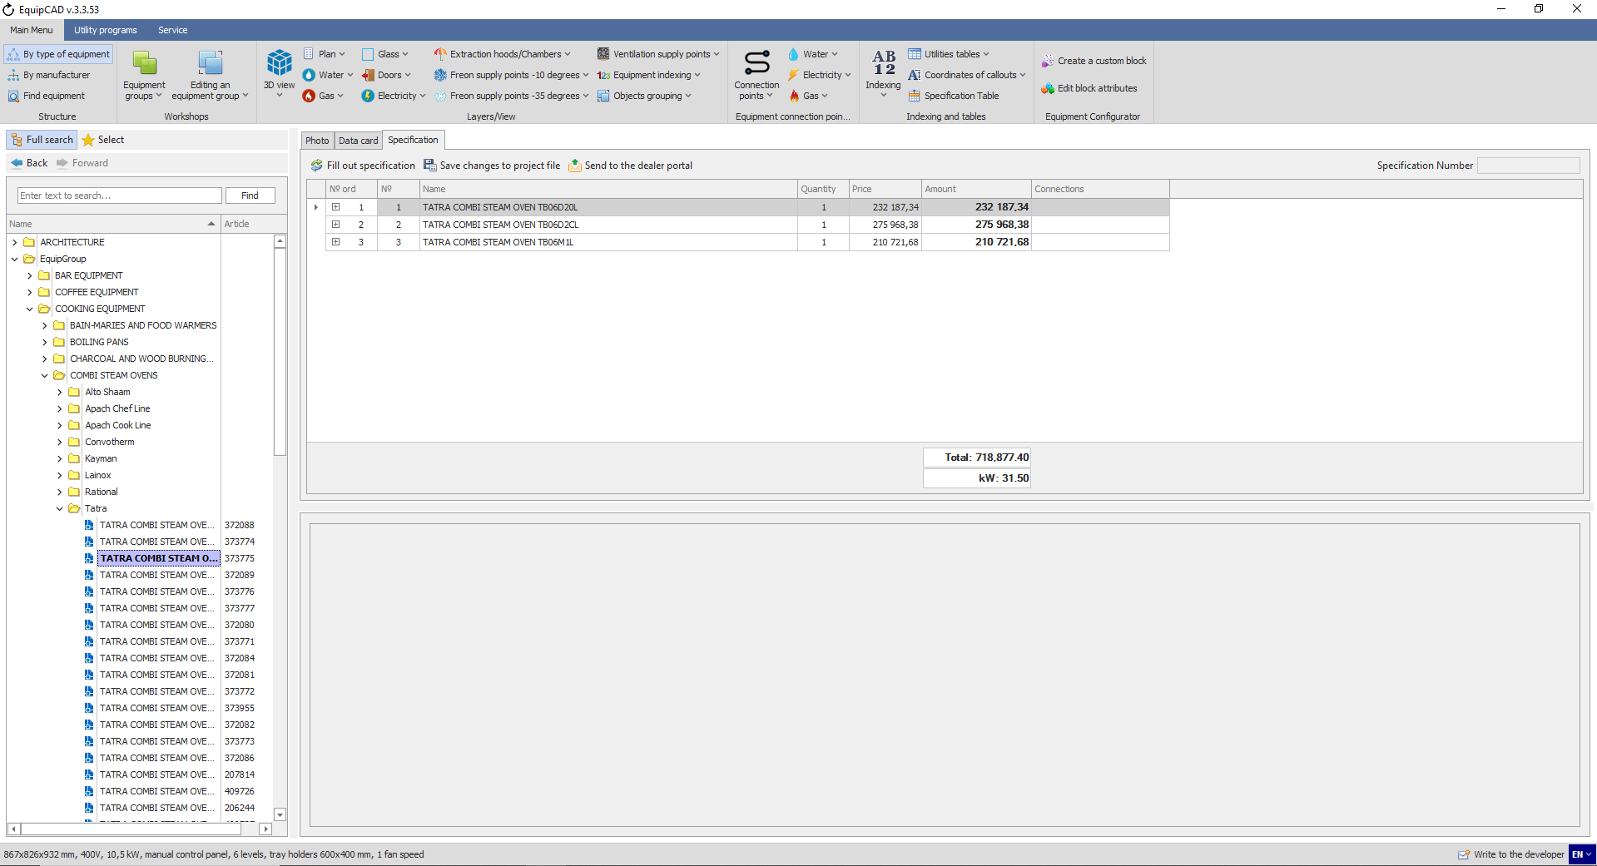
9.3.3

    - For example, let's change the numbers in the "№" column in reverse order;
    - Then click the button “Save changes to project file”;
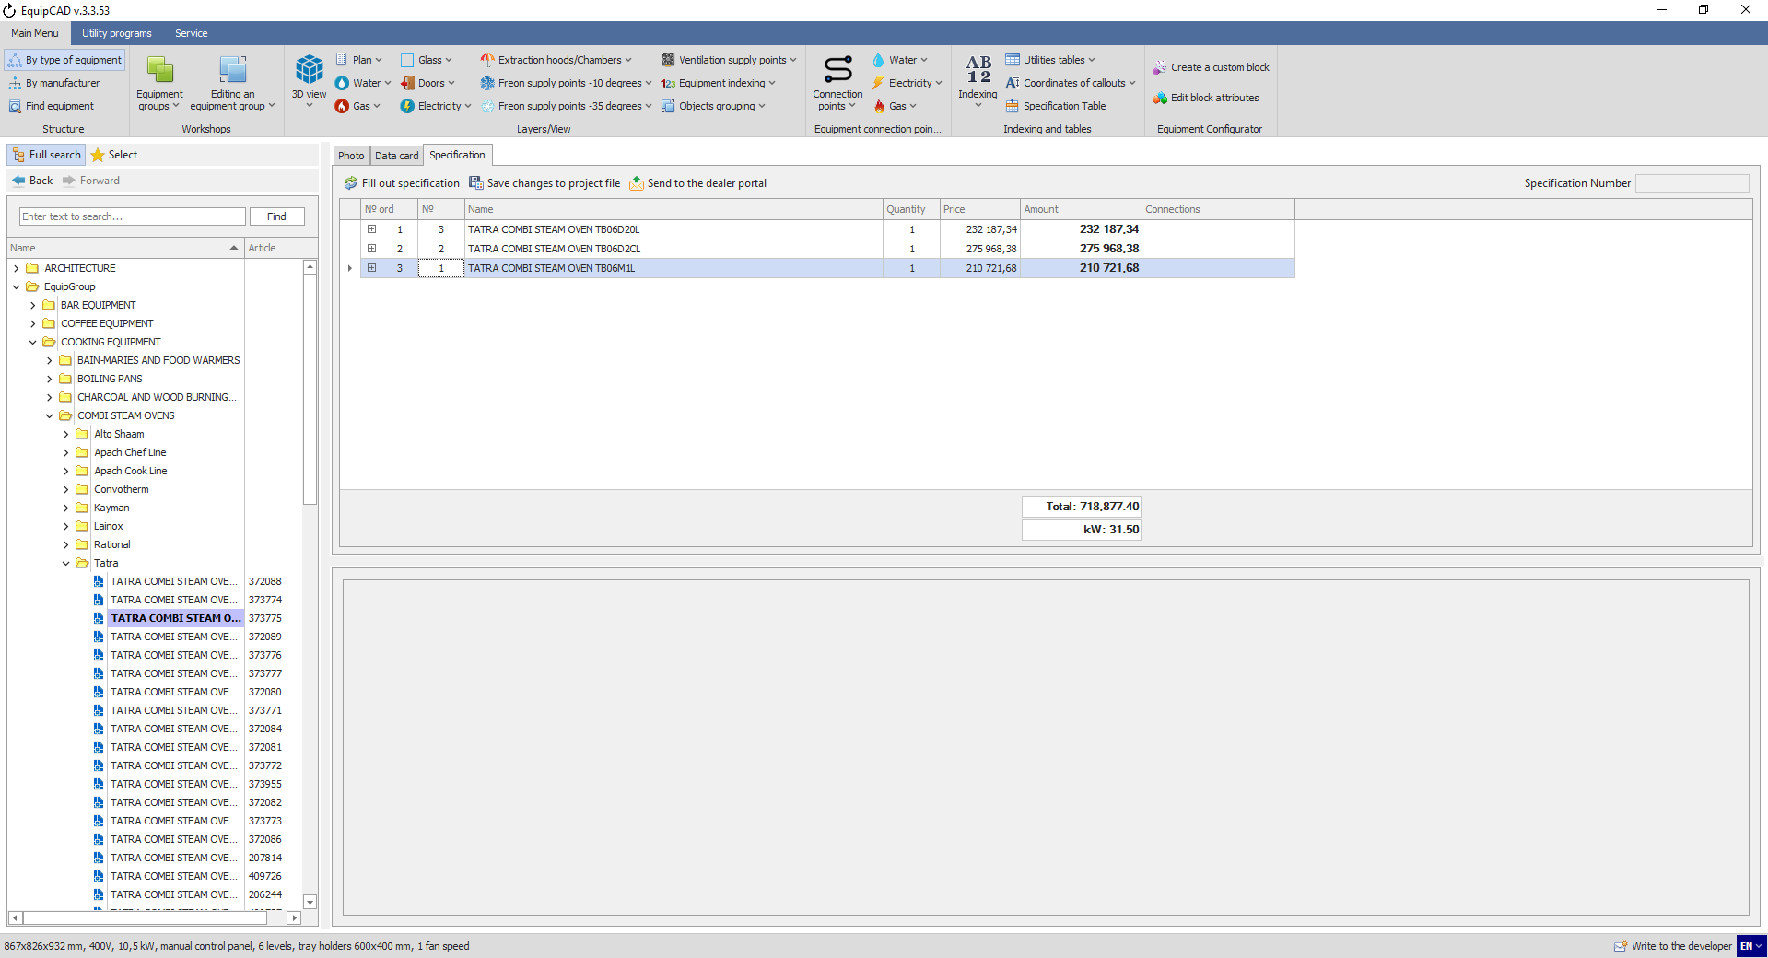
9.3.5
9.3.4
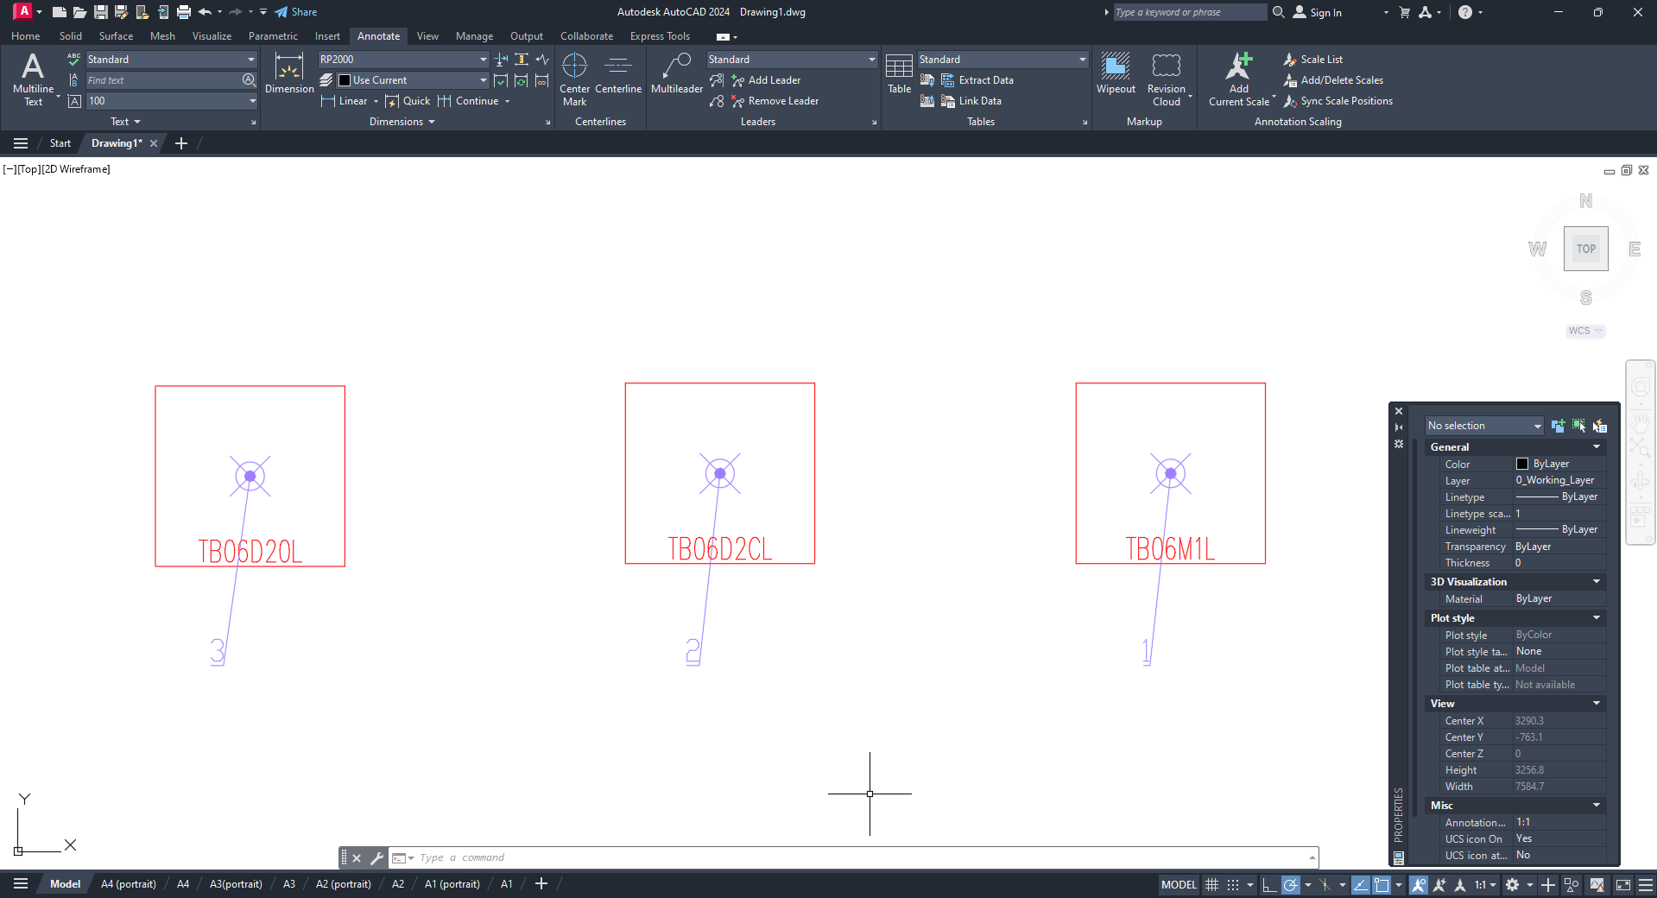
As you can see, the numbering in the project has changed, but the order in which the equipment is located in the specification has remained the same.

    - Change the numbers in the column “№ ord” in accordance with the column “№”;
    - Then we click the “Save changes to project file” button and fill out the specification again;
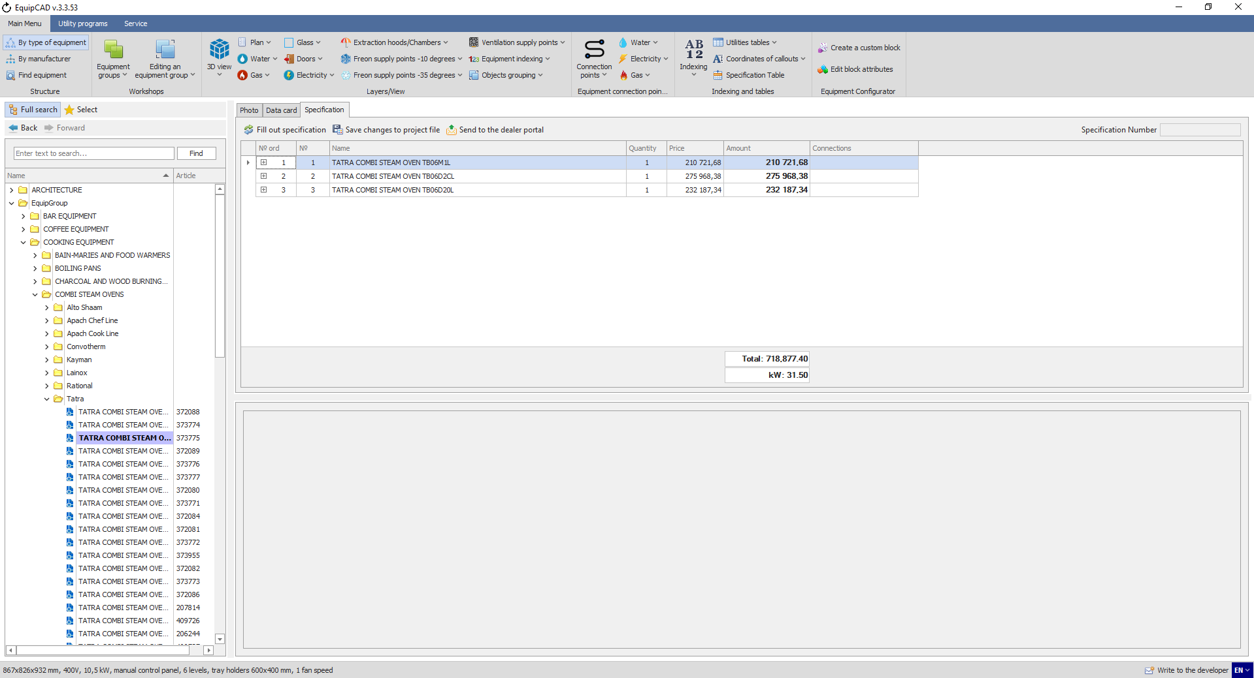
Now the order of equipment in the specification corresponds to the equipment numbers.

  - Saving and deleting callout coordinates
The button for saving callout coordinates allows you to leave the position of callouts unchanged when the numbers and connection points are removed and assigned again.
    - To save callout coordinates, click the “Coordinates of callouts” button in the “Indexing and tables” menu;
    - Select “Save” in the drop-down menu;
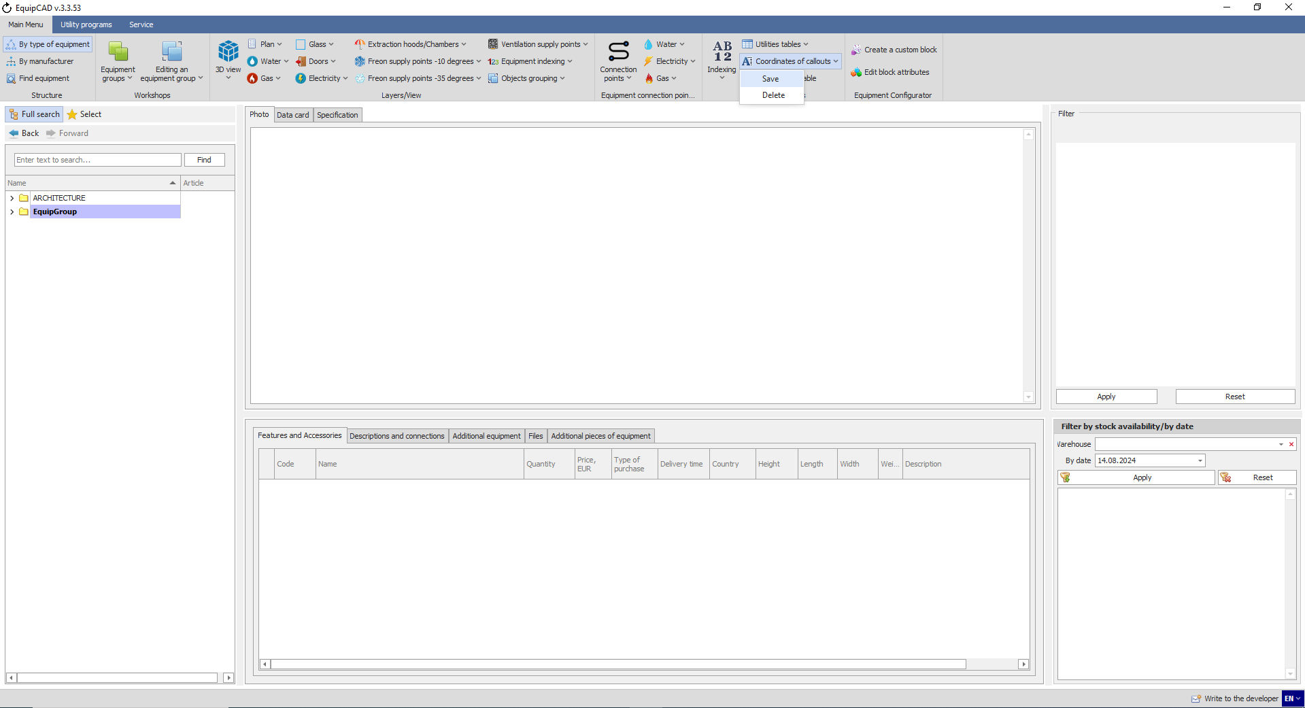
9.3.2
9.3.1

    - To delete callout coordinates, click the “Coordinates of callouts” button in the “Indexing and tables” menu;
    - Select “Delete” in the drop-down menu;
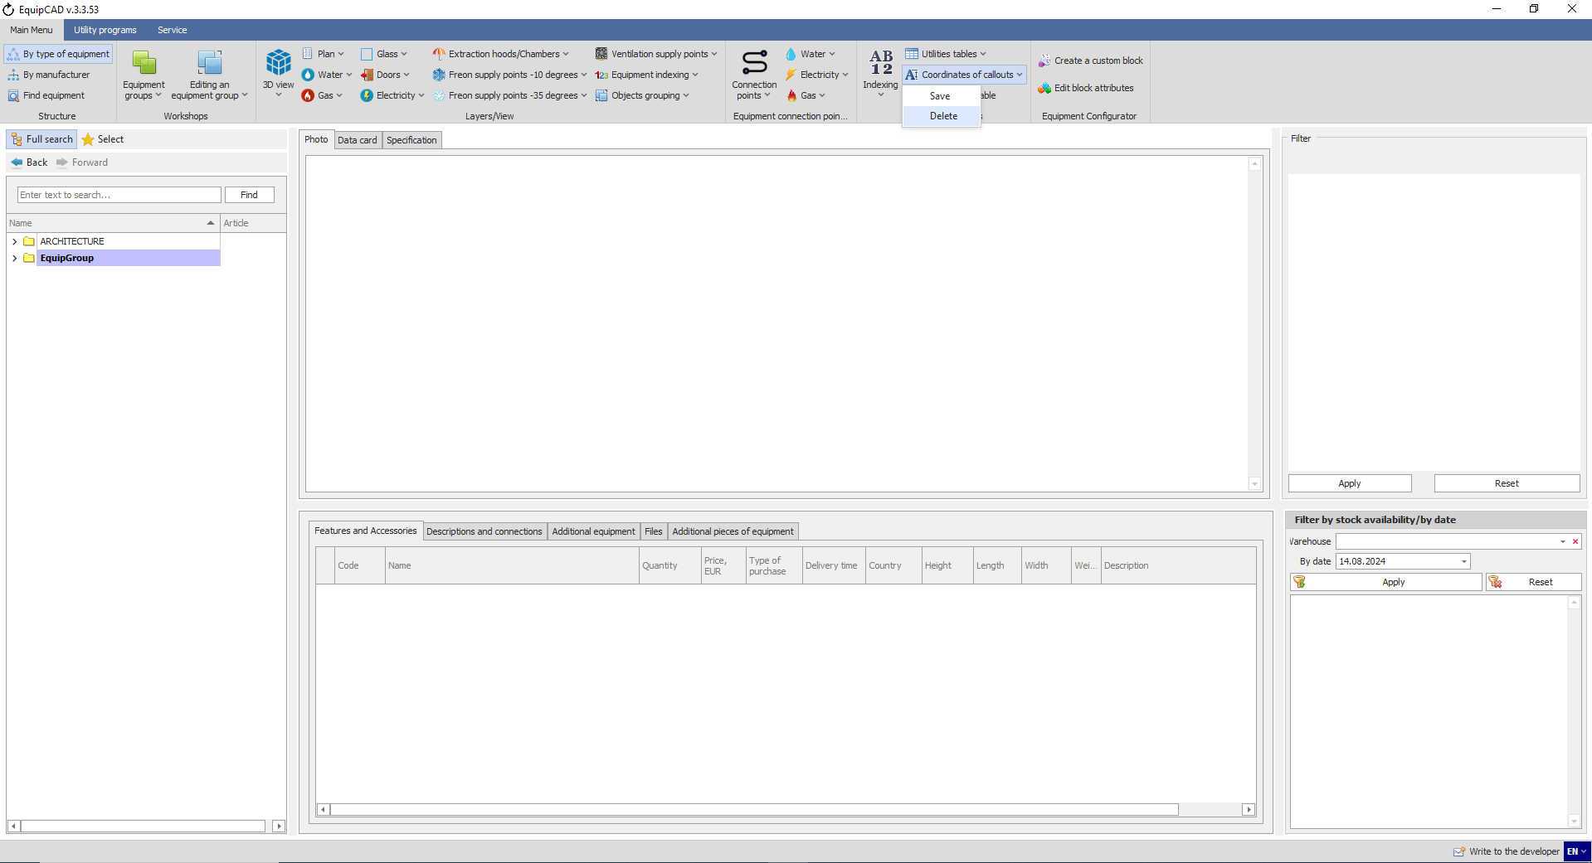
9.3.4
9.3.3

- Creating a specification
10.1 Specification in the program
10.2 Excluding equipment from the specification
10.3 Sorting workshops in the specification
10.4 Specification on the portal
10.5 Specification on the drawing
10.6 Explication table

  - Specification in the program

    - To create a specification in the program, go to the Specification tab;
    - Click the “Fill out specification” button;
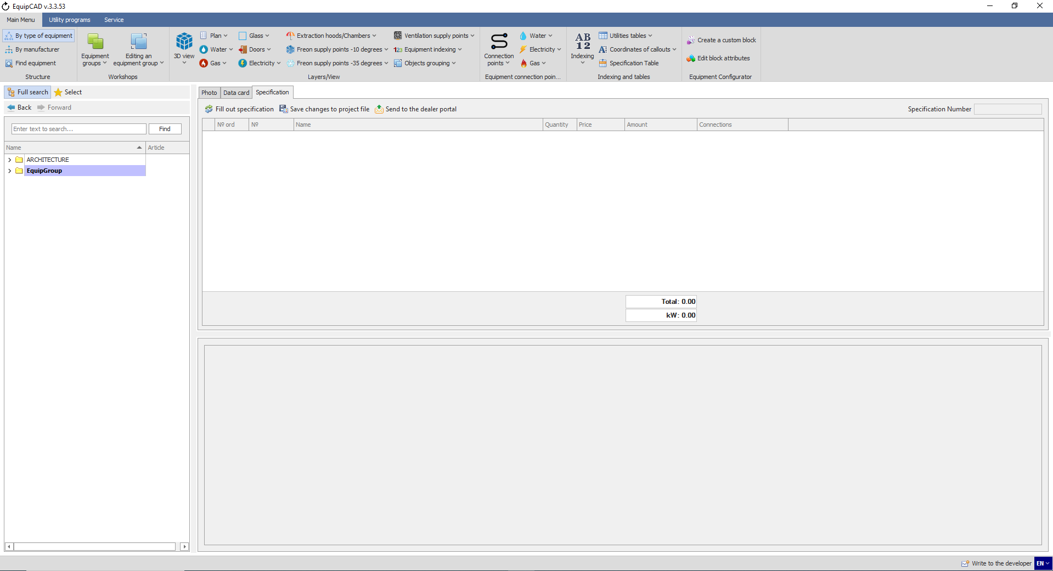
10.1.1
10.1.2

    - A specification to be displayed in the program includes: a breakdown by workshop; equipment number, name, quantity and price; cost based on the number of units; total cost and electrical capacity of the project (equipment without a workshop is listed in the beginning of the specification).
    - You can find equipment in the tree or in the project by right-clicking the equipment item in the specification (in the same manner as in section 6.7);
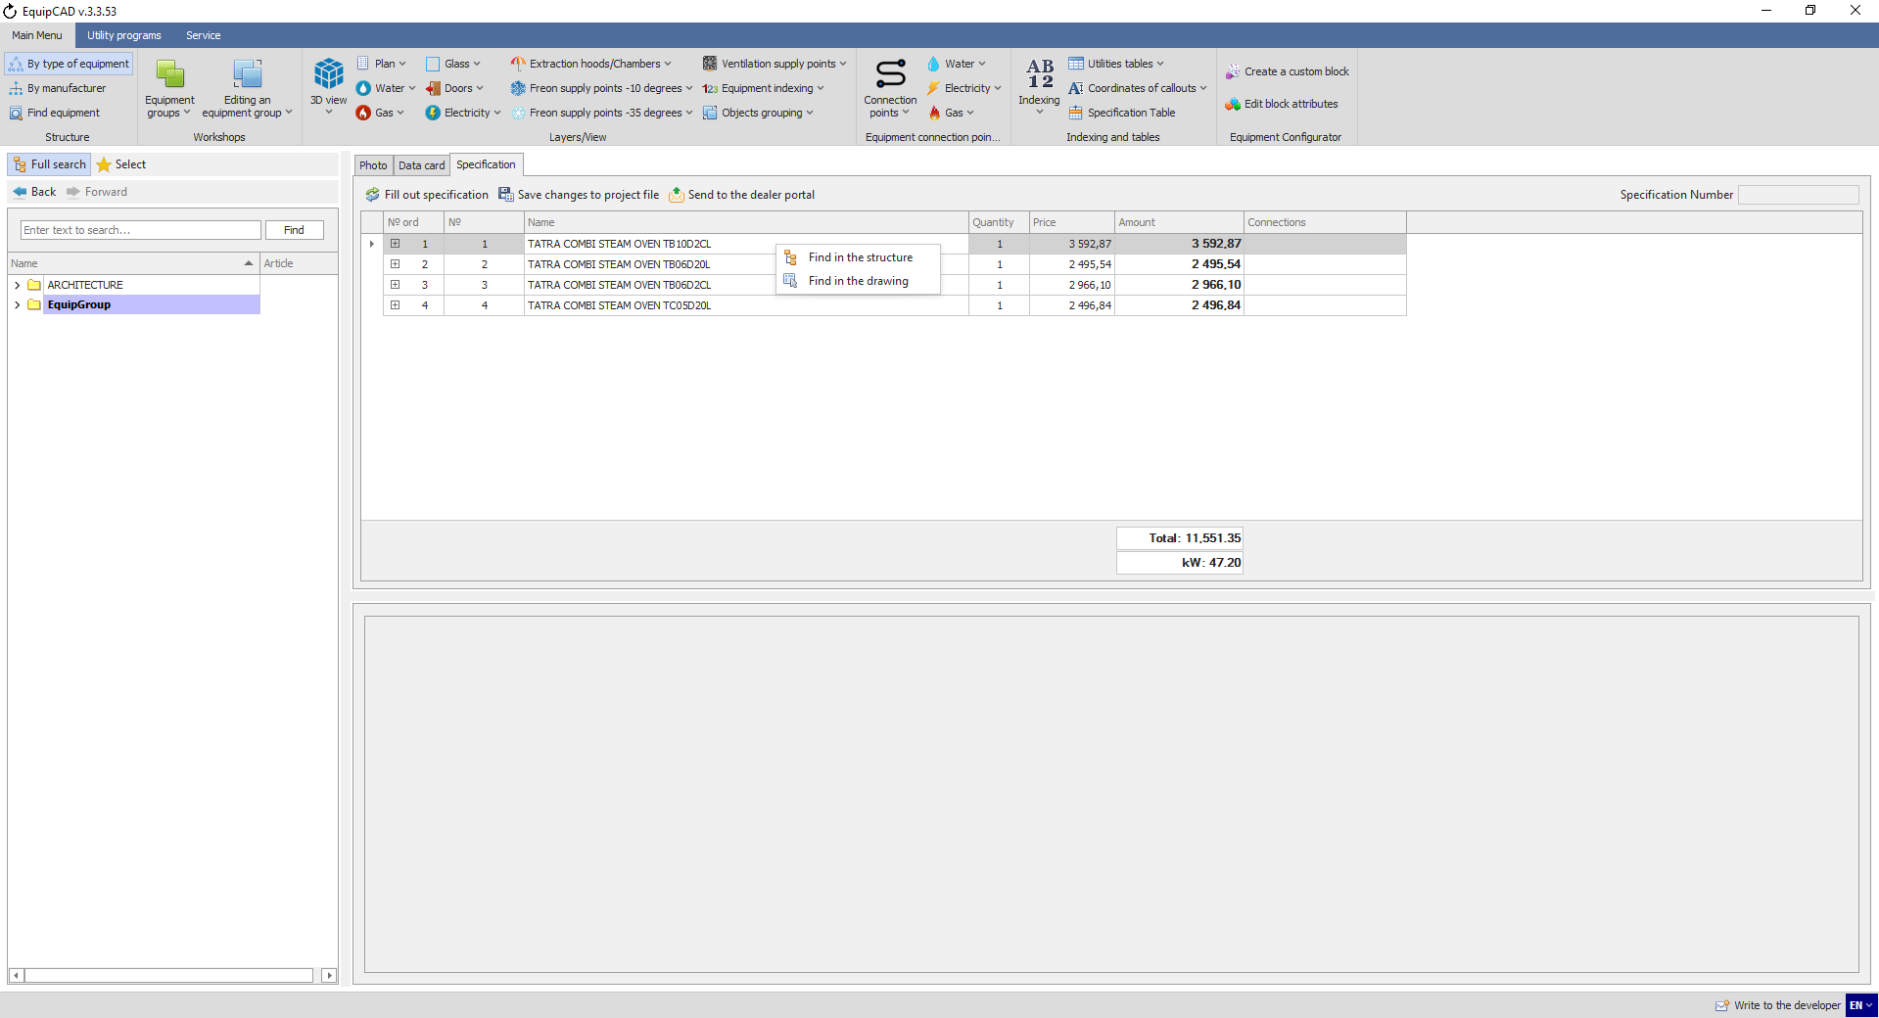
10.1.4
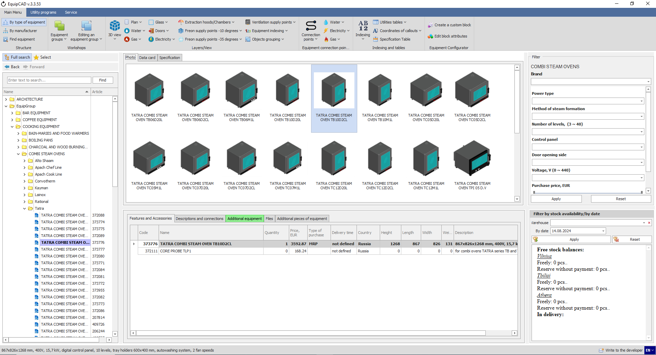
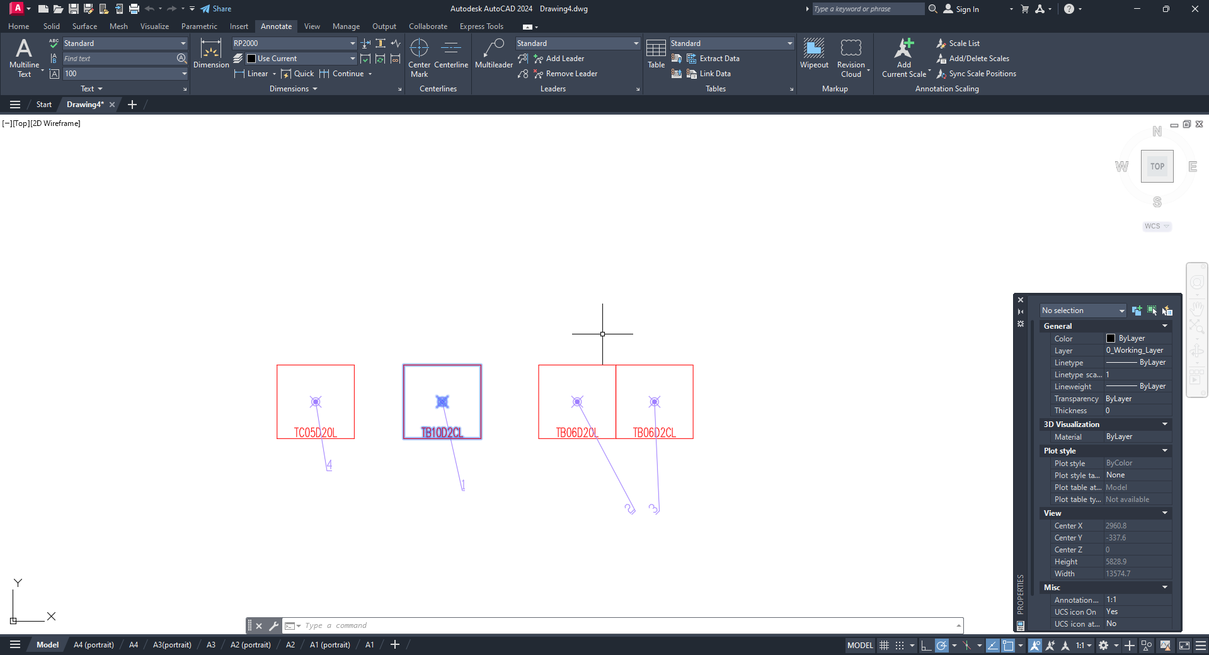

    - To view equipment accessories, click “+” to the left of the equipment number;
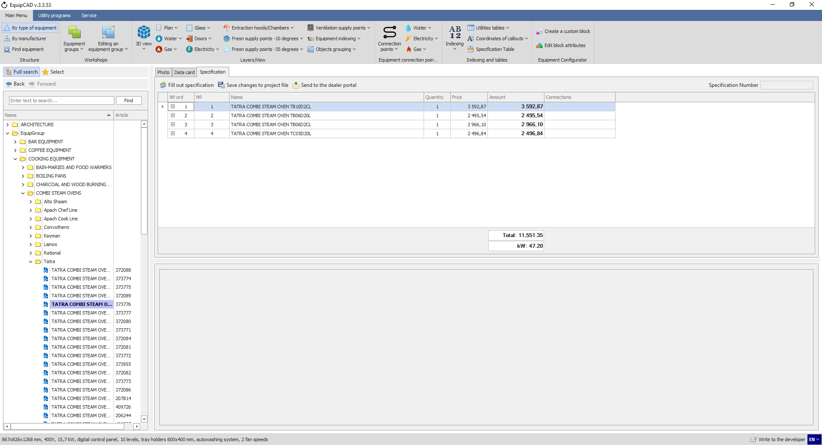
10.1.5

    - You can edit the quantity of accessories. If you don’t need an accessory, uncheck the box to the left of its name;
    - Once the editing of accessories is complete, click the “Save the accessory list in the project” button;
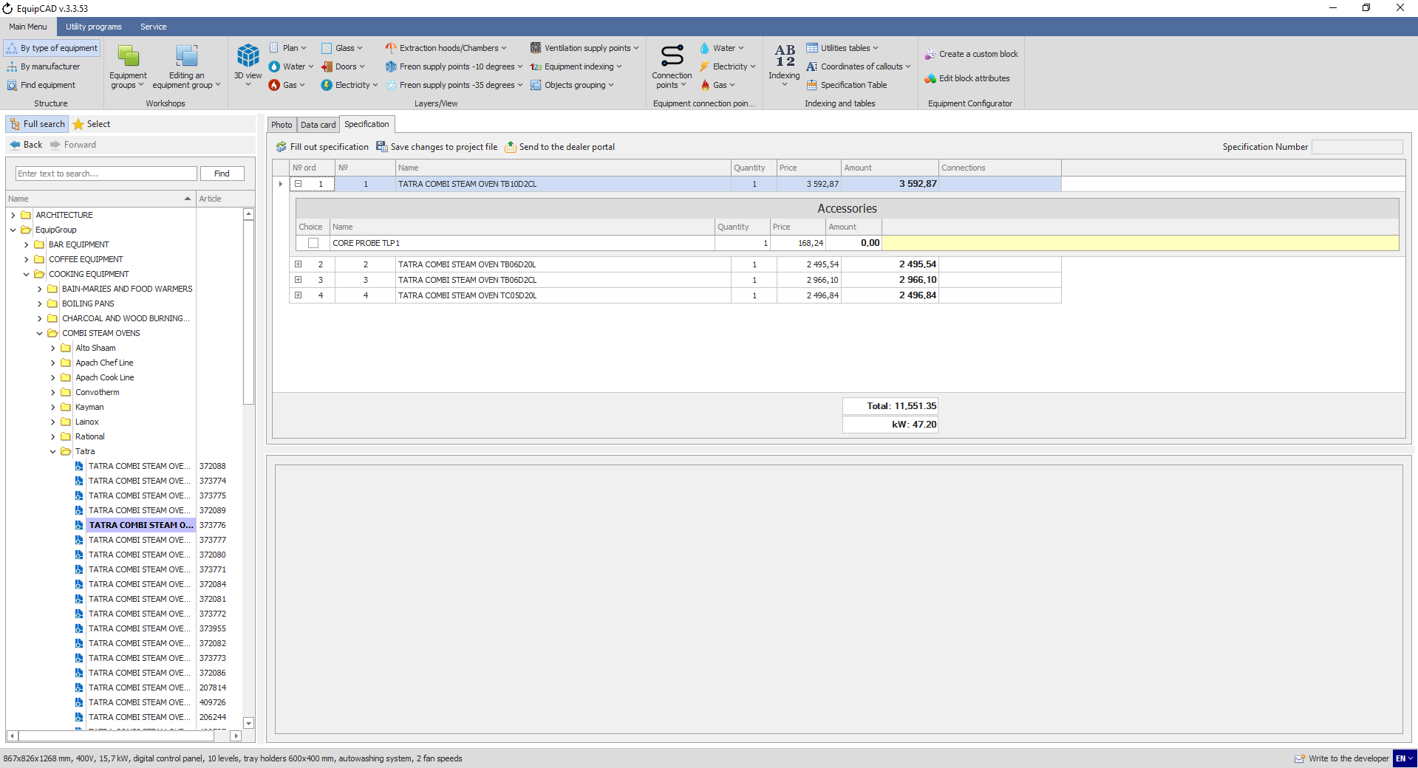
10.1.7
10.1.6

    - The program settings allow you to choose whether or not accessories will be added to each item by default.
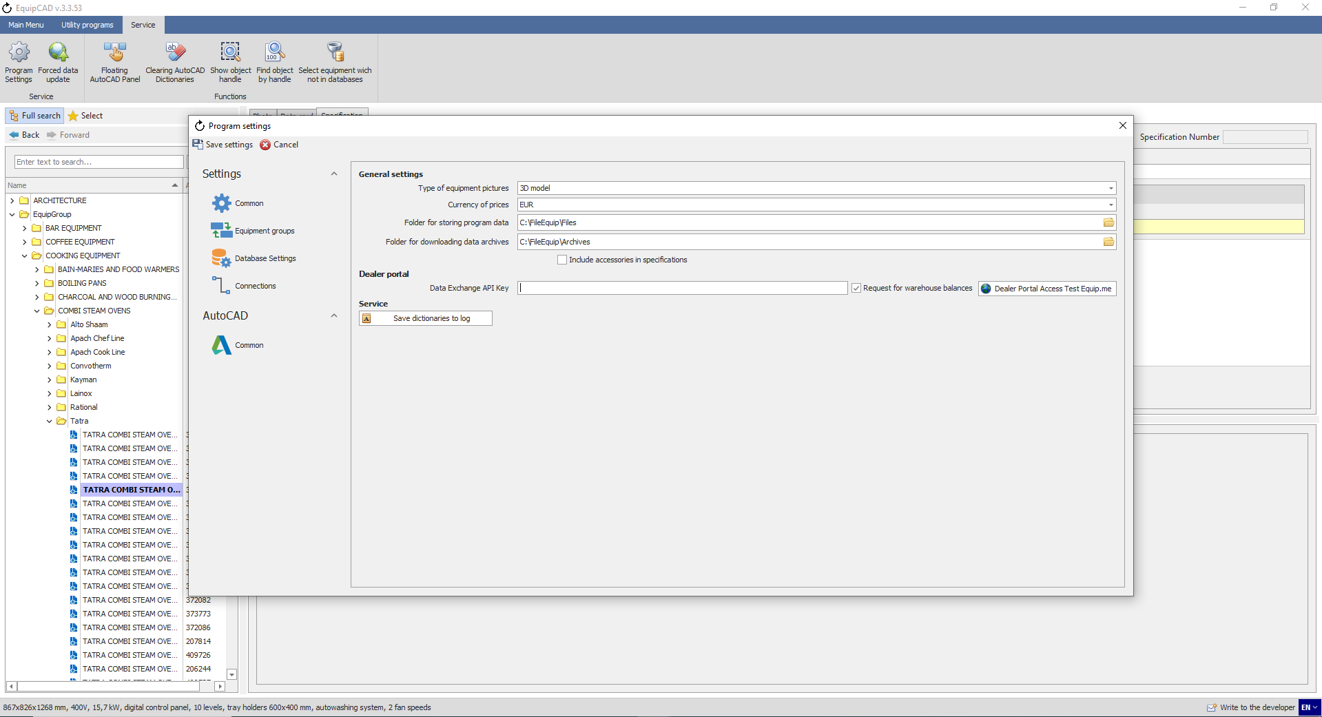
10.1.8

    - When the “Work with Architecture as with main equipment” setting is enabled, the equipment of the Architecture group will be displayed in the specification in the program and on the portal.
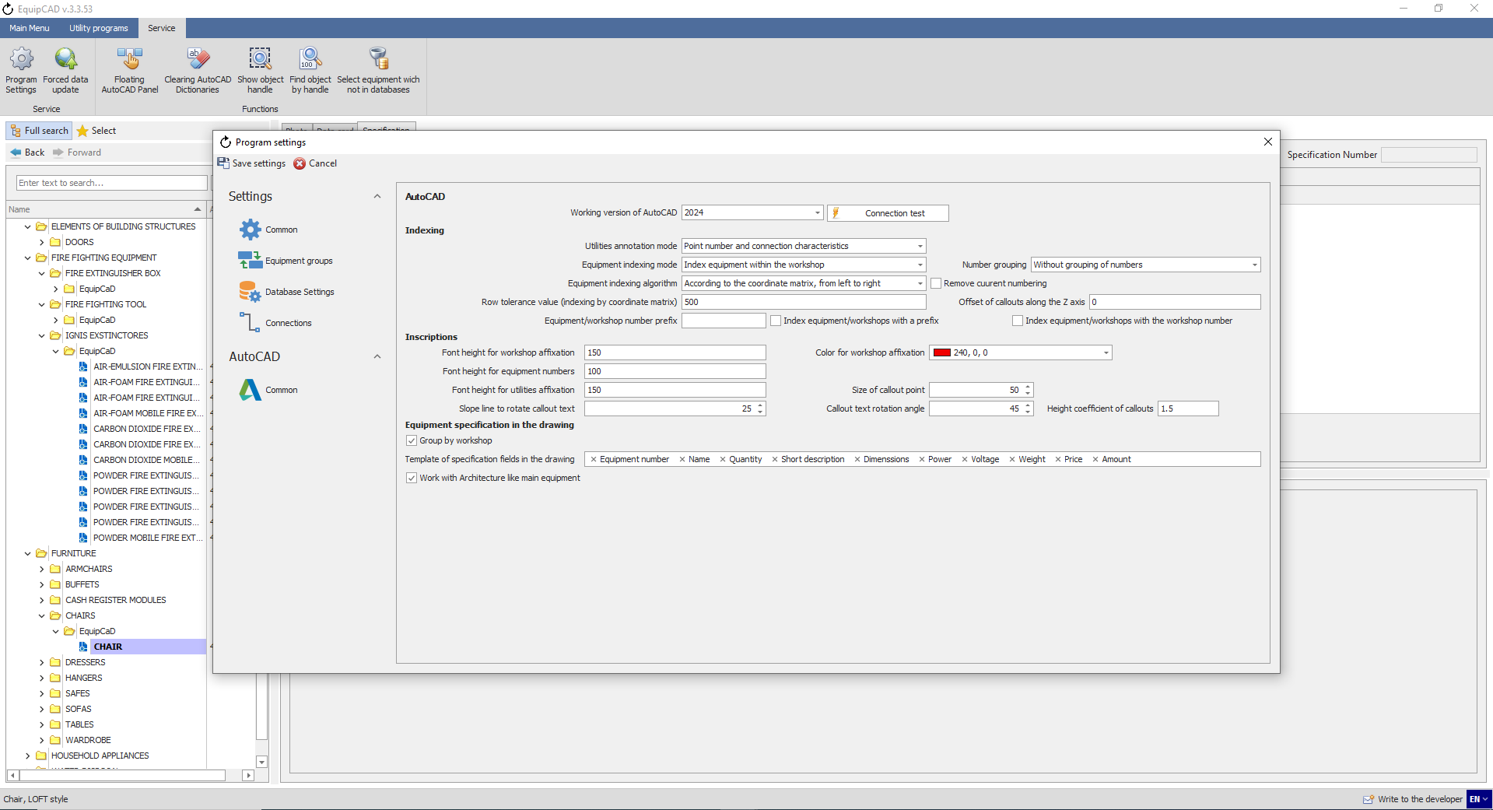
10.1.9
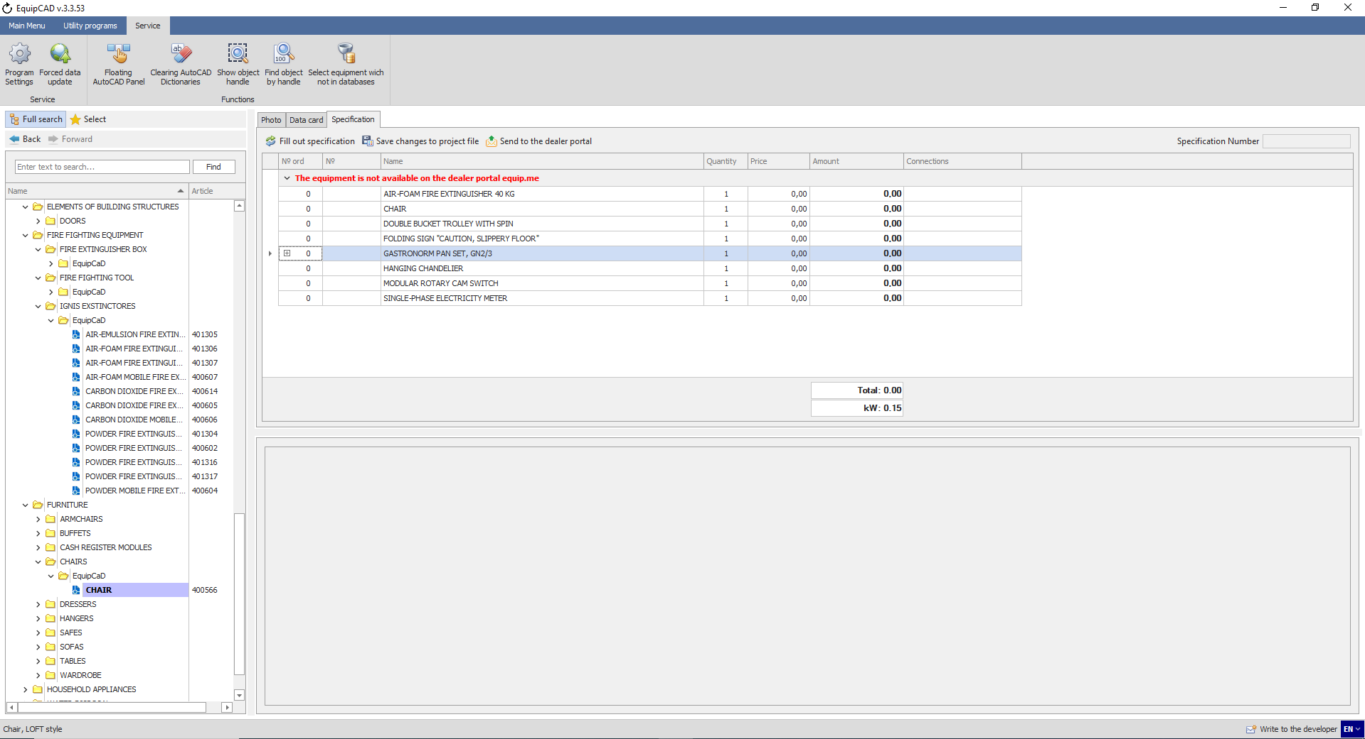
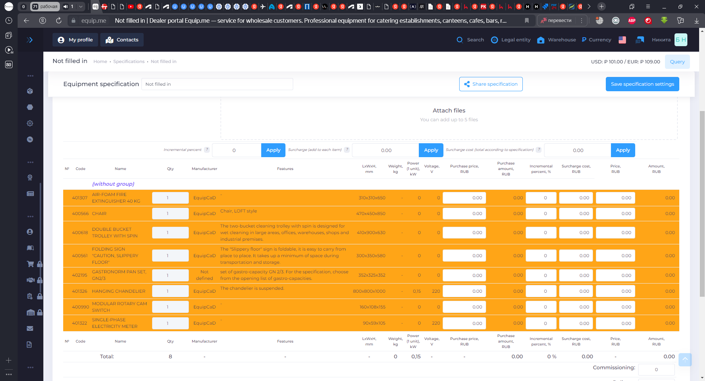

    - Similar to the product card in the specification, the last column contains links to the product card on the portal;
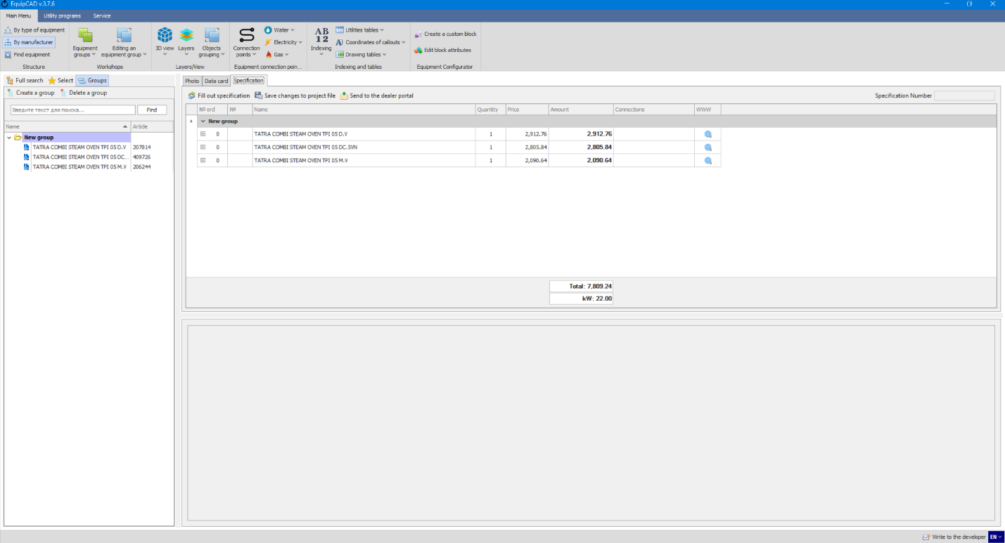
10.1.10
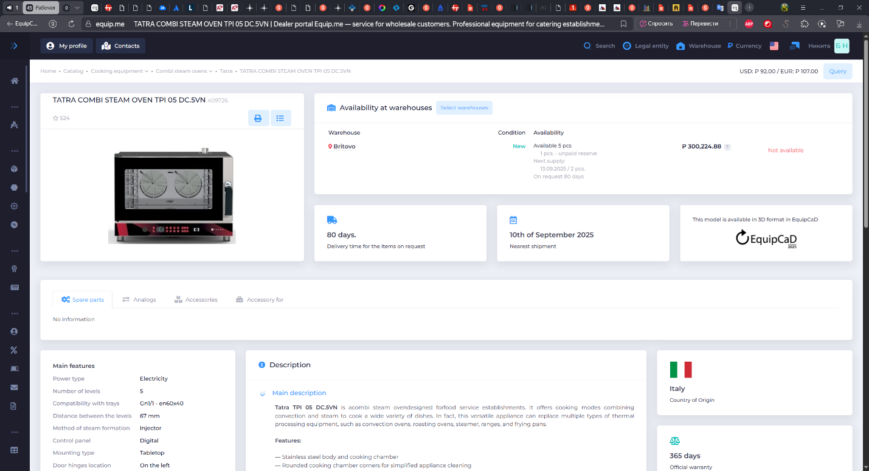

  - Excluding equipment from the specification
Using the "Work only with equipment in the workshops" setting, you can exclude individual units of equipment from your project. To do this, you need to:
    - Go to the “Service” tab;
    - Click the “Program settings” button;
    - Select the "AutoCAD Common" section;
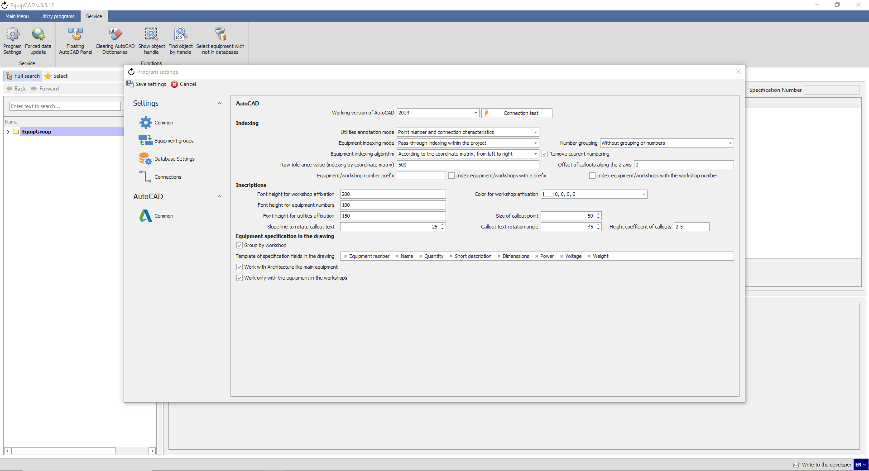
10.2.3
10.2.2
10.2.1

    - When the “Work only with equipment in the workshops” setting is enabled, all equipment that has not been added to any workshop will not: be displayed in the specification in the program and on the portal, have a number, have connection callouts;
10.2.4

    - For example, let's add 2 units of equipment to the drawing, one of which we will add to the workshop;
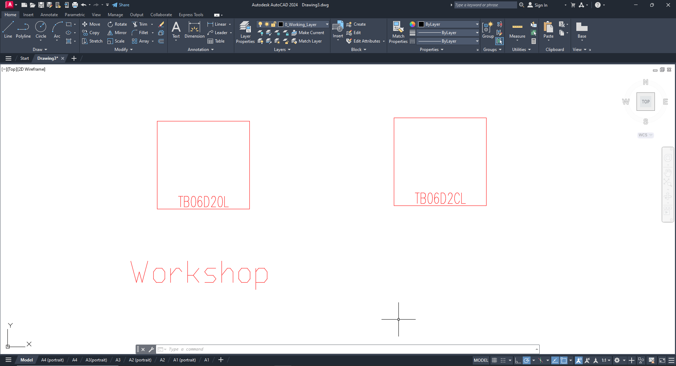

    - We will add numbering and footnotes;
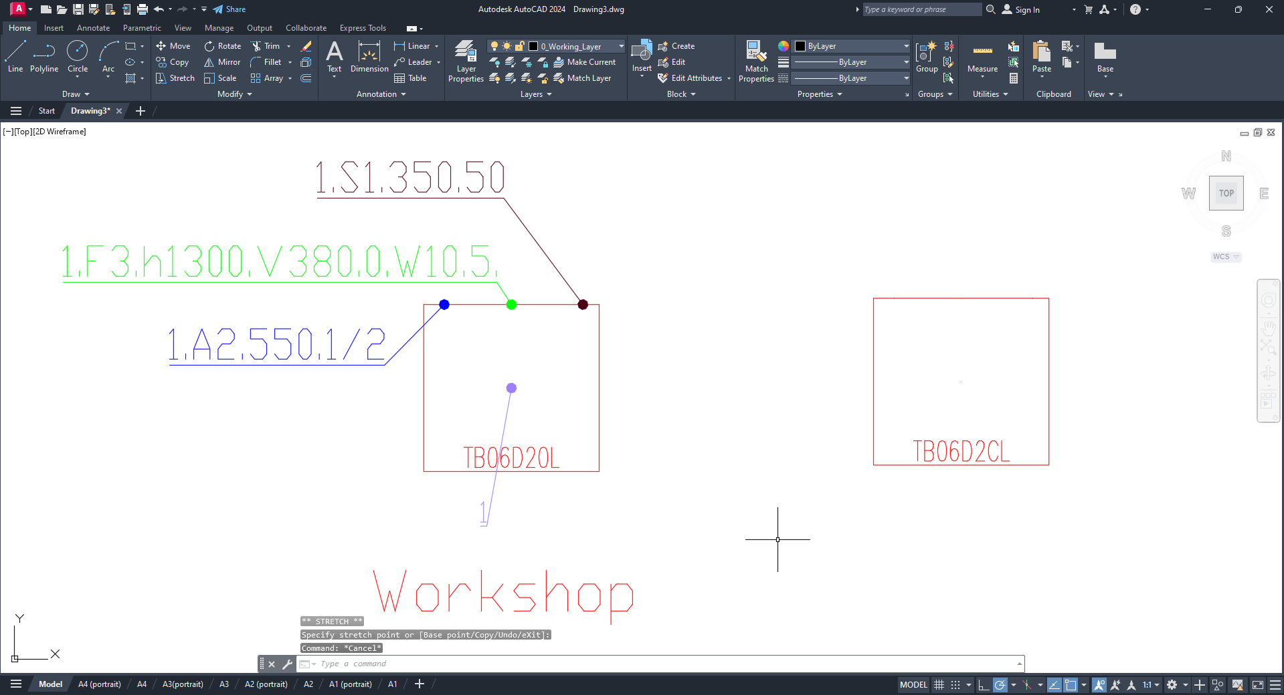
As we can see, on the drawing, numbering and callouts appeared only for the equipment that was added to the workshop.

    - Let's fill in the specification in the program;
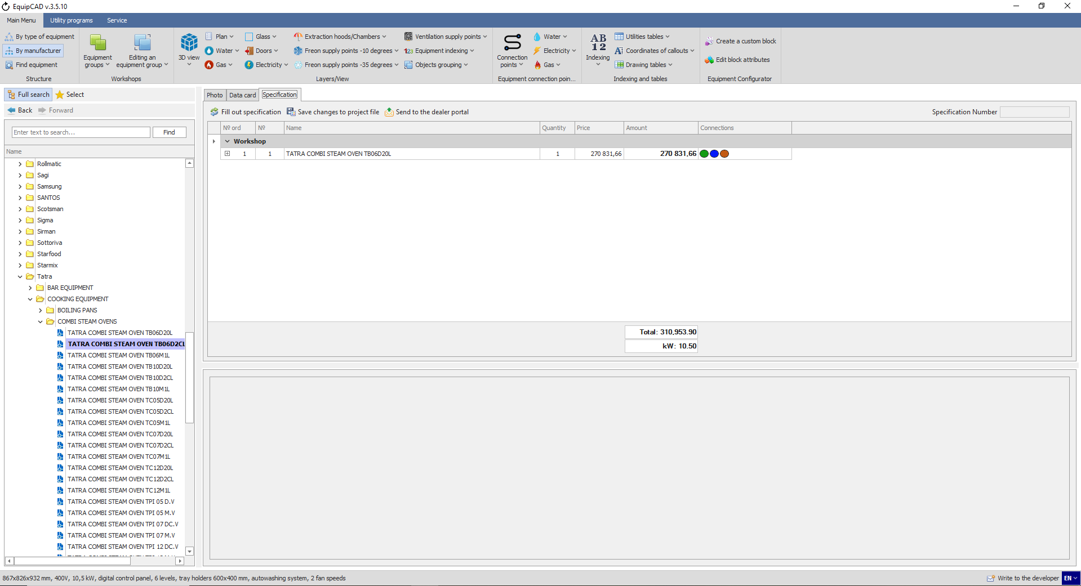
As we can see, the specification only displays the equipment that was added to the workshop.

  - Sorting workshops in the specification

    - To sort workshops, click the “Editing an equipment group” button in the Workshops menu;
    - Select “Order of equipment groups and prefixes” in the drop-down menu;
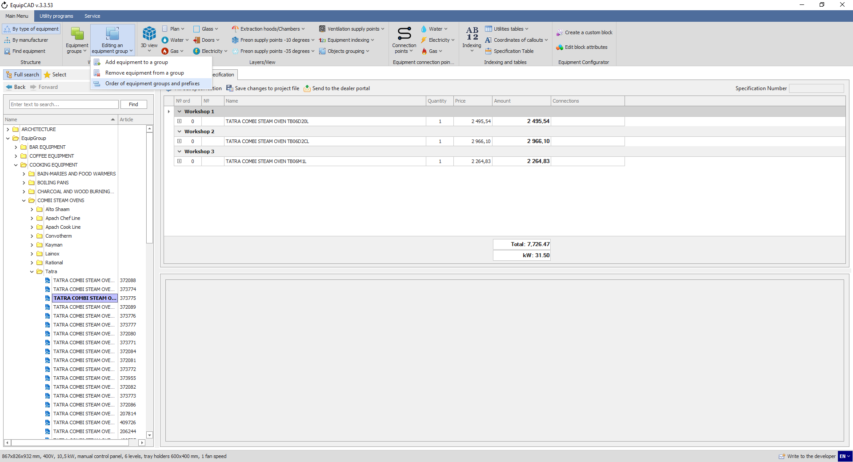
10.3.2
10.3.1

    - In the window that opens, select the desired workshop;
    - Move workshop 1 to the second position using the Up and Down arrows;
    - Click the Save button;
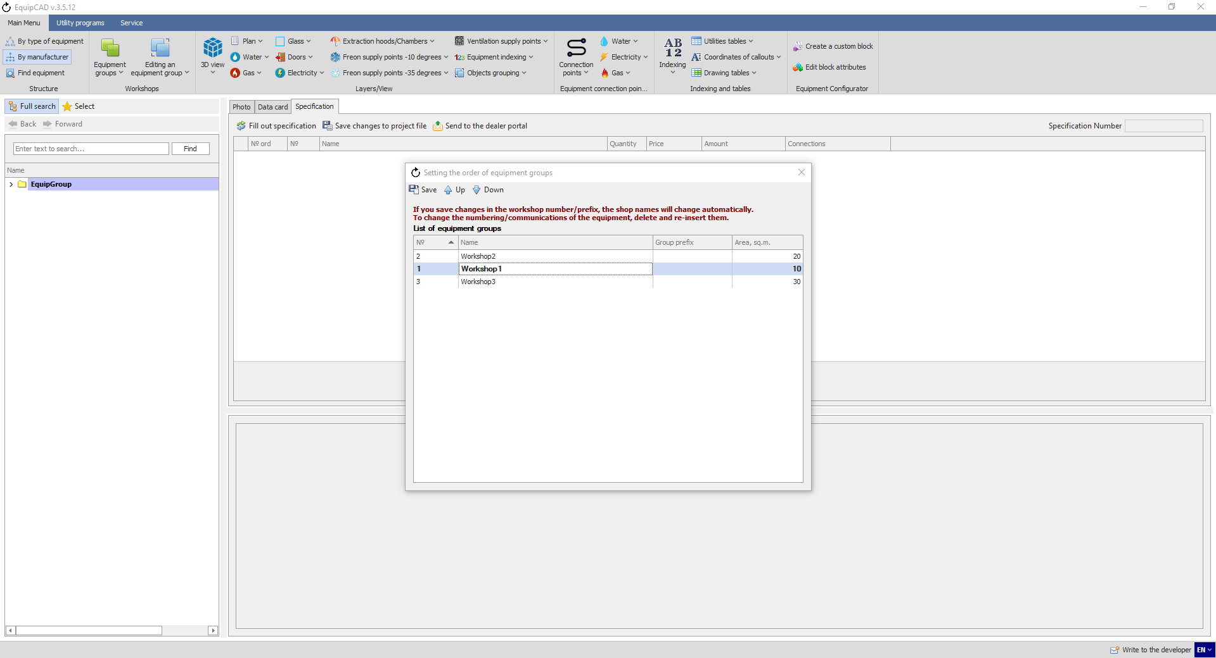
10.3.3
10.3.4
10.3.5

    - To check the changes, click the “Fill out specification” button;
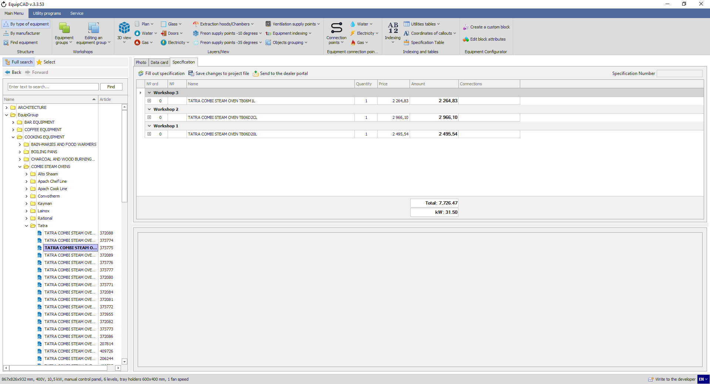

  - Specification on the portal

    - To send your specification to the portal, click “Send to the dealer portal” button on the Specification tab;
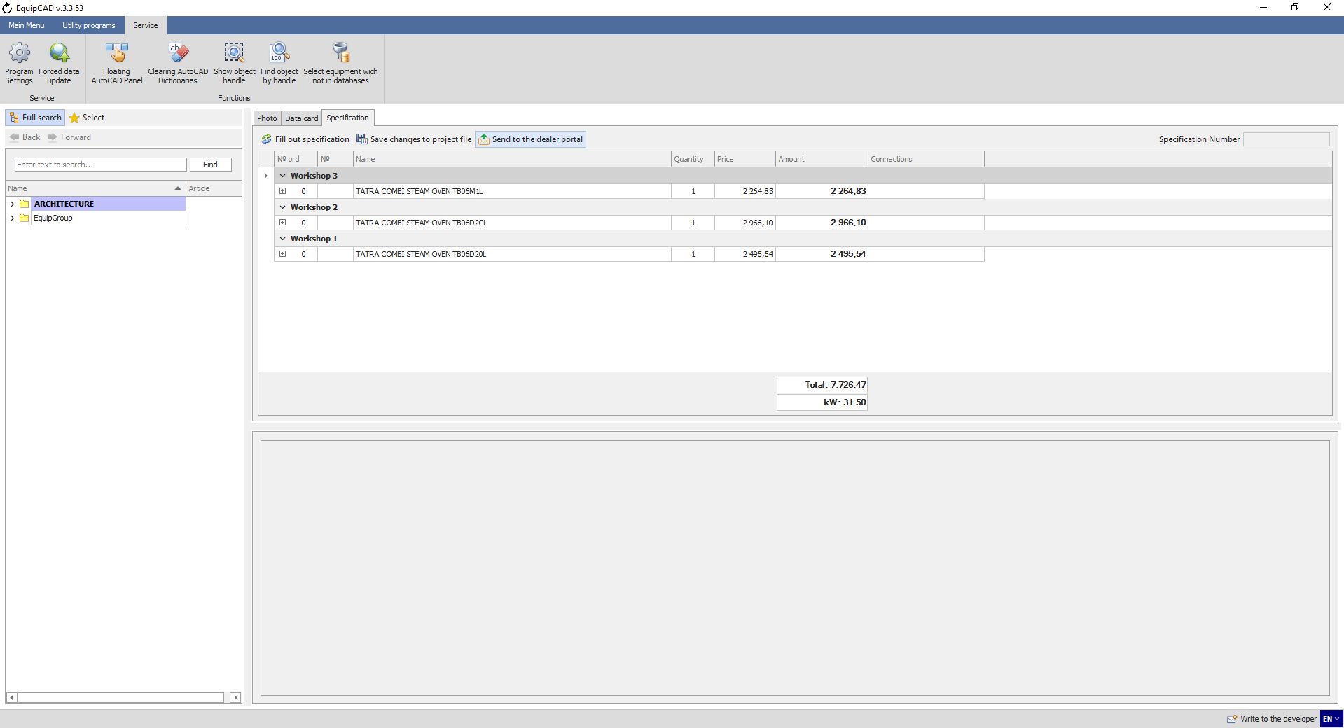
10.4.1

    - The program will automatically assign the number of your specification which will be displayed in the notification window and in the upper right corner of the Specification tab;
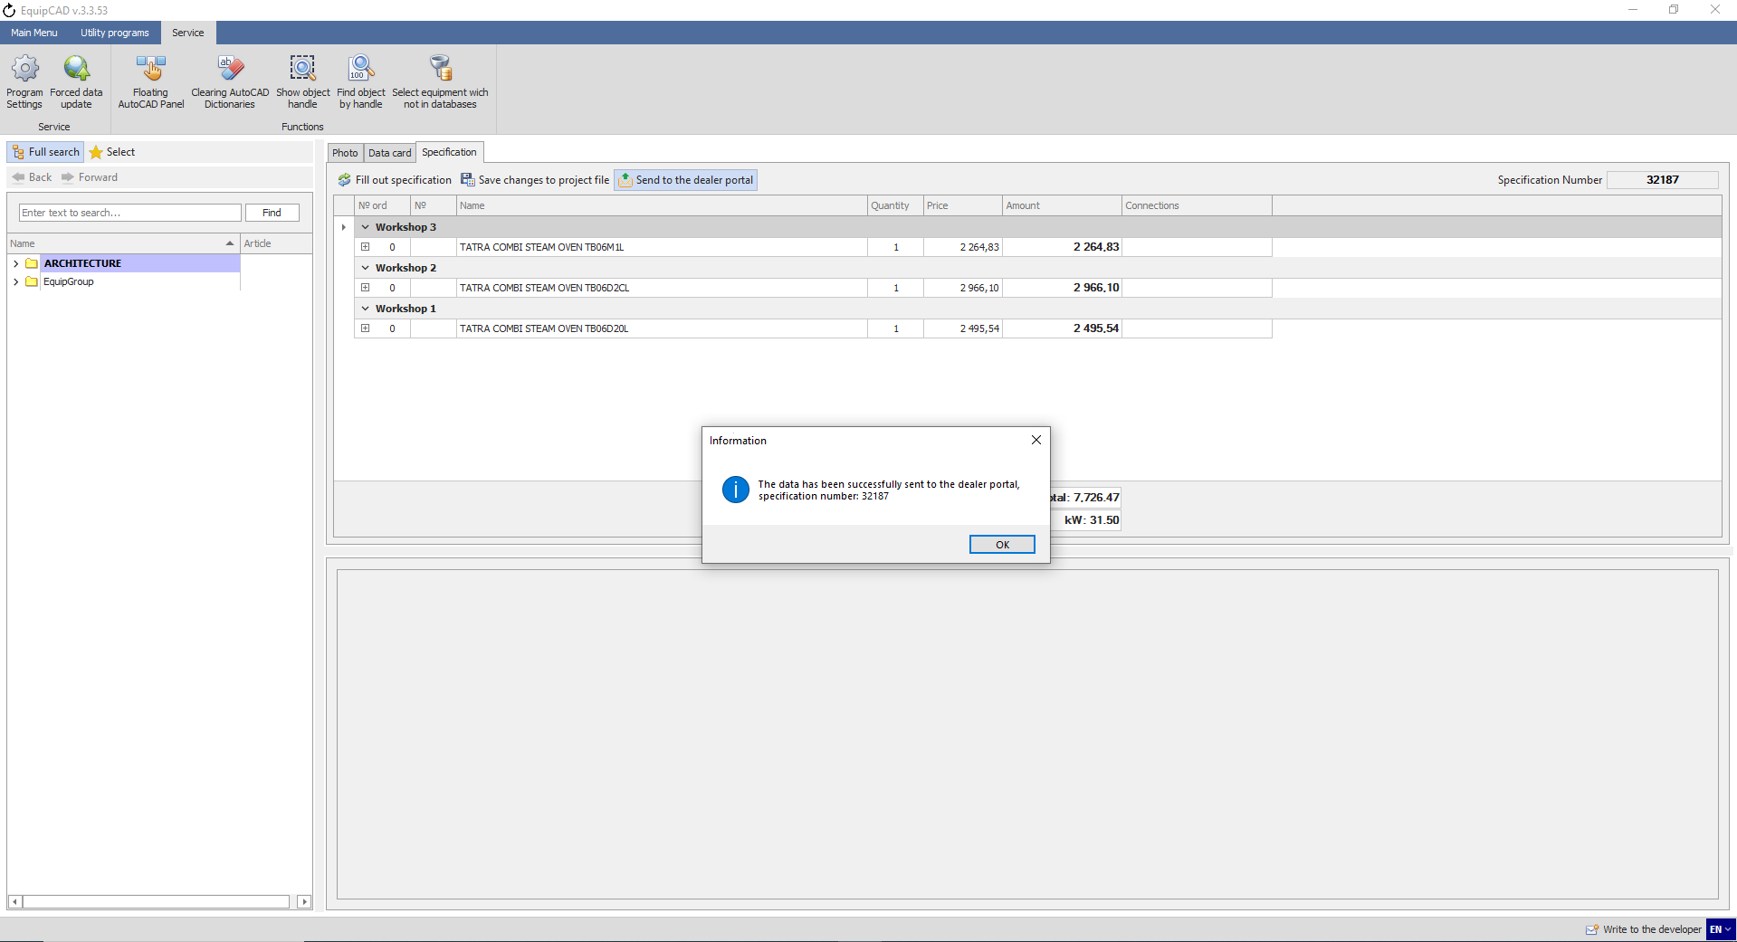
10.4.2
Note: If a specification you are sending to the portal includes any equipment items that are not available on the portal, the program will open a window in which you can choose whether to send the entire specification to the portal (Yes) or remove the equipment items that are missing on the portal (No).
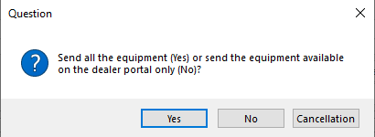
    - Go to the “Specifications and quotations” tab on the portal at equip.me;
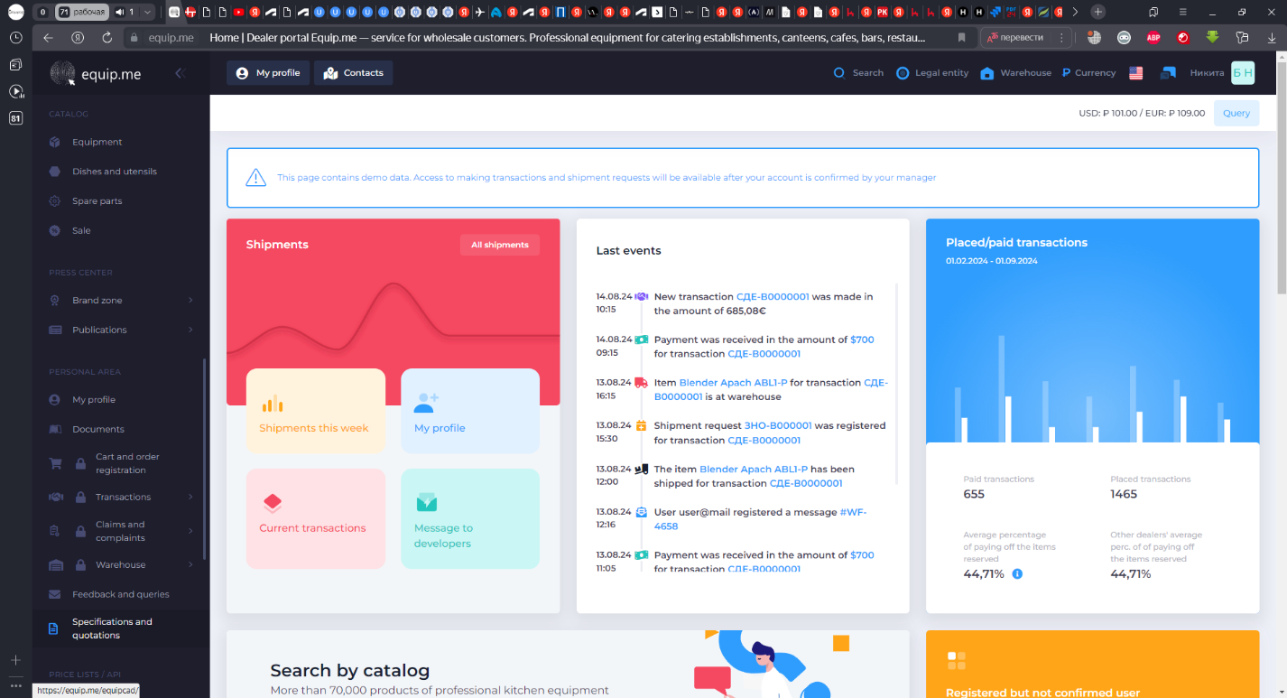
10.4.3

    - Find the ID assigned and go to the specification on the portal (specification number in EquipCaD = ID on the portal);
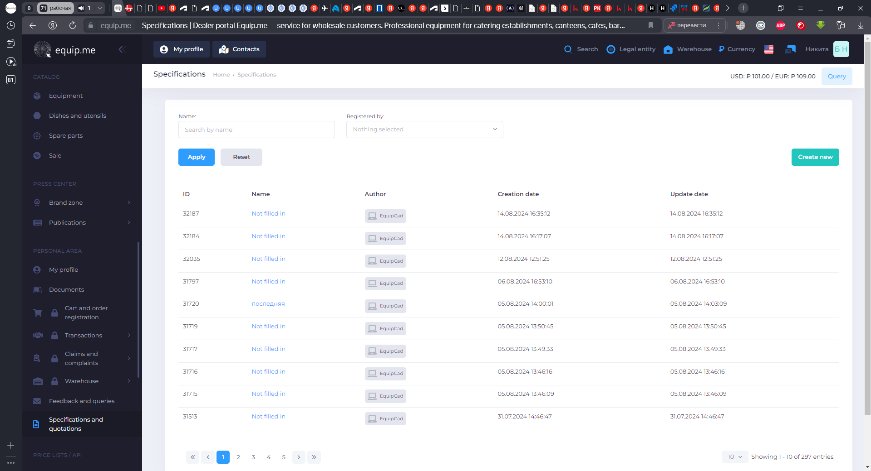
10.4.4

    - Upload a logo;
    - Enter necessary details;
    - Enter the markup percentage;
    - Click the “Save specification settings” button;
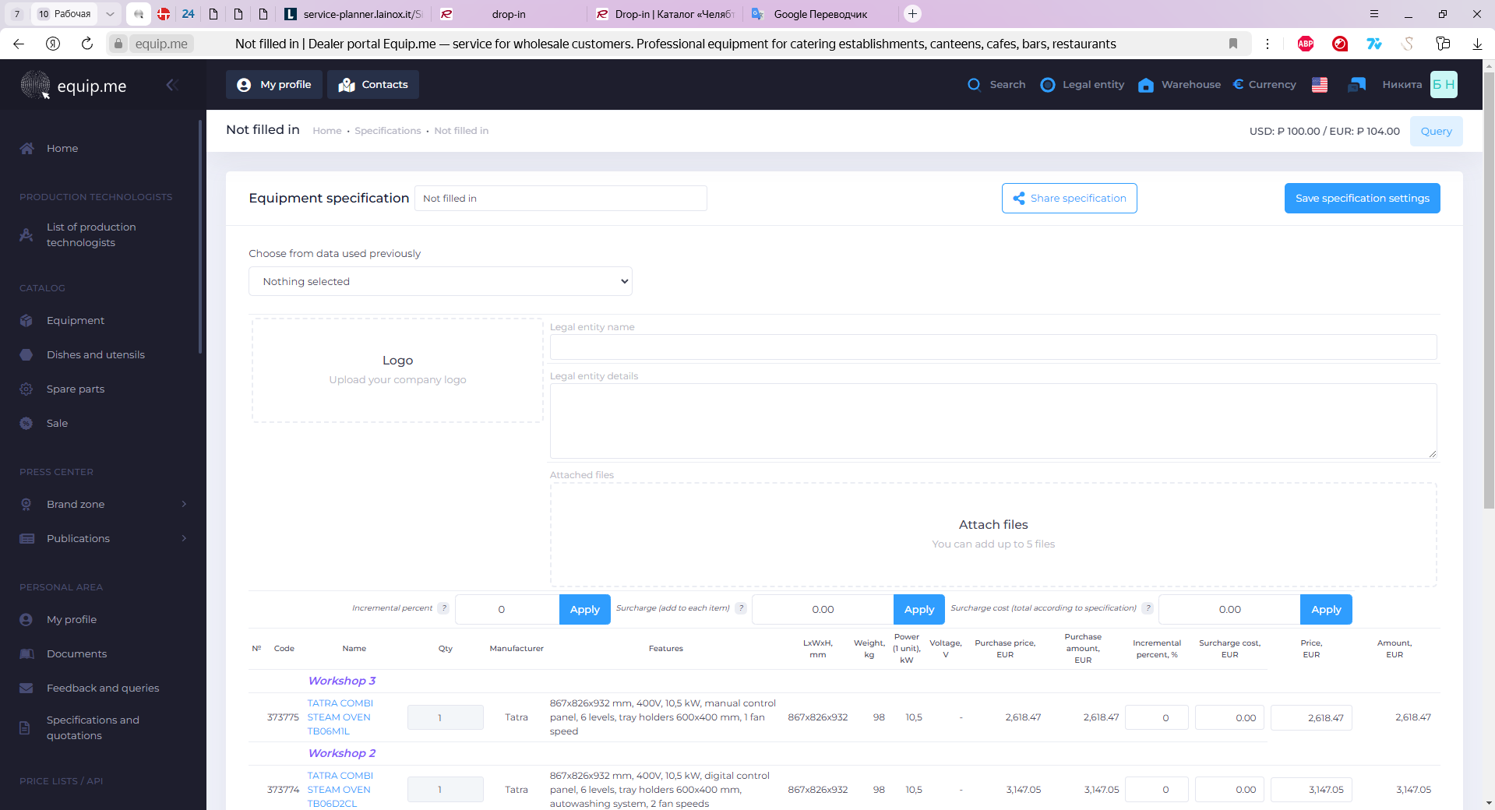
10.4.5
10.4.7
10.4.8
10.4.6

As we can see, the specification on the portal shows accessories, sorting by workshop, and all the data that we entered when creating the custom block;
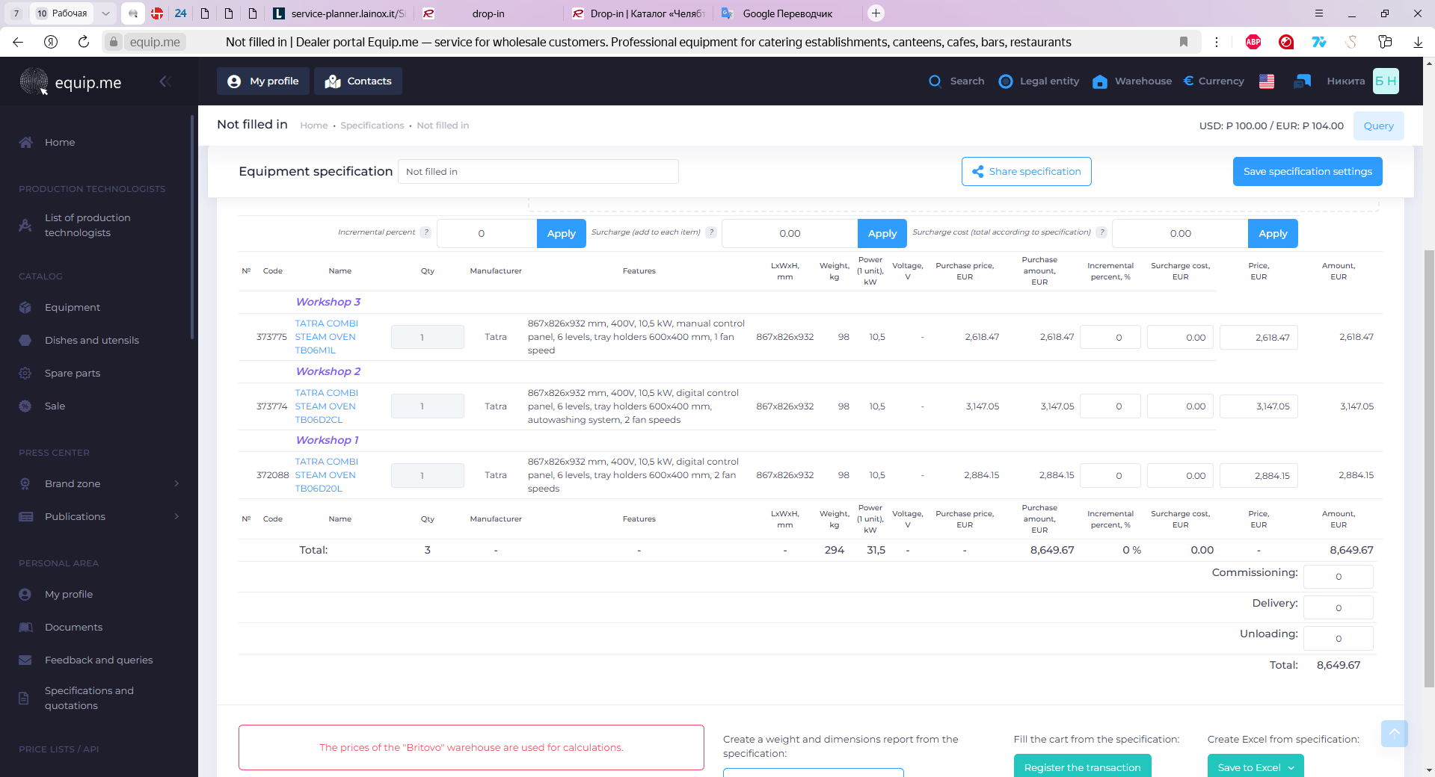

    - All the equipment items on the portal are active. Left-click the equipment name to view a product data card with instructions and a scheme;
10.4.9
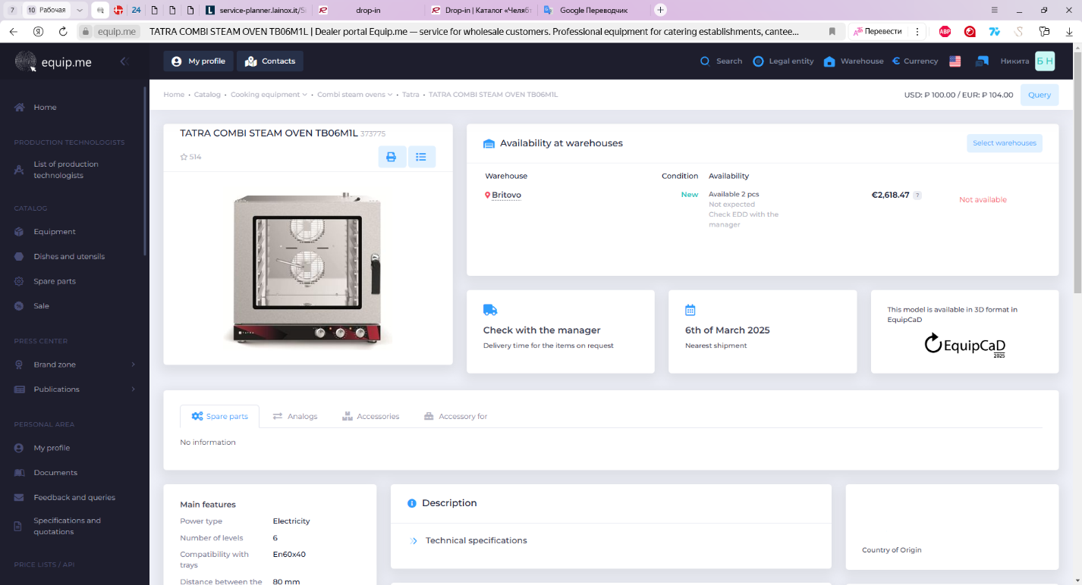

    - To save the specification, click the “Save in Excel” button, and the file will be automatically downloaded to the downloads folder on your PC. You can choose an option with or without photo, a GOST standard version, or 1C specification;
    - With the Close Transaction button, the goods and accessories from the specification you have created can be added to cart;
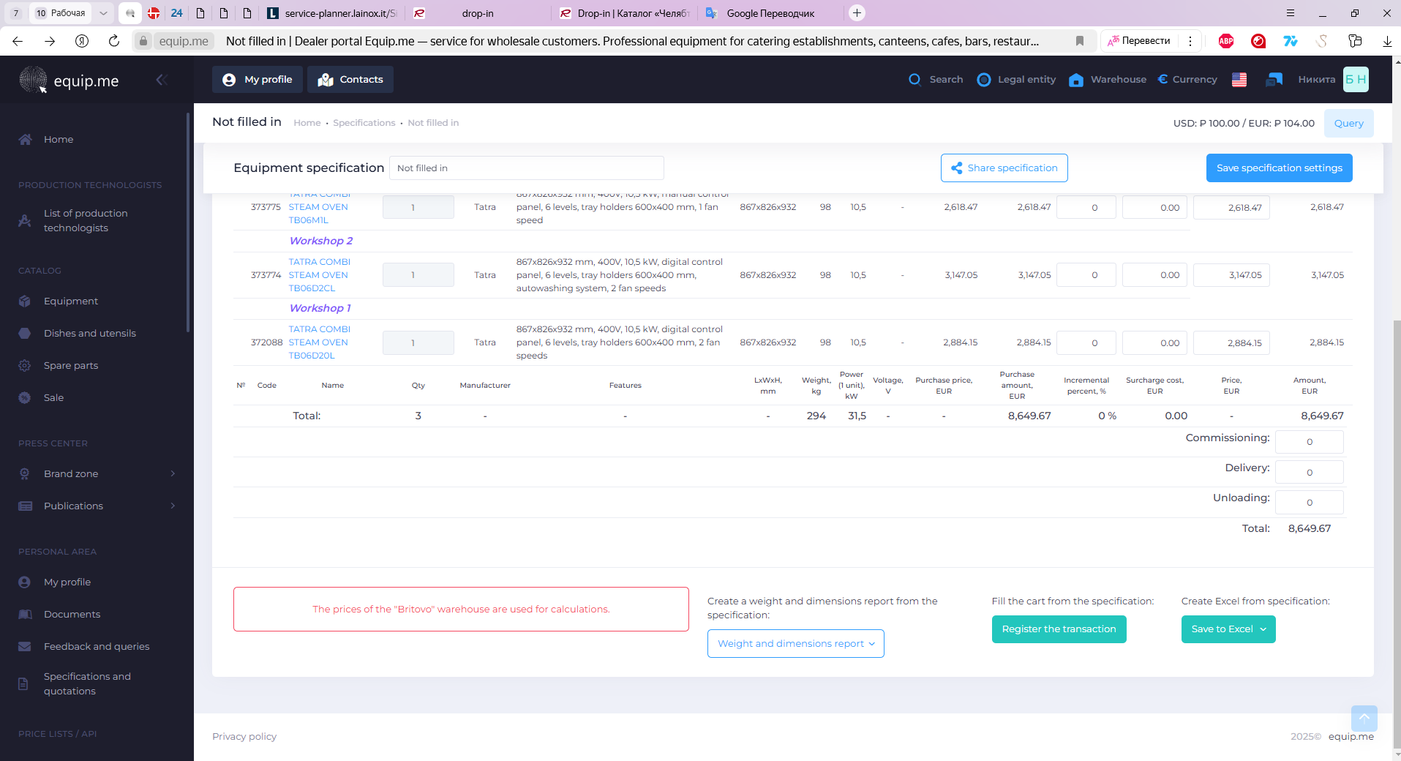
10.4.11
10.4.10
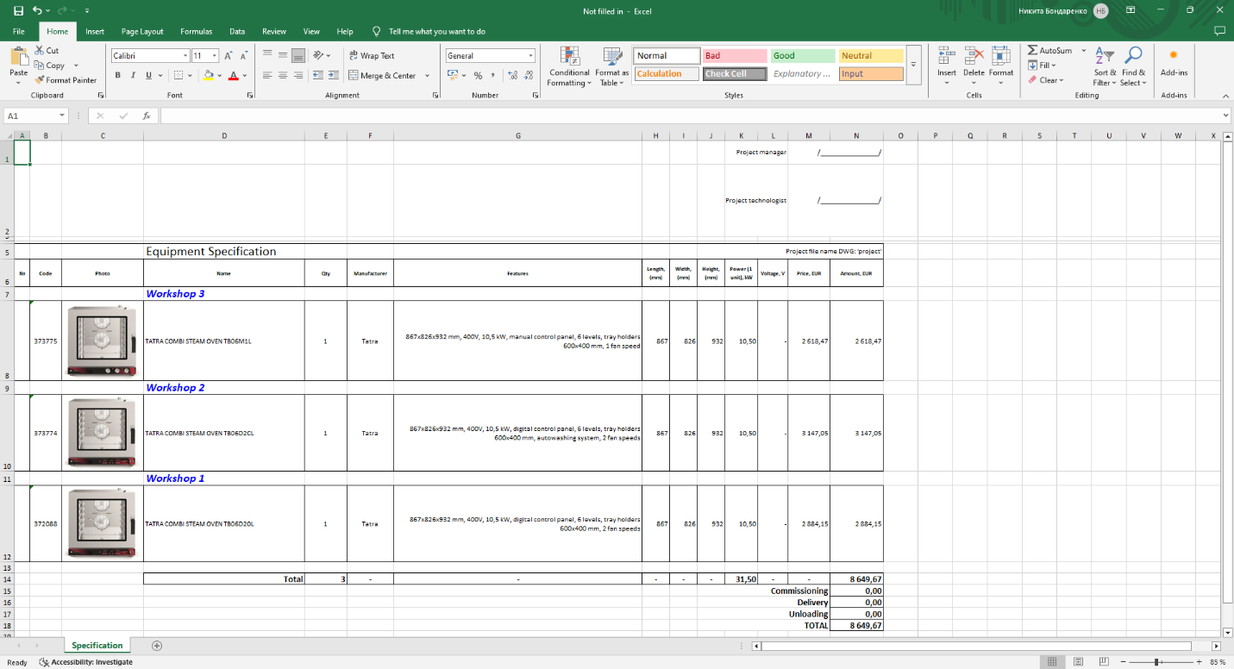
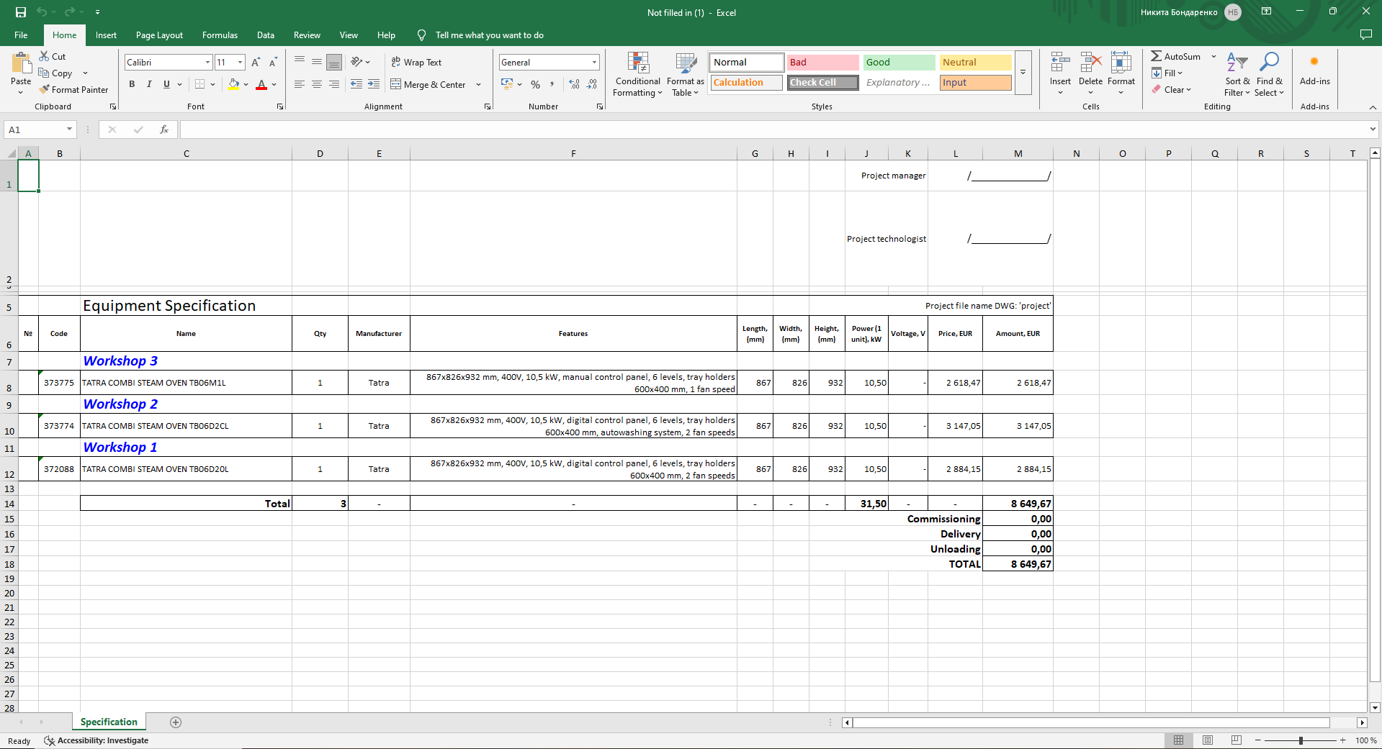
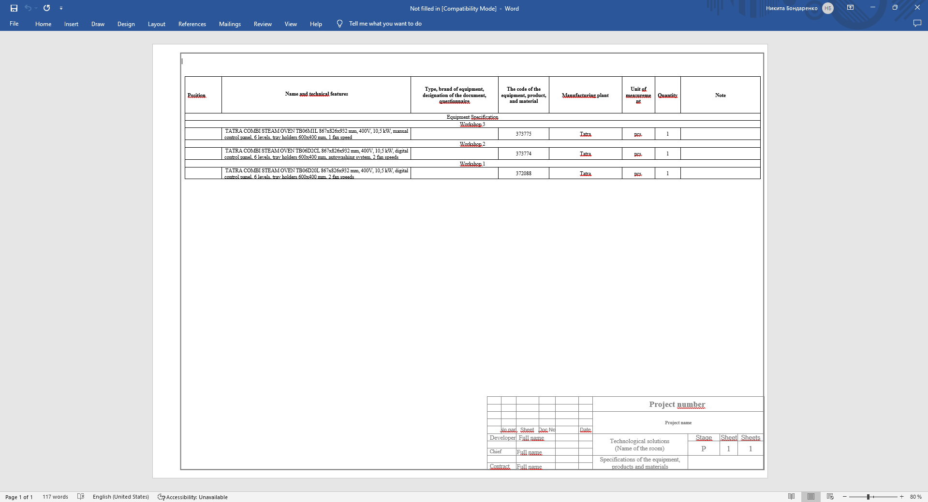
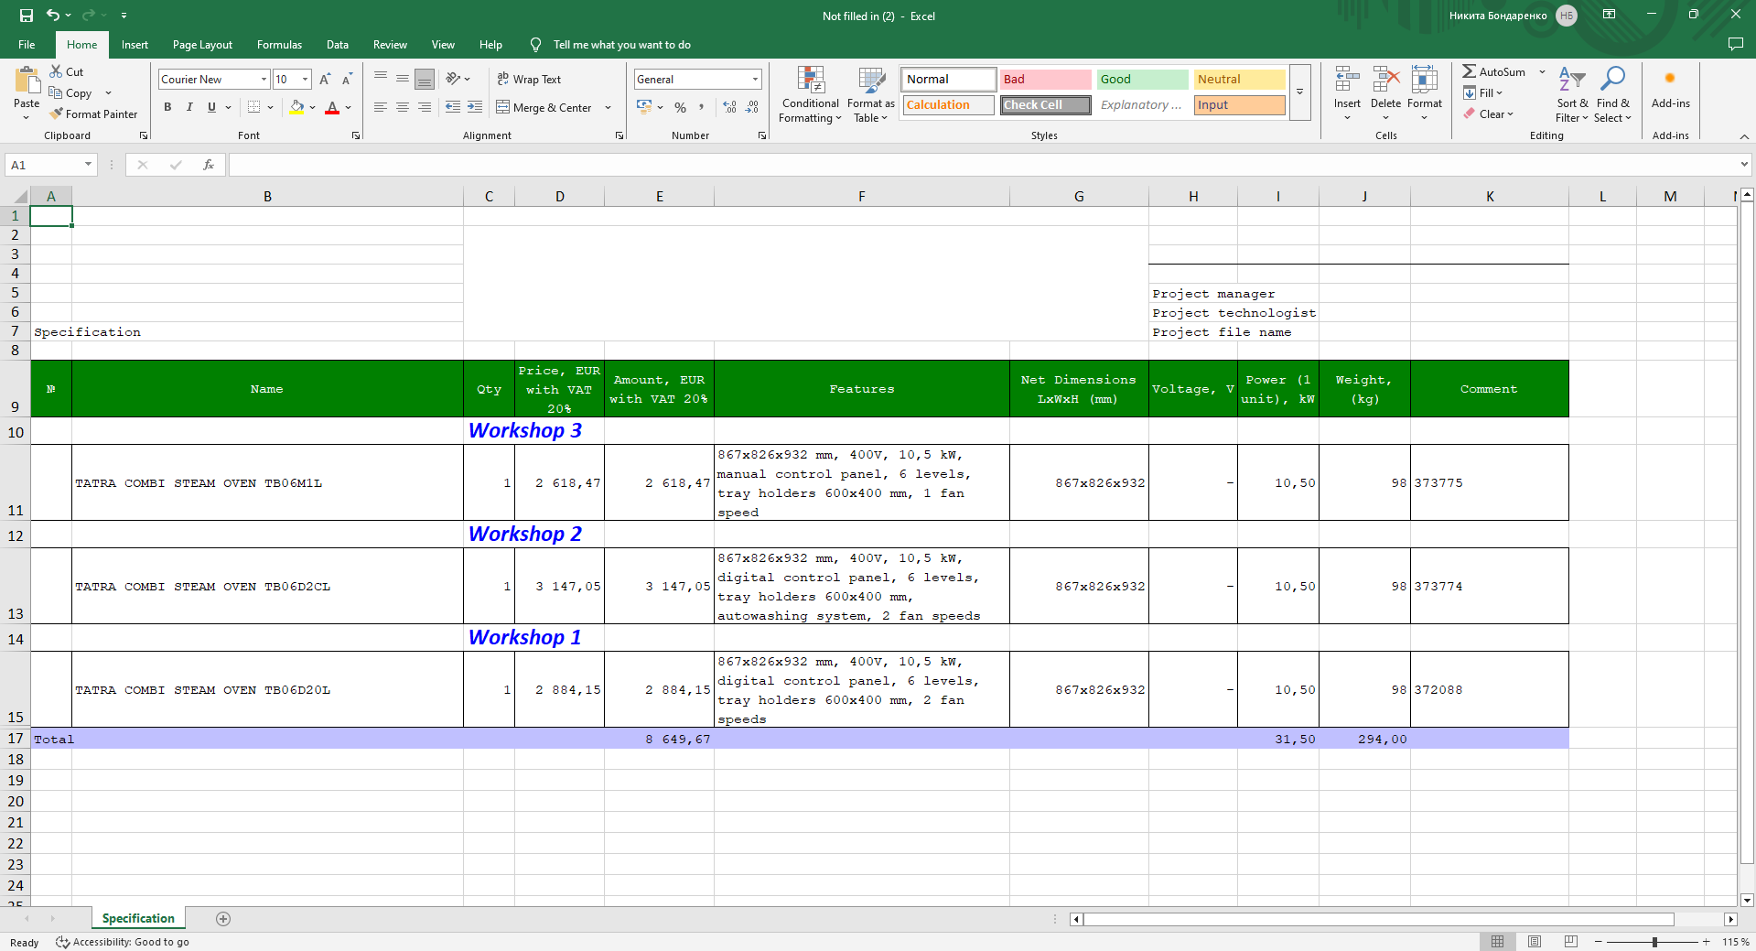

    - By clicking the Weight and Dimensions Report, you can generate a report showing the total net and gross weight and dimensions of the equipment from the specification (can be generated in Excel and PDF);
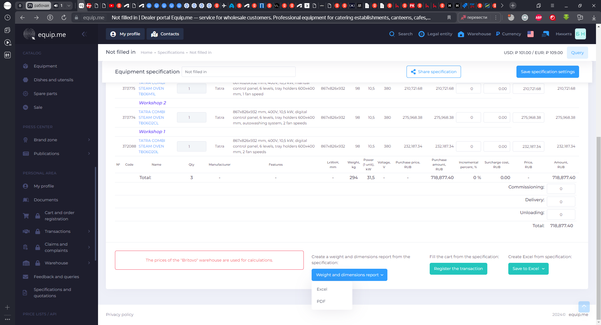
10.4.12
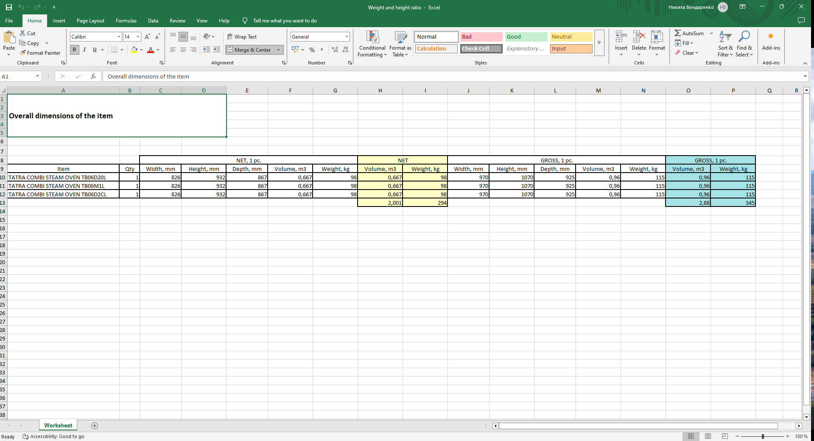
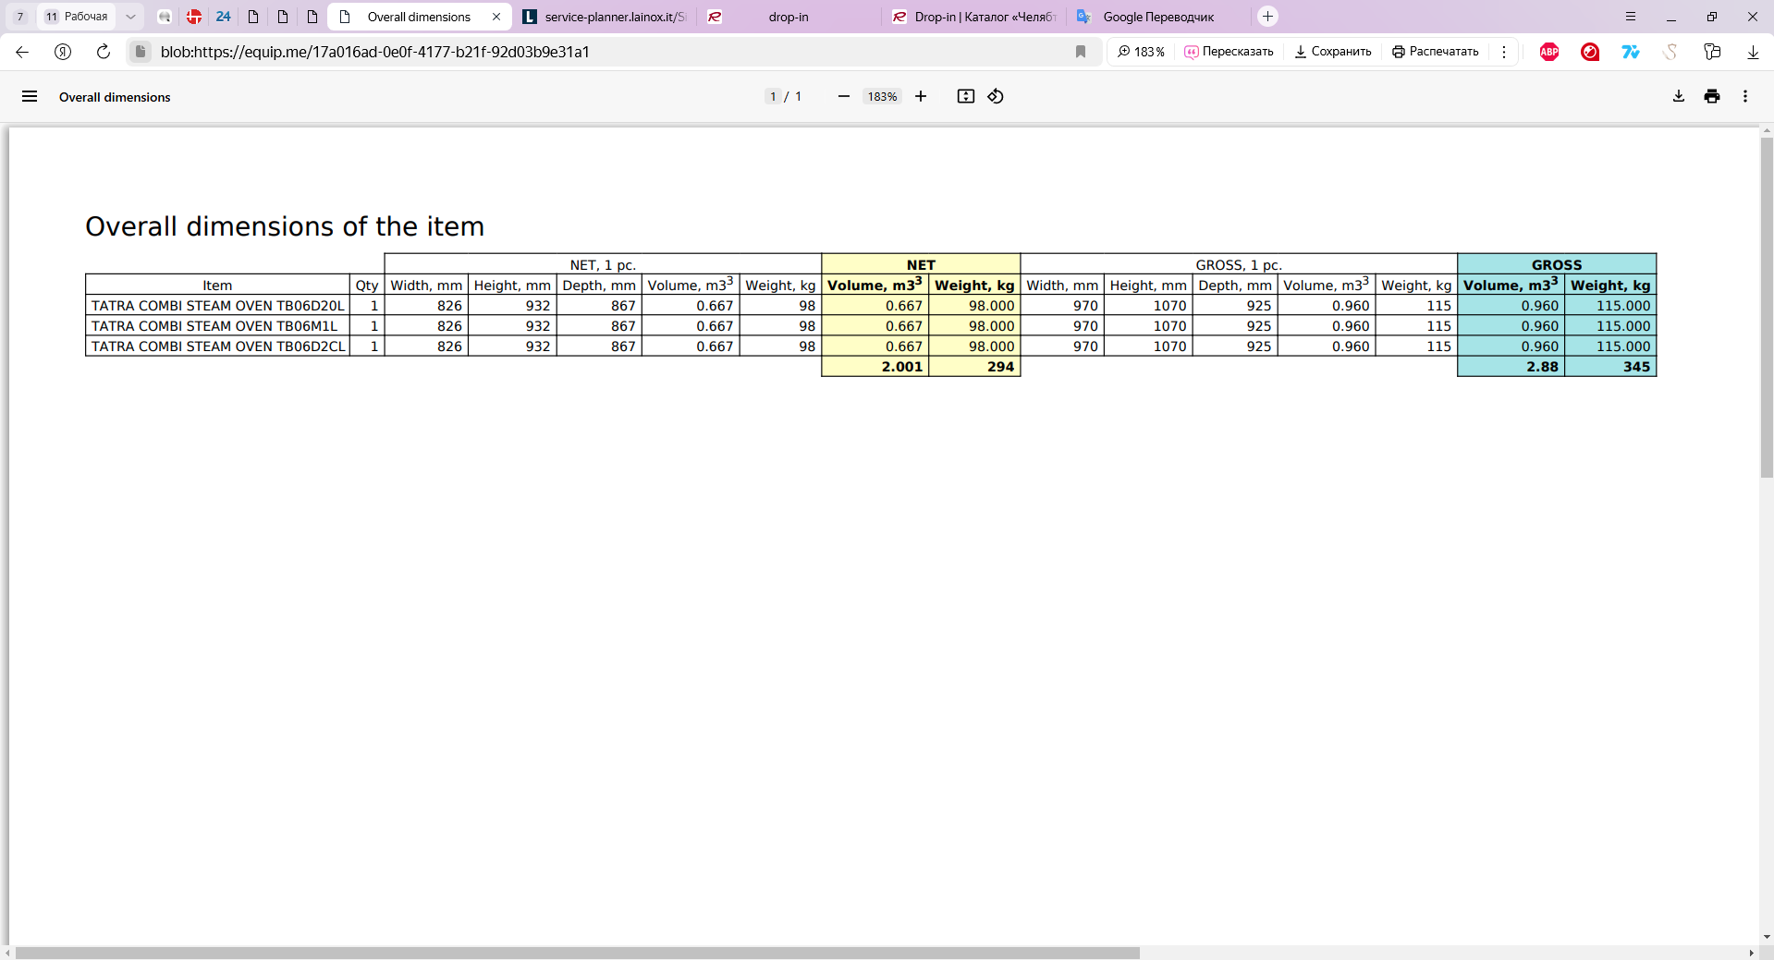

  - Specification on the drawing

    - To create a specification on the drawing, click the «Drawing tables» button in the “Indexing and tables” menu and select the menu item "Specification table", when the uploading is complete select the point on the drawing where the specification is to be placed;
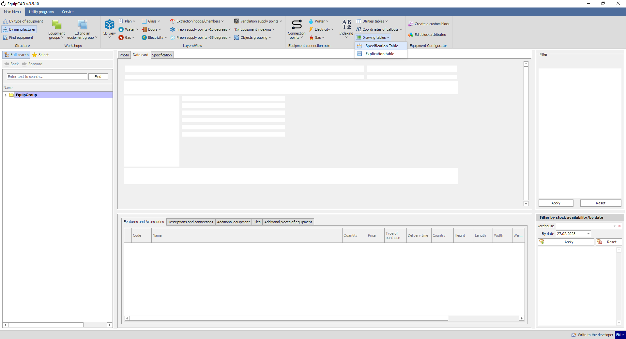
10.5.1
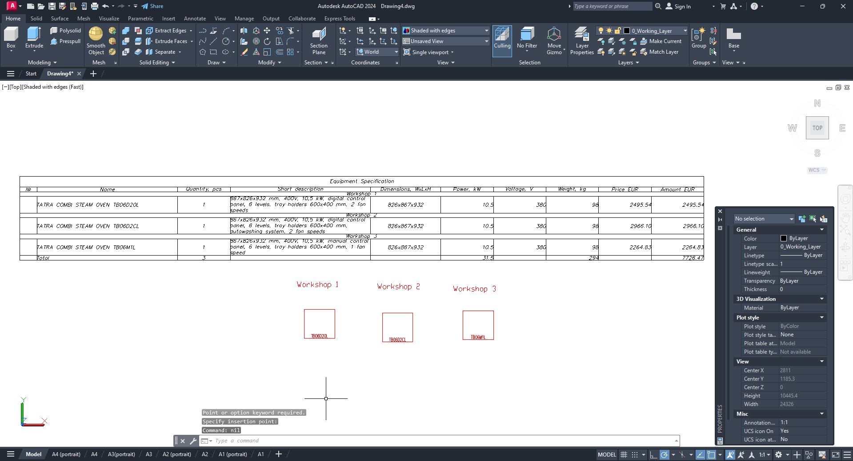

    - The settings allow you to choose whether to group equipment by workshop and to select the columns to be displayed in the specification;
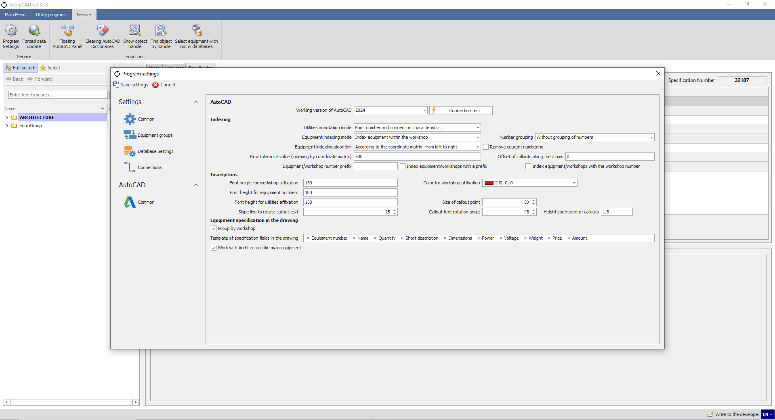
10.5.2

  - Explication table

    - To create an explication table on a drawing, you need to click the “Drawing Tables” button in the “Numbering and Tables” section and select the “Explication Table” menu item; after loading, select the point on the drawing where the table will be inserted;
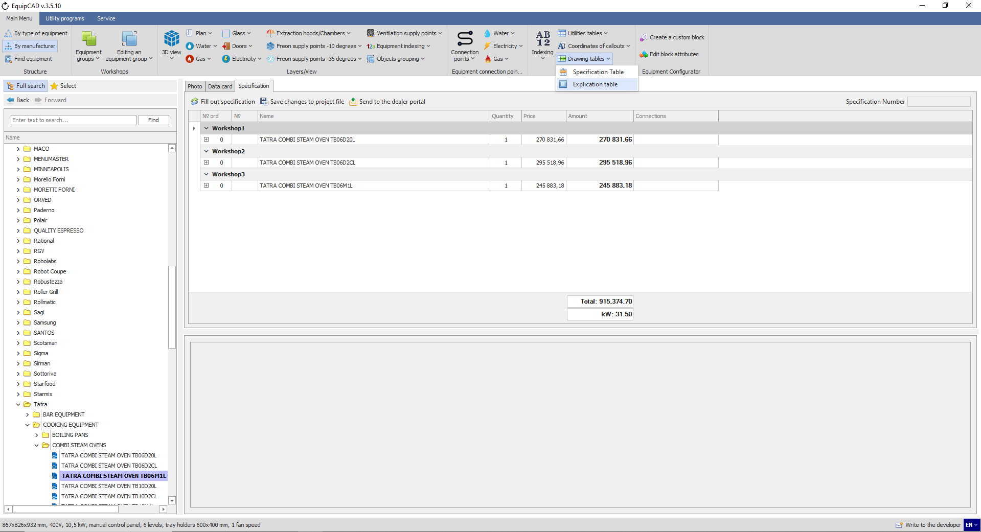
10.6.1
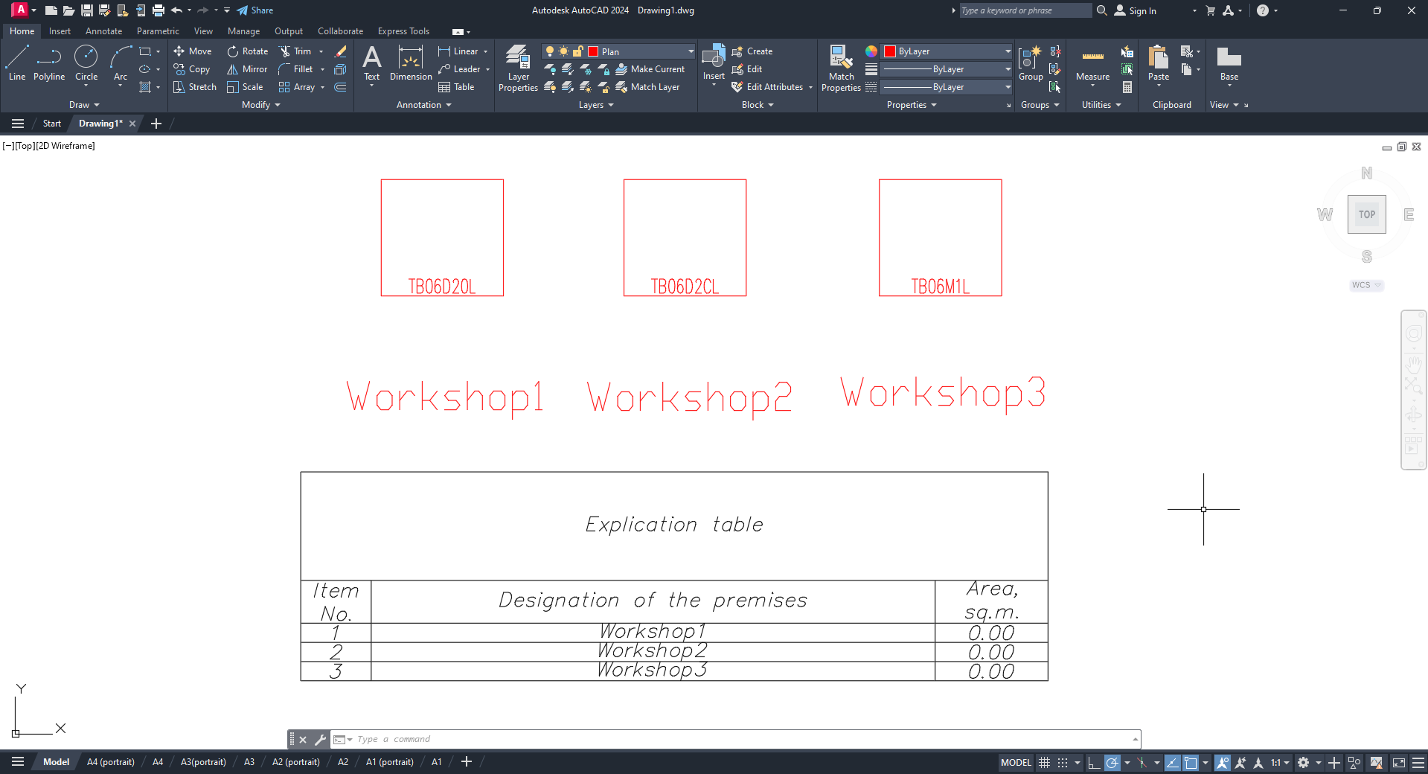
Note: The explication table is a table that contains the workshop number, workshop name and area.

    - You can fill in the values ​​in the explication table using the “Order of equipment groups and prefixes” button in the “Workshops” section;
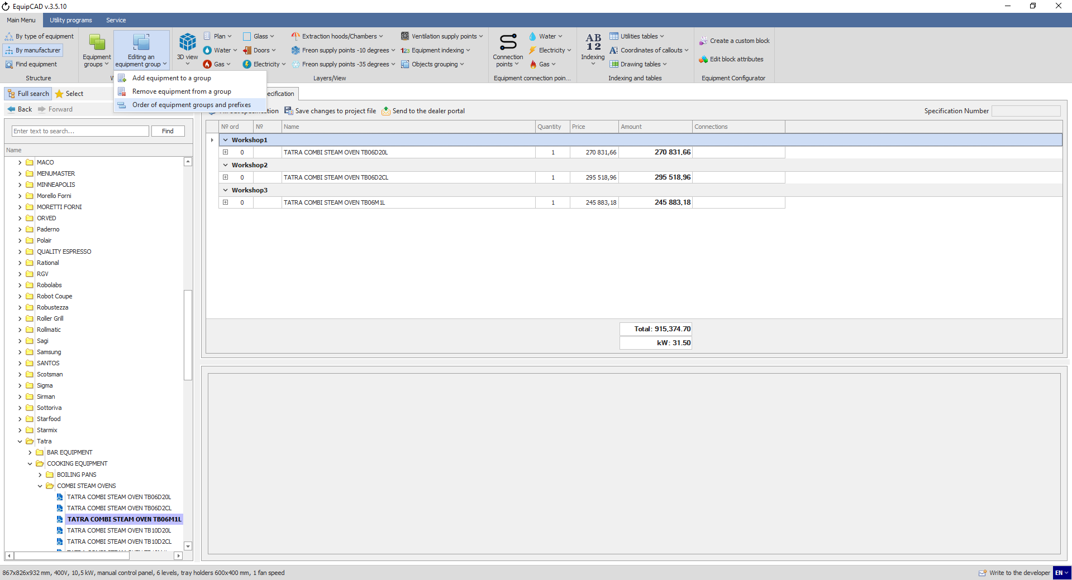
10.6.2

    - In the window that opens, in the column “Area, sq. m.”, enter arbitrary area values ​​and click the “Save” button;
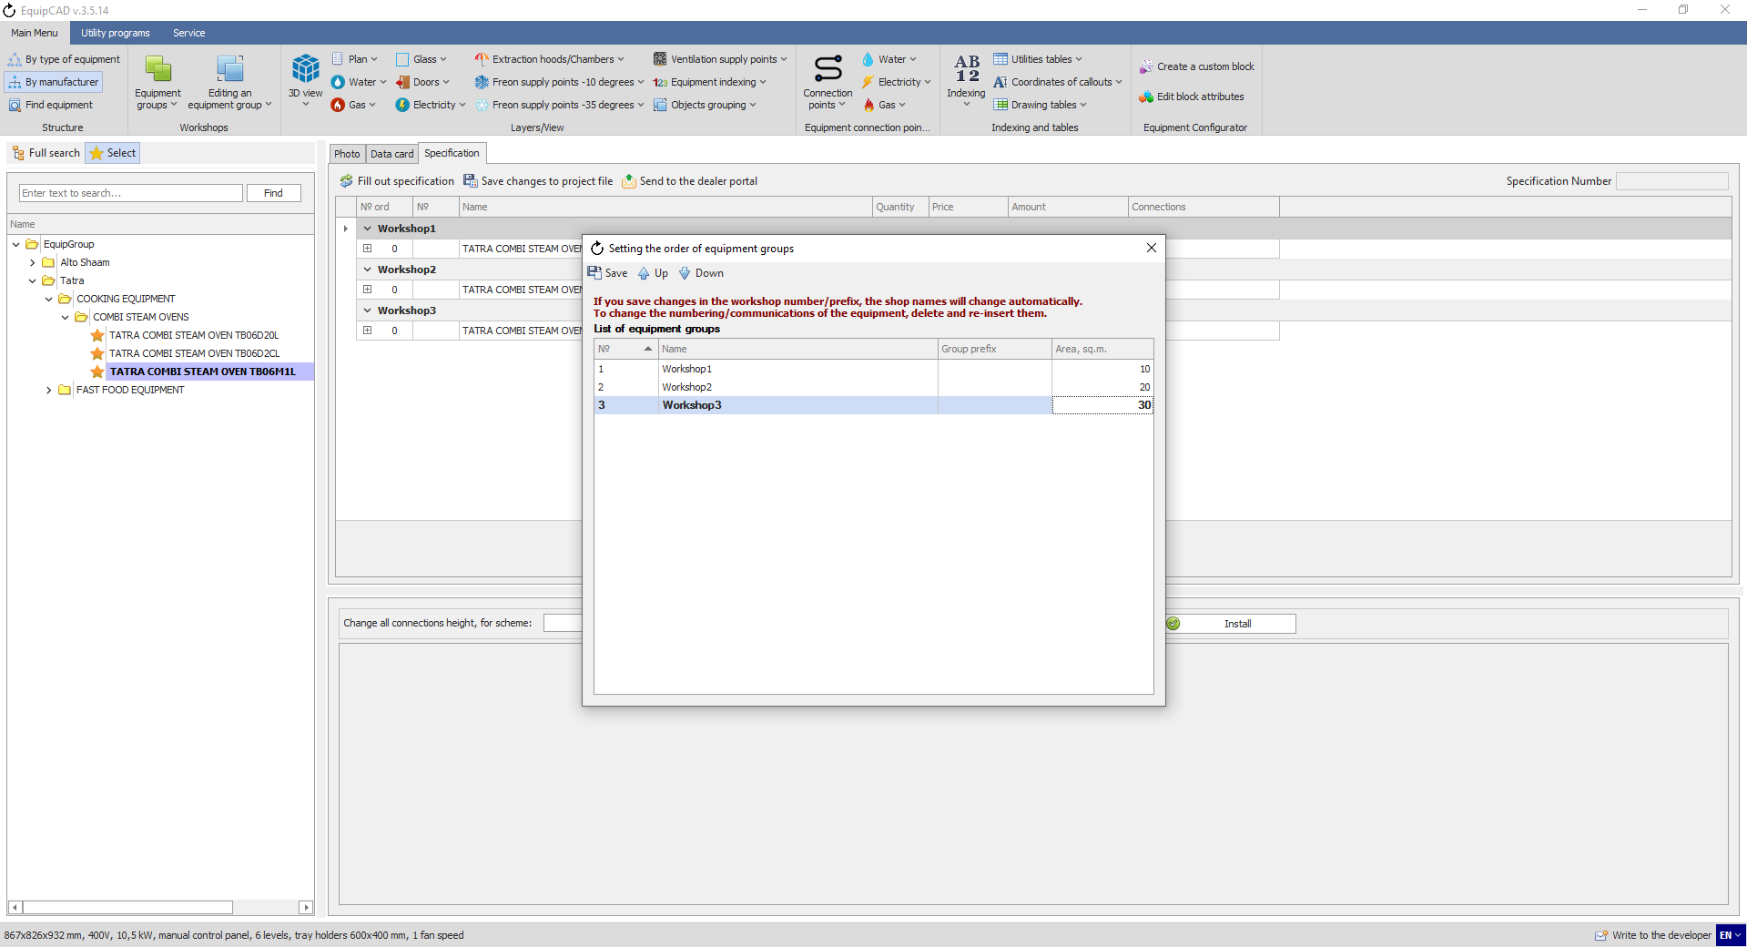
10.6.3

    - Then we will insert the explication table into the drawing again;
10.6.4
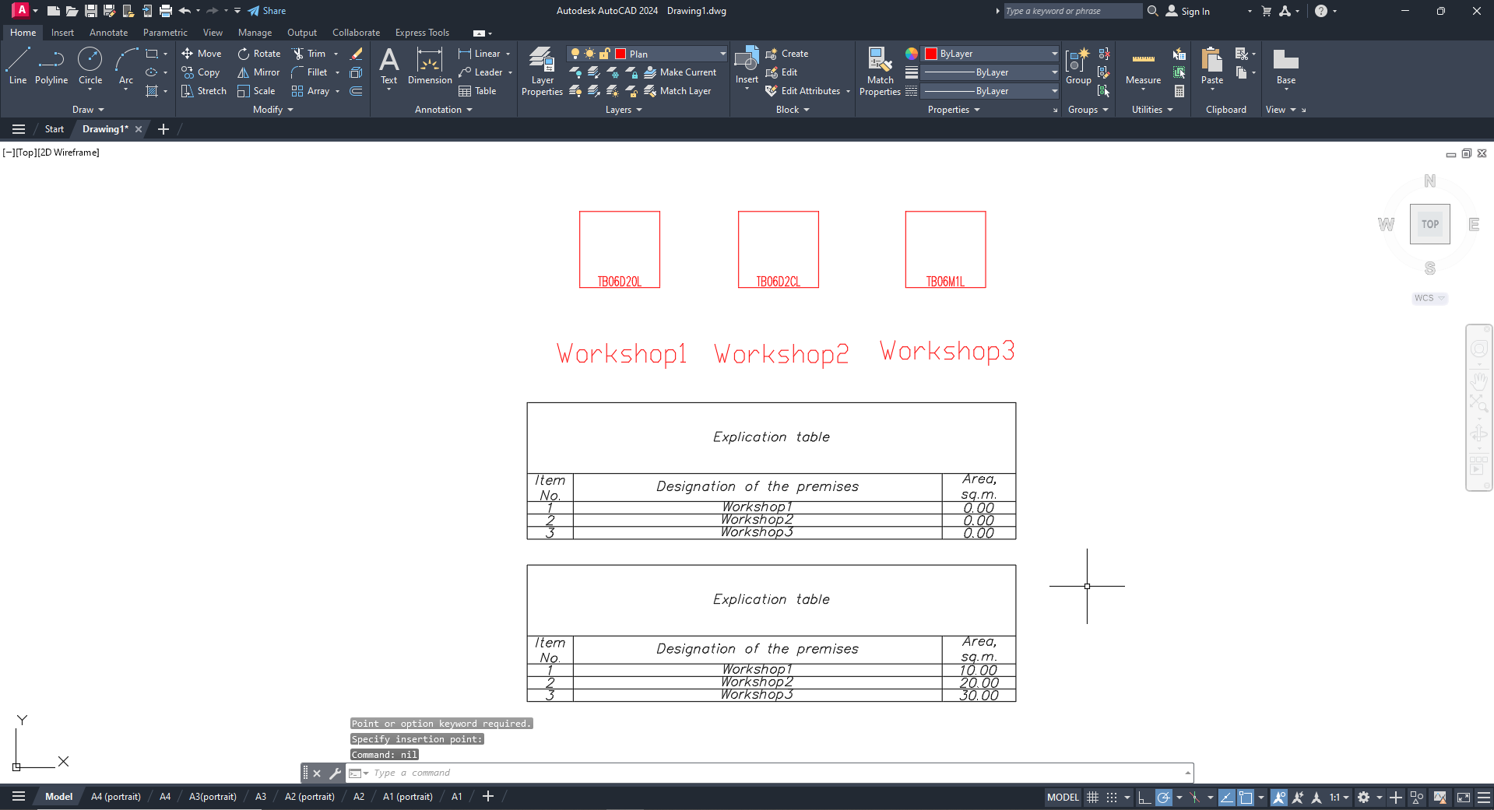

- Equipment connection points; callout templates and utilities tables
11.1 General explanations for designations
11.2 Putting connection points
11.3 Callout templates
11.4 Editing connection diagram names
11.5 Editing connection points in the drawing
11.6 Editing connection points in the specification
11.7 Utility programs
11.8 Utilities tables
11.9 Connection points in the specification

  - General explanations for designations
Below are the explanations regarding the schemes and designations that are used in EquipCaD for assembly plans, as well as the procedures for examining and verifying them.
The descriptions of assembly schemes and designations are available on the “Descriptions and connections” tab.
All the symbols and letters refer to the designations used in the program only.
Note: The equipment connection points specified in program blocks correspond to utilities installation points, and not to the positions of their physical connection to the equipment.
In total, the program has 19 utilities connection schemes.

    - Cold and hot water supply;
The height of connection is given in mm; the pipe diameter is in inches; the utility is designated with the symbol “A”.
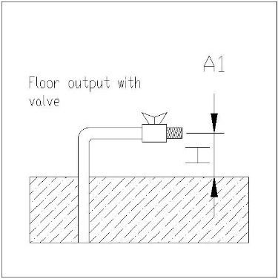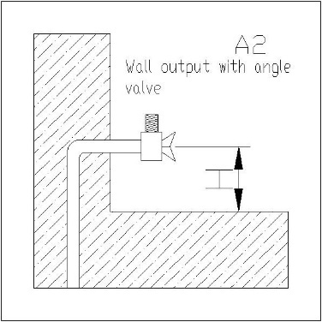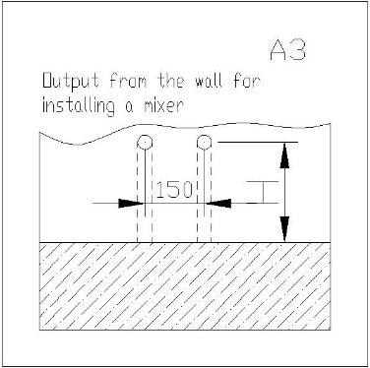

    - Sewage;
The height of connection is given in mm; the pipe diameter is in mm; the utility is designated with the symbol “S”.
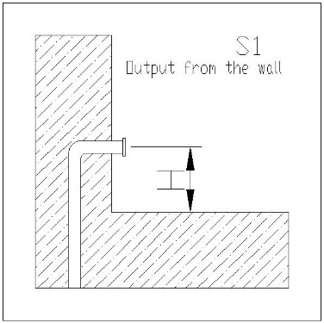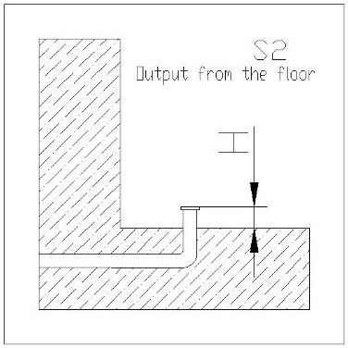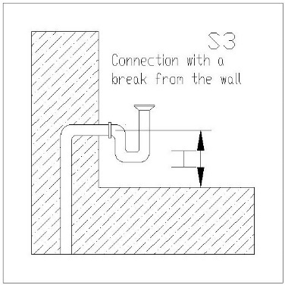

    - Gas;
The pipe diameter is given in inches.

    - Trap;
The pipe diameter is given in inches; the utility is designated with the symbol “T”.
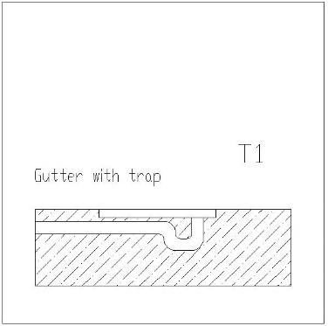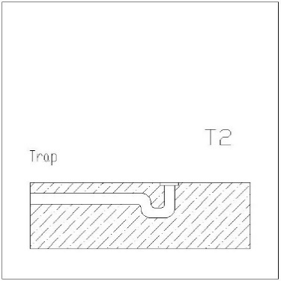

    - Electricity;
The height of connection is given in mm; the utility is designated with the symbol “F”.
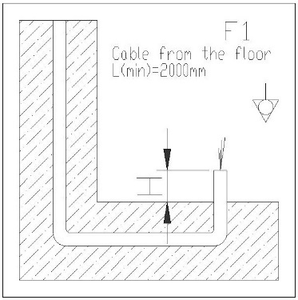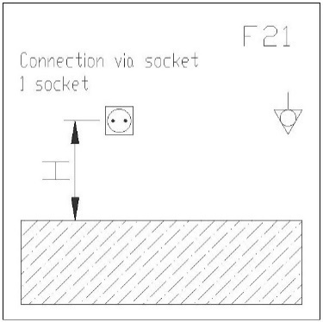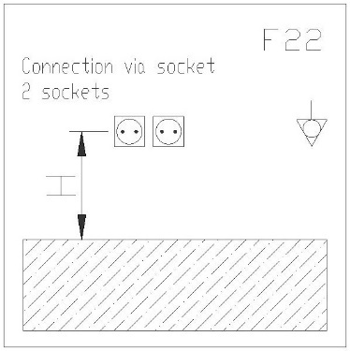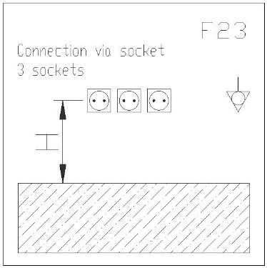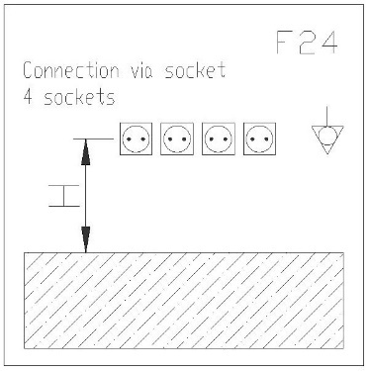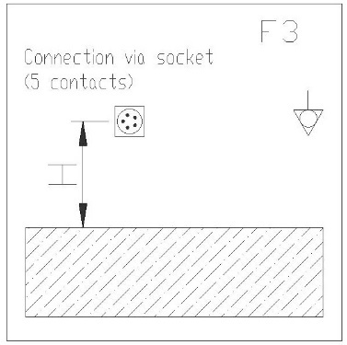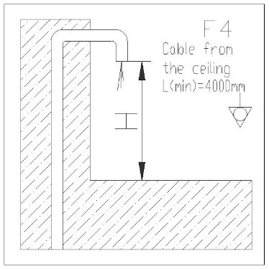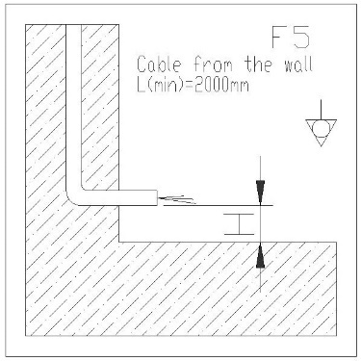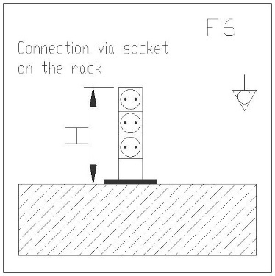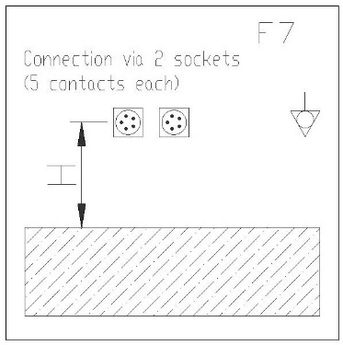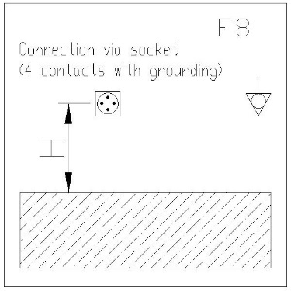

  - Putting connection points

    - To put connection points, click the “Water”/“Electricity”/“Gas” button in the “Equipment connection points” menu;
    - Select “Put” in the drop-down menu;
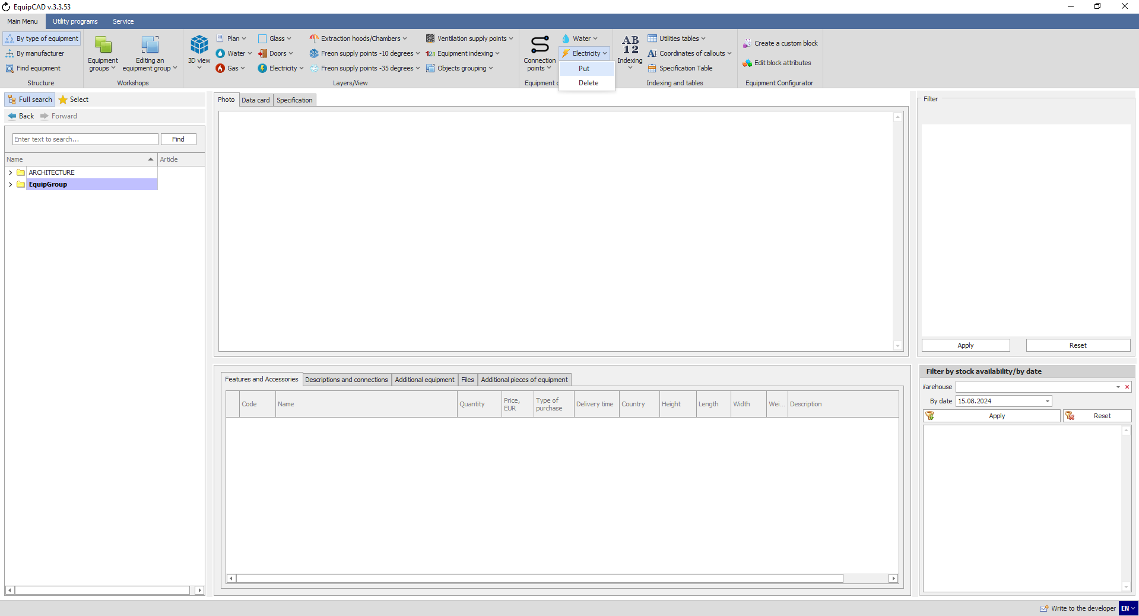
11.2.2
11.2.1
Let’s put connection points for water and electricity.
Note: In large projects, entering connection points may take up to several minutes.
    - Utilities connection points displayed on the drawing indicate the connection ordinal number, prefixes, scheme (F3; A2; S1), and characteristics;
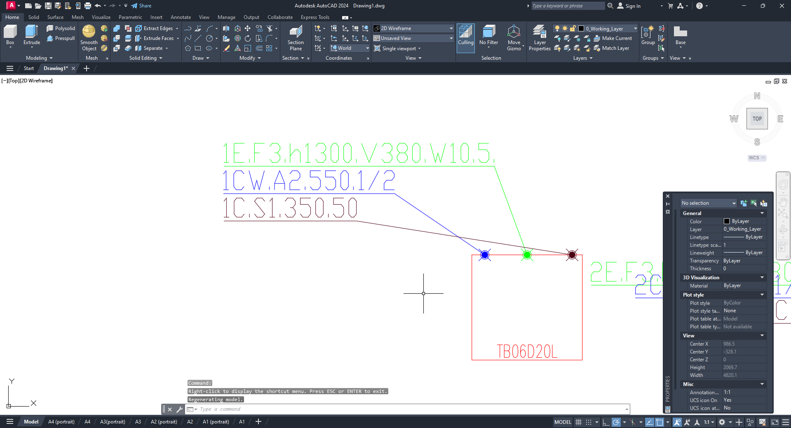
Point number
Prefix
Connection scheme
Connection characteristics

    - To configure the display of callouts for utilities connection points, go to Program Settings on the Service tab;
    - In the window that opens, select “General settings for AutoCAD”;
    - You can choose an option for displaying callouts in your project using the “Utilities annotation mode” setting.
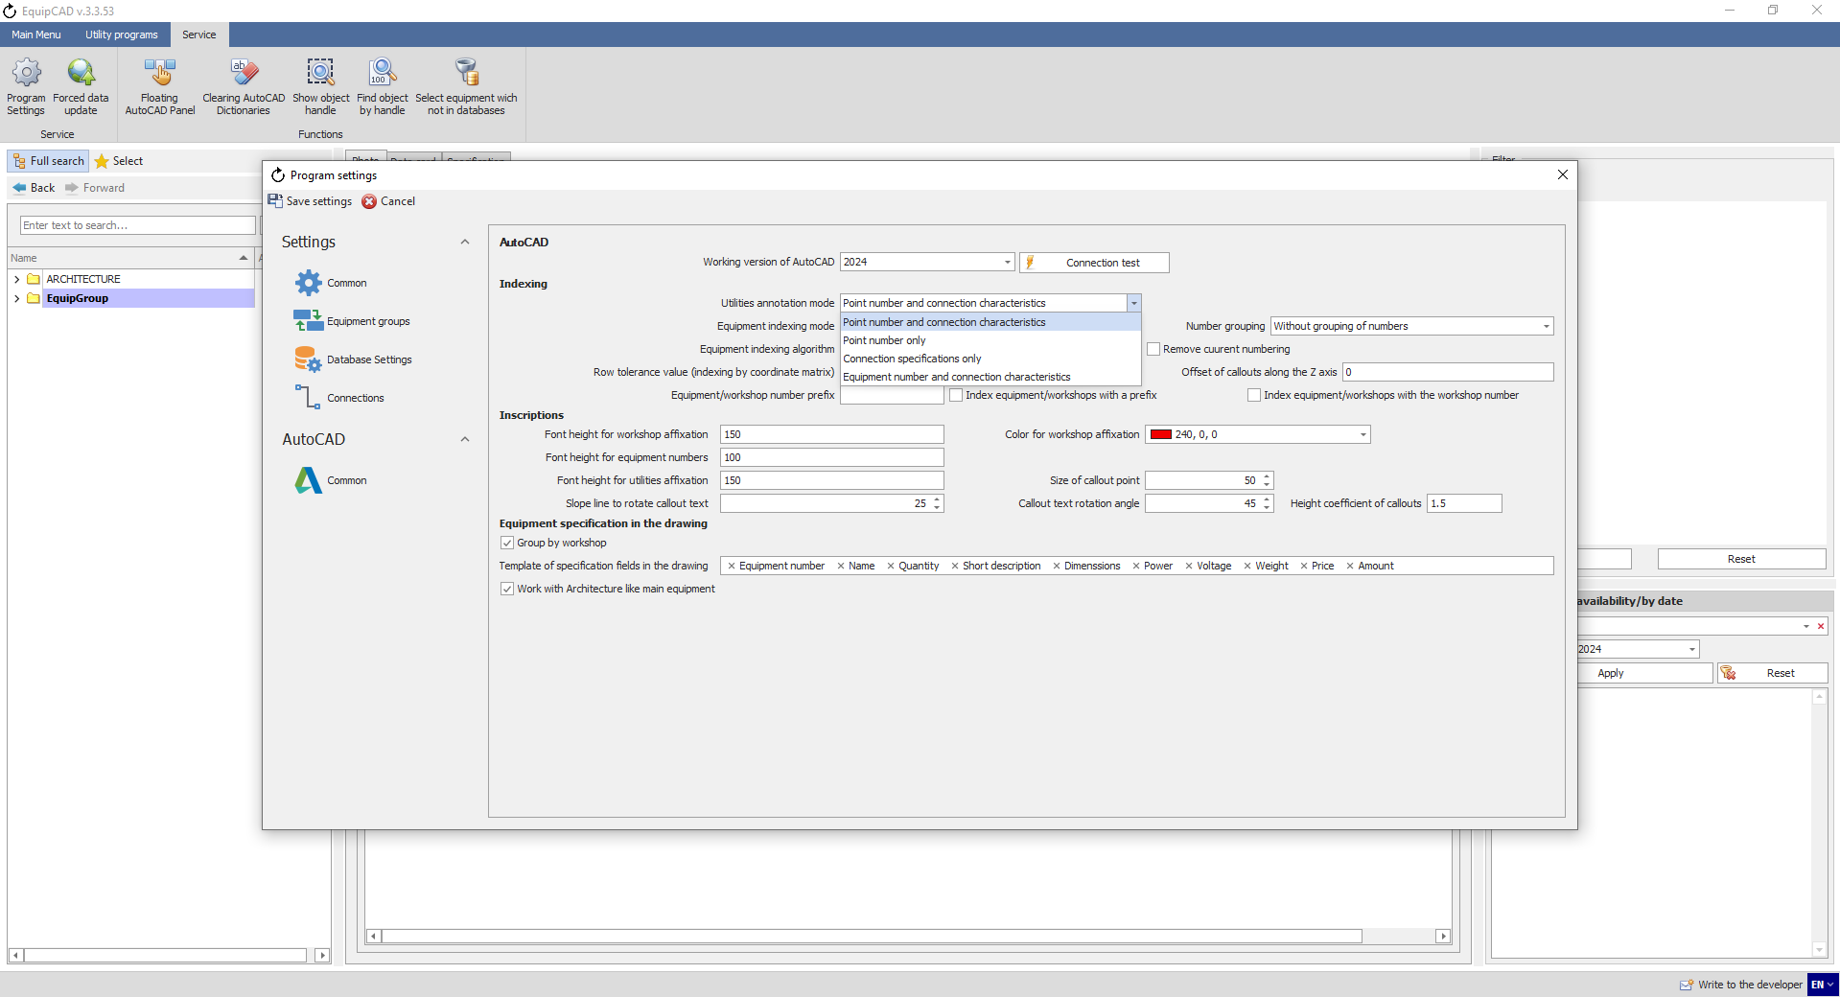
11.2.4
11.2.5
11.2.6

    - If you select “Equipment number and connection characteristics”, the program will assign two-level numbers to connection points of identical equipment items (for example, electricity connection points for identical combi steamers will be numbered as “1.1” and “1.2”);
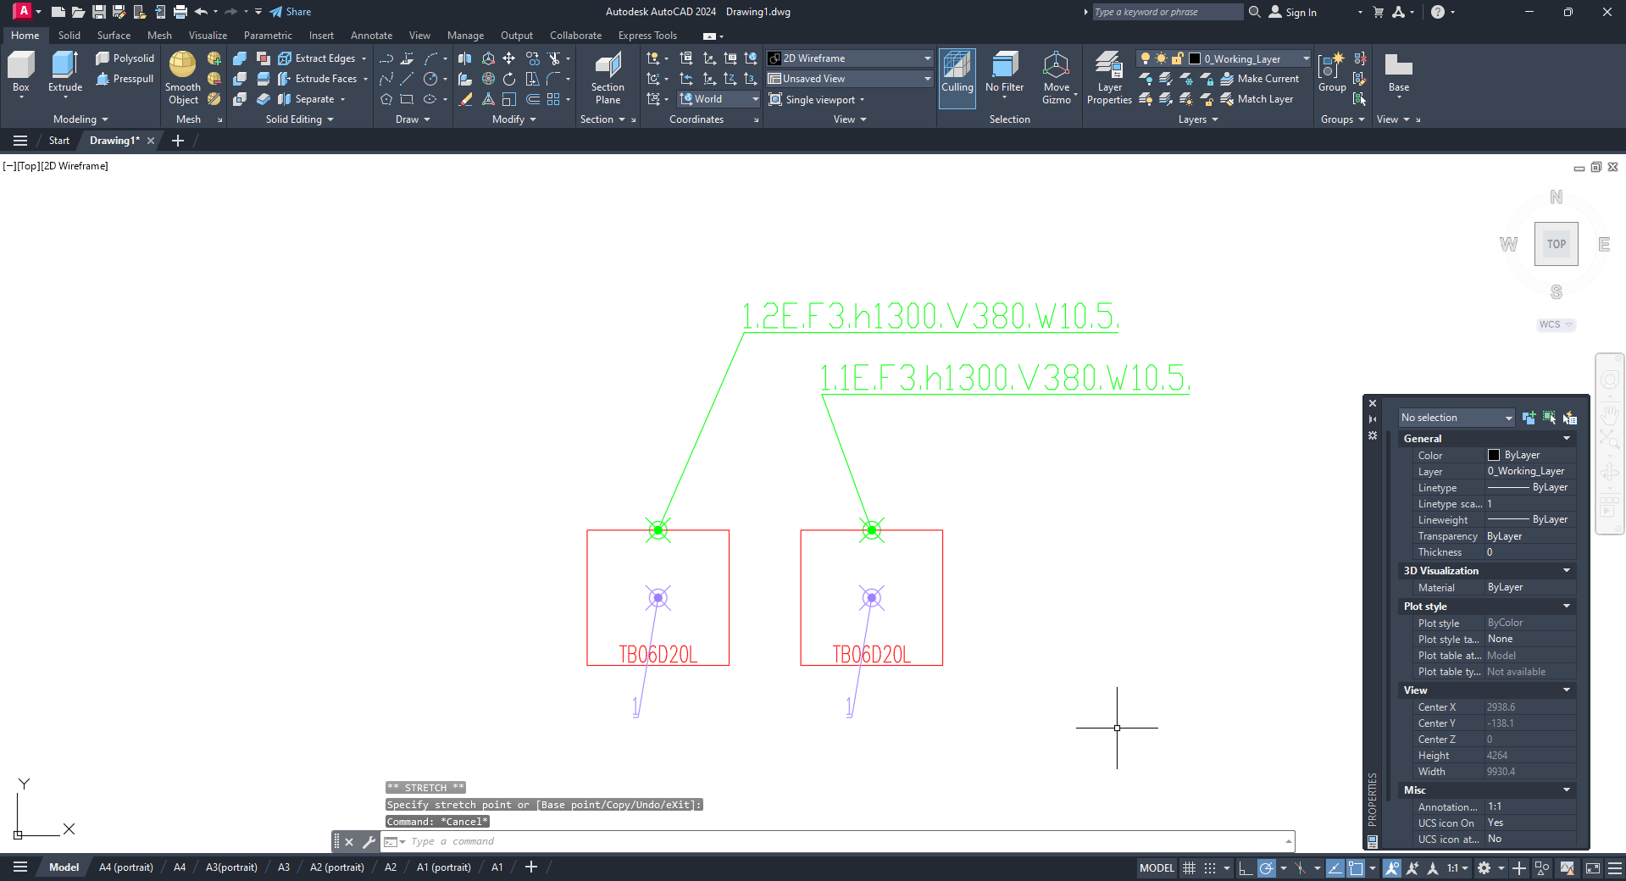
Note: To select the “Equipment number and connection characteristics” setting, the equipment must have been indexed; otherwise the program will report an error.
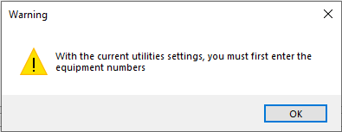

  - Callout templates
The “Callout templates” setting allows you to edit the representation of callouts for connection points.
    - To change callout templates, go to the Service tab;
    - Click the Program Settings button;
    - In the window that opens, select “Connections”;
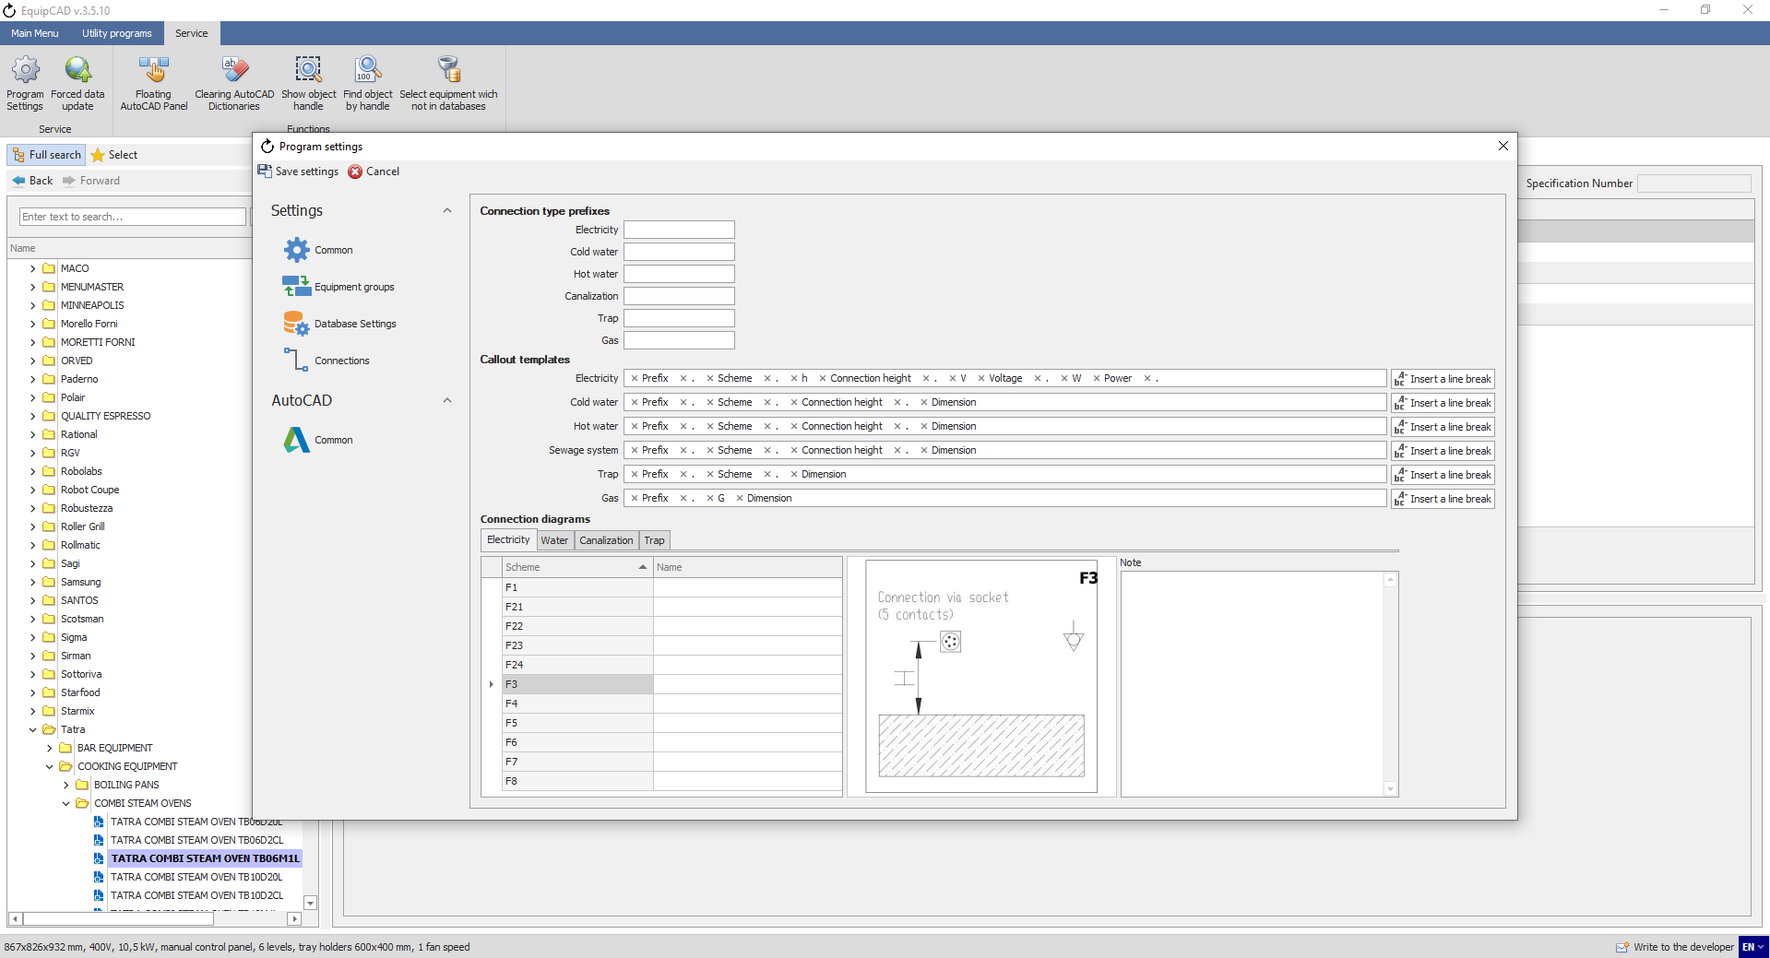
11.3.3
11.3.2
11.3.1

“Connection type prefixes” is an element of the callout template that you can use to designate each type of connections (for example, “CW” for cold water).
    - Let’s enter our symbols in the “Connection type prefixes” fields and click the Save button;
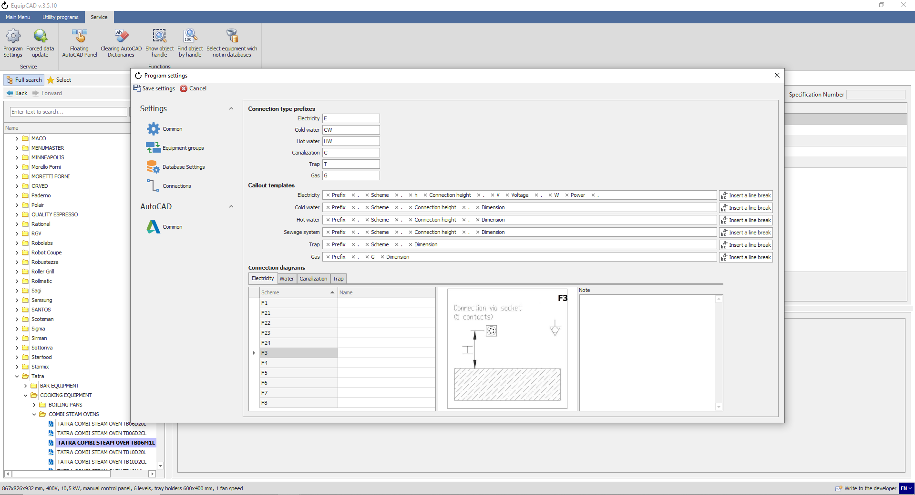
11.3.4
To change callouts, you should delete and set them again.
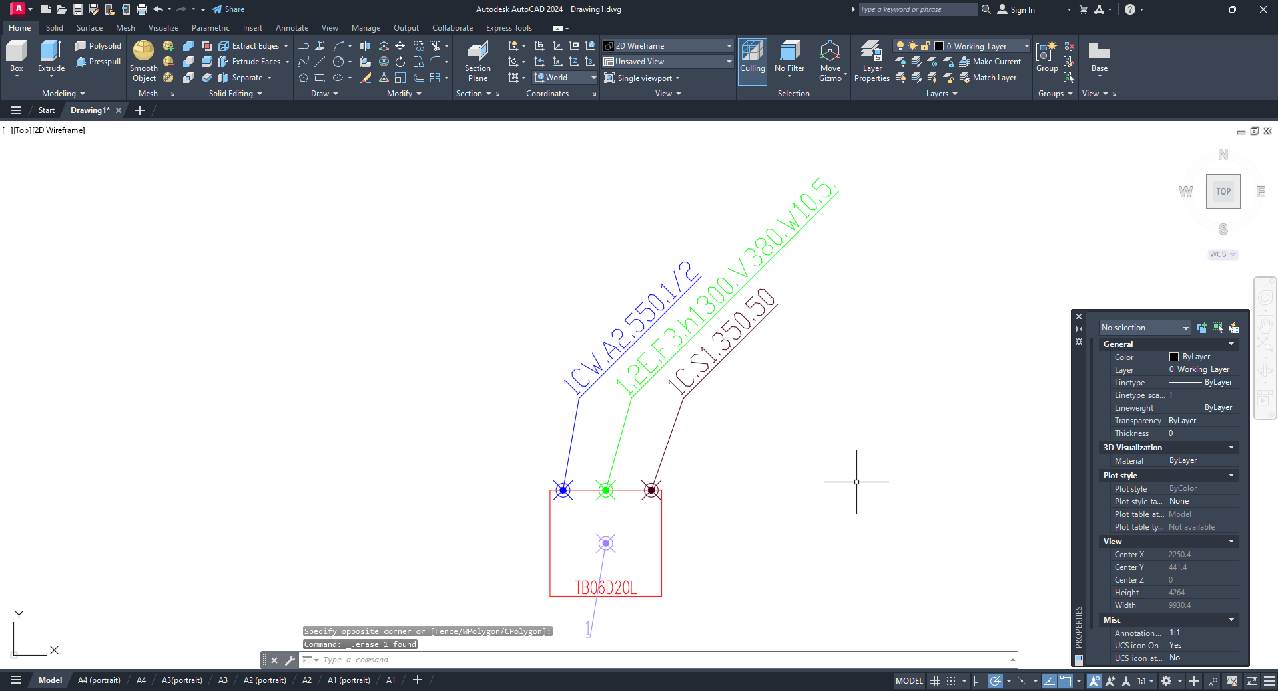
As you can see on the drawing, the callouts for electricity, cold water and sewage now have their respective prefixes.

    - You can use the fields in the “Callout templates” setting to change the characteristics of a connection that are to be displayed on the drawing. For example, let’s remove all values other than the prefix from the template for cold water, add “mm” to the template for sewage, and add the line break symbol “\n” to the template for electricity, and click the Save button;
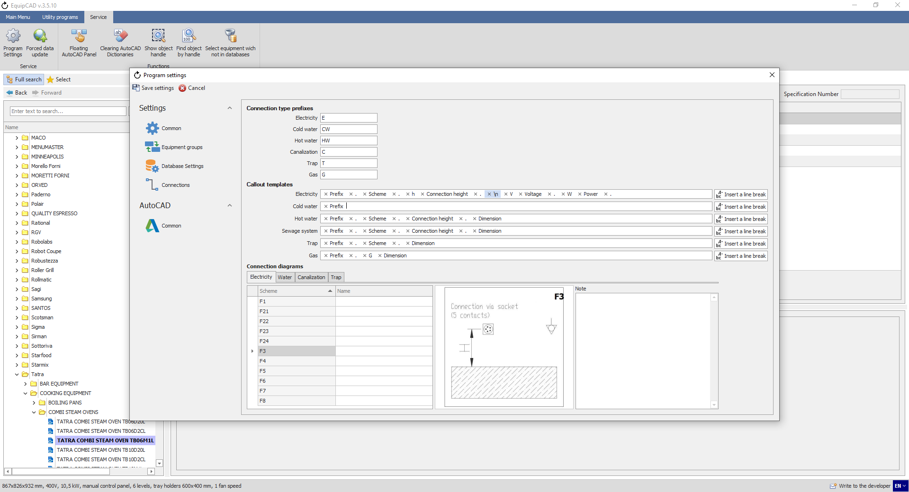
11.3.5
Let’s delete the callouts and enter them again.
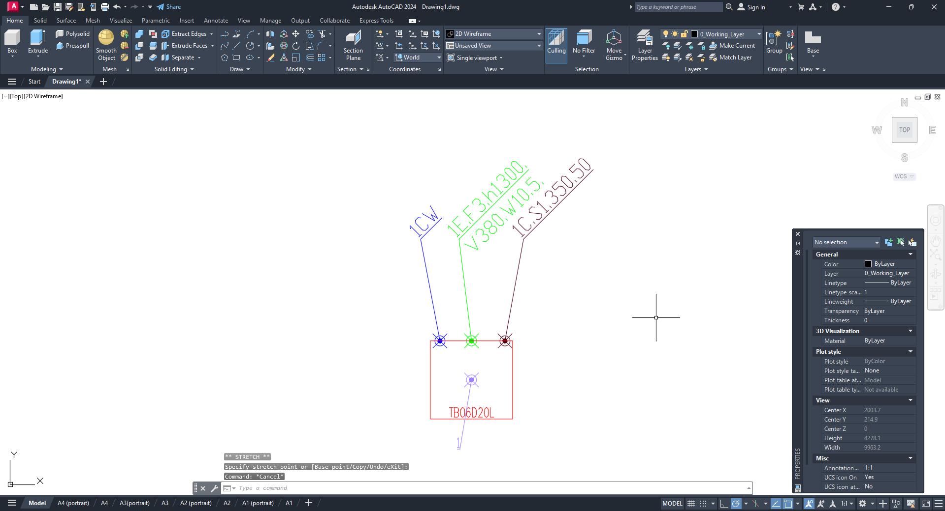
As you can see on the drawing, the callouts for cold water and sewage have changed accordingly.

The callout templates have standard characteristics of connections as follows:
For electricity: Prefix, Scheme, Connection height, Voltage, and Power;
For cold water, hot water and sewage: Prefix, Scheme, Connection height, and Dimensions;
For trap: Prefix, Scheme, and Dimensions;
For gas: Prefix, and Dimensions.
You can also add your own text and symbols to templates.
    - When any of the standard connection characteristics is deleted, it will be shown as an input option in the drop-down list;
    - With the button to the right of the line, you can insert a line break symbol;
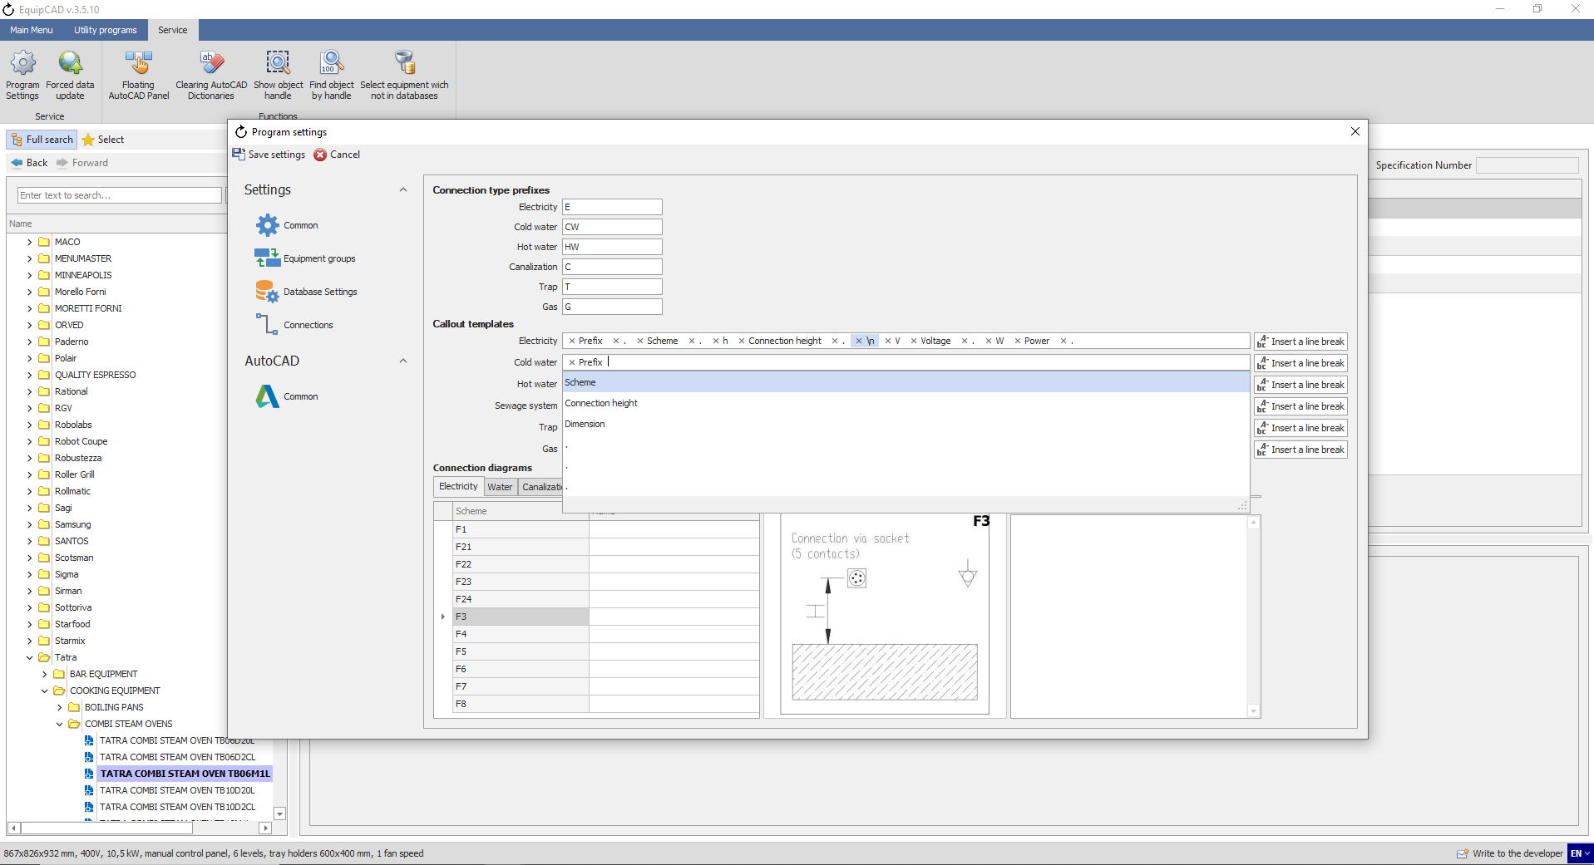
11.3.7
11.3.6
Note: You can shuffle the added characteristics while keeping the left mouse button pressed.

    - You can set the font size for callouts for utilities in the general settings for AutoCAD menu by using the “Font height for utilities annotation” setting;
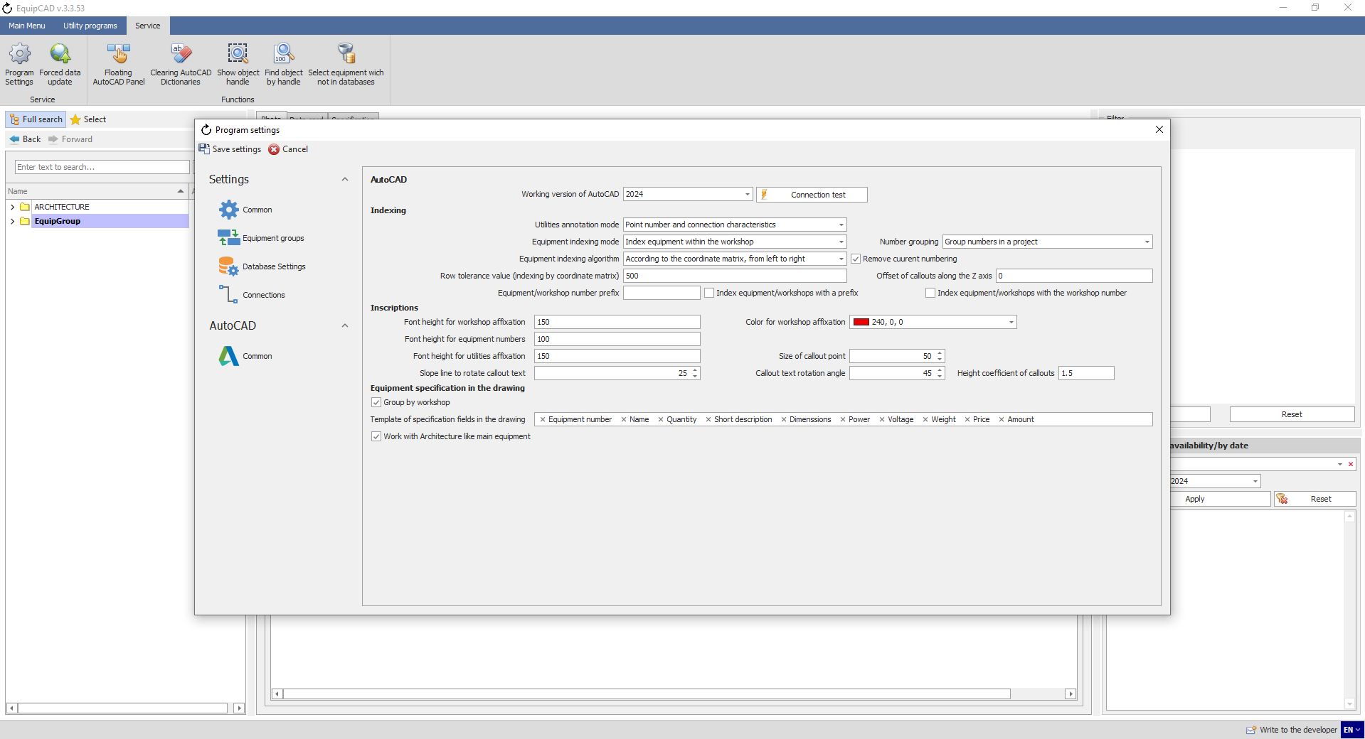
11.3.8

  - Editing connection diagram names

    - To edit the names of connection diagrams, go to the “Service” tab;
    - Click the “Program settings” button;
    - In the window that opens, select the “Connections” item;
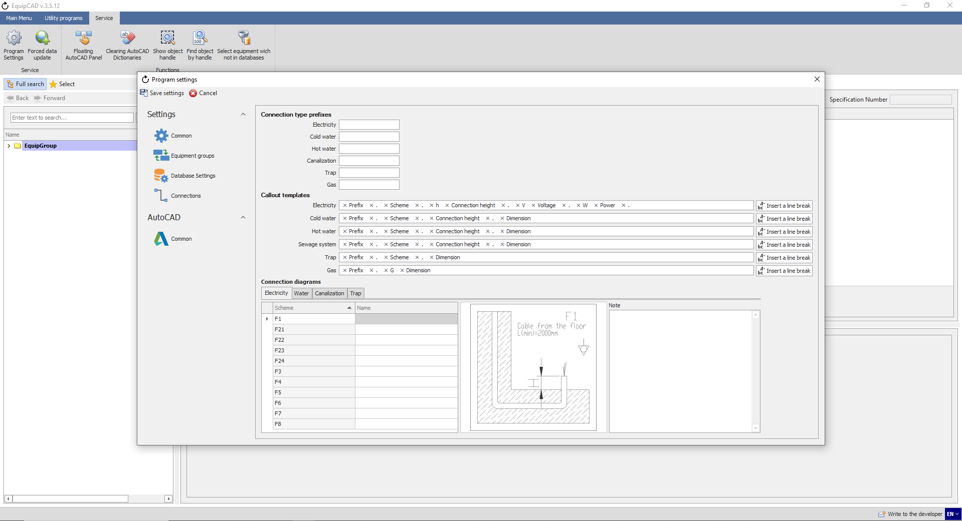
11.4.3
11.4.2
11.4.1

    - Select the required connection type tab;
    - In the "Name" column, enter a new name for the scheme;
    - In the "Note" field you can add the necessary information, which will be added by default to the note for each connection with the corresponding scheme;
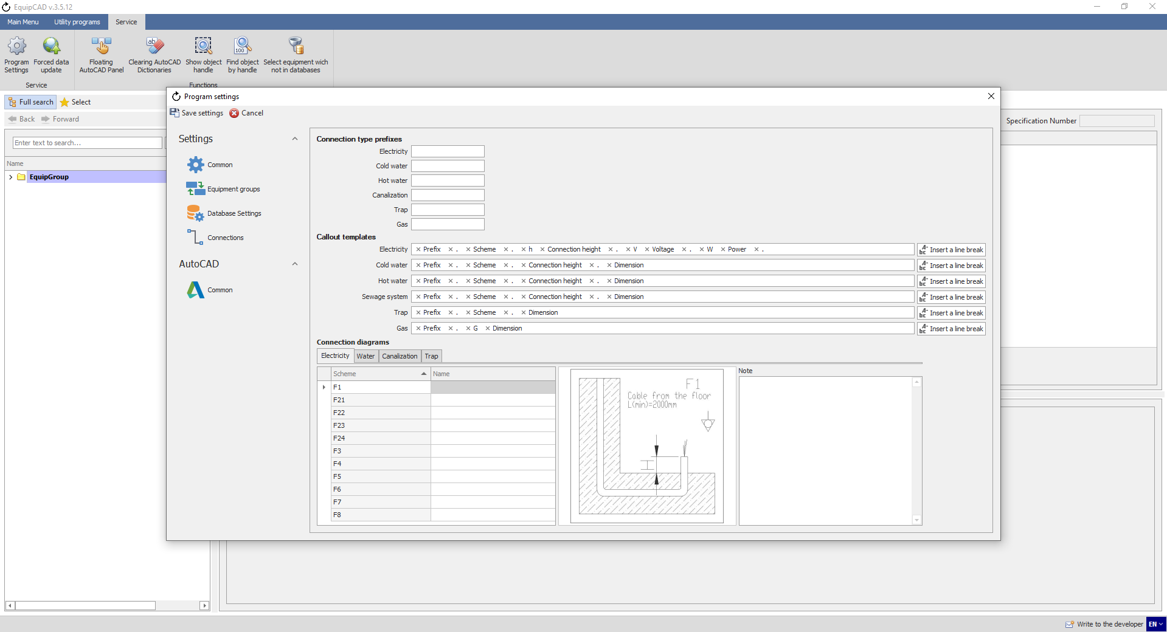
11.4.6
11.4.5
11.4.4

    - For example, let's change the name of the circuit "F3" to "EL3" and write "Example" in the note;
    - Then click the “Save settings” button;
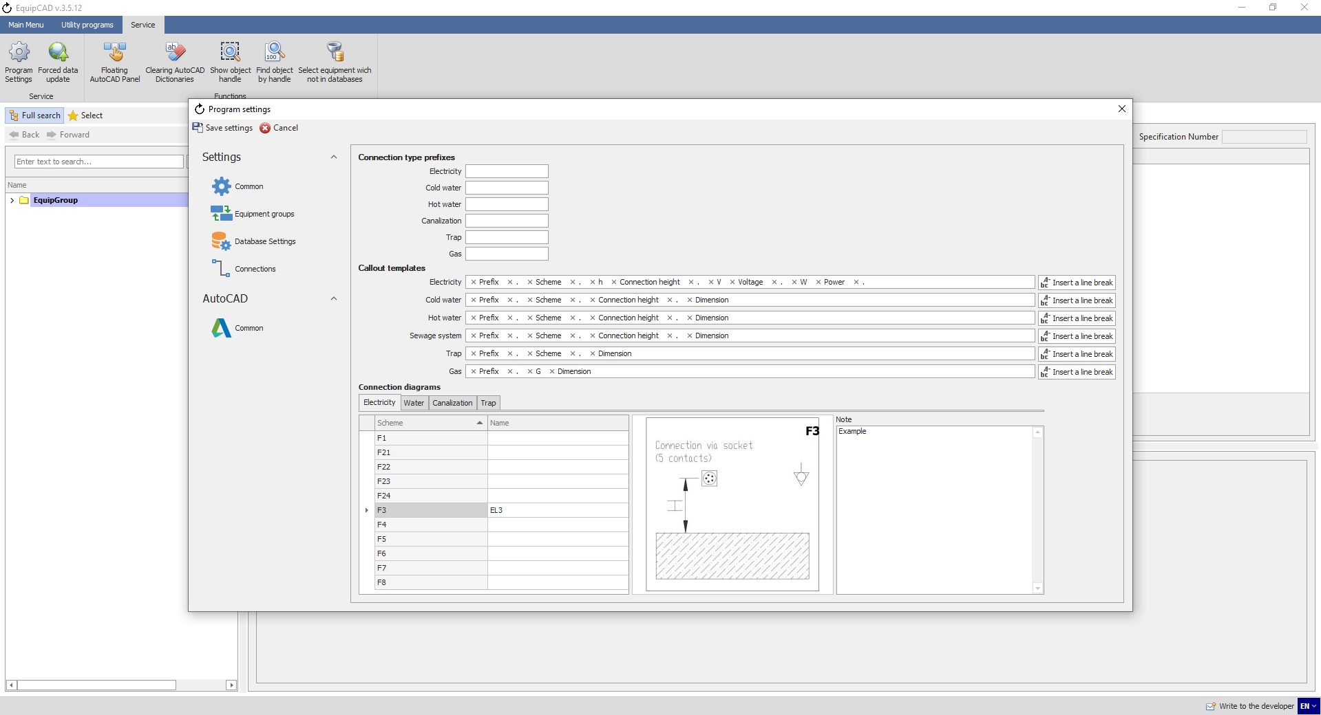
11.4.8
11.4.7
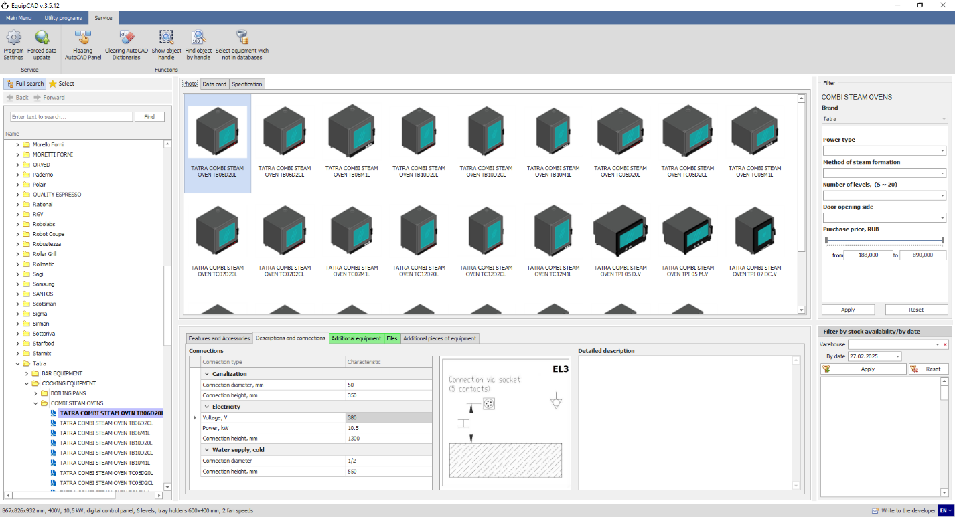
On the Descriptions and Connections tab, the schema name has changed to the specified one.
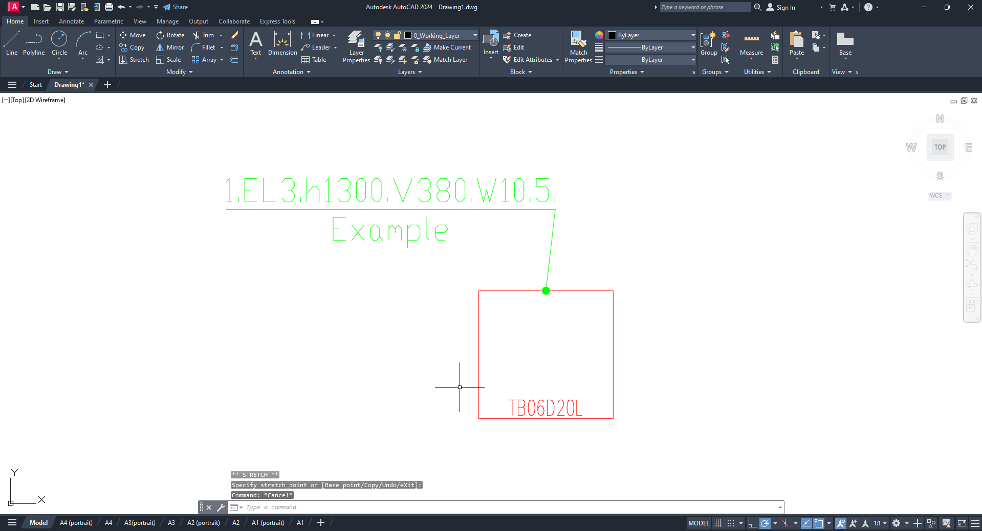
In the drawing after the electrical callout attachment, the circuit name has changed and a note has been automatically added.

  - Editing connection points in the drawing

    - To edit connection points in the drawing, click the “Connection points” button on the “Equipment connection points” tab;
    - Select “Edit the connection point” in the drop-down menu;
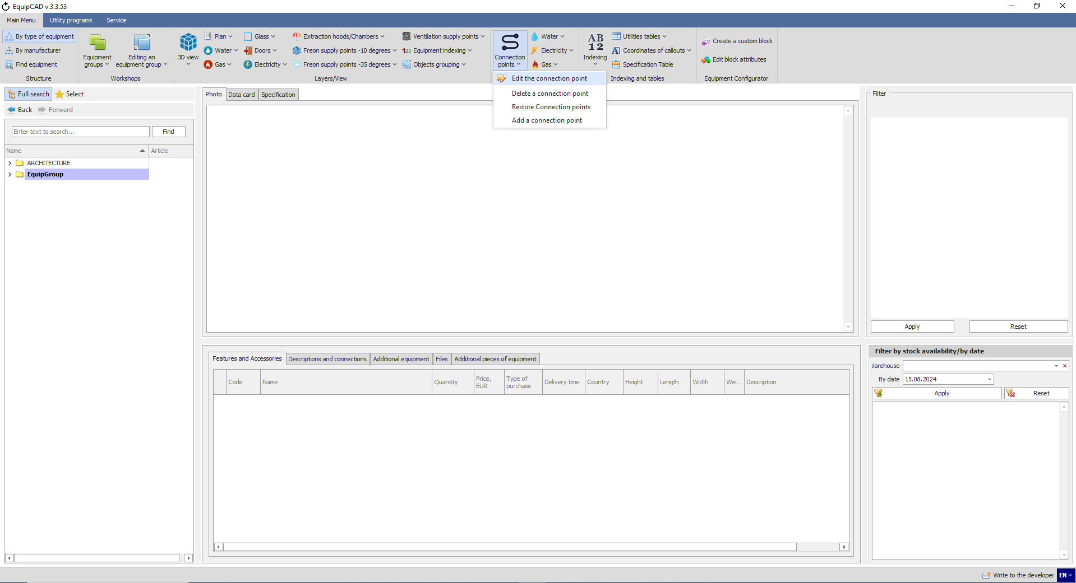
11.5.2
11.5.1

    - When the program has automatically switched to AutoCAD, select the connection point to be edited by highlighting it and confirm your choice by pressing the right mouse button or Enter/Space key;
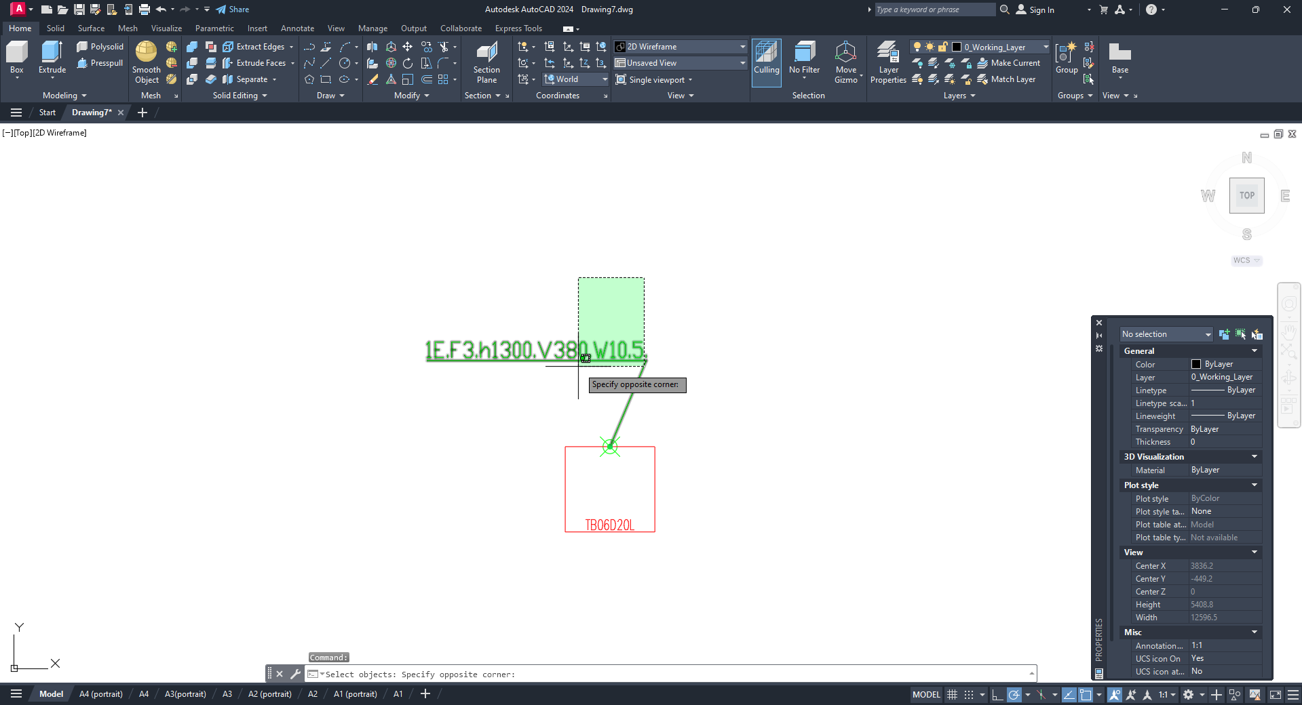

    - Once the connection point is selected, the connection point editing window will open where you can change the scheme and height of the connection (for water and sewage, you can change pipe diameter; and for electricity, you can change voltage and power) and add a comment;
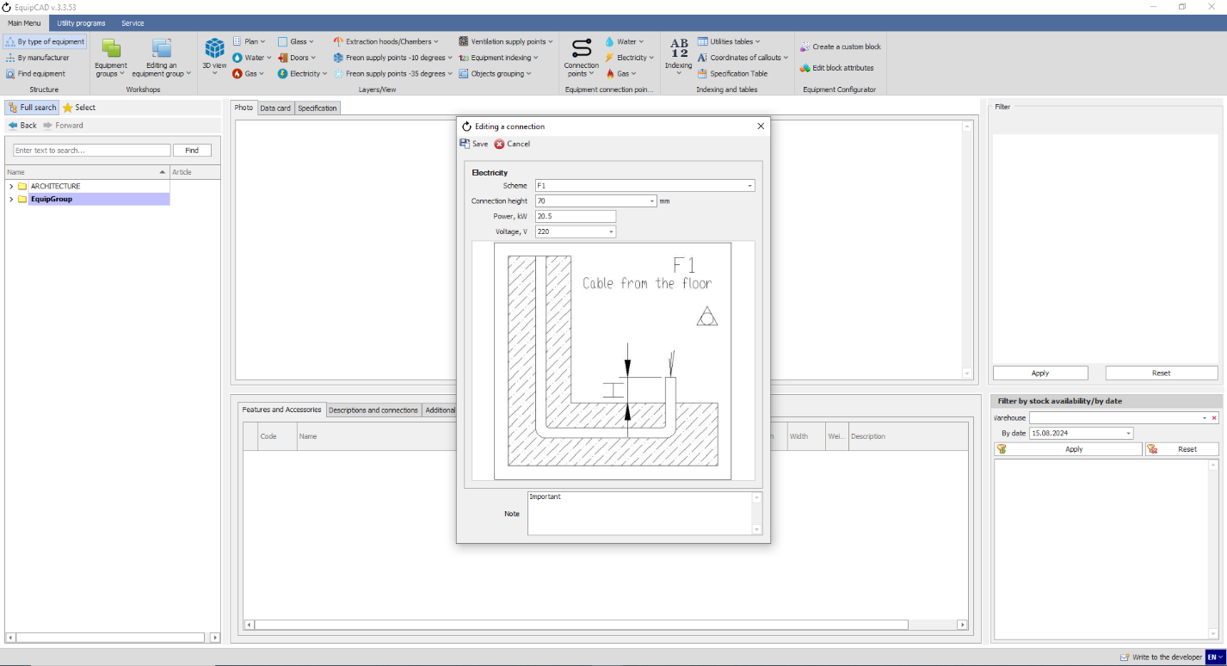

    - Let’s change the connection scheme to F1, the connection height to 70, voltage to 220, and power to 20.5, add the word “Important” in the Comment field, and click the Save button;
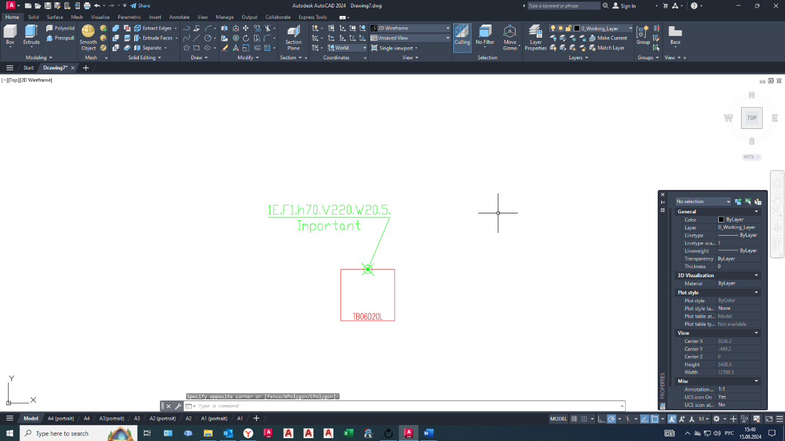
As you can see in the drawing, the connection has been changed;

    - To delete connection points, click the “Connection points” button on the “Equipment connection points” tab;
    - Select “Delete the connection point” in the drop-down menu;
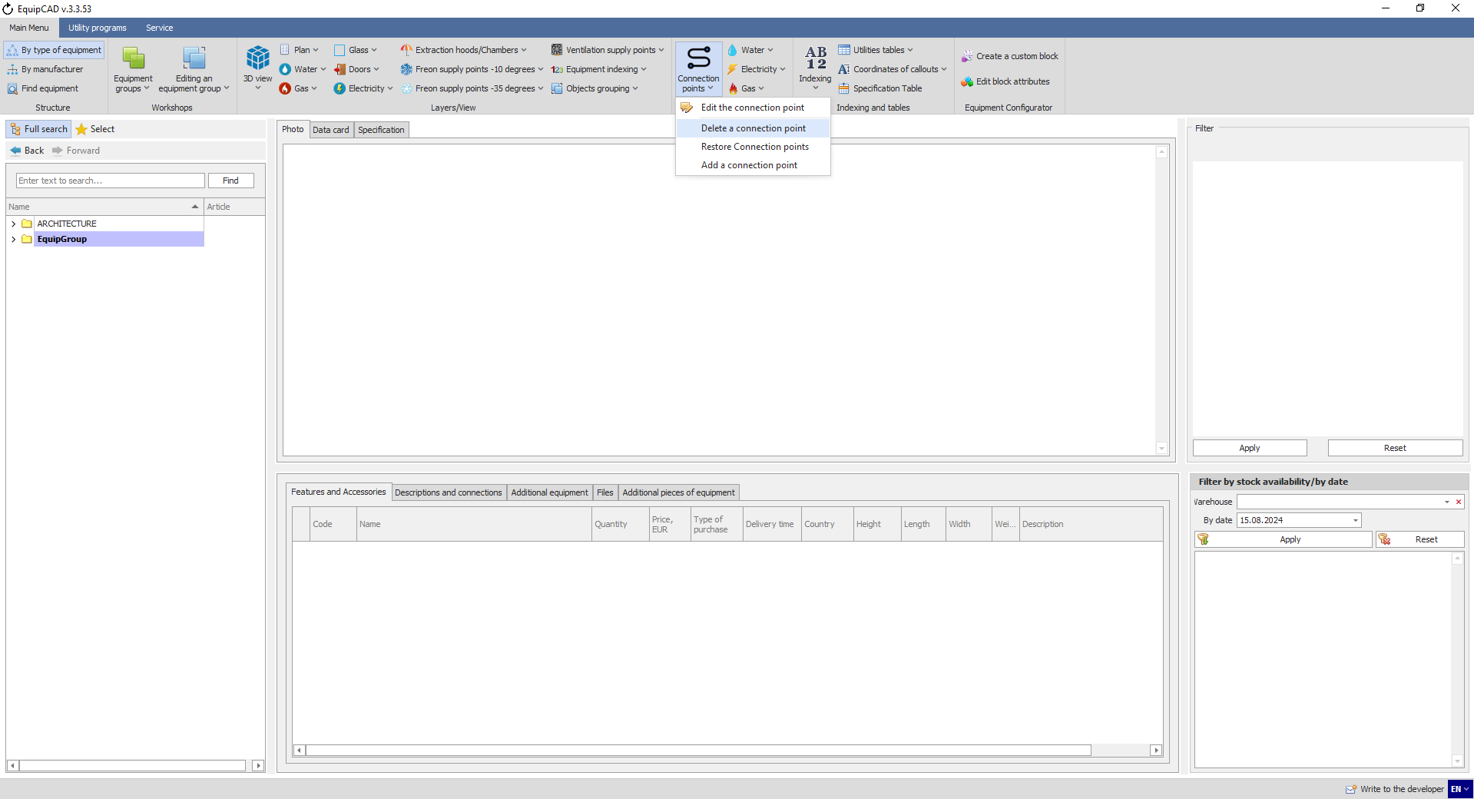
11.5.6
11.5.7

    - When the program has automatically switched to AutoCAD, select the connection point to be deleted by highlighting it and confirm your choice by pressing the right mouse button or Enter/Space key;
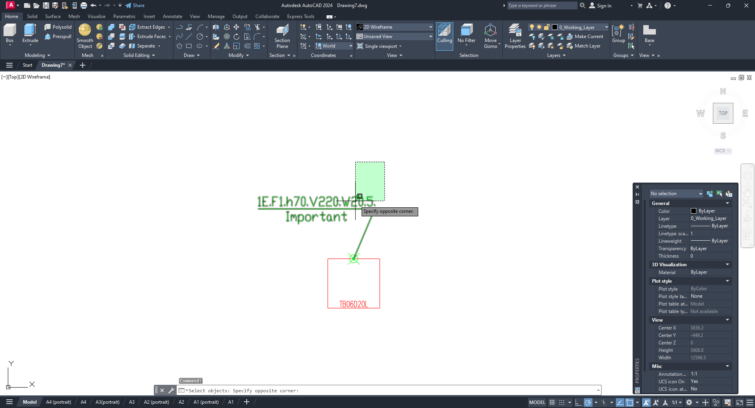
If you delete a connection point and then enter it again, the deleted connection point will not be displayed.

    - To restore connection points, click the “Connection points” button on the “Equipment connection points” tab;
    - Select “Restore connection points” in the drop-down menu;
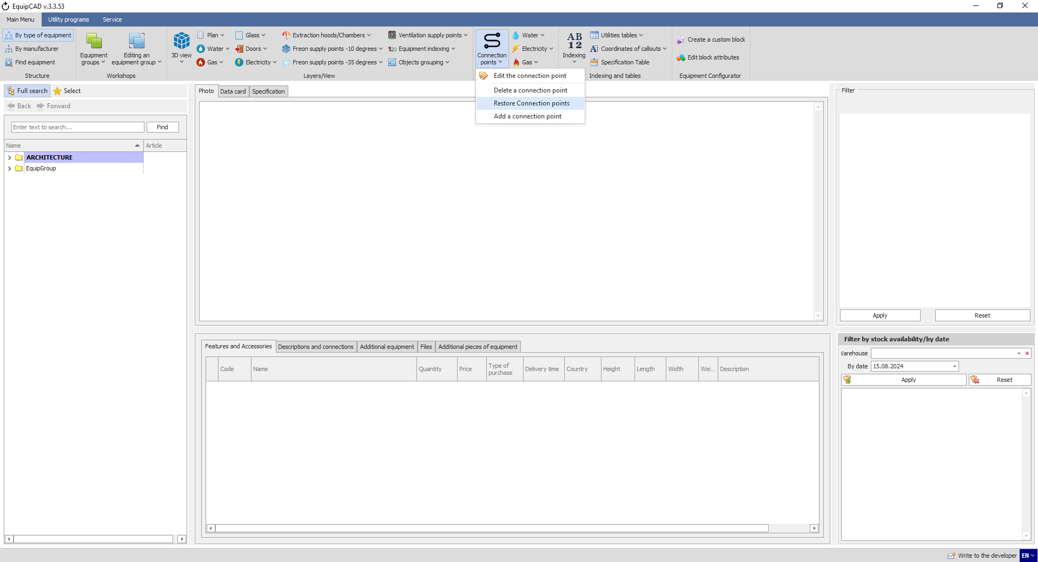
11.5.10
11.5.9

    - When the program has automatically switched to AutoCAD, select the model for which connection points are to be restored by highlighting it and confirm your choice by pressing the right mouse button or Enter/Space key;
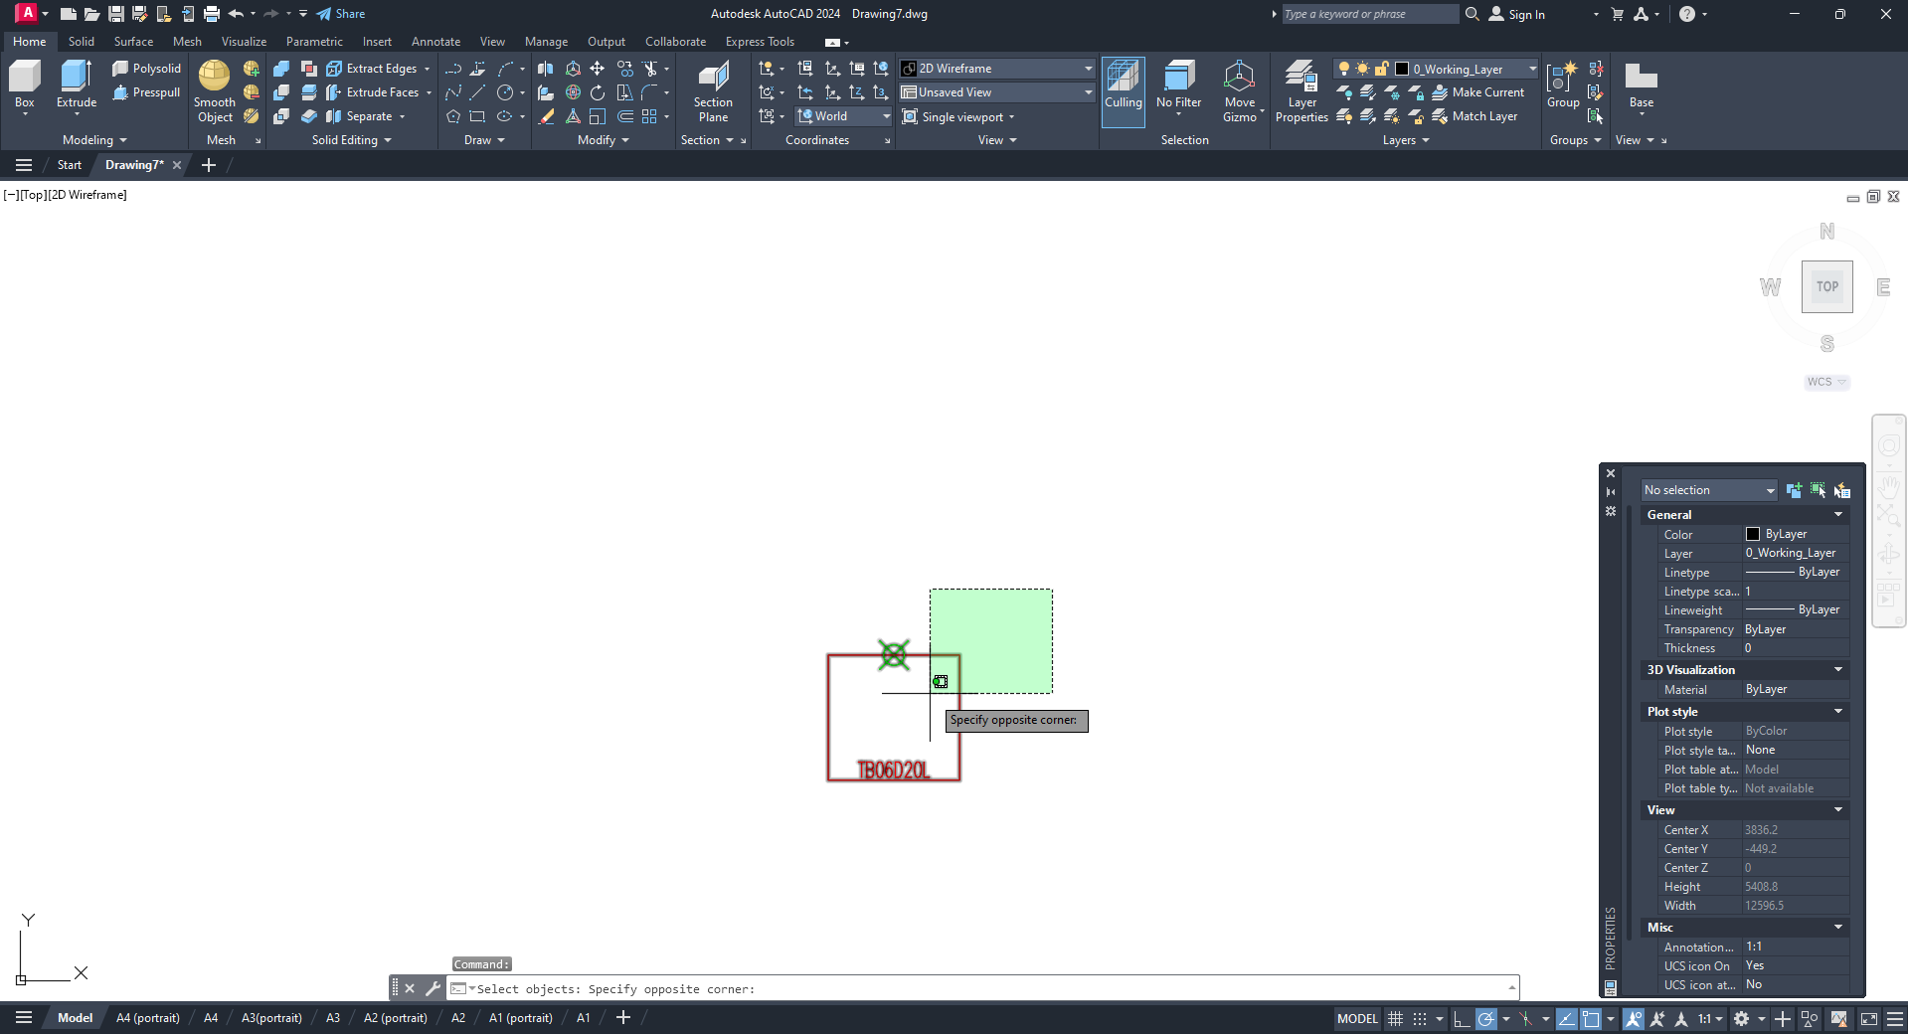
When connection points are restored, you should delete and put them again.

    - To add connection points, click the “Connection points” button on the “Equipment connection points” tab;
    - Select “Add the connection point” in the drop-down menu;
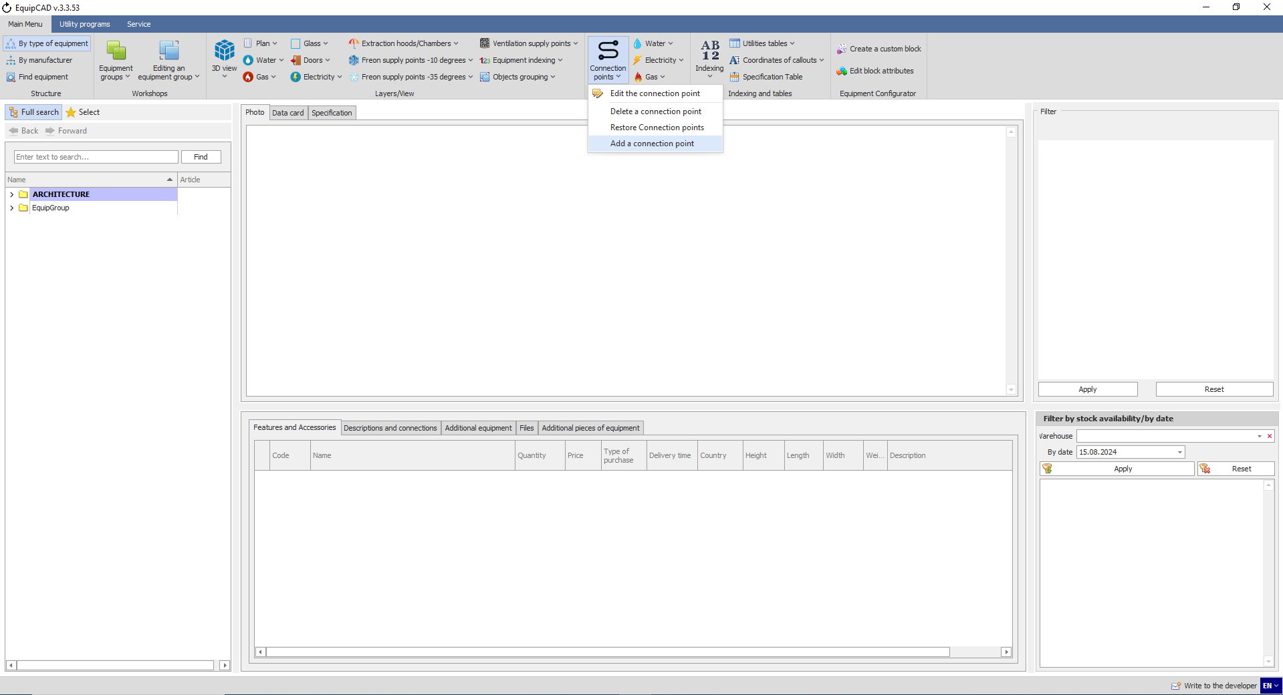
11.5.13
11.5.12

    - When the program has automatically switched to AutoCAD, select the model for which a connection point is to be added by highlighting it and confirm your choice by pressing the right mouse button or Enter/Space key;
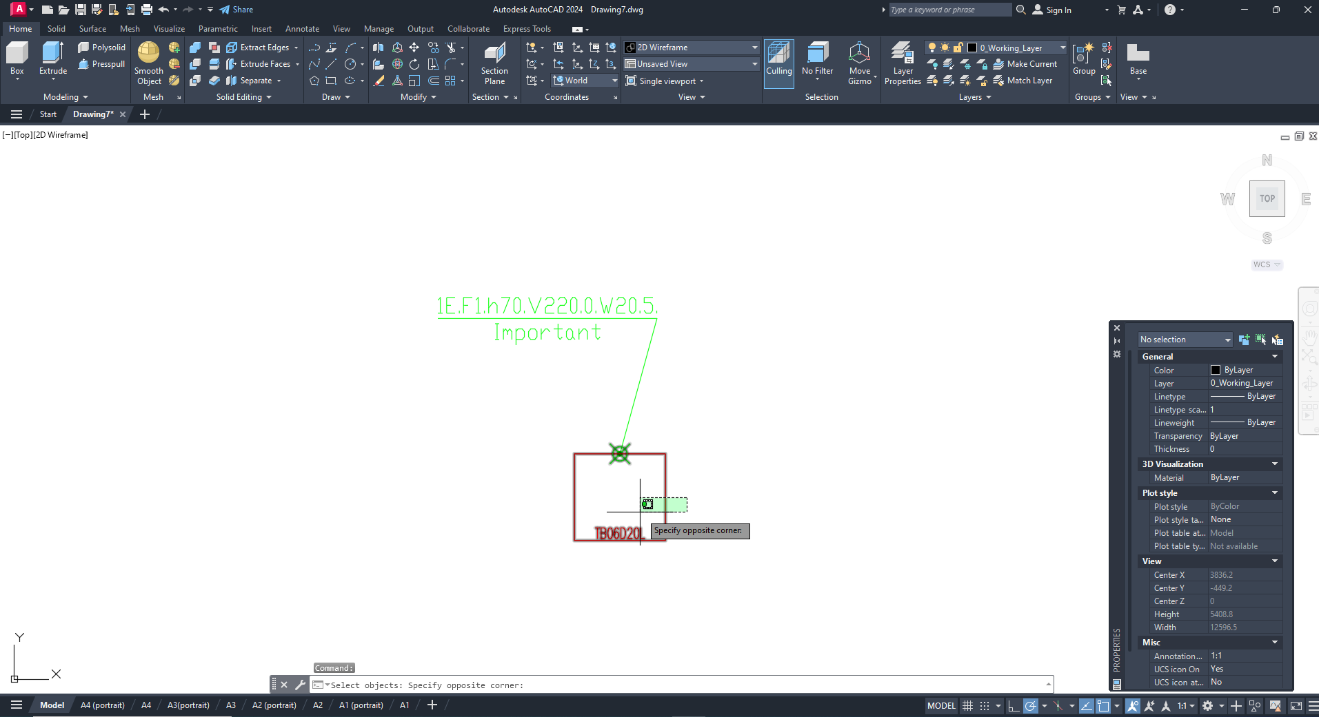

    - Once the equipment is selected, the connection point creation window will open where you should enter the scheme and height of the connection (and pipe diameters for water and sewage) and you can also add a comment, and click the Save button;
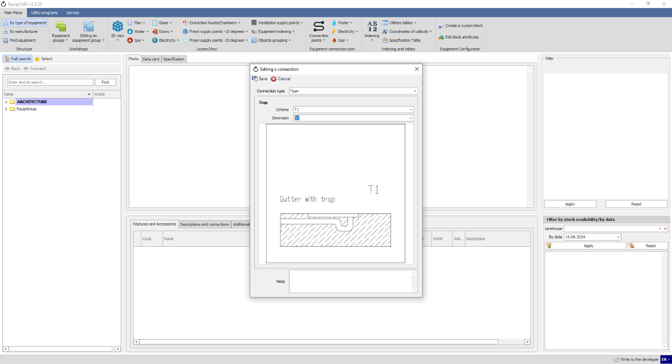

    - Then put the connection points;
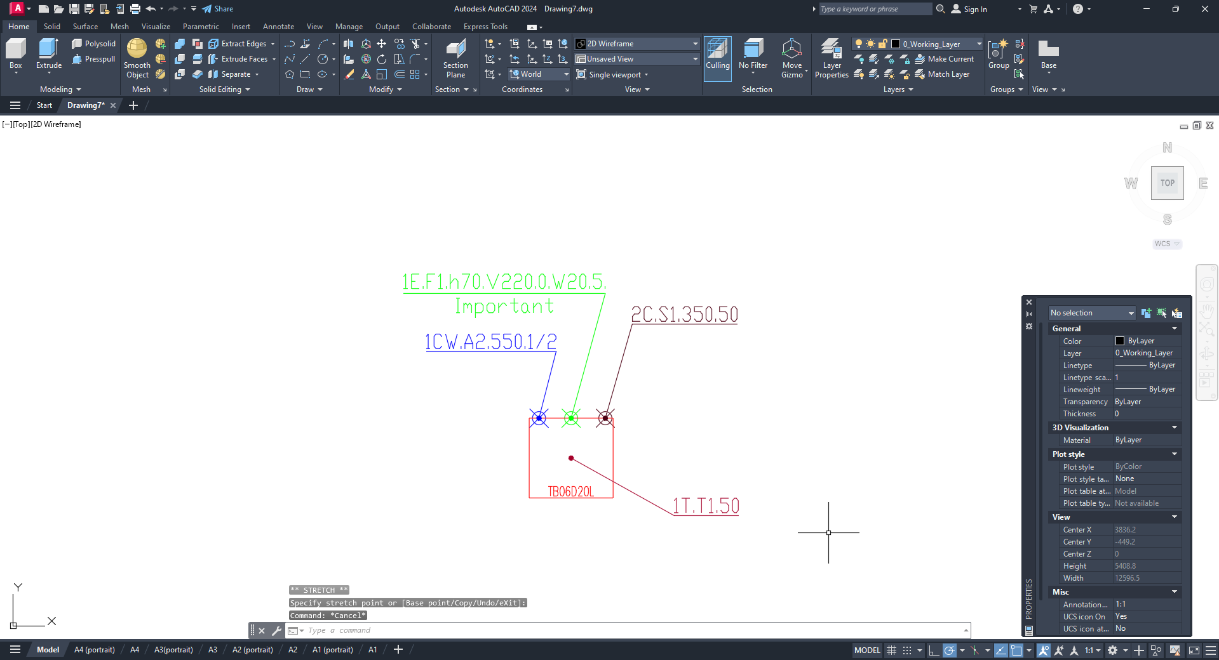
As you can see, our connection point has been added to the drawing.
  - Editing connection points in the specification

    - To edit connection points in the specification after they have been entered, go to the Specification tab and click the “Fill out specification” button;
    - Connections put for a particular equipment item are indicated using circles of corresponding colors under the “Connections” column header to the right of the “Amount” header;
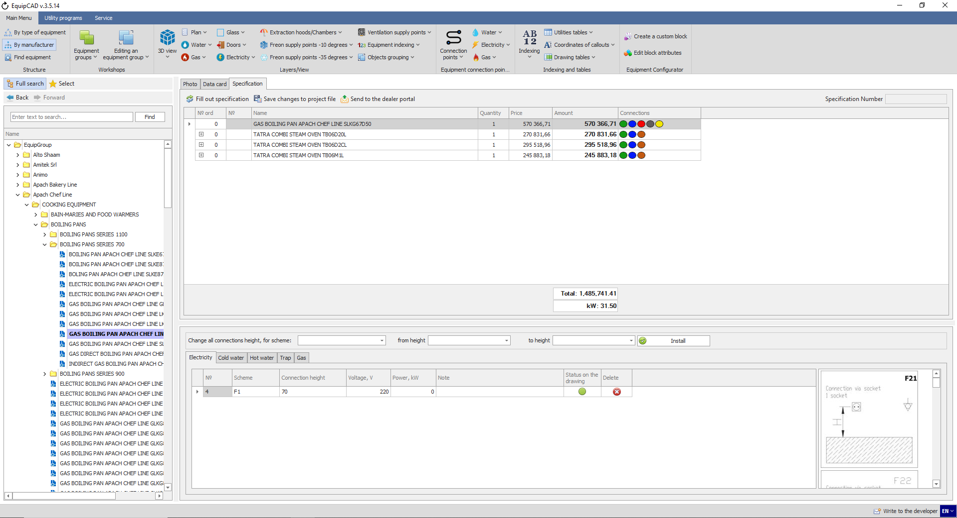
11.6.1
11.6.2
Note: The green circle indicates electricity; the blue circle indicates cold water; the red circle indicates hot water; the brown circle indicates sewage; the gray circle indicates trap; and the yellow circle indicates gas.

    - To change a connection point, go to Specification and select the equipment for which you need to edit the connection;
    - Then select the tab for the connection you want to change below;
    - You can change any parameter available in the table on the connection tabs;
    - A tooltip showing the schemes of the current connection is available to the right of the table for editing connections;
    - Once the changes are made, click the “Save changes to project file” button;
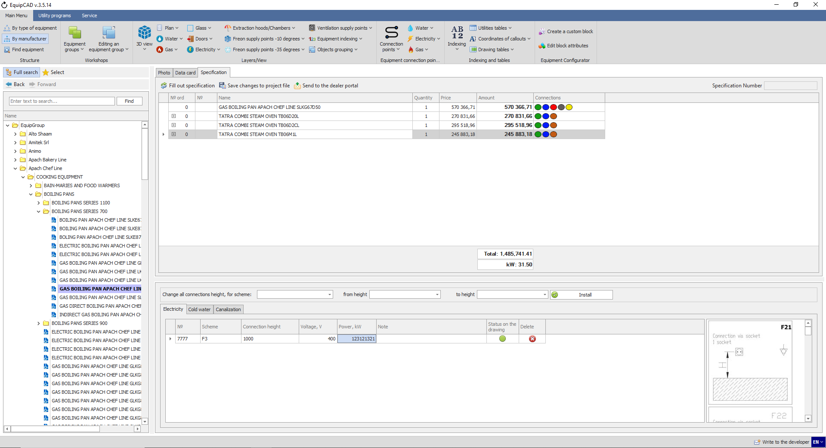
11.6.3
11.6.6
11.6.4
11.6.5
11.6.7
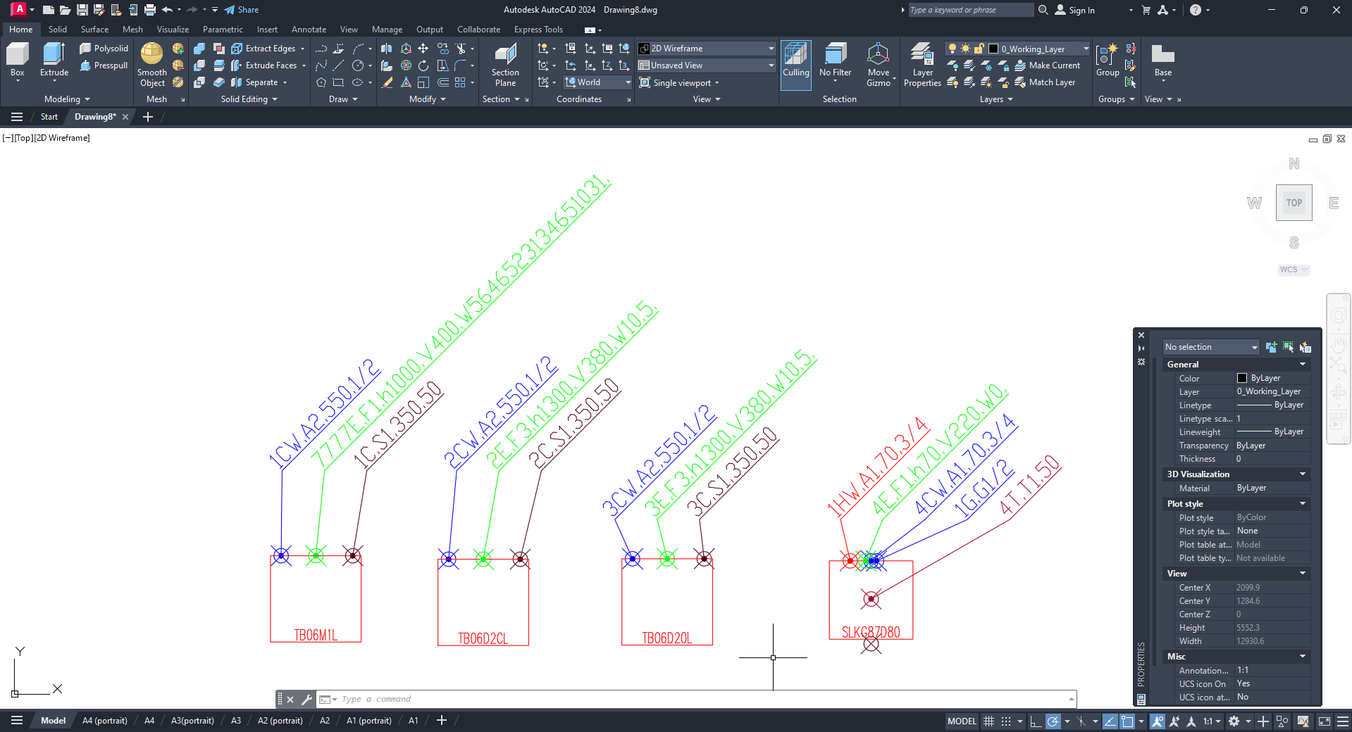
All the changes have been saved in your project.

    - To change the height of all the connections of a certain type and scheme, go the corresponding connection tab;
    - Then choose the scheme, the height to be changed, the initial height value, and the desired height value to be set;
    - Click the Set button;
    - Once the changes are made, click the “Save changes to project file” button;
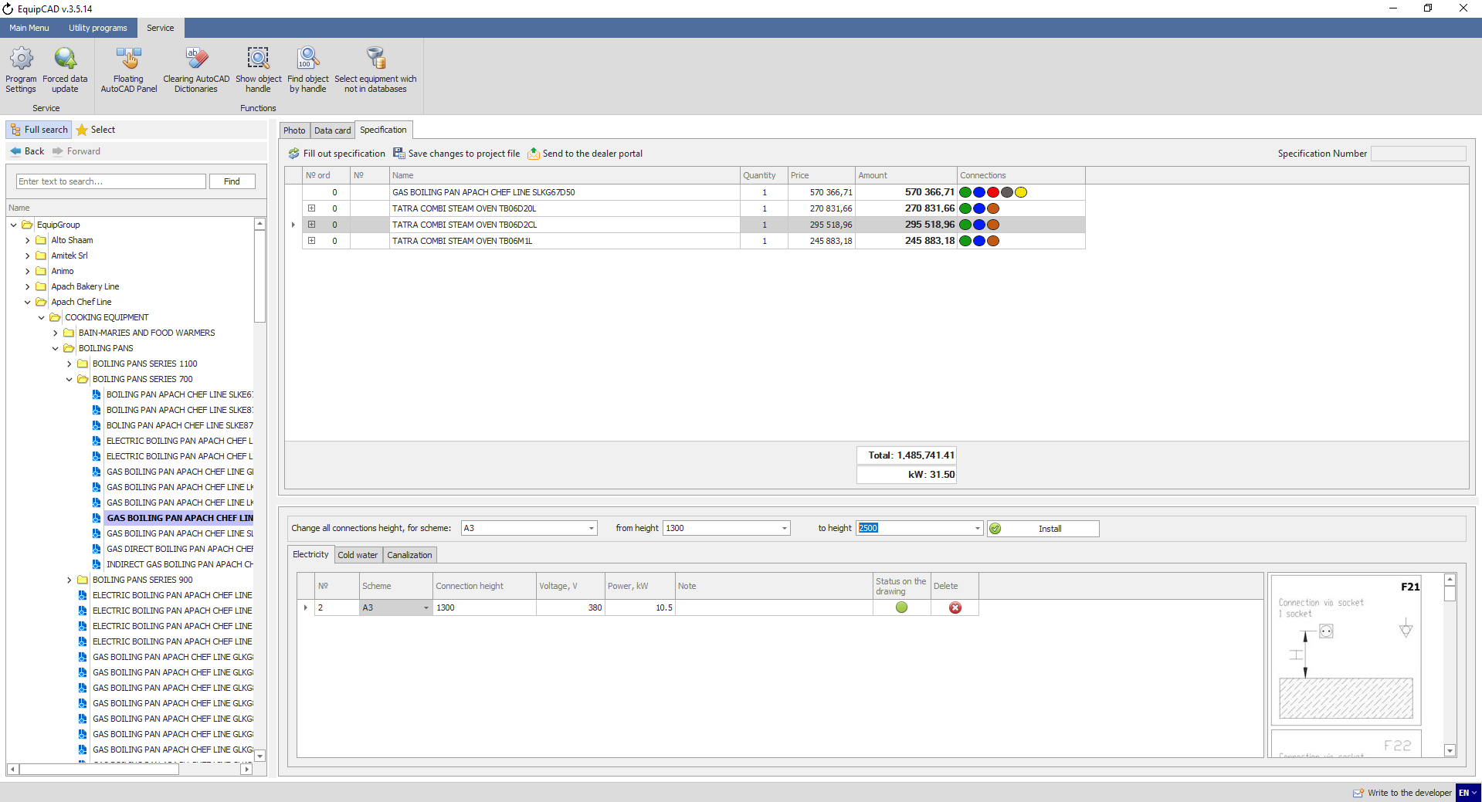
11.6.9
11.6.8
11.6.11
11.6.10
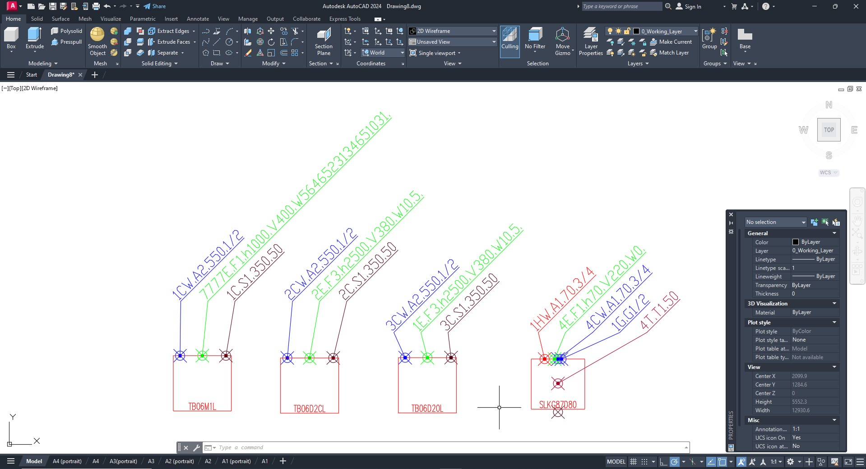
The height has changed to 400 for all the electricity connections with F3 scheme.

    - The icon in the «Delete» column allows you to delete callouts from the Specification tab;
    - The icon in the "Status on Drawing" column displays whether the callout has been removed;

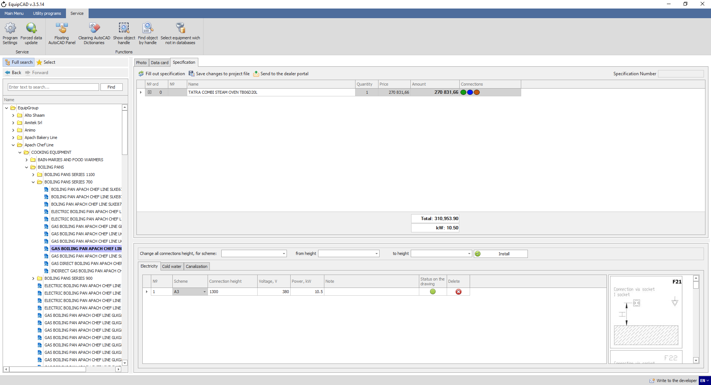
11.6.13
11.6.12

    - When you click on the icon from the "Delete" column, it will change, the callout line will change its color to red;
    - After clicking the "Save changes to project file" button, the callout will be removed from the drawing;
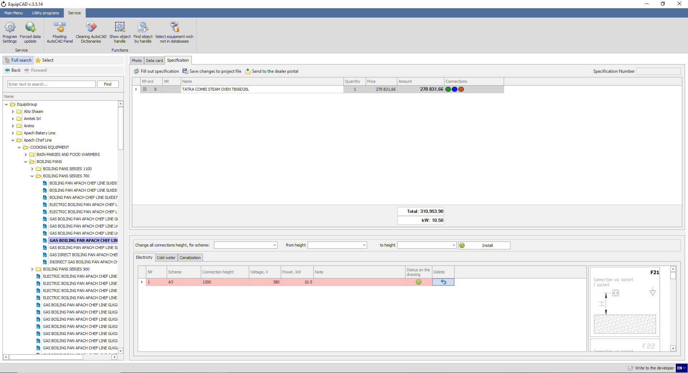
11.6.15
11.6.14
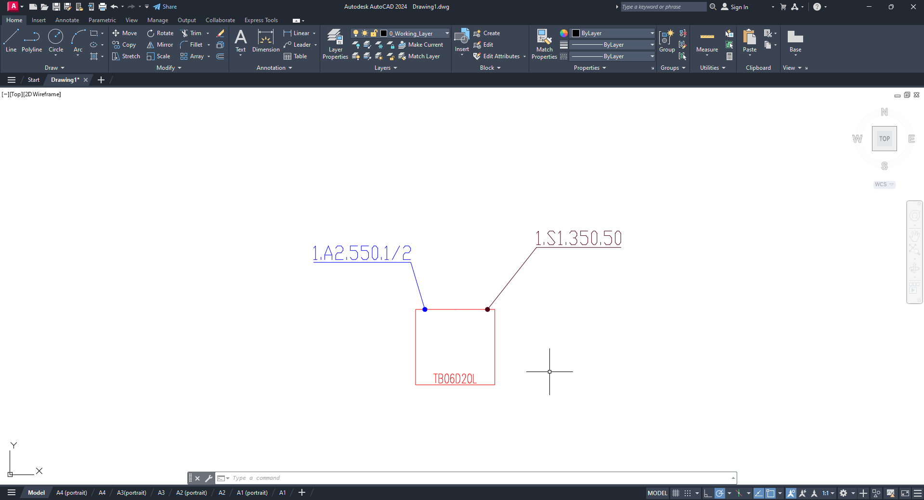

    - If the callout was manually deleted from the drawing, the icon in the “Status on Drawing” column will be colored red;
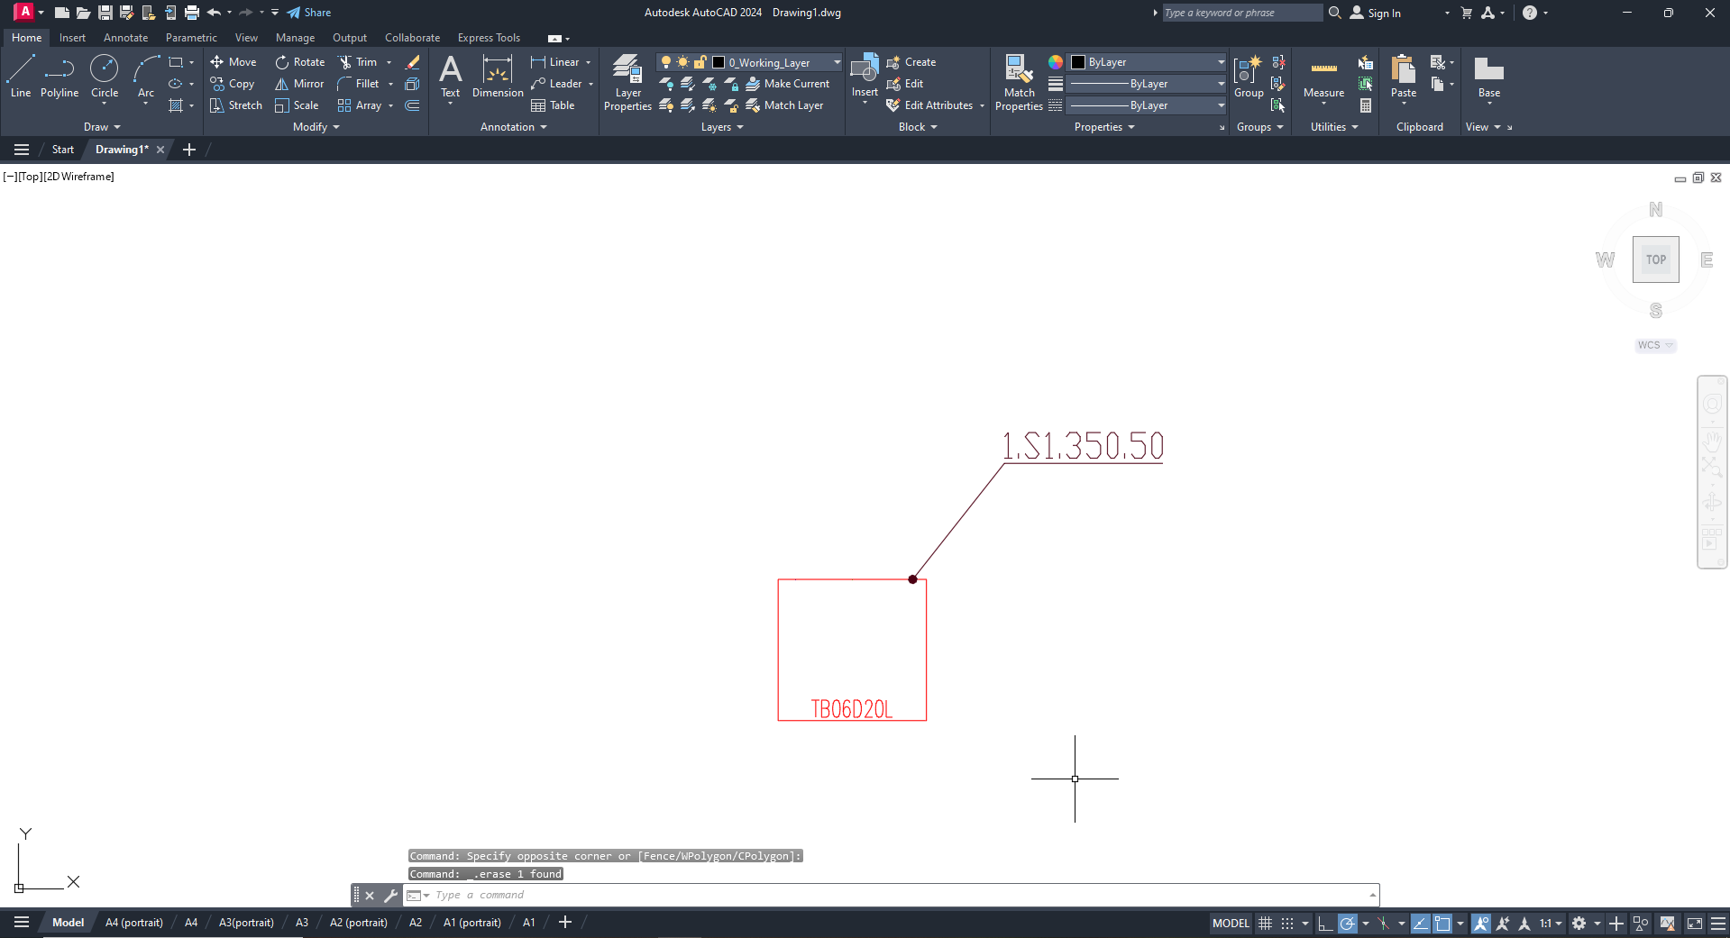
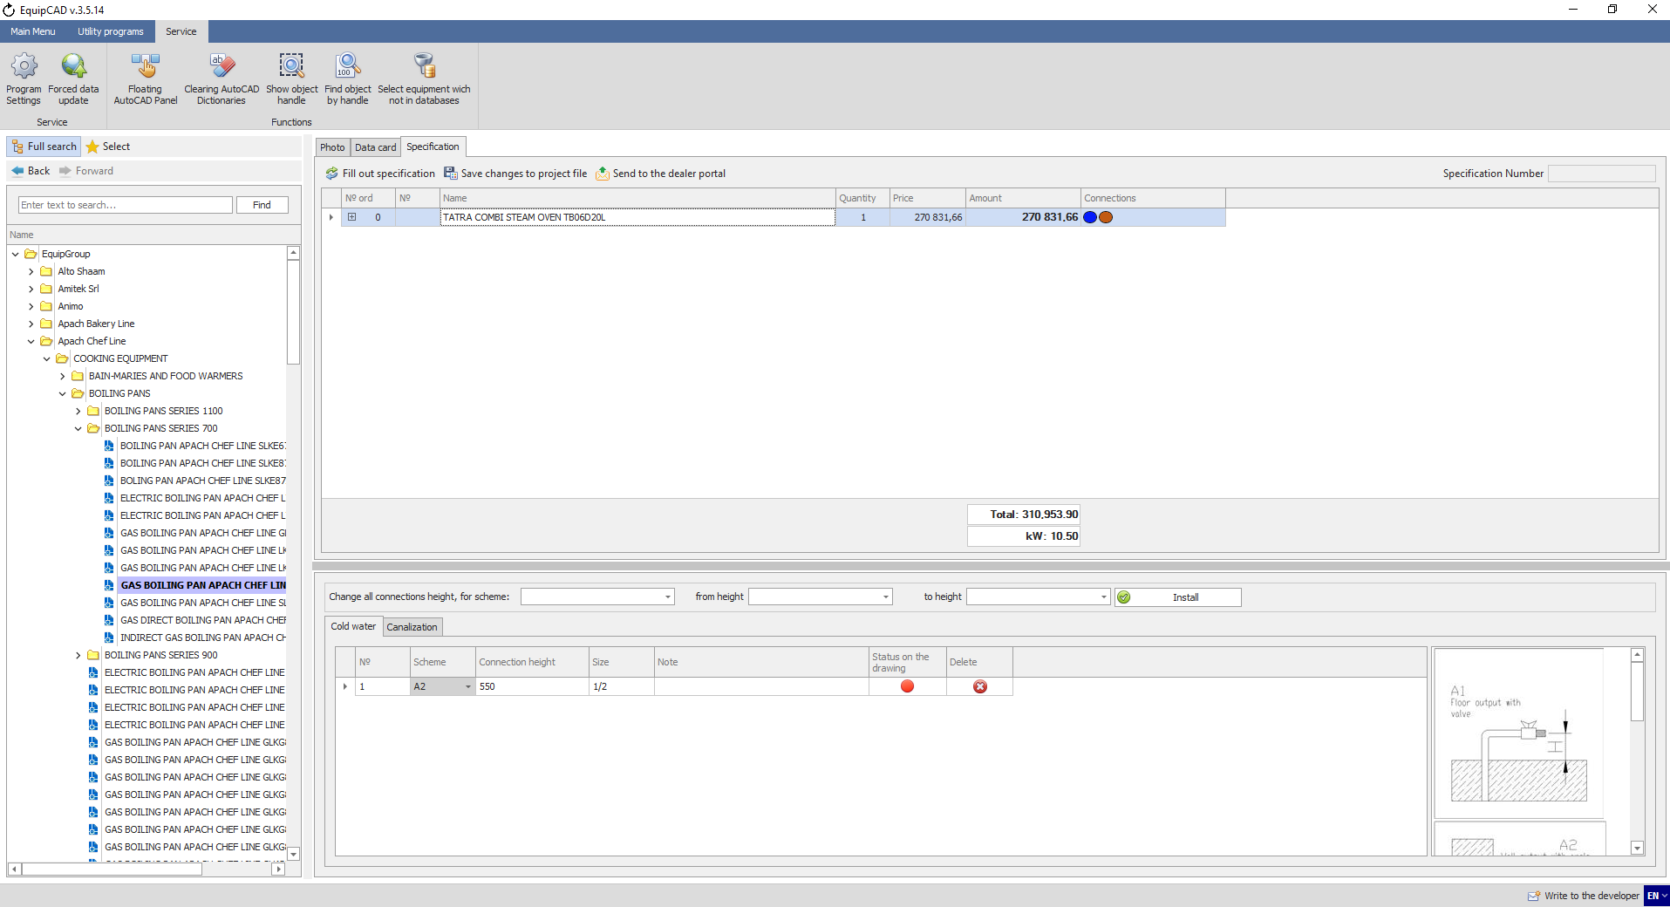
11.6.16
Note: The icon in the "Status on Drawing" column is updated when you switch to a specific piece of equipment in the specification.

  - Utility programs

    - To hide the names of equipment in your project, go to the “Utility programs” tab;
    - Then click the “Hide text on equipment” button;
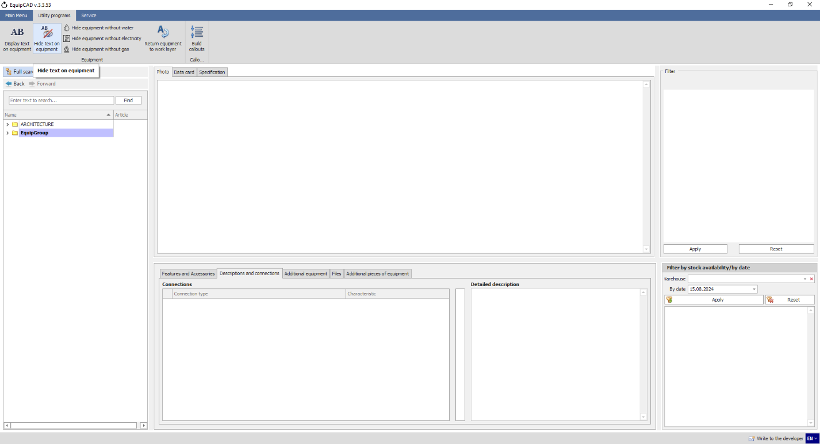
11.7.2
11.7.1
As you can see, the names of equipment are hidden.
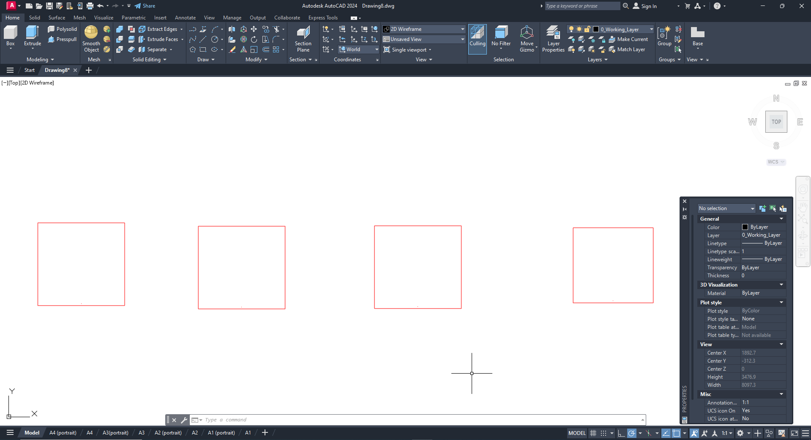

    - To display the names of equipment in your project, go to the “Utility programs” tab;
    - Then click the “Display text on equipment” button;
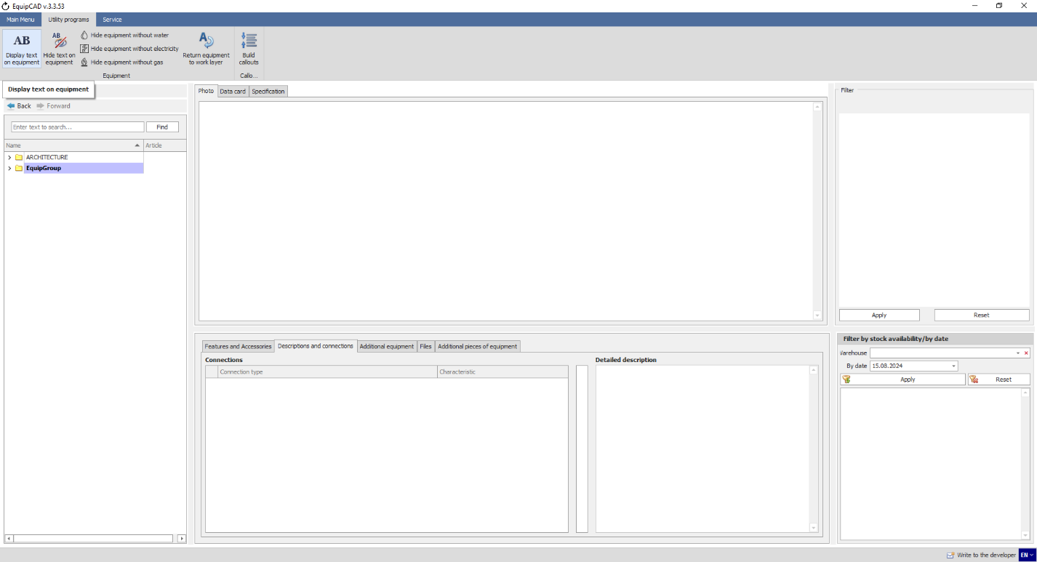
11.7.4
11.7.3
As you can see, the names of equipment are displayed again.
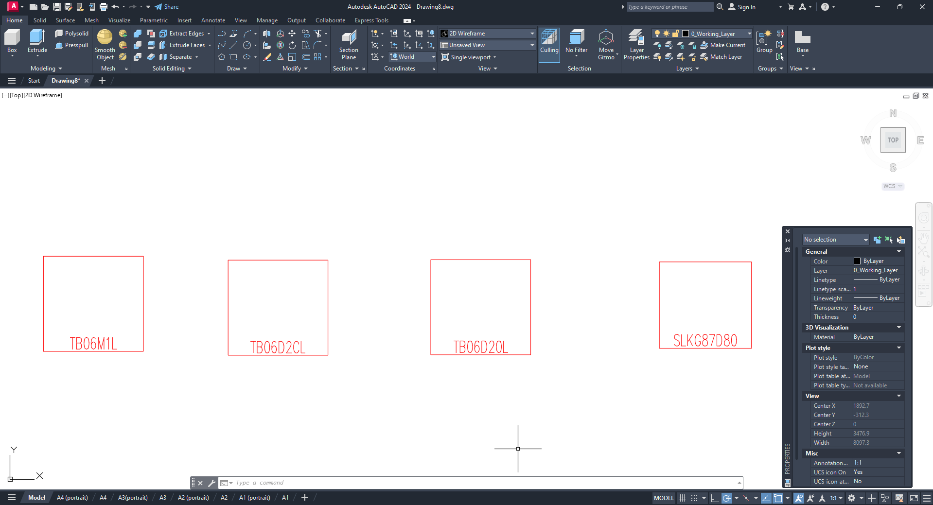

    - To hide equipment that has no connection to a certain utility service, go to the “Utility programs” tab;
    - Then click the “Hide equipment without water/electricity/gas” button;
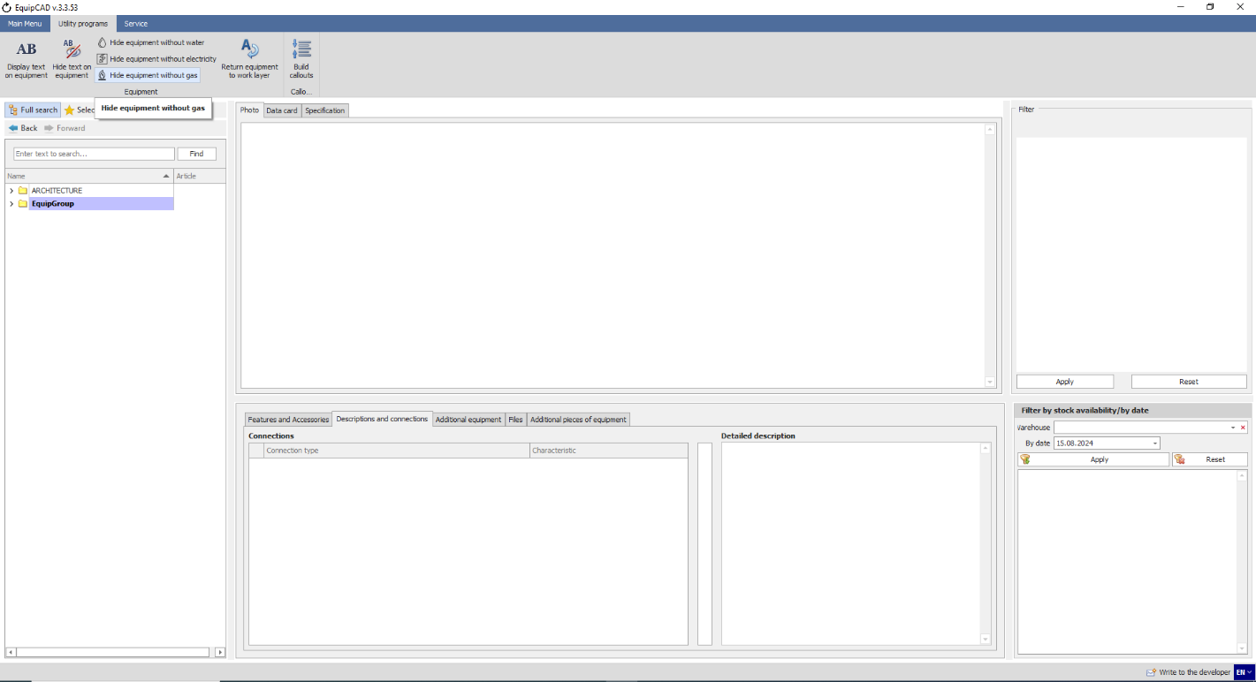
11.7.6
11.7.5
By way of example, let’s hide the equipment that is not connected to electricity.
The program will inform you that the equipment without electricity callouts has been moved to the “0_Working_Layer_Off” layer.
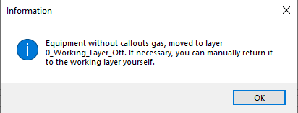
Once the operation is confirmed, the program will switch to AutoCAD, where, as you can see, the “Table” block for which no electricity connection was put is also missing.
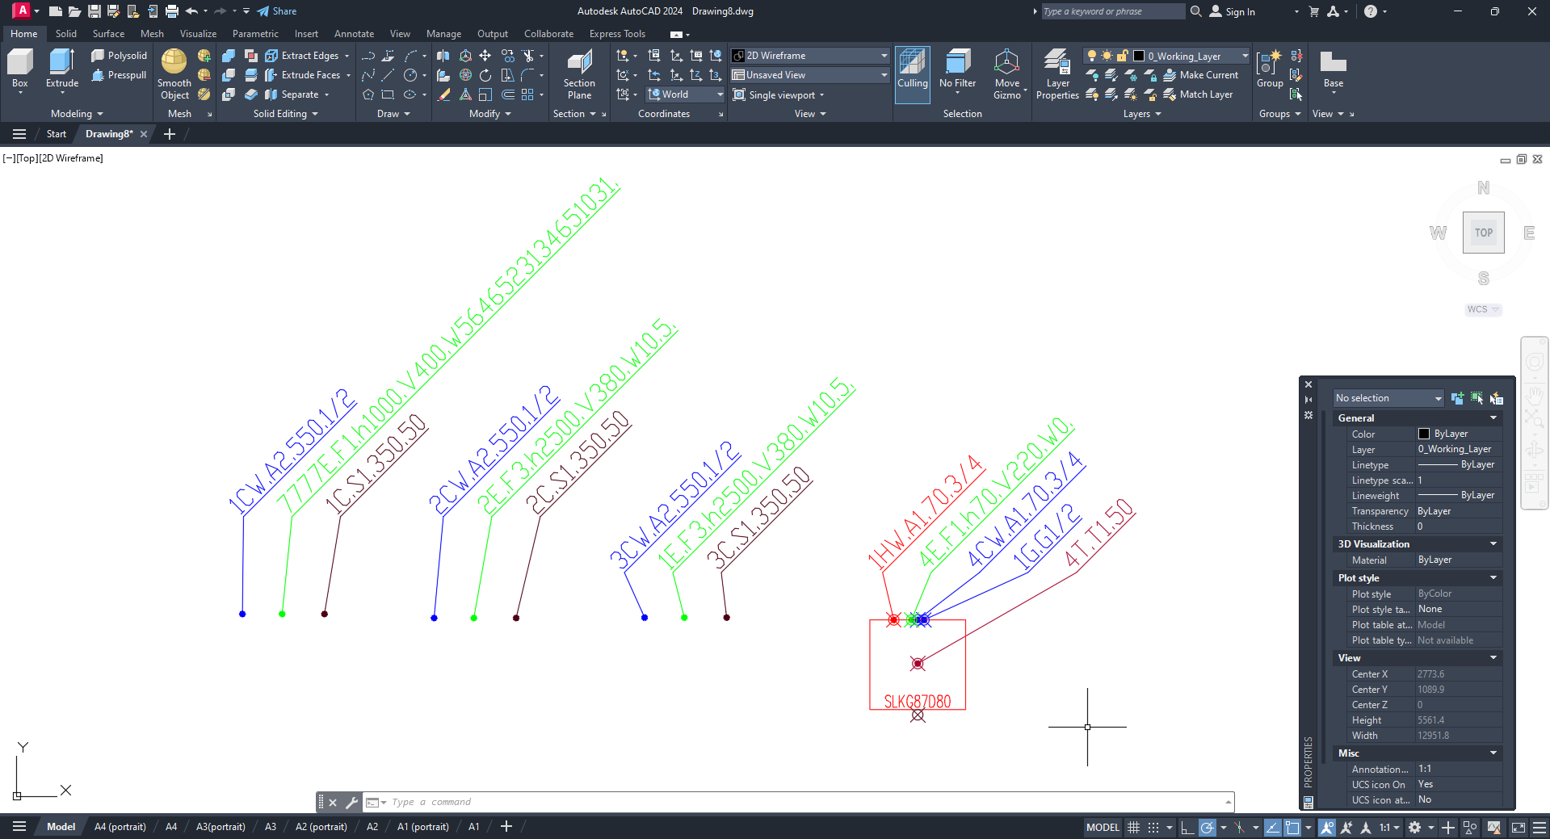
Note: These utility programs hide the equipment for which certain connection points HAVE NOT BEEN PUT!

    - To return equipment to the principal layer, click the “Return equipment to work layer” button;
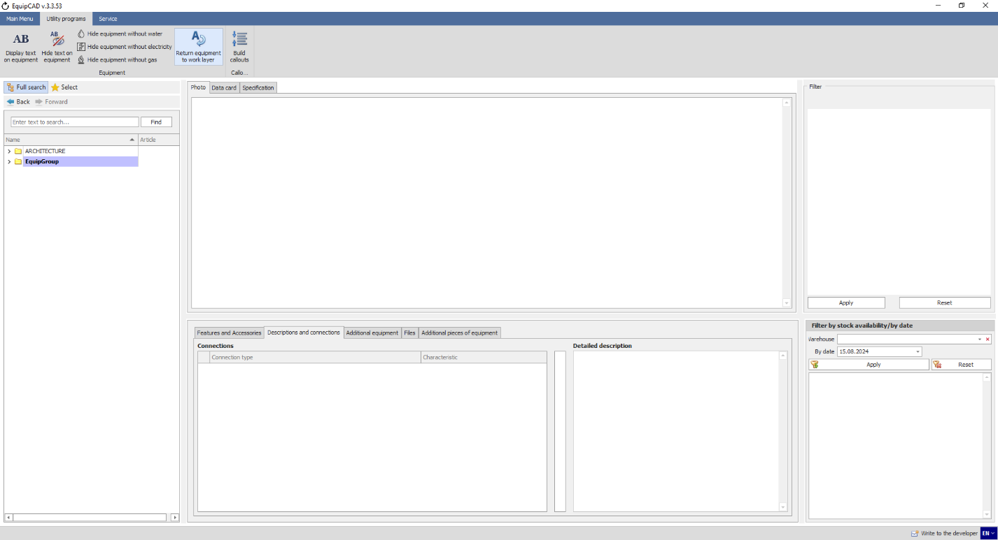
11.7.7
After that, EquipCaD will return the previously hidden equipment to the principal layer and switch to AutoCAD.

    - Before aligning callouts, you should draw a line in your project along which your callouts will be aligned;
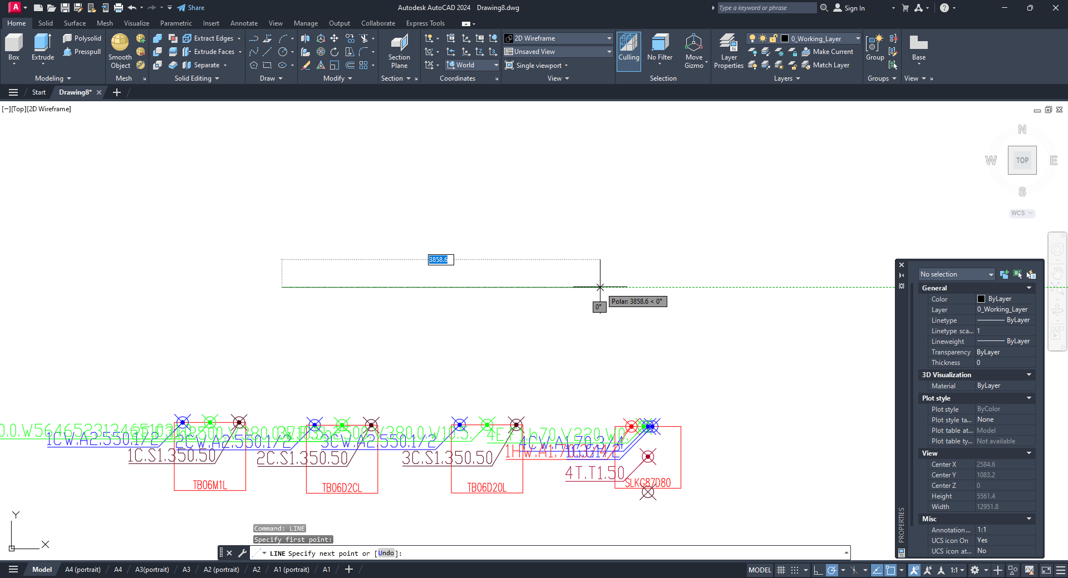

    - To align callouts for equipment, go to the “Utility programs” tab;
    - Then click the “Align callouts” button;
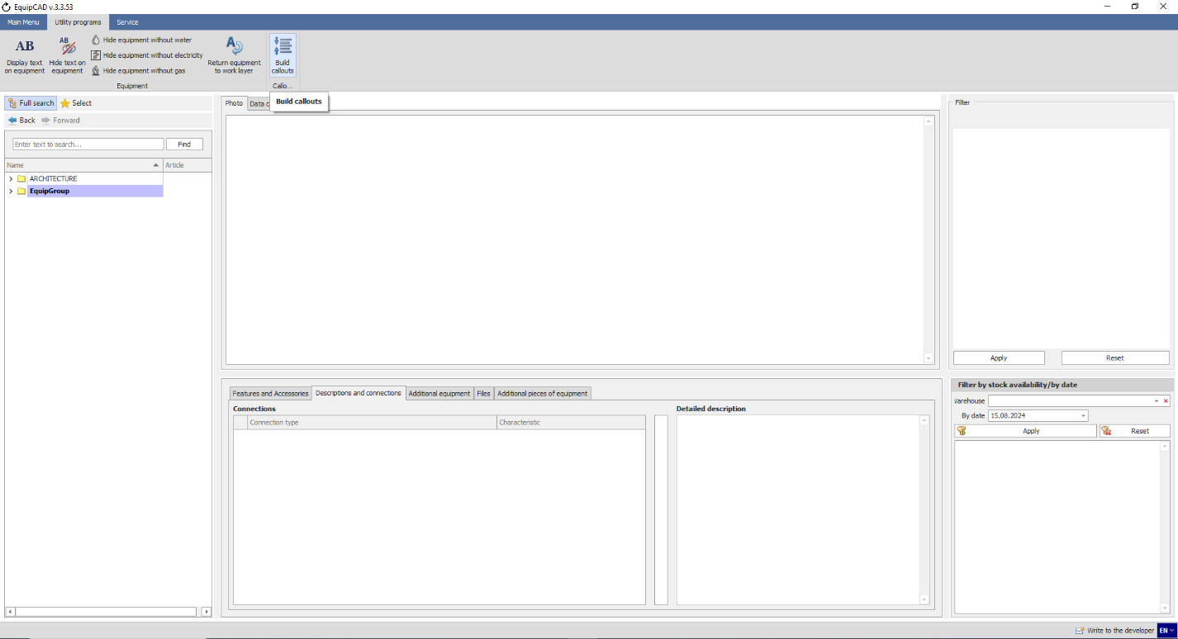
11.7.10
11.7.9

    - After that, the program will prompt you to choose callouts you would like to align;
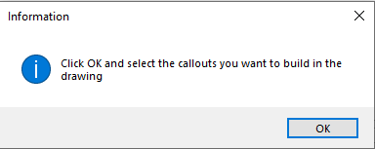

    - Once you have confirmed your choice, the program will switch to AutoCAD where you will need to select the callouts you want to align and press the right mouse button or Enter/Space key;
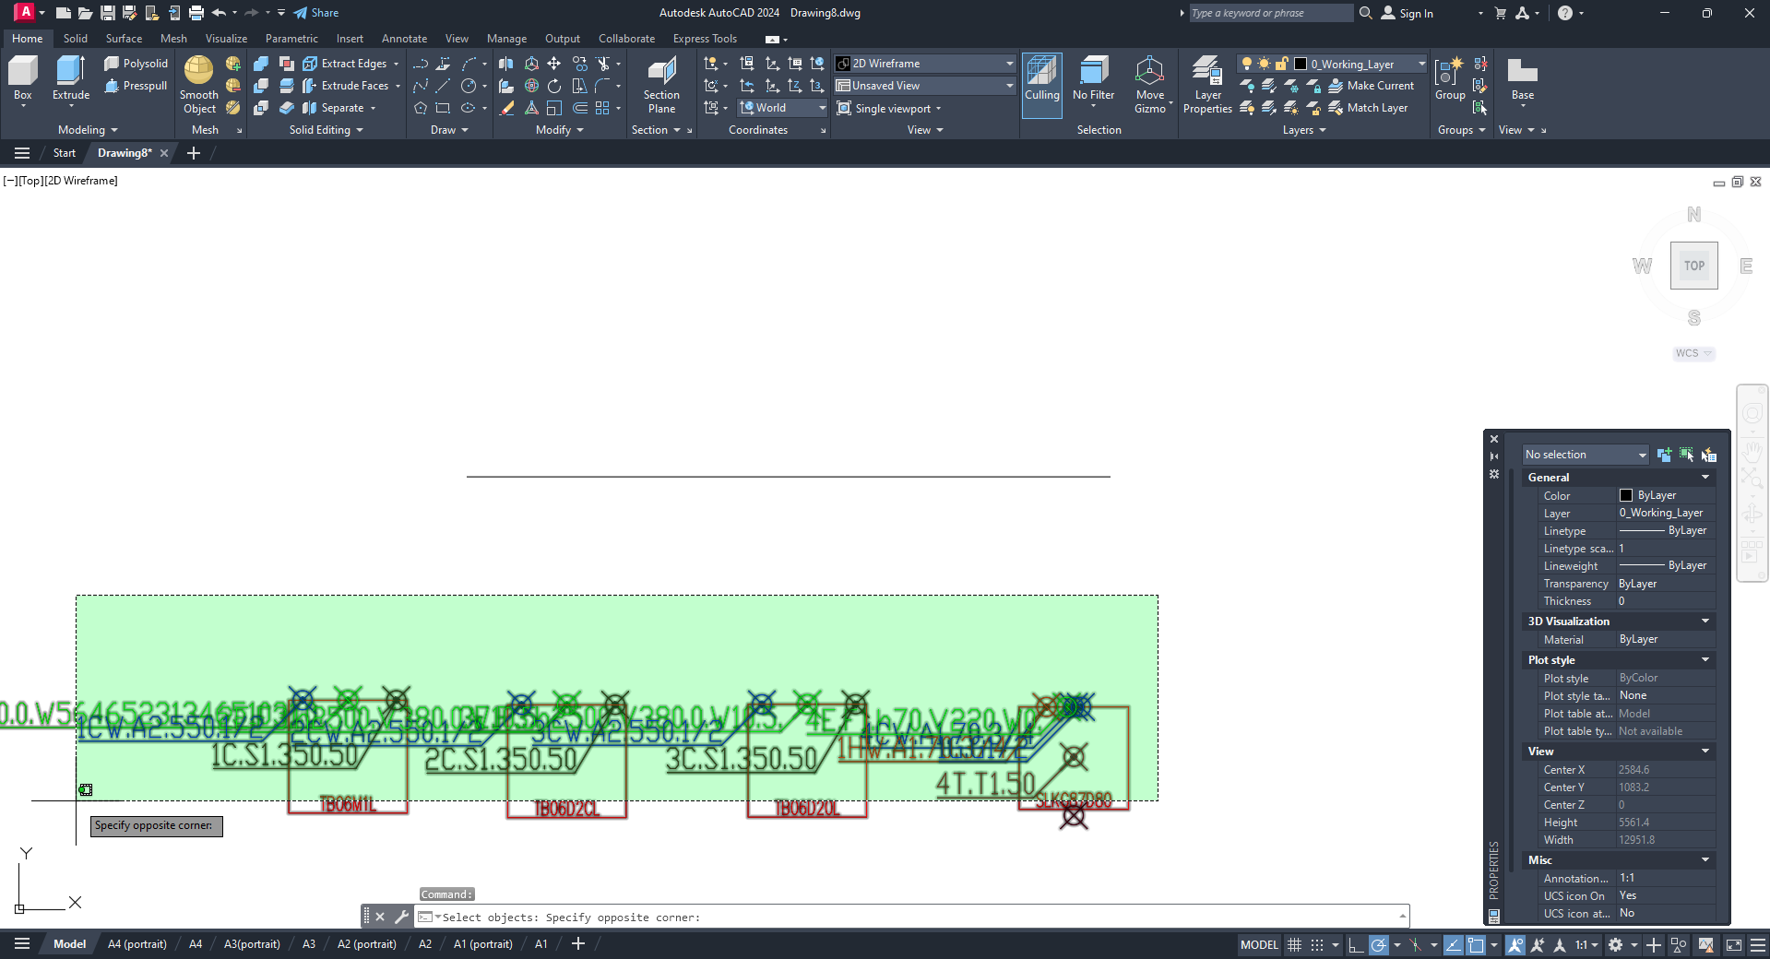

    - After that, the program will prompt you to choose a line to which your callouts are to be aligned;
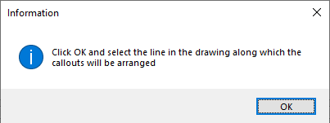

    - Once you have confirmed your choice, the program will switch to AutoCAD where you will need to select a line for aligning callouts and press the right mouse button or Enter/Space key;
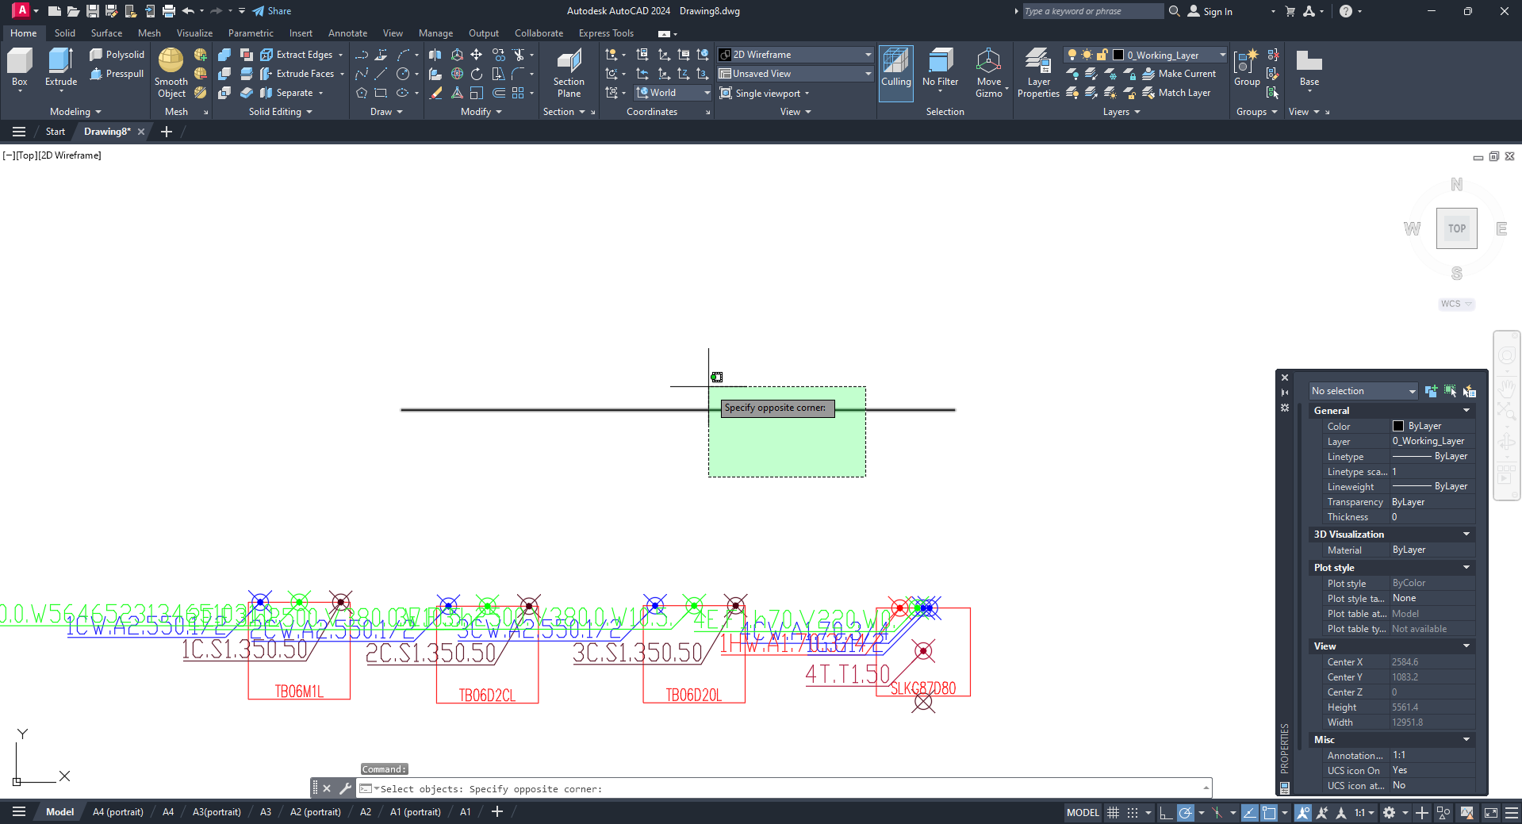

After that, the program will align the callouts you have selected along the chosen line.
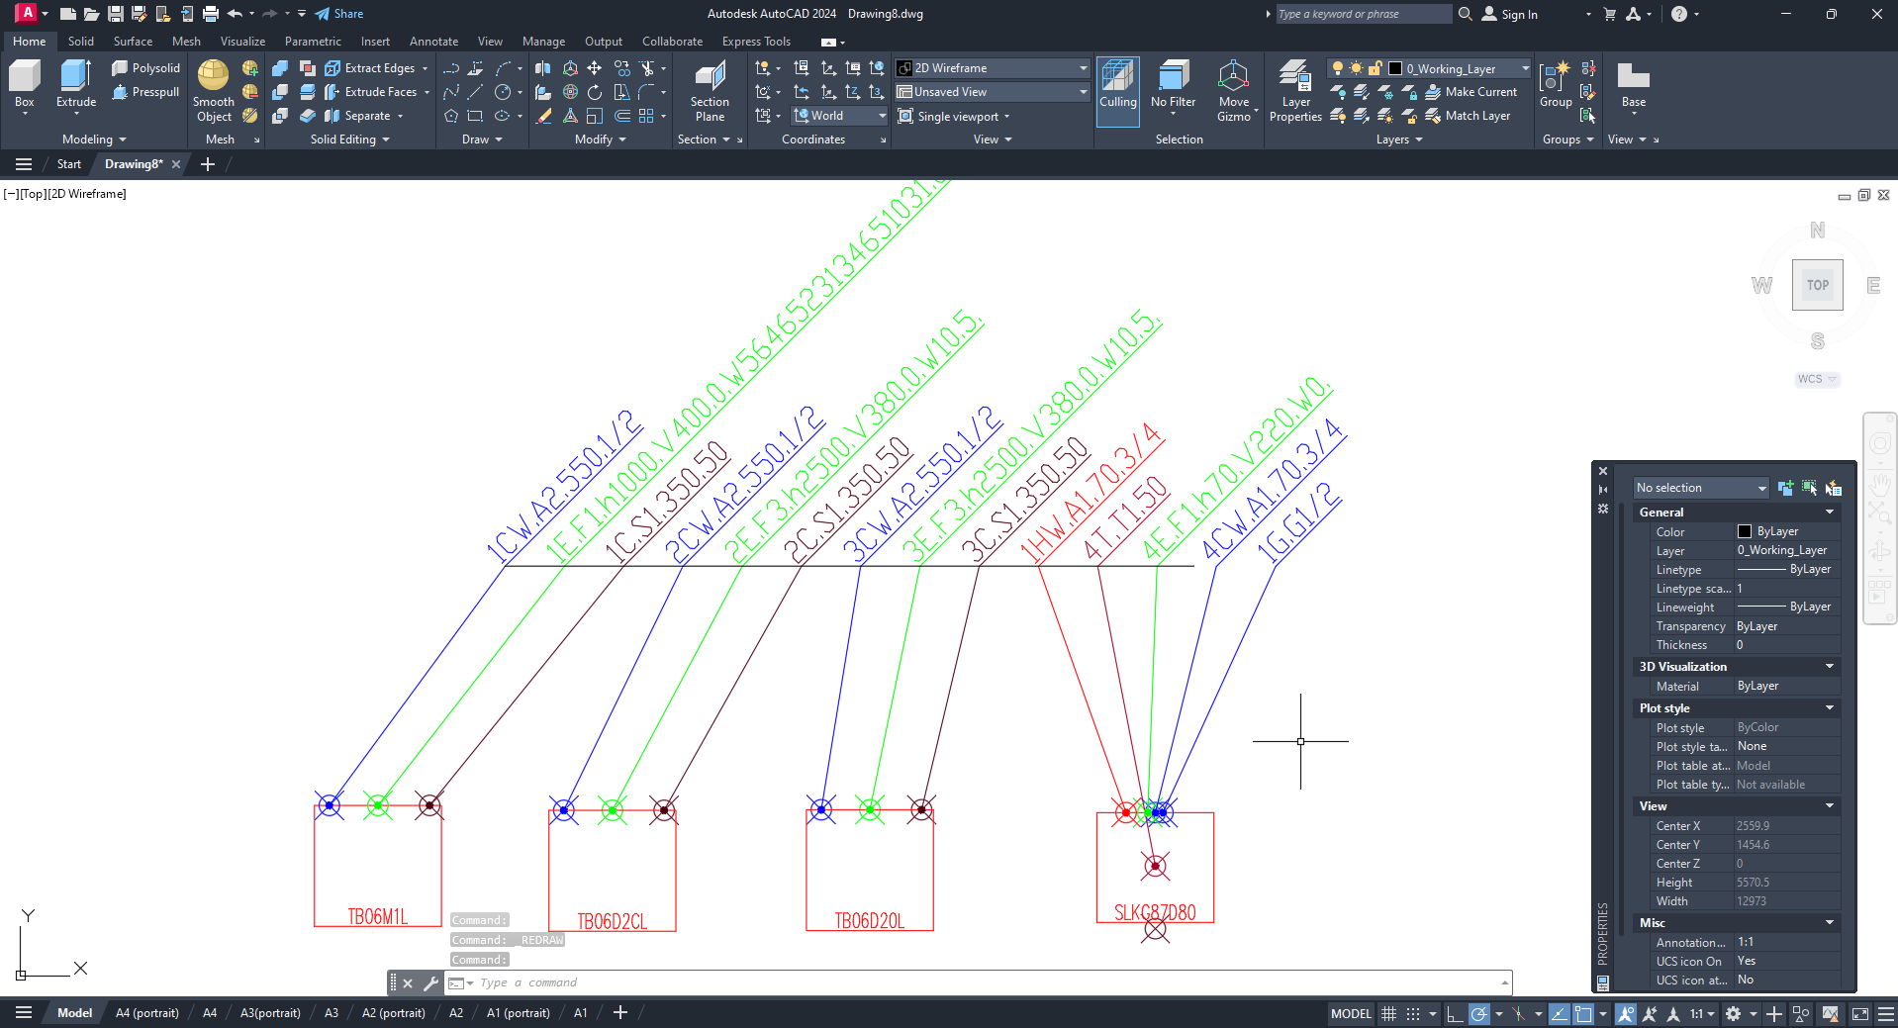

    - You can choose the maximum angle of the line you use for aligning callouts, at which callouts will rotate by a certain degree, in the general settings for AutoCAD in the Program Settings menu on the Service tab;
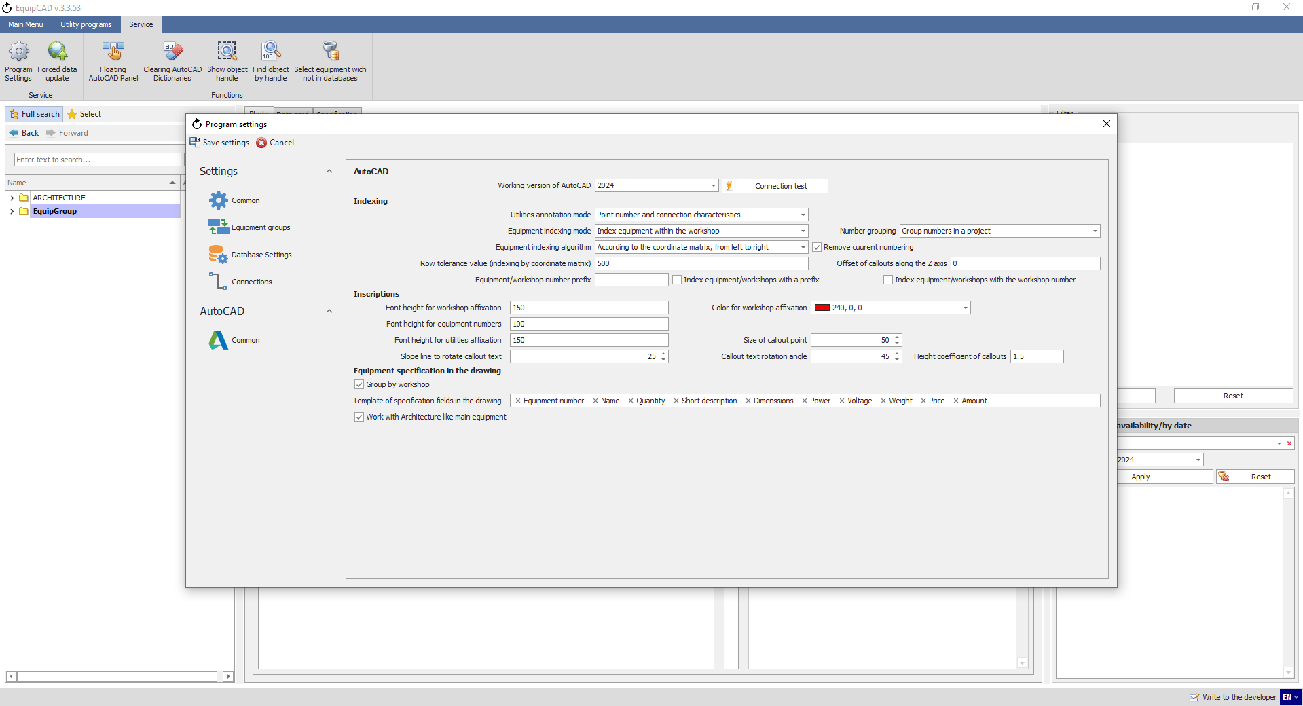
11.7.15
If the rotation angle of the segment is greater, callouts will not rotate by the specified degree.
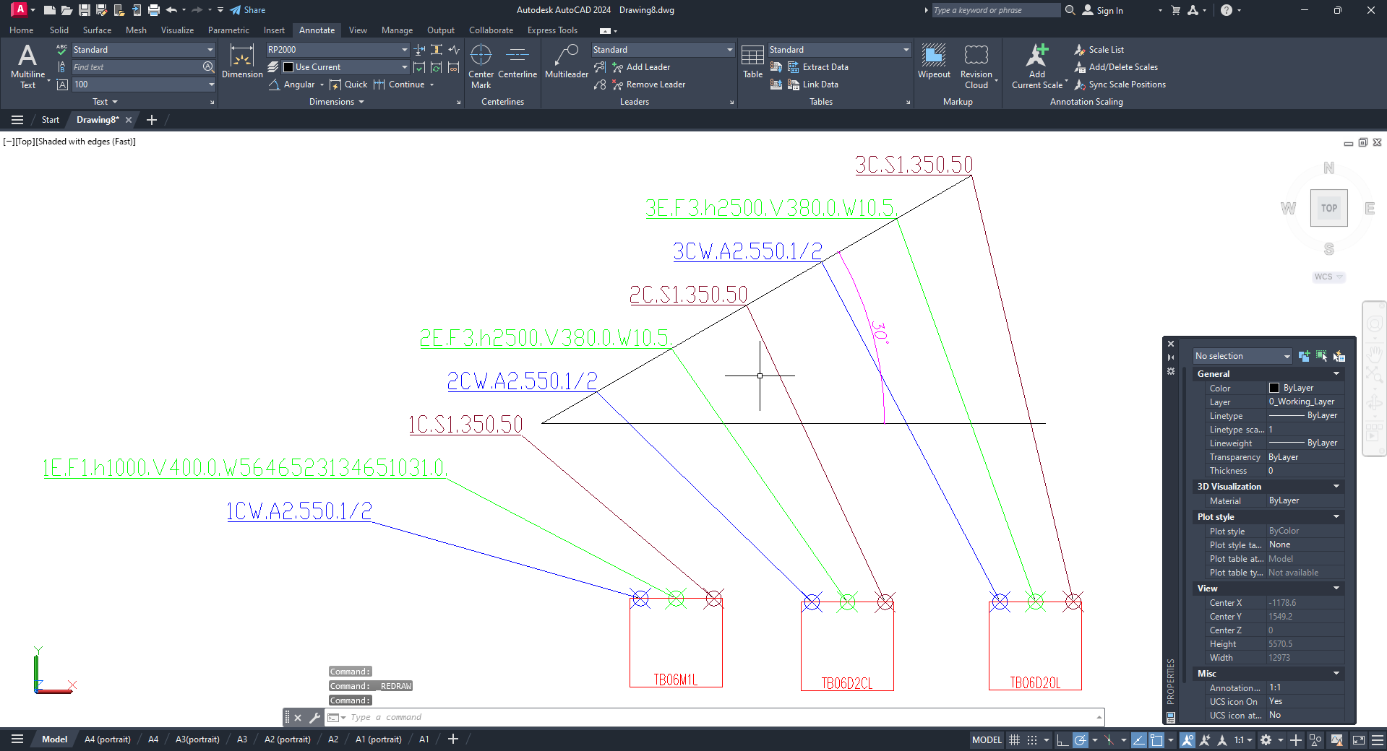
And the other way round, if the rotation angle of the segment is smaller than that specified in the settings, callouts will rotate by the specified degree.
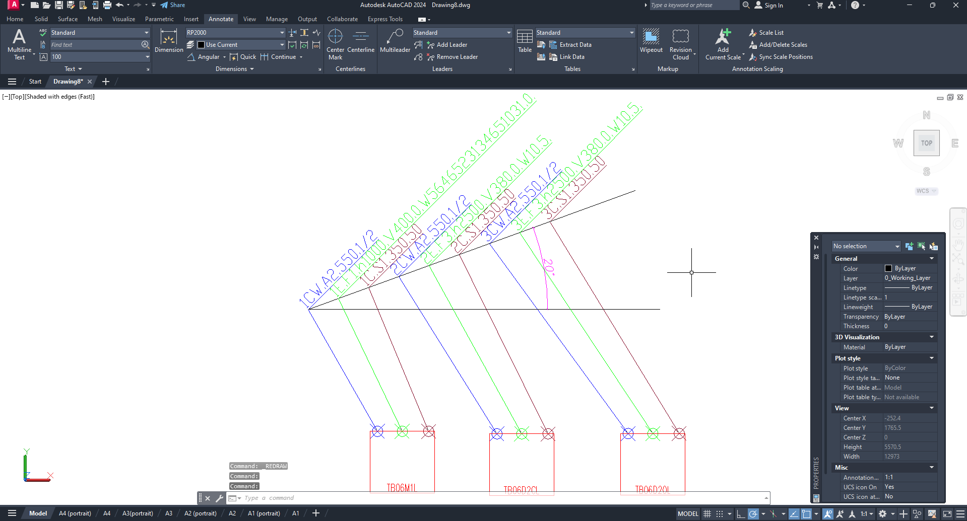

    - You can also use the “Height coefficient of callouts” setting to configure the distance at which callouts will be located from each other when arranged;
11.7.16

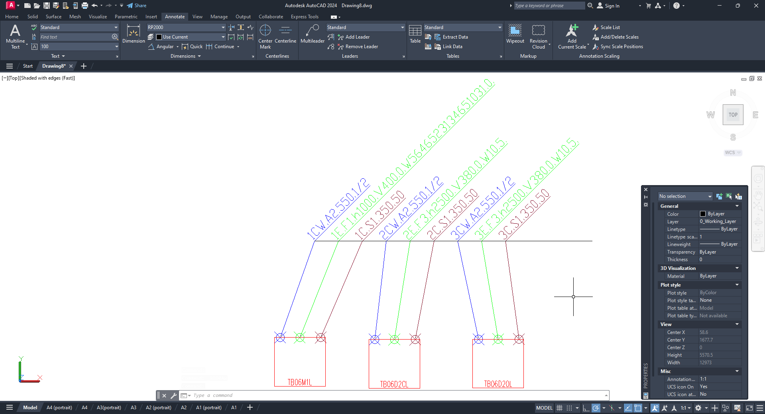
Coefficient 1.5

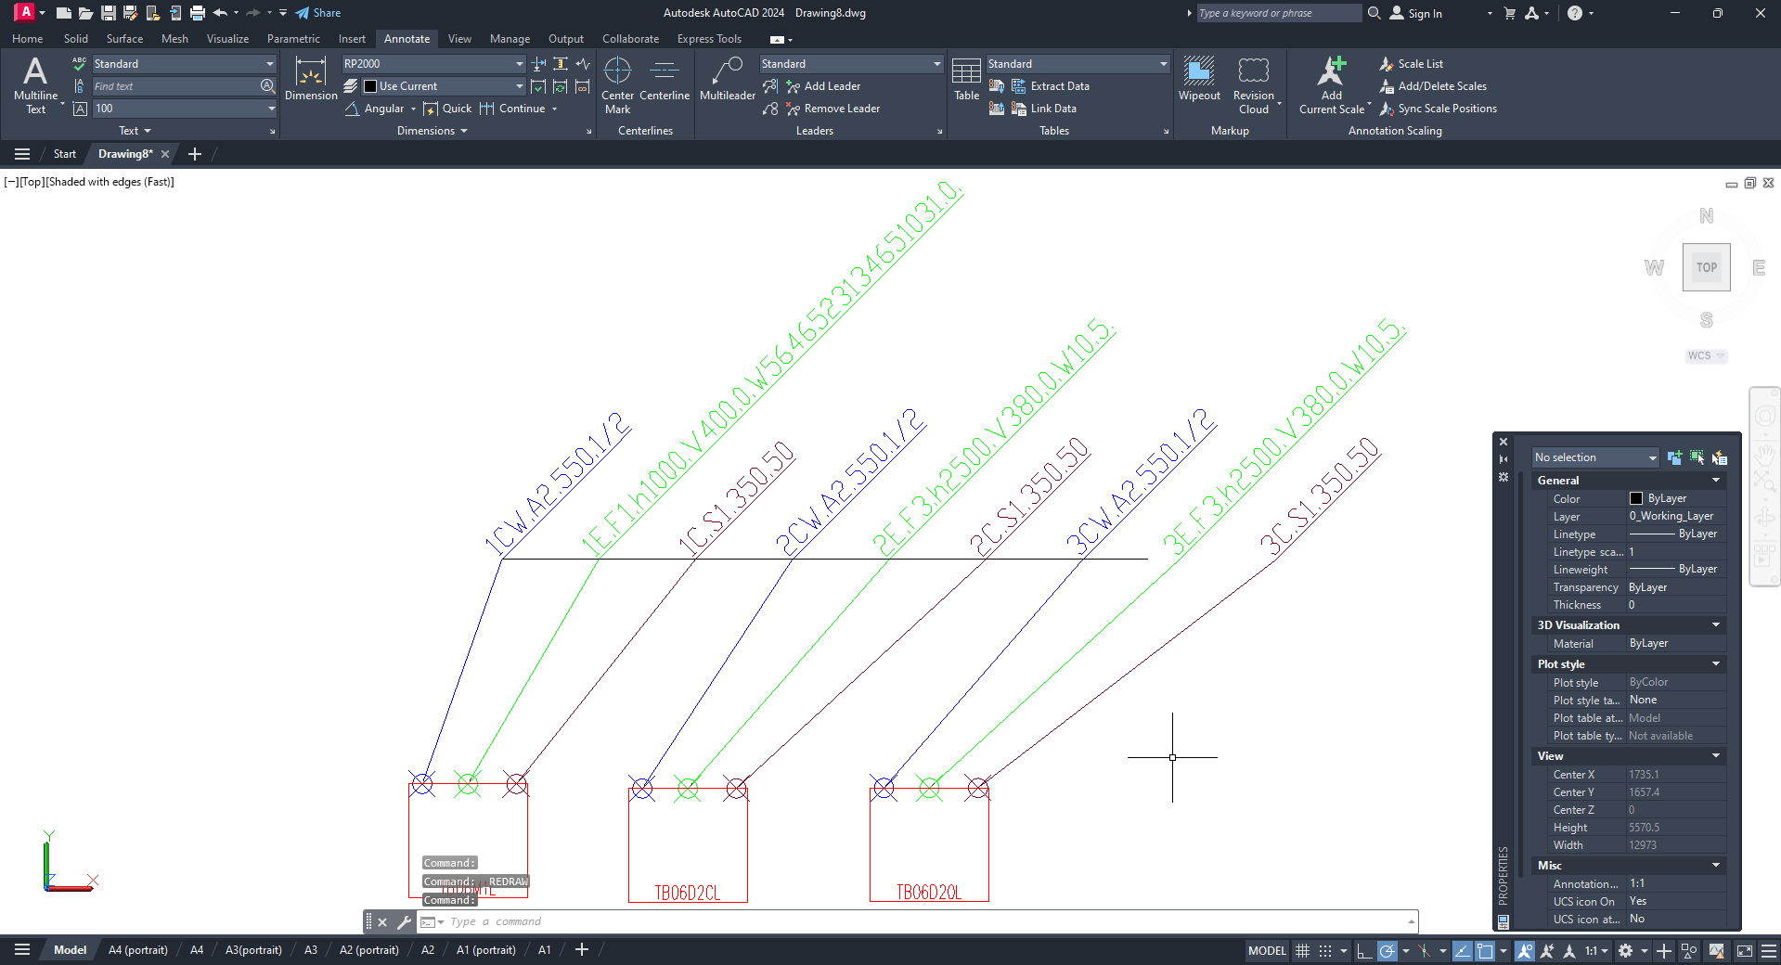
Coefficient 3.5

    - You can also set the angle at which callouts will rotate when aligned along a horizontal line.
11.7.17

    - To remove a 3D layer from a drawing, go to the “Utilities” tab;
    - Then click the "Remove 3D from drawing" button;
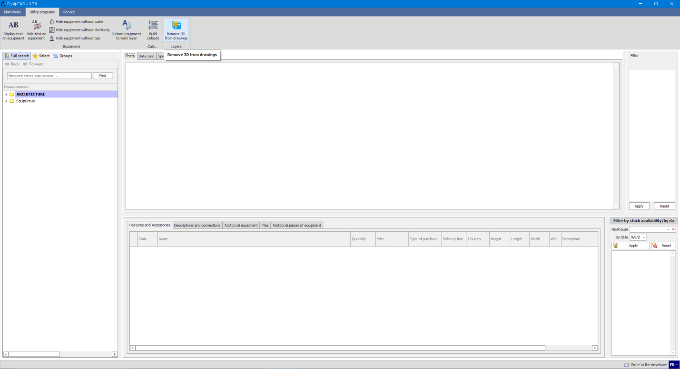
11.7.19
11.7.18

    - In the window that opens, select “Yes”;
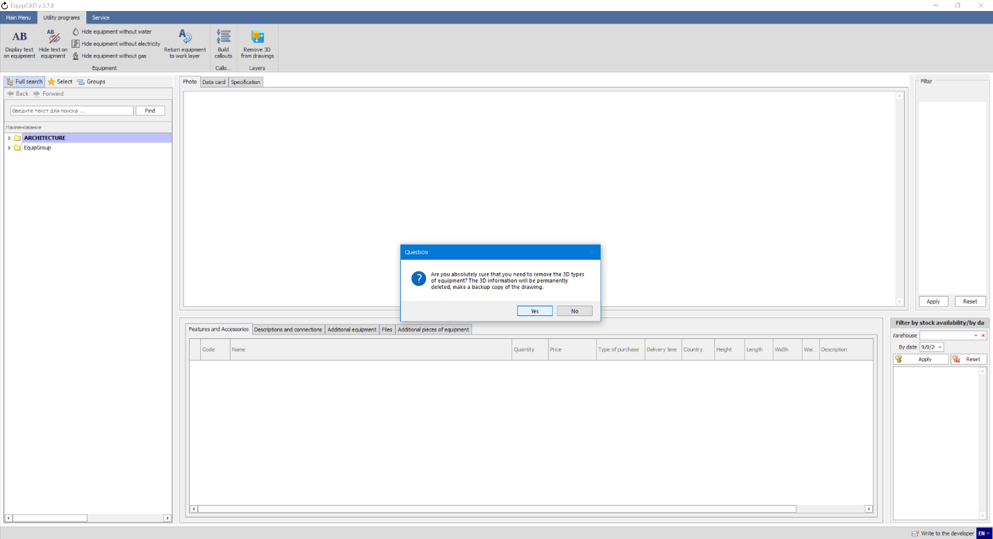
After this, the 3D layer will be deleted from the current drawing, along with all the elements that are on it.
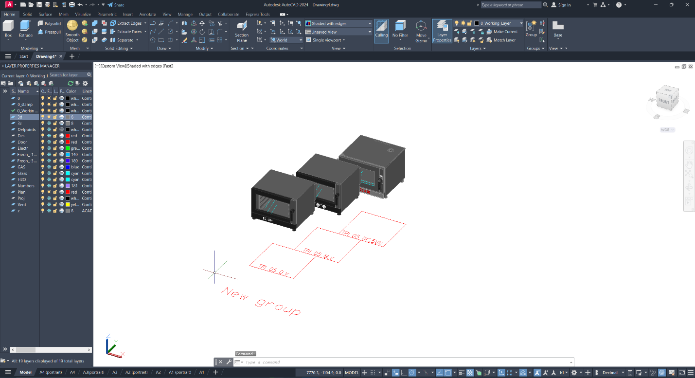
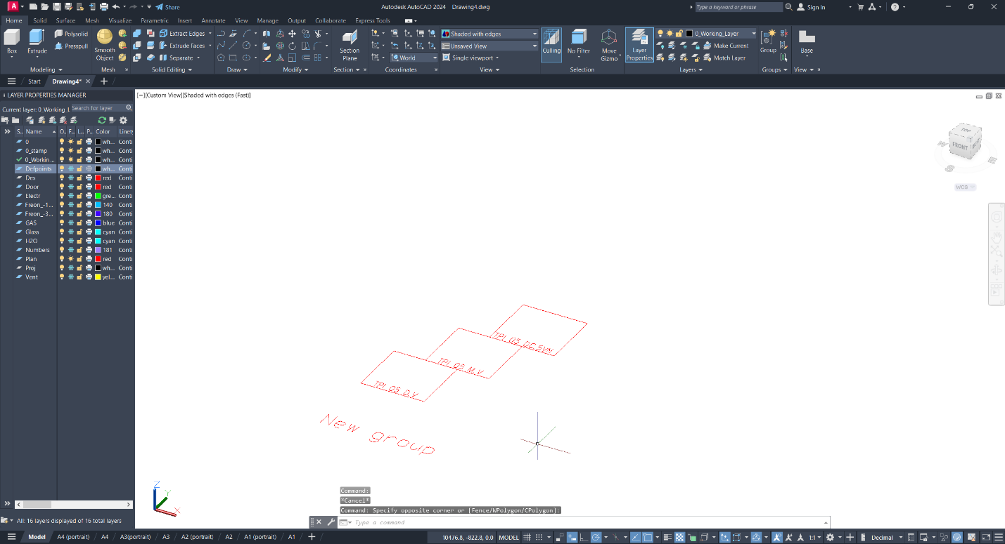
Note: The 3D layer is permanently deleted from the drawing, so you should first copy the drawing and only then delete it!

  - Utilities tables

    - To create a utility table, go to the “Indexing and tables” section and click the “Utilities tables” button and select the desired table;
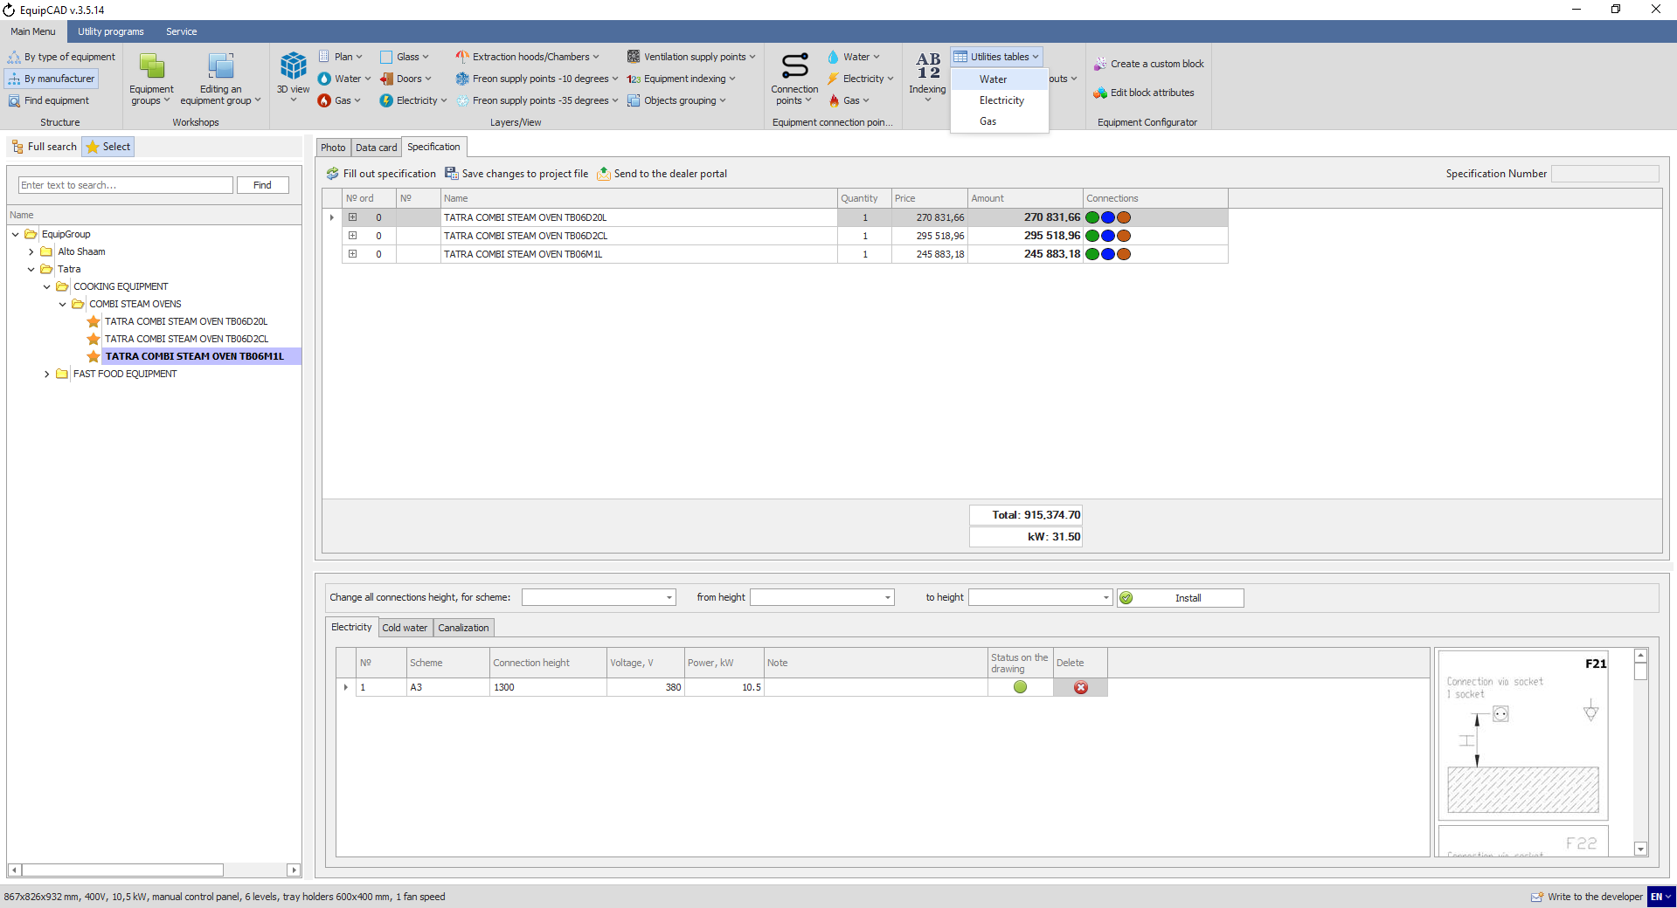
11.8.1

    - A utilities table is a table summarizing all the information about the connection points put for electricity, water or gas in the project (the table lists all the information on connection points whether or not the template has it, including Comments);
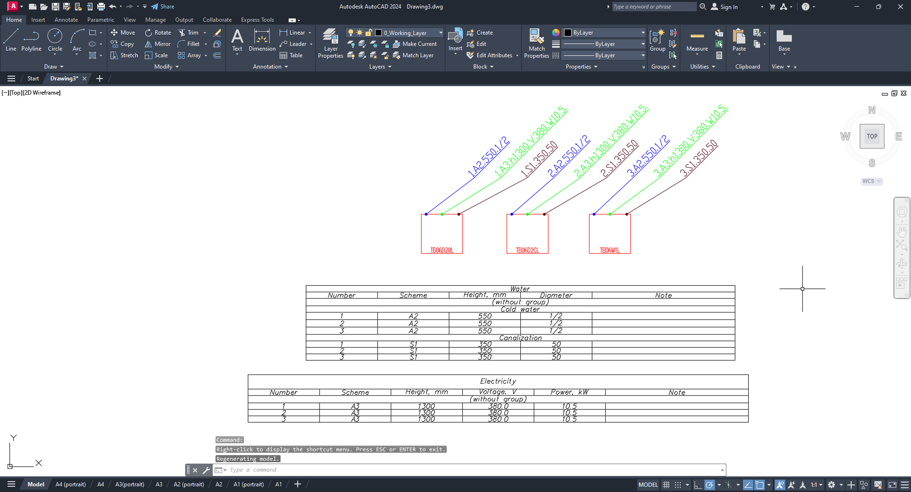
This case shows the Electricity and Water tables.

  - Connection points in the specification
To view information about connection points in the specification, follow the instructions in section 10.3 to send the specification to the portal and download it in Excel format. If connection points have been put in the project, the corresponding tabs will appear at the bottom.
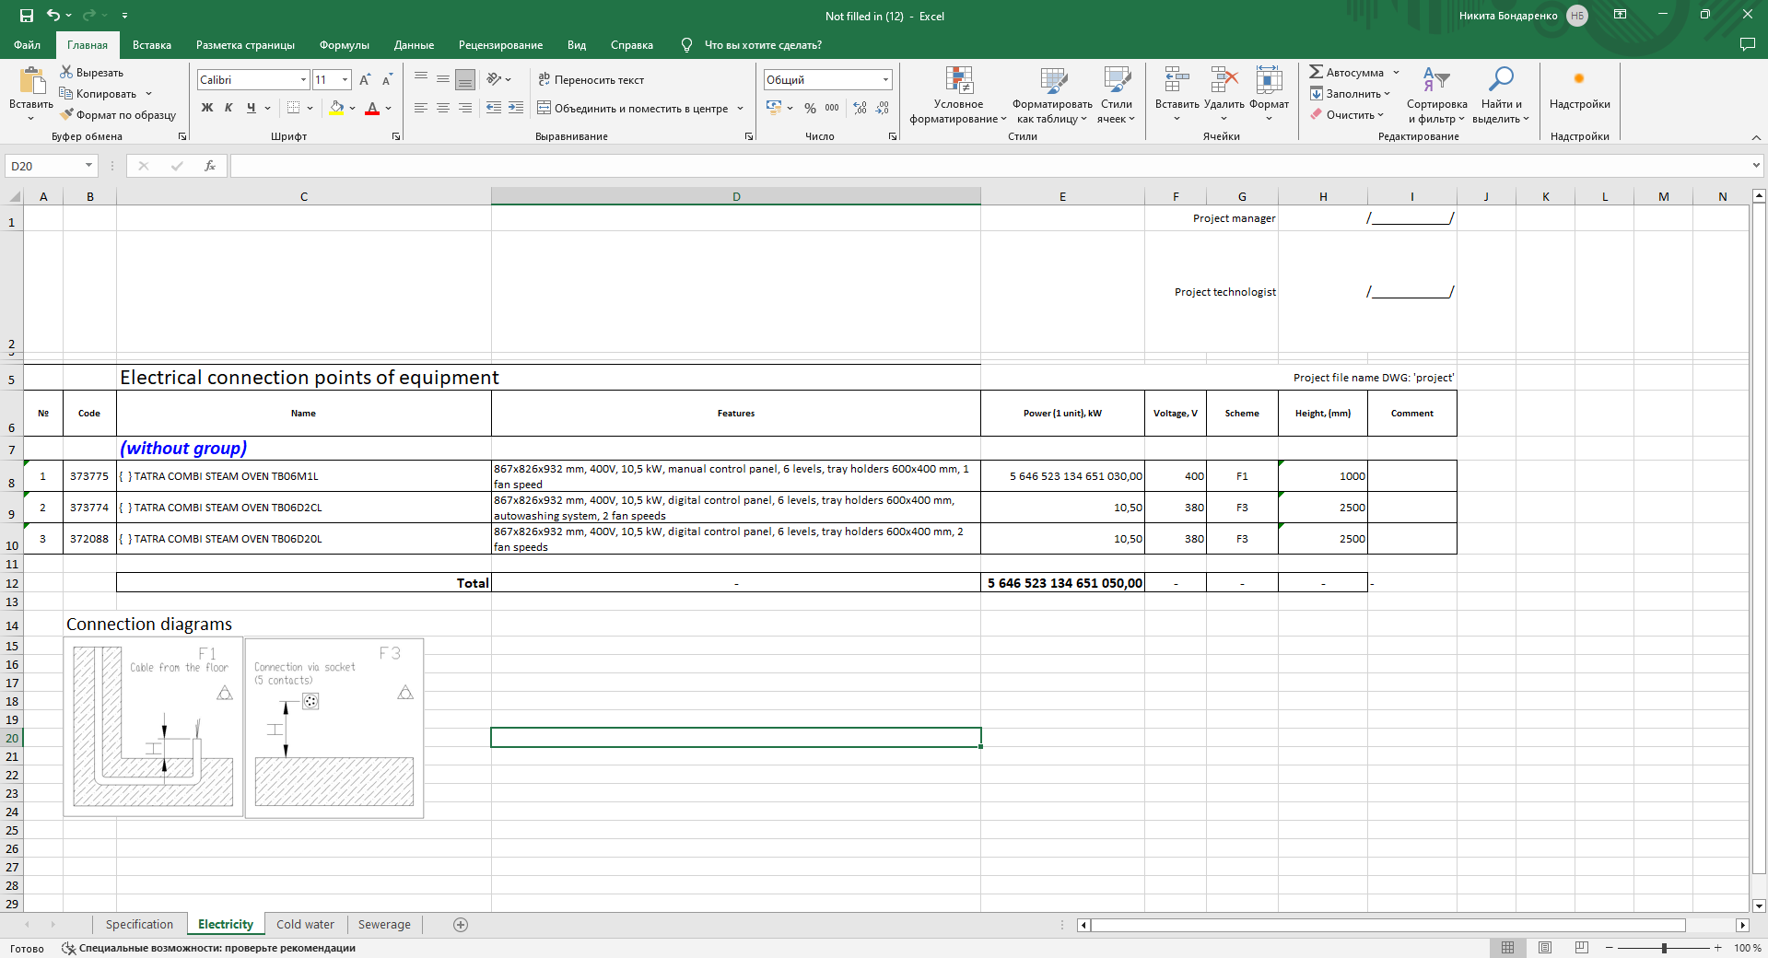
11.9
Each tab contains the connection tab number, article number, equipment number (in brackets in the Name field), equipment name with a breakdown by workshop, equipment characteristics and connection details, such as power, voltage, scheme, and connection height. Also, at the bottom you will find connection diagrams that are used in the project.
- Important operational aspects

  - Copying projects
When you copy a project to another AutoCAD file via the clipboard, all information about the created workshops, indexing, connections points, etc. will be lost. To avoid this, click the “Save as” button and save the file with a different name.

  - Removing workshops in a project
When deleting a workshop from a drawing, the serial numbers of other workshops will remain unchanged; you can adjust the workshop numbers by manually changing them in the "Group order, prefixes" window.
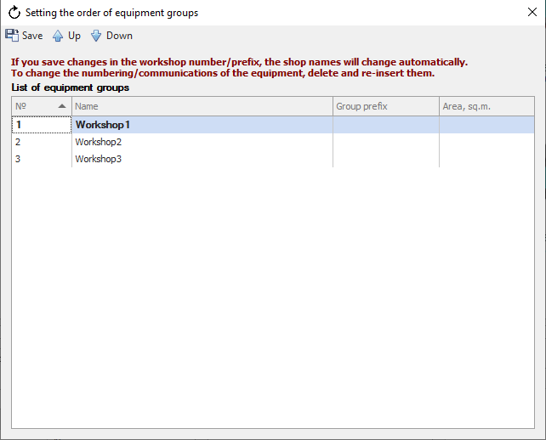
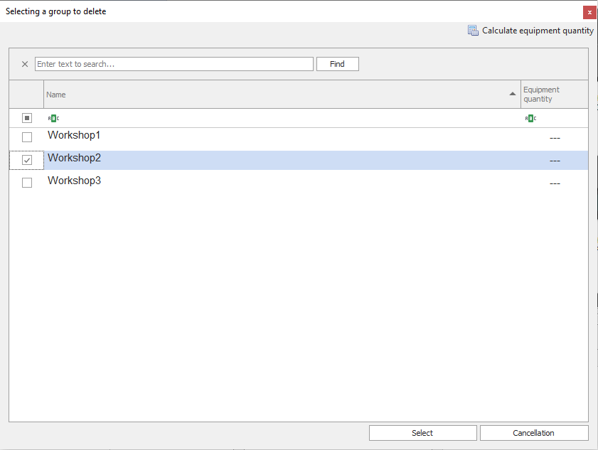
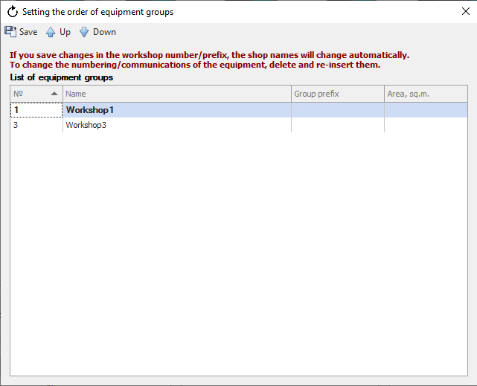
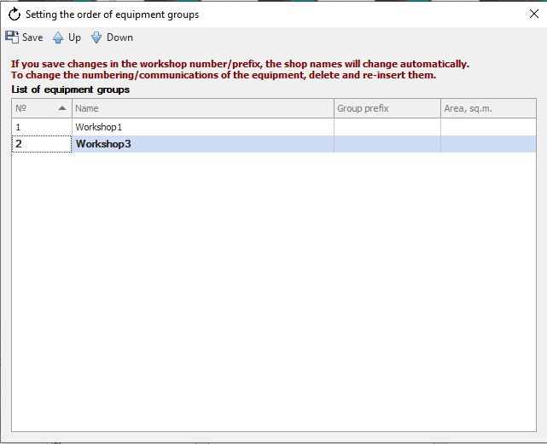

  - Cancel command execution
Some commands in EquipCaD can be cancelled by clicking the "Cancel" button in the lower right corner of the progress bar.
